What Can CAN Cans Contain?

WEC 2020
Senior Design Challenge
2020-01-24

Senior Design Coordinator
Adam Lozinsky
sr.design@wec2020.ca

1 Background

You and your team are a group of scientist and engineers living on a Martian research colony. During an exploration mission to nearby canyon that looked suspiciously artificial a Contained Alien Neo-artifact (CAN) was discovered. Entering the canyon blocked all transmissions and proved fatal to the explorer. Other signs of ancient intelligent life have been found. Scientists theorize these CAN’s have preserved ancient alien technology. Earth scientists have sent you information about the most likely possible contents. Your mission will be to correctly identify the contents of the CAN using supplies from the colony. All supplies are critical to the colony and will have to be replaced by the resupply mission which arrives in three Earth years.

2 Mission Objective

Correctly identify the contents of the CAN across three trials.

2.1 Mission Parameters

- You may not enter the canyon at any time. Except to setup up you solution.
- You may not directly control your solution either physically or remotely while it is within (partial or completely) the canyon.
- Your solution may be placed anywhere within the clean area but must begin at ground level. And, no clamping pressure or penetration may be made to the CAN during placement.
- Your solution may be multi-staged and/or have separate components but all parts of the solution must be made known prior to demonstrating.

2.2 CAN Theoretical Data

Designation | Name | Visual | Mass [g]
BEET | Photon-Emitting Acidic Regoltih |  | 480
BEAN | Binary Equivalent Arithmetic Node |  | 498
HARICOT |  |  | 474
CORN | Cancer Obliterating Rectal Nutrient |  | 493
Table 1: Earth scientist received CAN theoretical data.

2.3 Canyon Diagram

Mission environments always deviate from expected. Good design is capable of adapting to the changing situations and unknown variables. To simulate a changing environment the competition will have three trials. The CAN’s will be placed in three different position marked on the canyon and seen in Figure 1. Each trial will be attempted independently (only on CAN in the canyon at a time).

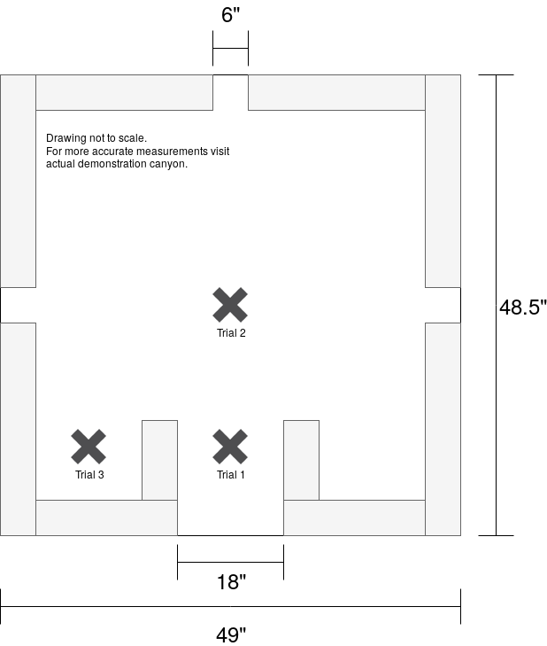
Figure 1: Canyon Diagram

2.4 Supplied Materials

These materials will be supplied freely:
- 1 toolbox with various tools. (You may not use this as materials for your design).
- 1 LEX motors.
- 1 LEX servos.
- 1 Arduino
- 6 9V Batteries (for development, testing, and demonstration! Do not waste colony power).
- 4 Hot glue sticks.
- 1 Kit with various electronic components.
- 1 Can opener.
- 1 Sample of each CAN type.

Additional materials can be purchased from the store.

2.5 Testing

Two testing zones are provided. No effort will be made to secure your intellectual property from competing teams. You may use a testing zone at any time within the development period. Limit your testing cycles to less than 10 minutes to allow other competitors fair access. In no way are the teams obligated to take turns use a testing zone or required to use them independently. This being said causing damage to another teams solution will result in immediate disqualification for both teams as it will be seen as a disruptive waste of the colonies precious resources.

3 Quantifiable Scoring Rubric

The demonstration period will follow these guidelines:
- Your team will be allotted a total of 15 minutes to complete three trials.
- During in-situ design improvisation is often required. Within your demonstration period (but not during an active trial) you may repair, adapt, or other wise change your design using your purchased materials.
- If during any trial a CAN is disturbed or otherwise modified and an identification is not given it will be replaced and position reset.
- Once an identification for a CAN is given that particular trial is over.
- Identification must be given with logical justification, guessing is not allowed (the odds of guessing all trials correctly is ~2%).
- You may re-try a trial as many times as you are able within the demonstration time period.
- Time will be paused to clean the canyon (if so an occasion arises) as to keep the competition fair for subsequent attempts.

Your team will be scored for the demonstration portion as follows:
Demonstration /40
Correct Identification Trial 1 /10
Correct Identification Trial 2 /10
Correct Identification Trial 3 /10
Total mass, team with lowest mass used gets 10, second lowest get 9, and so on to 0. /10

Correct identifications award 10 points. Incorrect or guessed identifications award 0 points. Replacement supplies from earth are expensive ($45K/kg) therefore the less mass used the better.

4 Presentation

A 15 minute power point presentation must be developed and submitted with your solution at the end of the development period. The presentation schedule will be posted exactly 30 minutes prior to the first presentation. All teams are required to be present at this time. All team members must be present and participate in the presentation or be penalized by the judges. Competitors have fifteen 15 minutes to present their designs after which the judges will have 5 minutes to ask questions. Directly following the first question period will be 15 minutes of demonstration. After then demonstration period the judges will have another 5 minute of question period.

The presentation must include the original design, its rationale, a description of the design process, and a critique of the prototype.
5 Appendix

5.1 Judging Matrix

Presentation /25
Team Strategy /5
Teams’ use of Design Process /5
Alternatives Considered /5
Presentation delivery and style /5
Question Responses /5

Design Quality /35
Abides to the spirit of the competition /5
Consideration of economic, social and environmental impacts of design /5
Total cost of prototype /5
Total cost, points to 5 teams with lowest cost /5
Design compliance with expectations /10
Technical innovation and creativity /10

Demonstration /40
Correct Identification Trial 1 /10
Correct Identification Trial 2 /10
Correct Identification Trial 3 /10
Total mass, team with lowest mass used gets 10, highest gets 0 points. /10

Penalties
Failure to address competition theme -10
Verbal disclosure of school during presentation -10
Disclosure of school in presentation files/documents -10
Disclosure of school by supporting audience members -10
Intentional disclosure of another teams’ school Disqualification
Absent Team Member -25 per member
Plagiarism Disqualification

Total /100

5.2 Feasibility

Given that the intention of the competition is to create a practicable, realistic solution to the given problem statement, a penalty of fifty (50) points will be deducted from the final score of any team whose design is based fundamentally upon an impossible concept, and/or makes no realistic attempt to solve the design problem solved within the constraints of the problem statement.

