Test 4 – curl comparisons
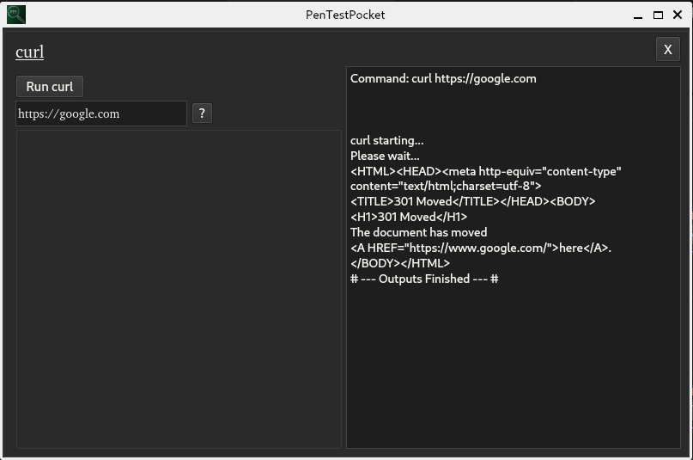
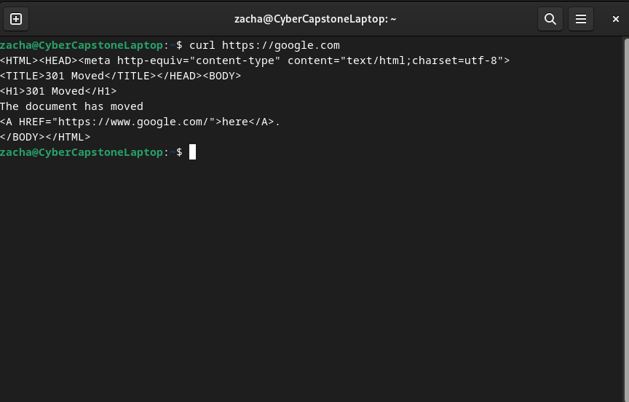
- Test Input – curl https://google.com/
Base Case
Test Case
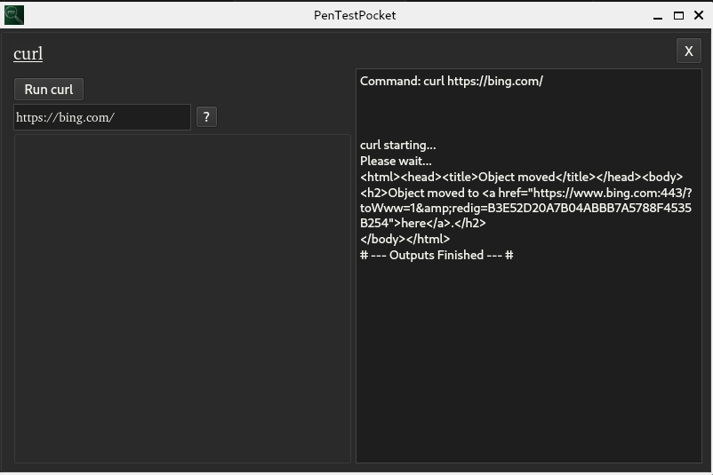
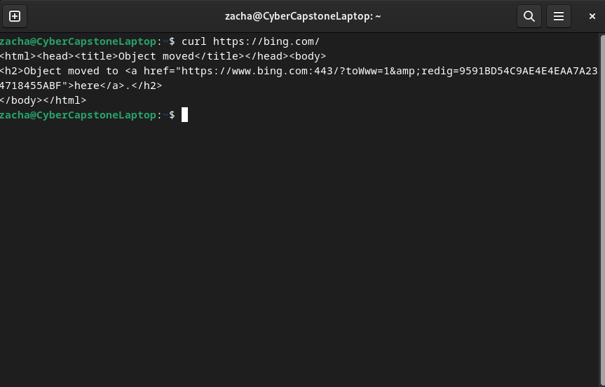
- Test Input – curl https://bing.com/
Base Case
Test Case
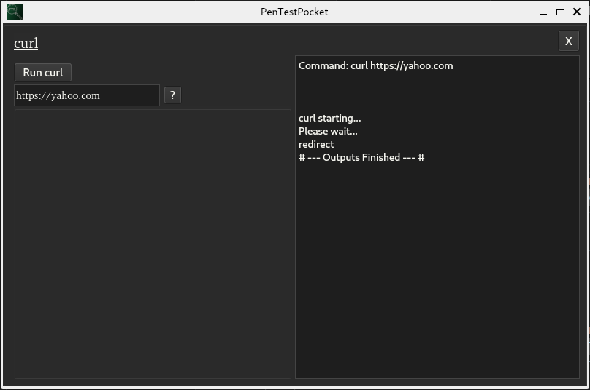
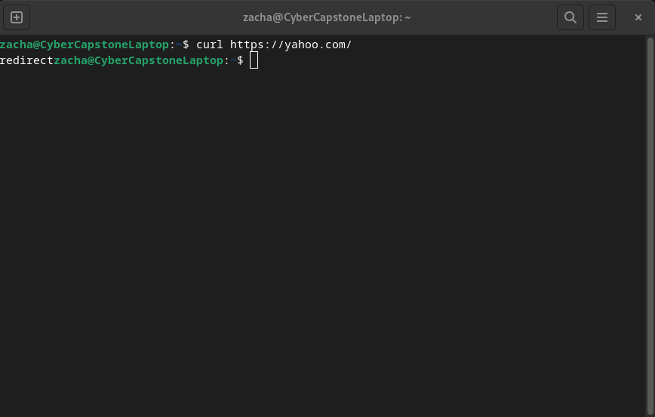
- Test Input – curl https://yahoo.com/
Base Case
Test Case
Test 5 – Data conversion comparisons
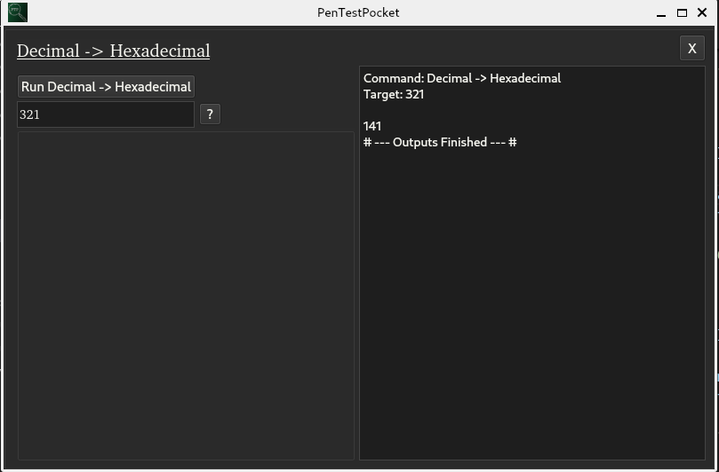
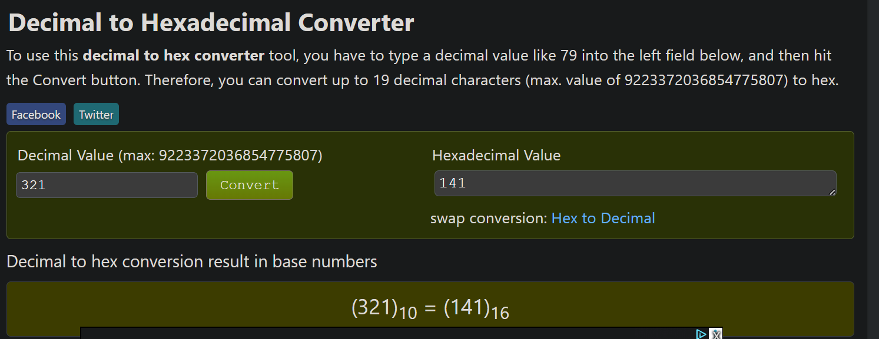
- Test Input – Decimal -> Hexadecimal 3
Base Case
Test Case
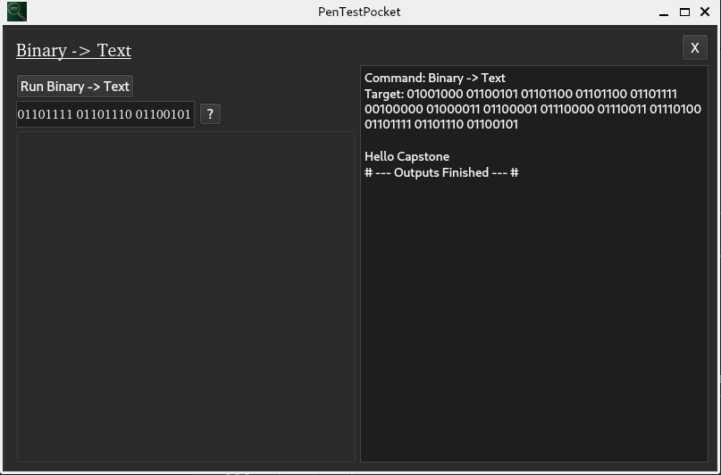
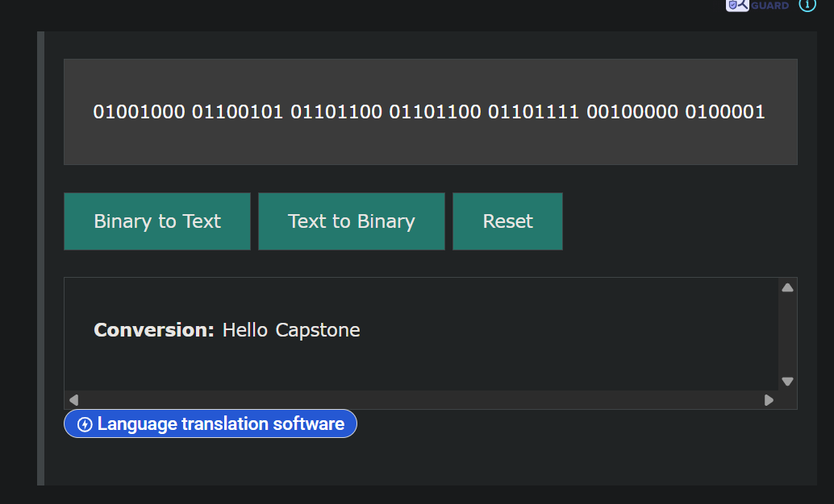
- Test Input – Binary -> Text 01001000 01100101 01101100 01101100 01101111 00100000 01000011 01100001 01110000 01110011 01110100 01101111 01101110 01100101
Base Case
Test Case
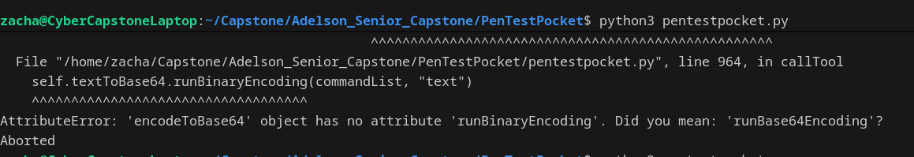
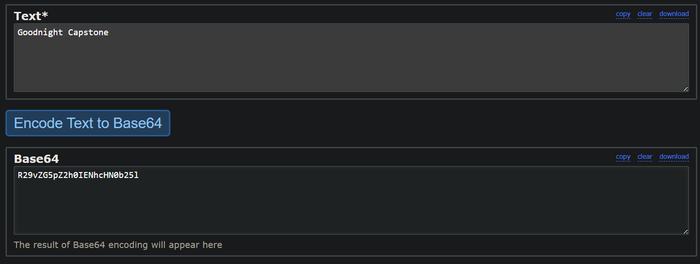
- Test Input – Text -> Base64 Goodnight Capstone
Base Case
Test Case

Test 6 – Hashing comparisons
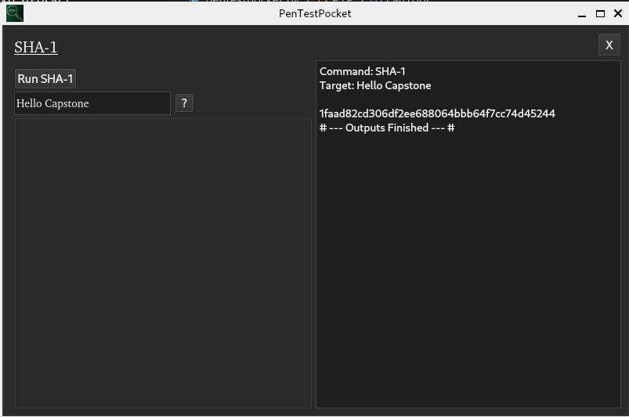
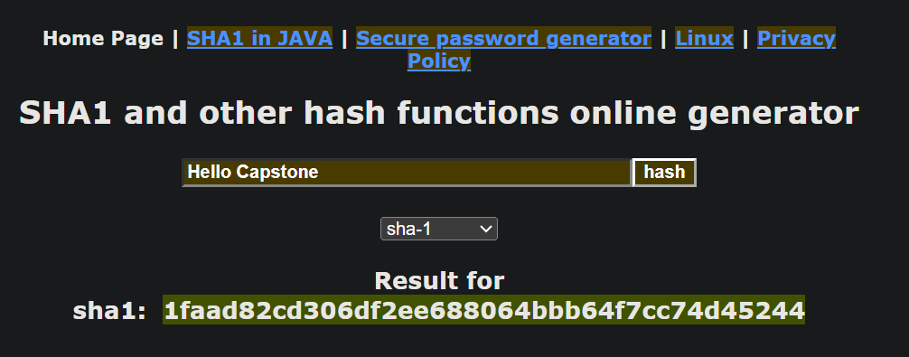
- Test Input – SHA-1 Hello Capstone
Base Case
Test Case
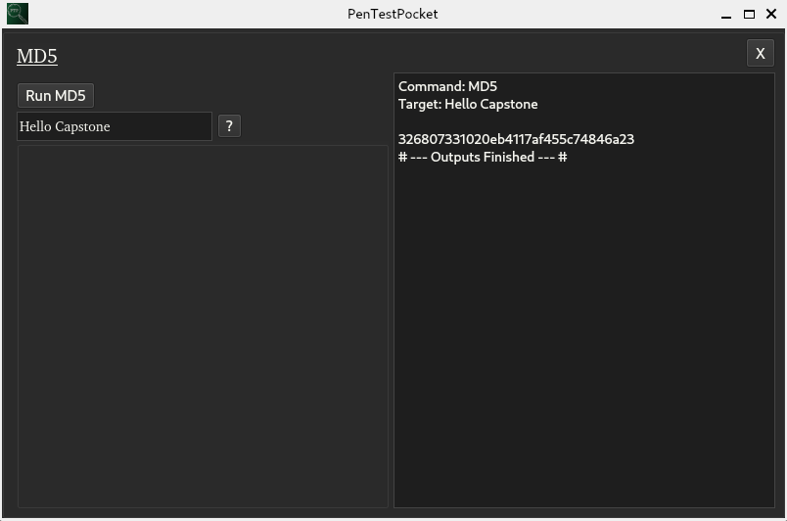
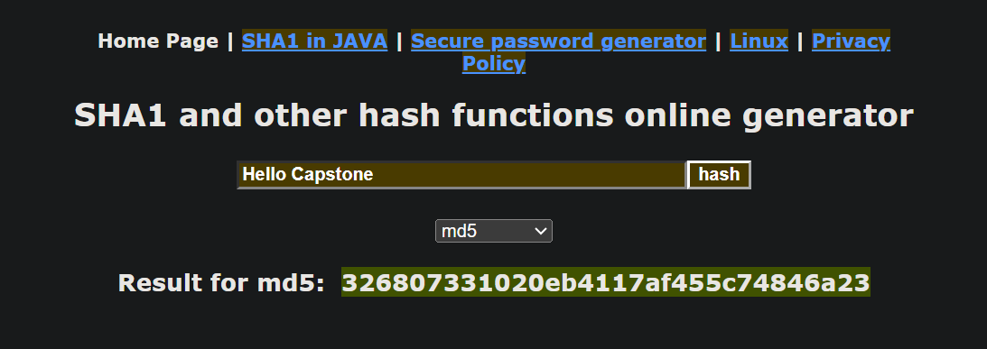
- Test Input – MD5 Hello Capstone
Base Case
Test Case
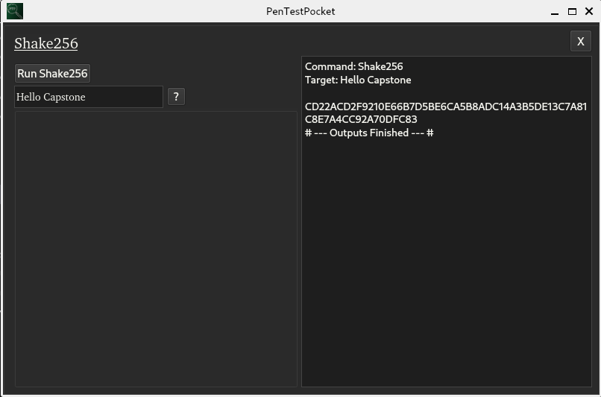
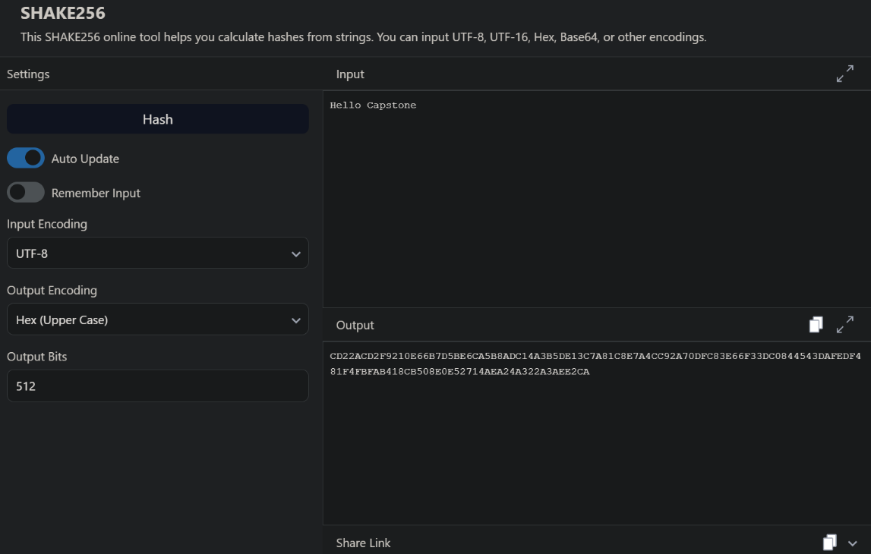
- Test Input – Shake256 Hello Capstone
Base Case
Test Case

