**Financial Accessibility Series**

Practicum in Data Writing and Online Journalism

**Financial Accessibility at Oberlin College**

**Part I**

Today, Oberlin College is [ranked](http://www.usnews.com/education/best-colleges/the-short-list-college/articles/2014/09/09/10-most-least-pricey-private-colleges-and-universities) the 7th most expensive college or university by tuition and 15th by total cost of attendance in the country. Naturally, how and why did we get to become so expensive? To answer this question, let us examine how costs and policies have changed over the years.

**Exploding Costs**:

First, [here](http://oberlin.edu/instres/irhome/www/databook/default.html) is how total cost of attendance at Oberlin has changed since 1964:

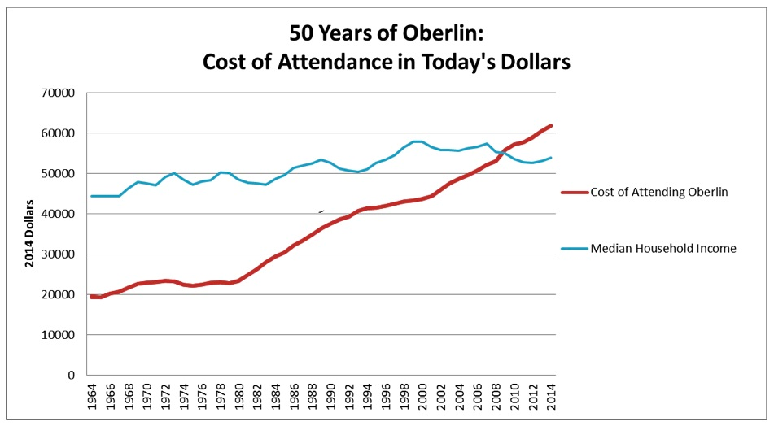

Of course, net cost differs by family income, and Oberlin, like most private institutions, gives financial aid to the majority of its students. In fact, 85% of students receive aid packages, which are calculated based on family income in addition to a work and loan requirement. Nonetheless, net costs have greatly risen too. In 2012, [net prices](http://www.collegefactual.com/colleges/oberlin-college/paying-for-college/financial-aid/" \l "FreshmenLoans) were:

|  |  |  |  |  |  |  |  |  |  |  |  |  |  |  |  |  |  |  |  |  |  |  |  |  |
| --- | --- | --- | --- | --- | --- | --- | --- | --- | --- | --- | --- | --- | --- | --- | --- | --- | --- | --- | --- | --- | --- | --- | --- | --- |
| Net Prices by Income at Oberlin College   |  |  |  | | --- | --- | --- | | **Oberlin College** | | | | Income Bracket | Net Price 2012-13 | Over 4 Years | | $0 - $30,000 | $10,774 | $43,096 | | $30,001 - $48,000 | $9,785 | $39,140 | | $48,001 - $75,000 | $17,445 | $69,780 | | $75,001 - $110,000 | $25,985 | $103,940 | | $110,001 and more | $40,082 | $160,328 | | **Average:** | $37,366 | $149,464 | |

The roughly 38% of Oberlin students who received federal loans in 2012, took out on [average](http://febp.newamerica.net/higher-ed/OH/308600) $6,914 or an estimated $28,000 over four years. This is to say, a student who takes out loans over four years at Oberlin will expect to take out just shy of the [national average](http://money.cnn.com/2013/12/04/pf/college/student-loan-debt/index.html) of $29,000 in debt for those who graduated in 2012. This isn’t a perfect juxtaposition, as we’re comparing those who started in 2012 with those graduated that school year. Yet, it still represents a significant increase from the average federal loan aid of $4,400 per year in 2009.

Rising costs at Oberlin have not been confined to tuition and loans. For example, the price of studying abroad has increased since 2013, as students are now charged Oberlin tuition for all study abroad programs, including those that cost less than Oberlin tuition. It has also become prohibitively expensive to be on a meal plan. While one can purchase meals individually at $7 from CDS, meals purchased through a [plan](https://dining.oberlin.edu/xcds/mealplans/calculator.php) are far higher:

|  |  |  |
| --- | --- | --- |
| **Meals/Week** | **Cost/Semester:** (with Flex subtracted) | **Cost/Meal** |
| 19/week | $3,478 | $13.08 |
| 14/week | $3,048 | $15.55 |
| 12/week | $2,863 | $17.04 |
| 10/week | $2,568 | $18.34 |
| 7/week | $2,028 | $20.69 |
| 5/week | $1,693 | $24.19 |

All these increases disproportionately affect low-income students and stifle economic and ethnic diversity at Oberlin.

**Low Income Students and Increased Burdens:**

On average, it costs nearly $11,000 per year for a low-income student to attend Oberlin today. This puts us at 59th most expensive for low-income students out of 99 similar institutions compiled by the [*New York Times*](http://www.nytimes.com/interactive/2014/09/09/upshot/09up-college-access-index.html?_r=1). However looking back a few years, low-income Oberlin students paid $5,400 as recently 2009. Due to the disproportionate impact on low-income students, in 2008, the Oberlin Access Initiative aimed to erase all loans for Pell-eligible students (essentially students in the lowest income bracket). When the initiative began, President Krislov announced:

We take great pride in Oberlin's historic and continuing commitment to providing access to students from all backgrounds. This initiative allows us to ensure that students from the neediest families do not have to bear the burden of loans during their college years. For these students, even a modest loan may limit their choices of majors, internships, and careers.

However, it appears that this measure was only temporary and did not last long after the 2008 financial crisis. In 2010, the average net cost for a low-income student increased to slightly over $11,000 and thus doubled in a single year where it has since remained steady. Yet given the rhetoric around helping low-income students, why is the burden of attendance costs still falling on those students?

About one-tenth of Oberlin College students receive federal aid such as Pell Grants, and therefore fall into this income bracket. An estimate of the revenue generated from the 2010 price increase for low-income students is an additional $1.5 million— a rounding error for a school with an $808 million endowment. Put differently, the additional revenue from low-income students could pay President Krislov’s 2012 compensation of $670,000 for two years. For the curious, “Marvin Krislov earned more than 83% of [the 500] presidents in *The Chronicle’s* survey,” most recently [published](http://chronicle.com/factfile/private-ec-2014/?cid=inline-promo" \l "id=21410_204501) for 2012. It is not simply rising costs that are troubling but also a lack of diversity that one would naturally expect for a college as historic as Oberlin.

**Lackluster Economic and Ethnic Diversity:**

Despite Oberlin’s current $280,000 endowment per student and generous financial aid commitments, we struggle to be an economically and ethnically diverse campus. Taking data compiled by the [*New York Times*](http://www.nytimes.com/2014/09/13/upshot/making-top-colleges-less-aristocratic-and-more-meritocratic.html?abt=0002&abg=0) last year, I added Oberlin to demonstrate where we stand on economic diversity:

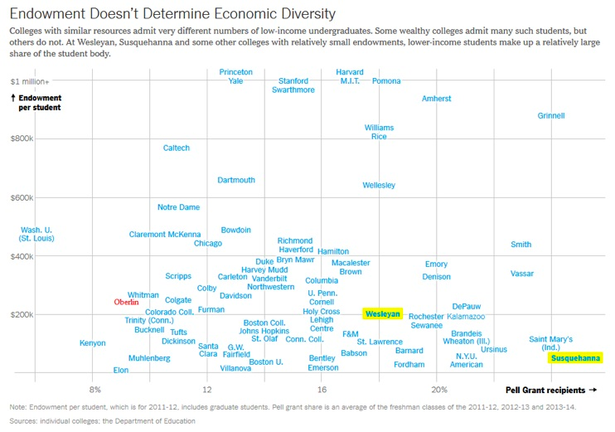

Only a handful of similar schools have a lower percentage of low-income students than Oberlin.

If it is not individual net cost or endowment per student, then what is causing our lack of economic diversity at Oberlin? Perhaps it’s institutional policy or choice. In a 2013 *New York Times* [article](http://www.nytimes.com/2013/07/31/education/elite-colleges-differ-on-how-they-aid-poor.html), Richard Perez-Pena writes:

Most of the elite colleges give only need-based aid. But a handful devote a significant part of their aid budgets to merit aid, and those, including Davidson College and Oberlin College, also tend to have fewer Pell recipients.

Additionally, Oberlin College had a “need-blind” admissions policy until 1993, where it admitted students without regard to their financial ability to pay. The rising sticker and real cost of Oberlin are almost certainly dissuading some low-income student from even applying. Looking at [data](http://www.usnews.com/education/blogs/college-rankings-blog/2008/02/22/do-top-colleges-enroll-enough-pell-grant-students) from 2000 to 2006, Oberlin College lowered its percentage of Pell Grant receiving students by 30%. Out of all liberal arts colleges, this was the third-sharpest decline during that time period. The proportion of low-income students has since remained stable— around 10% of the student body.

Moreover, the lack of economic diversity at Oberlin must have a negative impact on the racial and ethnic diversity of our school. Looking specifically at the percentage of black students at Oberlin, their enrollment is at a near 40-year low, regardless of how multi-racial students are [counted](http://oberlinreview.org/6882/uncategorized/activists-concerned-over-black-student-enrollment-numbers/) (either 7% or 5% of students currently). This is less than half of Oberlin’s peak enrollment of black students in 1974, who made up 12% of the student body. In fact, in [May 2013](http://nces.ed.gov/ipeds/datacenter/login.aspx), only 7 black men and 12 black women graduated. This want of diversity applies to not just black students but to all non-white students. A standard way to measure diversity is to calculate the probability that two individuals taken from random would belong to different groups. This number is 41%, ranking us at a middling 75 on U.S. News’ [list](http://colleges.usnews.rankingsandreviews.com/best-colleges/rankings/national-liberal-arts-colleges/campus-ethnic-diversity/page+3) of liberal arts colleges.

Where does all this leave us? In part two of this series on the cost of higher education, I will examine Oberlin in the broader national context and compare some competing solutions to reduce the current $1.1 trillion in student debt. Until then, I shall leave you with this quote from the [2005 Strategic Plan](http://www.oberlin.edu/strategicplan/pdfs/strategicplan.pdf), “Oberlin must enhance each of its revenue streams. Currently its most critical financial priority must be to realize more net tuition revenue per student”.

**Part II- A National Context**:

In the [first part](http://www.fearlessandloathing.com/2015/04/financial-accessibility-at-oberlin-college-part-one/) of this series, I analyzed how costs have risen at Oberlin. This time I will look at what drives cost differences among different universities more generally. In short, I believe the cost of higher education is being driven in part by students’ lack of bargaining power in economic decisions.

First, here are some basic figures on the nature of higher education in the United States: currently, there is $1.1 trillion in student debt nationally. The average new borrower graduates with just shy of $30,000 of debt while average for all borrowers is $25,000. The amount of student debt across the country has risen steadily [since](http://www.washingtonpost.com/posteverything/wp/2014/09/02/my-students-pay-too-much-for-college-blame-reagan/) “spending on higher education was slashed by some 25 percent between 1980 and 1985” and has especially skyrocketed since [2006](http://www.newyorkfed.org/studentloandebt/):

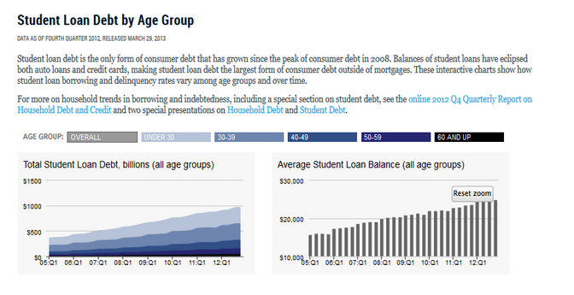

Let’s explore some of the competing explanations in this explosion of student debt.

**Administrative Bloat**

One theory about the rising price of education is that administrative costs are significantly driving up the overall cost. This is because administrative costs, as well as the number of administrators, at the [average university](http://www.bloomberg.com/news/articles/2012-11-14/bureaucrats-paid-250-000-feed-outcry-over-college-costs) have rapidly been rising—much more so than those of other staff, like instructors.

However, the salaries of Oberlin administrators s do not appear to be very out of line when compared with peer institutions. The only salary which stands out as an outlier is that of the President, who made more than 83% of college presidents in his peer group in 2012. It is possible that we have an excessive number of administrators at Oberlin, but it’s unlikely to be an egregious number. In fact, as a total percentage of Oberlin College’s expenditures, institutional support (i.e. the category that most closely aligns with administrative costs) was about 17% in 2012, which is on the lower end of our [peer group](http://docs.google.com/viewer?a=v&pid=sites&srcid=b2Jlcmxpbi5lZHV8c3R1ZGVudHNlbmF0ZXxneDozN2Q1ZjRlYmQzYjdkNGM3). Due to the limited nature of the data, I won’t say much more on how administrative bloat plays in Oberlin’s overall cost. However, it is apparent that administrative bloat is only one part of explaining rising costs and is unlikely to be the main contributor particularly at Oberlin.

**Public Spending**

There is a line of thought, particularly [popular](http://www.nytimes.com/2015/04/05/opinion/sunday/the-real-reason-college-tuition-costs-so-much.html?_r=0) among conservative commentators, that increased public support and loans only drive up costs, by making students insensitive to rising costs as support doesn’t affect an individual's ability to pay. With careful analysis this argument quickly falls apart. Looking at 2014 dollars spent per year, and per full-time student from 1986 to 2014 by both state appropriations and net tuition (i.e the amount students paid to attend a public university in a particular state), I find that for a 1 % decrease in state spending per enrolled student there is an associated .22 % increase in net tuition per enrolled student1. In short, states with high public support for higher education have lower tuition costs:

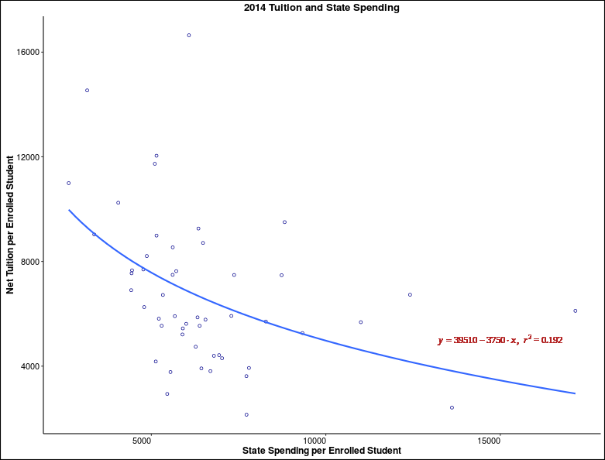

Of course, these are merely observational data. We can also compare growths rates between the two in order to capture a dynamic or real time picture. I find that for a 1 percentage point increase in the growth rate of state spending there is an associated .1 percent point decease in growth rate of net tuition2. This dynamic estimate is about as half as strong as the observational one. Finally, I ran several supplemental tests, and the results are strongly suggestive that public spending on higher education indeed lowers net tuition3.

Thus, declining public support per student is a significant part of rising net tuition costs at public universities. This cost shift likely spills overs to private universities. If public universities become more expensive, a private university can also increase prices without losing students who might have otherwise enrolled in a cheaper public university. From the nature of being a college in Northeast Ohio, Oberlin competes more directly with public universities than many of our peer institutions, and so public-private competition is particularly relevant to us.

This helps explains why (in many countries such as Canada and most of Europe) the state often plays a major role in higher education, and those costs are generally much lower than those in the United States. For example, the average low-income student at [Oberlin](http://www.fearlessandloathing.com/2015/04/financial-accessibility-at-oberlin-college-part-one/) pays around $11,000 a year to attend college which is similar or even more than what the wealthiest students at many European schools pay (e.g. tuition at current exchange rates ranges from $9,000 to $12,000 in the United Kingdom and is $11,250 at the Paris Institute of Political Studies).

**Endnotes**:

Source for Panel Data: [SHEEO](http://www.sheeo.org/sites/default/files/project-files/SHEF FY 2014-20150410.pdf)

1. Full static model from Stata using a fixed effects model and robust standard errors:

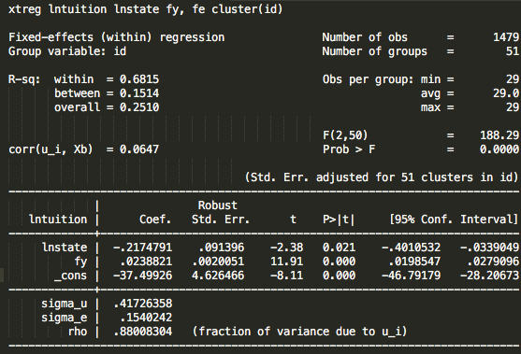

1. Full dynamic model from R using a fixed effects model:

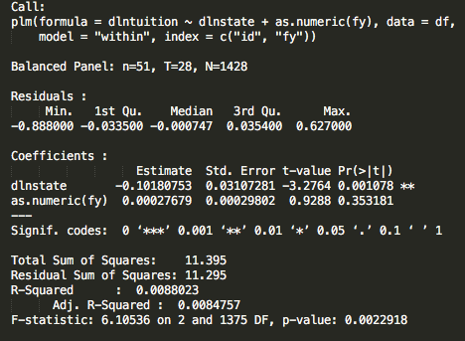

1. The dynamic model passes panel tests for both autocorrelation and heteroscedasticity. Moreover, the time series for the whole U.S. passes a granger causality test for state spending on tuition but not the reverse. Finally, an omitted set of regressions show substantively and statistically equivalent results after including potential confounding variables like unemployment rates.

**Linked Sources:   
  
Part I**1. <http://www.usnews.com/education/best-colleges/the-short-list-college/articles/2014/09/09/10-most-least-pricey-private-colleges-and-universities>

2. <http://oberlin.edu/instres/irhome/www/databook/default.html>

4. [http://www.collegefactual.com/colleges/oberlin-college/paying-for-college/financial-aid/#FreshmenLoans](http://www.collegefactual.com/colleges/oberlin-college/paying-for-college/financial-aid/" \l "FreshmenLoans)

5. <http://www.oberlin.edu/strategicplan/pdfs/strategicplan.pdf>

6. <http://www.oberlin.edu/newserv/08apr/access.html>

7. <https://dining.oberlin.edu/xcds/mealplans/calculator.php>

8. <http://money.cnn.com/2013/12/04/pf/college/student-loan-debt/index.html>

9. [http://chronicle.com/factfile/private-ec-2014/?cid=inline-promo#id=21410\_204501](http://chronicle.com/factfile/private-ec-2014/?cid=inline-promo" \l "id=21410_204501)

10. <http://www.nytimes.com/2014/09/13/upshot/making-top-colleges-less-aristocratic-and-more-meritocratic.html?abt=0002&abg=0>

11. <http://www.nytimes.com/interactive/2014/09/09/upshot/09up-college-access-index.html>

12. <http://febp.newamerica.net/higher-ed/OH/308600>

13. <http://www.nytimes.com/2013/07/31/education/elite-colleges-differ-on-how-they-aid-poor.html>

14. <http://www.usnews.com/education/blogs/college-rankings-blog/2008/02/22/do-top-colleges-enroll-enough-pell-grant-students>

15. <http://colleges.usnews.rankingsandreviews.com/best-colleges/rankings/national-liberal-arts-colleges/campus-ethnic-diversity/page+3>

16. <http://oberlinreview.org/6882/uncategorized/activists-concerned-over-black-student-enrollment-numbers/>

17. <http://nces.ed.gov/ipeds/datacenter/login.aspx>

**Part II**  
1. <http://www.fearlessandloathing.com/2015/04/financial-accessibility-at-oberlin-college-part-one/>

2. <https://www.washingtonpost.com/posteverything/wp/2014/09/02/my-students-pay-too-much-for-college-blame-reagan/>

3. <https://www.newyorkfed.org/studentloandebt/index.html>

4. <http://www.bloomberg.com/news/articles/2012-11-14/bureaucrats-paid-250-000-feed-outcry-over-college-costs>

5. https://docs.google.com/viewer?a=v&pid=sites&srcid=b2Jlcmxpbi5lZHV8c3R1ZGVudHNlbmF0ZXxneDozN2Q1ZjRlYmQzYjdkNGM3

6. http://www.nytimes.com/2015/04/05/opinion/sunday/the-real-reason-college-tuition-costs-so-much.html

7. http://www.sheeo.org/sites/default/files/project-files/SHEF%20FY%202014-20150410.pdf