Project Report
Class: PROG 1204, Section: 01
Project: HW6 - Chain
Name: Zach Allen

Problem
The problem is to simulate a chain and its links, finding where it starts and ends. The program takes input from either the console or a file, and outputs to console with the option to output to file.
Analysis
We decided to solve the problem by having a parent class of Chain that inherits a linked list. The linked list stores ChainLink objects, which hold all the relevant information (starting position, end position, etc). The Chain class is the parent class because it performs all the operations of the links and stores them.
Design
The design decisions were very similar to what we did for homework 5, Circuit, with the class setup and such. The hardest/funniest part that we decided to do was in each ChainLink class, store it’s end position, and a pointer to the previous ChainLink’s end position – thus saving some memory, and redundant calculations.
Though, my favorite part was the ProjectManager class I made, which basically simplifies the logic that was present in all of our main functions: asking a question, then parsing the answer.
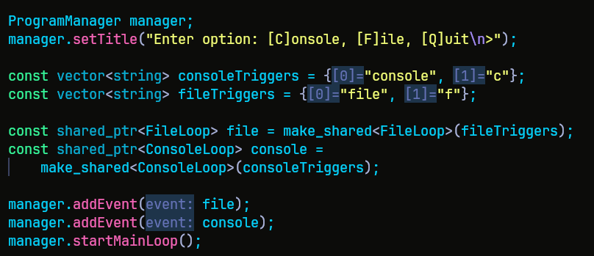
First, it sets the title, aka the question to be asks, and then takes options for what the user can say, and what they link up to. “console” or “c” = console loop, and “file” or “f” = file loop. The ProgramManager holds a vector of BaseEvent objects with a mainLoop function, and the File and ConsoleLoop inherit the BaseEvent and override the mainLoop. Whenever the user enters something, the ProgramManager loops over all of its “events” and compares the user input to them; if they match, it calls the event’s mainLoop function, and that’s where the logic is implemented, thus saving bloat in the main function.
Here’s an example of a mainLoop function (for the FileLoop):
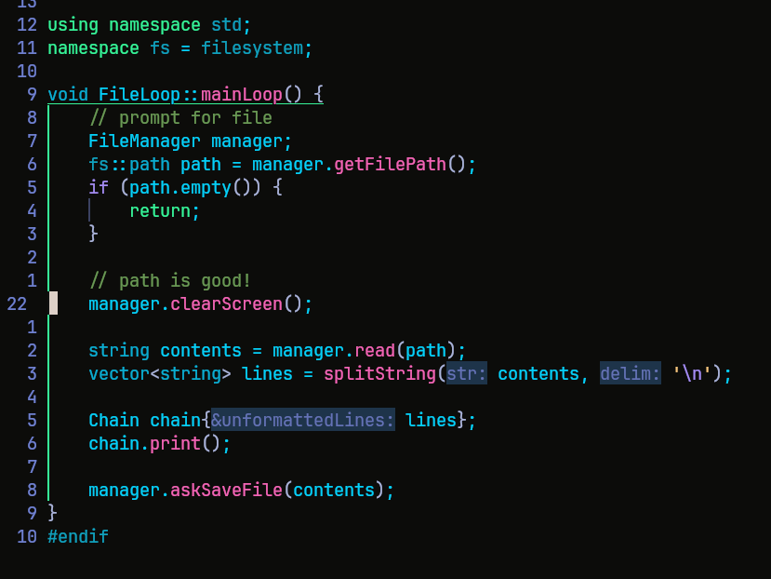

Testing
As always for testing, we just threw stuff at the wall until we encountered an issue, then just fixed it. We went through all the relevant tests provided. For the validation, we took a fail early approach, so all of the actual intensive calculations are guarenteed to work, if they pass the tests.
Reflection
For this project, the main things I’ve learned is just working with a team, and what that entails. If I had to redo it, I don’t think I would do anything different; though the format checking of the console was a bit rough, so knowing that in hindsight could help a lot.

