Project Report
Class: PROG 1204, Section: 01
Project: HW5 – Circuit
Name: Zach Allen

Problem
The problem to be solved with HW5 is simulating circuits; Taking a fully built circuit and figuring out the total resistance of the circuit. There are both file & console input / output required, as well as making each component (ParallelCircuit / SerialCircuit / Resistor) a base class off of Circuit, the main “board” of the circuit.
Analysis
The actual math part of the circuit was by far the easiest. With polymorphism, all we have to do is call circuit→getResistance() and it will do the recursiveness automatically.
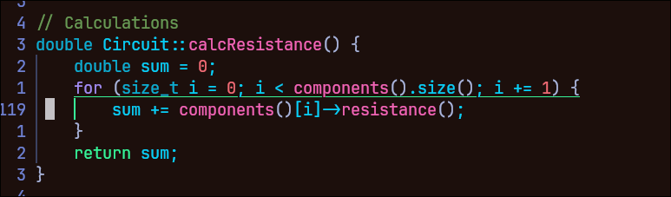
`components()` is the list of components for the circuit; and each component also has this `resistance()` function, which just calls the class’ calcResistance (except for the Resistor, which returns its resistance).
By far, the hardest part to figure out was the parsing of the file; I decided to look up an example of a matching brace algorithm, because the file structure is similar. Once I experimented and figured out how stacks work, it was a lot easier to wrap my brain around how it would work; then it just took some adapting to use the actual Circuit object when that was made, instead of a test struct.
There wasn’t really any other way to do the parsing without a stack, so yes, in my opinion it is the best approach.
Design
This time, we didn’t really meet up to flesh everything out, so it was a bit of a cluster at the beginning; we lent out and chose certain tasks that would be required for the project, and then got them done about a week before the project was due, and then have spent the past week going through integration hell.
Every major section of the project is in its own header / cpp file, with everything being connected through `HW5.cpp`. Surprisingly, the console input is a class, and I designed it that way to keep variables shared between functions more easily.

Testing
Our testing was pretty normal, we just took the circuits in the pdf, made them into txt files, and then just compared the results to your results. For the random edge cases, we just tried to break our program, and fix it from there.
Reflection
The biggest thing I’ve learned from this project is polymorphism, and maybe how stacks work. If I had to start from the beginning again, I would’ve made the project handle multiple circuits in one text file better, because it’s kinda a hacky solution that we threw in near the end of the project. It would be nice if I could redo the console class to be more versatile, so I could use it in other projects, but oh well.

