# Site Name

The Idaho Weather Hub  
**idahoweatherhub**.com

**Tagline**: Blue skies and sunshine or majestic white covering the ground, we have something here for you.

# Purpose

The purpose of the site is to provide quick and easy access to current and forecasted weather data in Idaho. The page will also provide local event information along with how forecasted weather might affect those events.

# Target audience

**Who**: Farmers, hunters, fishermen, and tourists looking for winter activities such as Snowmobiling, snowshoeing, and cross-country skiing.  
**Age**: 10-100  
**Income**: Income levels will be $40,000 and above annually.  
**Motivation**: The page will provide a quick easy way for all visitors to find the current and forecasted weather and help them plan daily activities appropriate for the weather.

**Scenario 1**: Are there any winter storms forecasted this week that could prevent us from doing snow activities safely? Will there be enough snow on the ground?

**Scenario 2**: How should I dress for working outside today? Is there going to be rain that would require me to wear rain gear or work inside? Will it be warm outside?

**Scenario 3**: Will it be hot or cold for my hike today? Do I need to plan for extra layers for cooler weather? Do I need to be prepared with extra water for hot weather?

**Scenario 4**: What will the weather be like for camping this weekend? Do I need to bring an extra warm or a light sleeping bag with me?

**Scenario 5**: What would be the best time of day for me to go out hunting? When will the animals likely be out?

**Name**: William Jones  
**Occupation**: Farmer  
**Quote**: “The farmer has to be an optimist or he wouldn't still be a farmer.” Will Rogers.  
**Demographics and Education**: Married Male, Age 45, with a wife and 3 kids. Has a Bachelor of Science in Agriculture. Grew up in the area working the family farm prior to going to college and returned to take over and run the farm.  
**Motivation for using the site**: William will use the site to help plan his crop planting and harvesting. He will also use it to plan watering schedules. It will also help him with planning his daily activities.  
**Technical:** William will use a computer for most of his planning and will periodically use a mobile phone while out in the fields for updates as needed. He is not a heavy user of technology, using it only when necessary.

**Name**: Jennifer Albright  
**Occupation**: Analyst  
**Quote**: “I am always looking for my next big adventure. I work so I can fund those adventures.”  
**Demographics and Education**: Single female, age 30, no kids. Holds a bachelors degree in Business Administration. She has been working as an analyst for 5 years in the tech industry.   
**Motivation for using the site**: Jennifer wants to make the most of her vacation time so she wants to make sure the weather is going to be optimal for enjoying the things she has planned. She will check the weather that is forecasted for the time she will be vacationing leading up to her vacation and will plan her activities accordingly.  
**Technical**: Jennifer spends a majority of her day on a computer for work. In her free time she is often on her phone or her iPad surfing the web or chatting with friends. She is very comfortable with technology and searches around for the best option for websites to get what she is looking for. While she is on vacation she will be using her phone to check the weather each day. She also will use the camera feature of the phone to take photos and will post them to social media.

# Sitemap

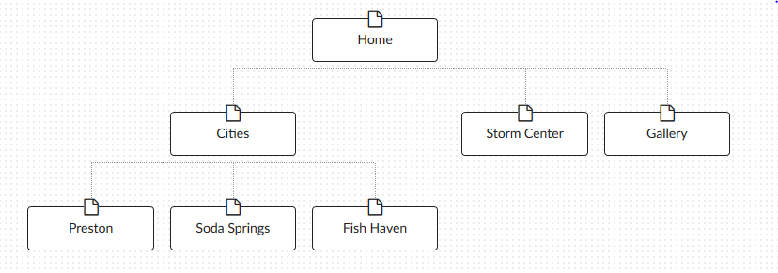

# Color scheme

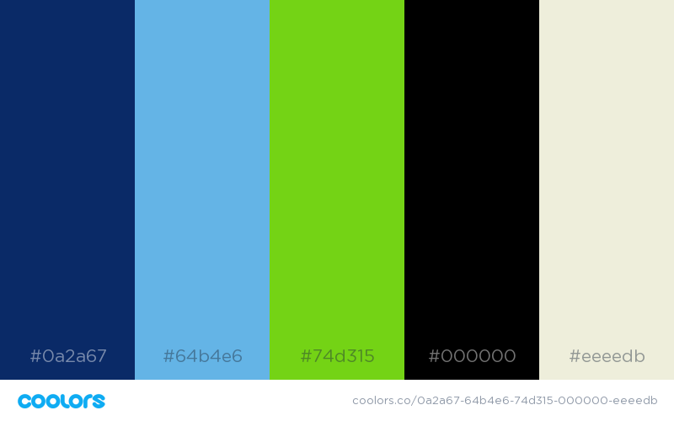

# Typography

|  |  |  |  |  |
| --- | --- | --- | --- | --- |
| Site header | Oswald | 45px | #0a2a67, #74d315 |  |
| Primary navigaton | Oswald | 25px | #64b4e6 |  |
| Footer navigation | Oswald | 25px | #0a2a67, #74d315 |  |
| Heading 1 (h1) | Oswald | 35px | #0a2a67 |  |
| Heading 2 (h2) | Oswald | 30px | #000000 |  |
| Heading 3 (h3) | Oswald | 25px | #000000 |  |
| Paragraph text (p) | Open Sans Condensed | 20px | #000000 |  |

Code to embed fonts in <head> of HTML Doc: <link href="https://fonts.googleapis.com/css?family=Open+Sans+Condensed:300|Oswald&display=swap" rel="stylesheet">

How to use in CSS:

font-family: 'Oswald', sans-serif;

font-family: 'Open Sans Condensed', sans-serif;