# Site Name

Site Name: The Temple Inn and Suites

URL: templeinnandsuites.com

Domain Cost: $12/year

Tagline: We take care of the details so you can have a relaxing visit to the temple.

# Purpose

The purpose of the site is to provide information to customers on what the Temple Inn and Suites has to offer in order to make their trip to the temple stress free. It will list the available amenities as well as the different room options.

# Target Audience

Target audience will be those who are traveling long distances to attend the temple or senior missionaries who will need long term housing while serving at the temple. Age range will be mostly 11 years old and up, with some small children that will be traveling with family.

**Who**: Youth groups attending to do temple baptisms. Ages 11-18 and their leaders

**Motivation**: they will be traveling a great distance to do multiple baptism sessions and will need multiple rooms in close proximity to each other.

**Who**: Couples who are attending to be sealed in the temple along with their guests.

**Motivation**: they will be interested in available room types and costs to share with their guests. They will also be interested in the wedding reception space to hold the reception after the sealing.

**Who**: senior missionary couples who will be serving at the temple. They will be needing long term stay with kitchen options.

**Motivation**: they will want to see what room options are available to be sure they will meet their needs for long term stay. They will want to make sure that the suite will meet their budget needs as well.

**Who**: Young families who are attending to be sealed together. They will potentially have multiple young children who will need child care for part of the stay so they can attend additional sessions while they are there.

**Motivation**: They will want to know what room options there are to accommodate their family as well as child care options.

# Sitemap

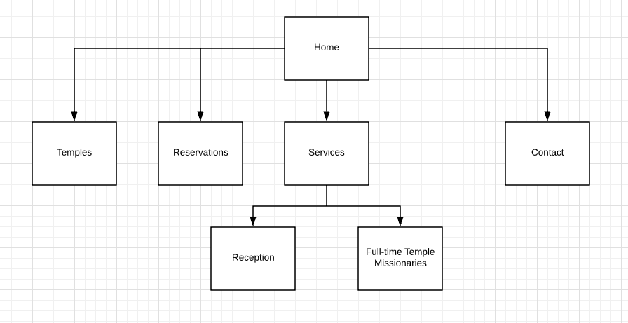

# Color Scheme

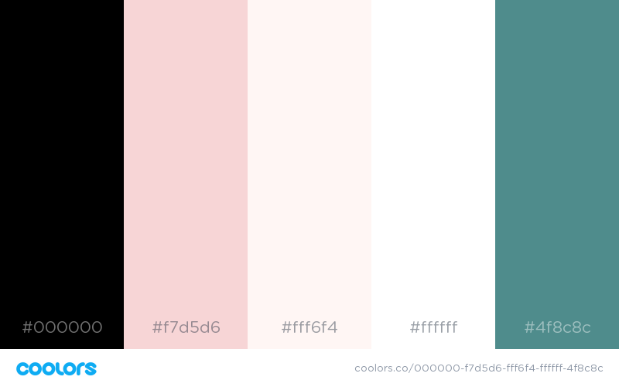

# Typography

|  |  |  |  |  |
| --- | --- | --- | --- | --- |
| Site header | Great Vibes | 55px | #fff6f4  #4f8c8c |  |
| Primary Navigation | Hind Siliguri | 25px | #000000  #f7d5d6 |  |
| Footer navigation | Hind Siliguri | 25px | #fff6f4  #4f8c8c |  |
| Heading 1 (h1) | Great Vibes | 45px | #4f8c8c |  |
| Heading 2 (h2) | Hind Siliguri | 35px | #000000 |  |
| Heading 3 (h3) | Hind Siliguri | 30px | #000000 |  |
| Paragraph Text (p) | Hind Siliguri | 25px | #000000 |  |
| List text (li) | Hind Siliguri | 25px | #000000  #f7d5d6 |  |
| Links (a) | Hind Siliguri | 25px | #4f8c8c |  |
| Active Link (a:active) | Hind Siliguri | 25px | #000000  #f7d5d6 |  |
| Hovered link (a:hover) | Hind Siliguri | 25px | #4f8c8c |  |
| Visited Link (a:visited) | Hind Siliguri | 25px | darkblue |  |

# Wireframes Homepage large screen

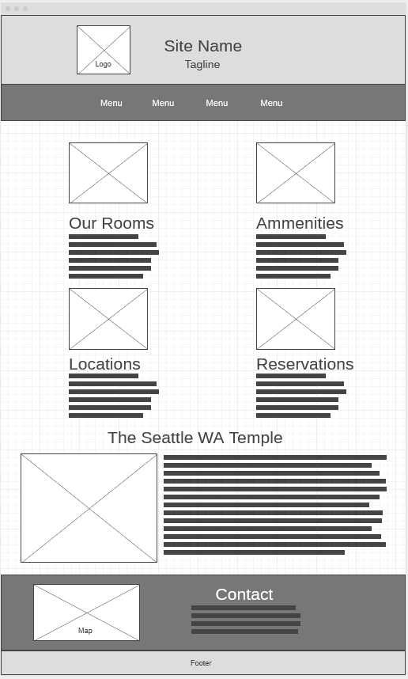

# Homepage Medium

# Homepage Small

