Virtual Alt Net

**January 27, 2010**

## Website Enhancement Initiative

Goal of this is to make the website more self supporting by integrating information from Speaker topic submissions to approved speaking events and then ideally a recording when the event is uploaded.

## Current Model

Currently the one domain object, Recording handles all of the functionality and consequently does too many things and is illustrated as per Figure 1 below.

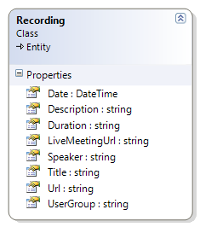

Figure – Current Recording Domain Object

A recording will now be comprised of the following

Association to Speaker domain object

Association to User Group domain object

Association to Category domain object

Duration will be removed and replaced by two new fields representing the Start time and end time of the recording. Duration is really a presentation field and with the two new fields above we will have more flexibility.

Description will be removed as this information will be found in the new Upcoming Event domain object.

The URL property will be removed and we will put emphasis on the LiveMeetingUrl as the hot link to download or play the content of the recording. The recordings are being uploaded to Azure and Mike Brown has offered assistance with completing this task and he will also take charge of recording all upcoming events. Mike should only be required to edit an existing recording record and populate the LiveMeetingUrl field after the recording has been uploaded to Azure.

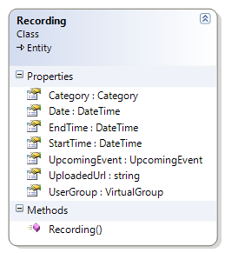

Figure - Proposed Recording Domain Object

## Proposed Model and Workflow

In a nutshell here is a detailed view that encapsulates all changes.

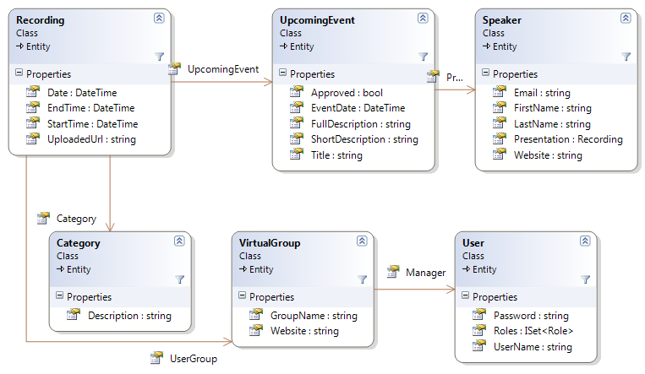

Figure - Overall Domain Object changes

Upcoming events will now drive the creation of a recordings object. A speaker will fill out a form that allows them to create a new proposed event. The Virtual Group Manager(s) will be emailed a notification of the new event proposal and will then edit the proposed event which will create a Recording object if approved when the edit is saved. The Speaker will be notified of the status change on the proposed event by way of email. A new service will be created to publish the approved event to VAN blog, twitter and potentially to a VAN Face Book profile that as yet does not exist. The new model above will also allow us to generate less static content with respect to Virtual Group listings that contain the RSS feed and the group’s respective website URL.

## Request for vote

There is also been mentioned the addition of a Series domain object to further classify events and therefore recordings as a series of talks. Can we get a consensus vote on this addition? Additionally we would like to hear opinions on the changes proposed so far date.

## Team additions

Zach and I would like to offer a big THANKS to Stephen Bohlen who will provide guidance and mentoring time periodically to the development team during the overhaul to the website. We are hopeful that we can assemble a 2-3 man team to bang this out.