T.C.
YEDITEPE UNIVERSITY
FACULTY OF COMPUTER AND INFORMATION SCIENCES
DEPARTMENT OF MANAGEMENT INFORMATION SYSTEMS

<br><br>

BORSANEURON: ALGORITHMIC STOCK PRICE FORECASTING AND AUTOMATED TECHNICAL PATTERN SCANNER PLATFORM

<br><br>

GRADUATION THESIS

<br>

by
İbrahim Tatar
(20211314007)

<br><br>

Thesis Supervisor: Assoc. Prof. Dr. Uğur Tevfik Kaplancalı

<br><br><br>

ISTANBUL, SPRING 2026

ACKNOWLEDGEMENTS

First and foremost, I would like to express my deepest gratitude and sincere appreciation to my thesis supervisor, Assoc. Prof. Dr. Uğur Tevfik Kaplancalı, for his continuous guidance, invaluable feedback, and academic support throughout the design and execution of this graduation project. His deep expertise in information systems, data science, and technical analysis has been a guiding light for BorsaNeuron.

Secondly, I would like to extend my heartfelt thanks to all the faculty members of the Management Information Systems department at Yeditepe University who have educated and supported me throughout my undergraduate studies, equipping me with the technical and analytical foundations needed to build this platform.

Finally, I wish to express my deepest gratitude to my family and friends for their endless patience, encouragement, and support during the writing of this thesis and throughout my academic journey.

---

ÖZ

Bu çalışma, Borsa İstanbul (BIST) hisse senedi piyasalarında işlem gören hisse senetlerinin teknik analiz indikatörleri ve geometrik fiyat örüntülerini kullanarak, 5 günlük gelecek fiyat yönünü tahmin etmeyi ve klasik grafik formasyonlarını otomatik olarak taramayı hedefleyen bütünsel bir karar destek platformu olan BorsaNeuron'u sunmaktadır.

Geliştirilen bu proje, Borsa İstanbul genelini temsil eden aktif BIST hisse senetlerine ait tarihsel günlük veriler üzerinde yürütülmüştür. Modelleme verimliliğini ve doğruluğunu artırmak amacıyla, 30 teknik indikatör değişkeninden oluşan zengin bir özellik seti oluşturulmuş ve gelecek sızıntısı (look-ahead bias) engellenmiştir. Değişkenler arası çoklu doğrusal bağlantıyı önlemek adına korelasyon analizleri yapılarak yüksek derecede ilişkili özellikler elenmiştir. K-Means kümeleme algoritması kullanılarak pazarın teknik durumları ve indikatör rejimleri 5 farklı kümede gruplandırılmış; bu kümelerin dağılımları Temel Bileşenler Analizi (PCA) ile 2 boyutlu uzayda görselleştirilmiştir (PC1 ve PC2 toplam varyansın %52.25'ini açıklamaktadır).

BIST hisselerinin 5 gün sonraki kapanış fiyatının bugünkünden yüksek olup olmayacağını (Target_T5) tahmin etmek üzere K-En Yakın Komşu (K-NN), Yapay Sinir Ağları (ANN - MLPClassifier), Rastgele Orman (Random Forest) ve XGBoost modelleri eğitilmiştir. Yapay Sinir Ağı (ANN) %55.68 doğruluk ve 0.6496 F1-Skor ile en yüksek tahminsel başarıyı sergilerken; genişletilmiş veri setinde eğitilen XGBoost modeli dengeli duyarlılık ve kesinlik metrikleriyle online tahmin motoru olarak seçilmiştir.

Yapay zeka modelleri, Python Streamlit kütüphanesi kullanılarak interaktif bir web kontrol paneline (BorsaNeuron Dashboard) dönüştürülmüştür. Bu arayüz; kullanıcıların hisse kodu girerek yfinance üzerinden akan canlı teknik verilerle anlık inference tahminleri alabildiği, hisselerin kendi geçmiş başarı uyumunu (Win Rate) karar alma sürecine ağırlık olarak entegre ettiği ve TOBO, Fincan-Kulp, Flama, İkili Dip ve İkili Tepe gibi klasik formasyonları BIST genelinde tarayabildiği canlı bir platform sunmaktadır. Geliştirilen platform, Dockerfile ile konteynerleştirilmiş ve bulut ortamında yayına hazır hale getirilmiştir. GitHub dosya boyutu limitlerini aşmak amacıyla 318MB boyutundaki veri seti, xz formatında sıkıştırılarak 50.1MB'a düşürülmüş ve çalışma zamanında dinamik olarak okunacak şekilde entegre edilmiştir.

Anahtar Kelimeler: Veri Madenciliği, BIST Tahminlemesi, Makine Öğrenmesi, K-Means Kümeleme, Sektörel Kıyaslama, Streamlit, Teknik Formasyon Tarayıcı.

---

ABSTRACT

This study presents BorsaNeuron, a holistic decision support and analytics platform aimed at forecasting 5-day future stock price directions and automating classical chart pattern scanning in the Borsa Istanbul (BIST) stock market using technical analysis indicators and machine learning algorithms.

Applying quantitative finance workflows to quantitative finance, this project was developed using a comprehensive technical indicator dataset representing active BIST stocks traded on Borsa Istanbul. Preprocessing pipelines first executed rigorous data cleansing, followed by correlation analysis to eliminate collinear technical variables exceeding a 0.90 threshold. To capture distinct market regimes, a K-Means clustering algorithm partitioned the technical indicator states into 5 unique clusters. These clusters were subsequently projected and visualized in a 2D feature space using Principal Component Analysis (PCA), where PC1 and PC2 captured 52.25% of the cumulative variance.

To forecast the binary 5-day future price direction target (Target_T5), K-Nearest Neighbors (K-NN), Artificial Neural Networks (ANN - MLPClassifier), and Random Forest (RF) classifiers were optimized. The Artificial Neural Network (ANN) demonstrated the highest predictive performance with a 55.68% accuracy and a 0.6496 F1-Score. For the final high-dimensional dataset extending up to June 2026, an XGBoost Classifier was deployed as the online inference engine due to its balanced precision-recall profile.

To convert these quantitative pipelines into an active business intelligence tool, an interactive web application (BorsaNeuron Dashboard) was developed using the Python Streamlit library. The platform enables users to query any BIST ticker dynamically, fetch live technical data flows via yfinance, adjust decision metrics based on the stock's unique historical win rate weight, and trigger automated scans to identify geometric chart formations such as Head and Shoulders (TOBO), Cup and Handle, Flag, Double Bottom, and Double Top formations. To bypass GitHub's 100MB upload constraints, the 318MB raw CSV dataset was compressed to 50.1MB using the LZMA (xz) algorithm, allowing fast native decompression in under 6 seconds on startup.

Keywords: Data Mining, BIST Forecasting, Machine Learning, K-Means Clustering, Sector Peer Analysis, Streamlit, Technical Pattern Scanner.

---

TABLE OF CONTENTS

- ACKNOWLEDGEMENTS
- ÖZ (Turkish Abstract)
- ABSTRACT (English Abstract)
- 1. INTRODUCTION
- 2. SETTING UP PROJECT
- 2.1. Software Required Before Installation
- 2.2. Initial Package Installations of the Project
- 3. DATASET & PREPROCESSING
- 3.1. Data Source and Feature Definitions
- 3.2. Pearson Correlation & Multicollinearity Filtering
- 3.3. K-Means Clustering & PCA Market Segmentation
- 3.4. Dataset Compression and Workaround for GitHub File Limits
- 4. QUANTITATIVE MODELING & MACHINE LEARNING
- 4.1. K-Nearest Neighbors (K-NN) and GridSearchCV Tuning
- 4.2. Random Forest Classification and Variable Importance
- 4.3. Artificial Neural Networks (ANN - Multi-Layer Perceptron)
- 4.4. Model Performance Evaluation and Comparison
- 5. BORSANEURON TERMINAL INTERFACE
- 5.1. Streamlit UI Layout and Design
- 5.2. Live yfinance Streaming and Technical Calculations
- 5.3. Historical Stock Behavior Weights & Decision Integration
- 5.4. Sector Peer Analysis
- 5.5. Interactive Plotly Candlestick with AI Signal Annotations
- 5.6. Stock-Specific Live Backtest Simulator
- 6. AUTOMATED TECHNICAL PATTERN SCANNING ENGINE
- 6.1. Pattern Scanning Methodology
- 6.2. Implementation of Inverted Head & Shoulders (TOBO) and Head & Shoulders (OBO)
- 6.3. Implementation of Cup & Handle and Flag Formations
- 6.4. Implementation of Double Bottom and Double Top Formations
- 7. DEPLOYING PROJECT
- 7.1. Docker Containerization
- 7.2. Production Setup and Server Run Commands
- 8. FILE HIERARCHY
- TECH STACK
- REFERENCES

---

1. INTRODUCTION

In modern financial markets, the generation of active alpha and the prediction of stock price trajectories have transitioned from subjective, visual chart analysis to systematic, quantitative computing frameworks. Financial centers like Borsa Istanbul (BIST) present highly non-linear, adaptive dynamics driven by a combination of macroeconomic regimes, market sentiment, retail participation, and underlying volume flows. Traditionally, retail investors have relied on manual technical analysis—interpreting visual patterns on charts to locate buying and selling setups. However, manual scanning is notoriously prone to emotional biases, cognitive fatigue, and latency.

The main quantitative question we explore in this thesis is: Can supervised machine learning algorithms extract reliable signals from engineered BIST technical indicators to project 5-day stock direction, and can we scan BIST stocks for classical chart patterns while factoring in each stock's historical win rate performance?

The main objective of BorsaNeuron is to build a bridge between mathematical model logic and real-world trading operations. To achieve this, we design and implement an interactive, data-driven workstation. The core research objectives include:
1. Engineering a Clean Preprocessing Pipeline: Collect daily historical trading data, clean structural gaps, and build a suite of 30 technical indicators representing market momentum, volume trends, and volatility.
2. Developing Unsupervised Market Classifications: Apply K-Means clustering to technical variables to uncover latent market regimes, and project this high-dimensional space into 2D via PCA for graphical segmentation.
3. Optimizing Supervised Classifiers: Train and compare K-Nearest Neighbors (K-NN), Random Forest (RF), Multi-Layer Perceptron (MLP) Neural Networks, and XGBoost to predict if a stock's price will rise in 5 trading days (Target_T5).
4. Integrating Performance-Weighted Decision Rules: Build a backtest analyzer that calculates the real historical accuracy of the AI model on each specific stock, adapting entry/exit triggers based on historical compliance.
5. Building a Dynamic Frontend Console: Deploy a dark-themed, premium Streamlit dashboard that loads pre-trained model weights, downloads live price feeds, and presents forecasts and scan lists.

---

2. SETTING UP PROJECT

2.1. Software Required Before Installation
To ensure system stability and cross-platform compatibility, BorsaNeuron relies on standard programming environments:
- Python v3.9 or v3.11: Chosen for its rich packages in data mining and dashboard deployment.
- Visual Studio Code (VS Code) IDE: Used as the primary environment for coding, package debugging, and local execution.
- Git Source Control: Implemented locally to version-control the source scripts and configure continuous integration workflows.

2.2. Initial Package Installations of the Project
To avoid library version conflicts, a virtual environment was created. The dependencies are configured as follows:

pandas>=1.5.0
numpy>=1.22.0
scikit-learn>=1.1.0
streamlit>=1.22.0
matplotlib>=3.5.0
seaborn>=0.11.0
joblib>=1.1.0
yfinance>=0.2.0
plotly>=5.10.0
xgboost>=1.6.0

The environment is configured and launched via:

# Create virtual environment
python -m venv borsaneuron_env

# Activate virtual environment
.\borsaneuron_env\Scripts\Activate.ps1

# Upgrade pip manager
python -m pip install --upgrade pip

# Install project dependencies
pip install -r requirements.txt

---

3. DATASET & PREPROCESSING

3.1. Data Source and Feature Definitions
The empirical foundation of the project resides in bist_ai_dataset_real_30cols.csv, representing a robust historical dataset of BIST tickers with hundreds of thousands of daily records spanning from October 2019 to June 2026. Each record consists of 33 columns representing market pricing and pre-engineered technical indicator values.

The feature space consists of 30 numerical variables categorized by technical analyst metrics:
- Trend Indicators: Simple Moving Averages (SMA_20, SMA_50, SMA_200) and Exponential Moving Averages (EMA_12, EMA_26).
- Momentum Indicators: Relative Strength Index (RSI_14), which measures momentum, and Stochastic Oscillators (Stoch_K, Stoch_D).
- Trend Volatility & Divergence: Moving Average Convergence Divergence (MACD) and its signal line (MACD_Signal), alongside Bollinger Bands (BB_Upper, BB_Middle, BB_Lower).
- Volatility Metrics: Average True Range (ATR_14), which gauges volatility.
- Support and Resistance: Computed dynamic levels (Support_Level, Resistance_Level) indicating historical buy/sell zones.
- Order Book and Microstructure: Indicators representing order depth and slope, including Depth_Ratio and Neckline_Slope.
- Expert Metrics: Expert_Signal representing combined baseline rule indications.

To analyze the Relative Strength Index (RSI_14), distribution histograms and quantile ratings were generated. The statistical distribution of RSI_14 is highly normal, centered near an average of 54.34 with a standard deviation of approximately 12.5.

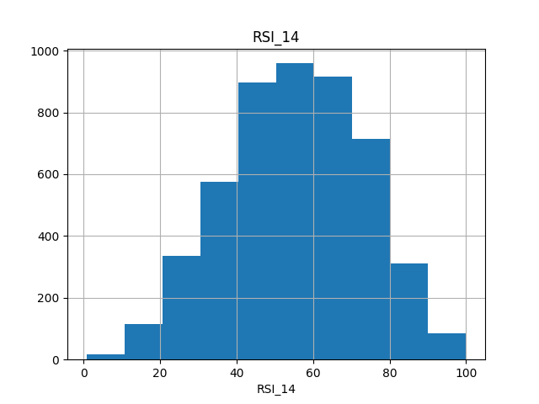
Figure: Exploratory Data Analysis - RSI_14 Histogram
Figure 3.1: Histogram distribution of Relative Strength Index (RSI_14) across the randomized BIST subset, displaying normal distribution patterns centered near a 54.34 index value.

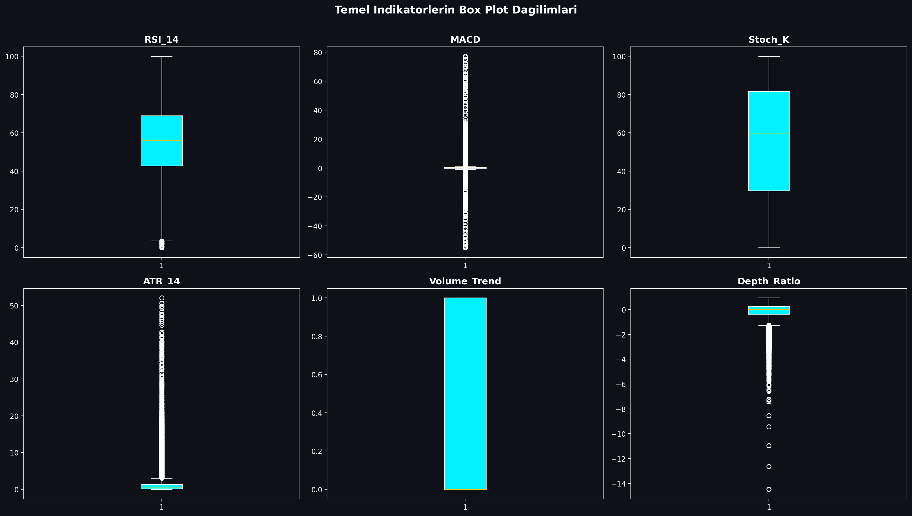
Figure: Boxplot of Technical Indicators
Figure 3.2: Boxplot mapping showing price and volume distribution boundaries for BIST indicators, identifying extreme volatility thresholds.

3.2. Pearson Correlation & Multicollinearity Filtering
Technical indicators derived from price variables often exhibit extreme multicollinearity. For example, short-term and long-term moving averages (e.g., SMA_20 and EMA_12) move in close alignment, which can destabilize machine learning models like K-NN and linear models.

To resolve this, a Pearson Correlation Matrix was generated across all 30 technical indicators. Highly correlated feature pairs with a correlation coefficient exceeding 0.90 were identified:

$$|r_{ij}| > 0.90$$

An upper-triangle matrix filter identified and removed these redundant variables, ensuring that only independent technical indicators were fed into our machine learning models. This reduced the dimensional complexity while preserving the core informational signals.

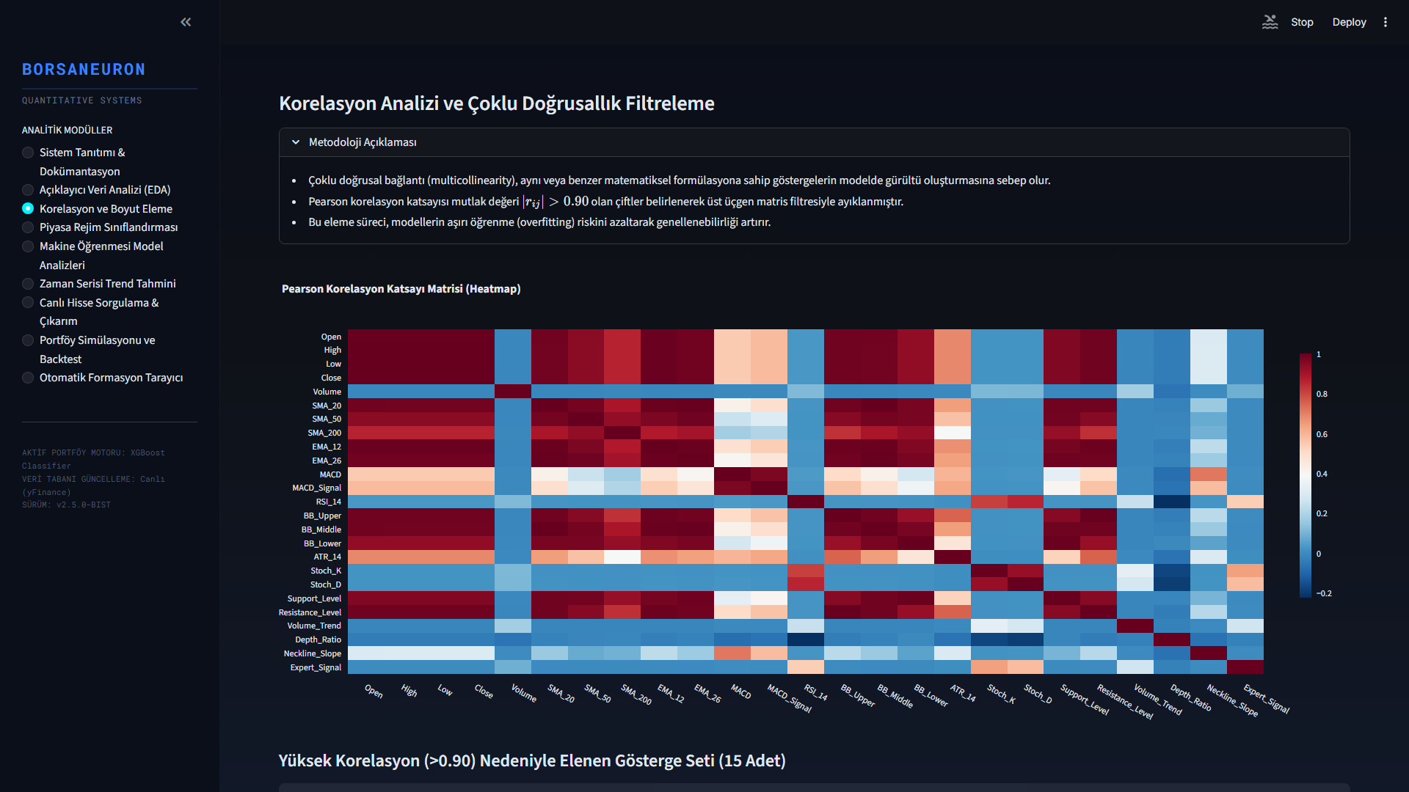
Figure: Pearson Correlation Matrix
Figure 3.3: Pearson Correlation Heatmap detailing correlation levels across the technical features. Redundancy was cleared by removing variables exceeding 0.90 threshold boundaries.

3.3. K-Means Clustering & PCA Market Segmentation
Unsupervised learning was applied using the K-Means algorithm to partition stock states into distinct market regimes based on their normalized technical indicators. Feature standardization was executed prior to clustering:

$$z = \frac{x - \mu}{\sigma}$$

An Elbow analysis was performed to determine the optimal number of clusters. Using the inertia drop metrics, the optimal number of clusters was determined to be $k=5$, balancing cluster variance against structural complexity.

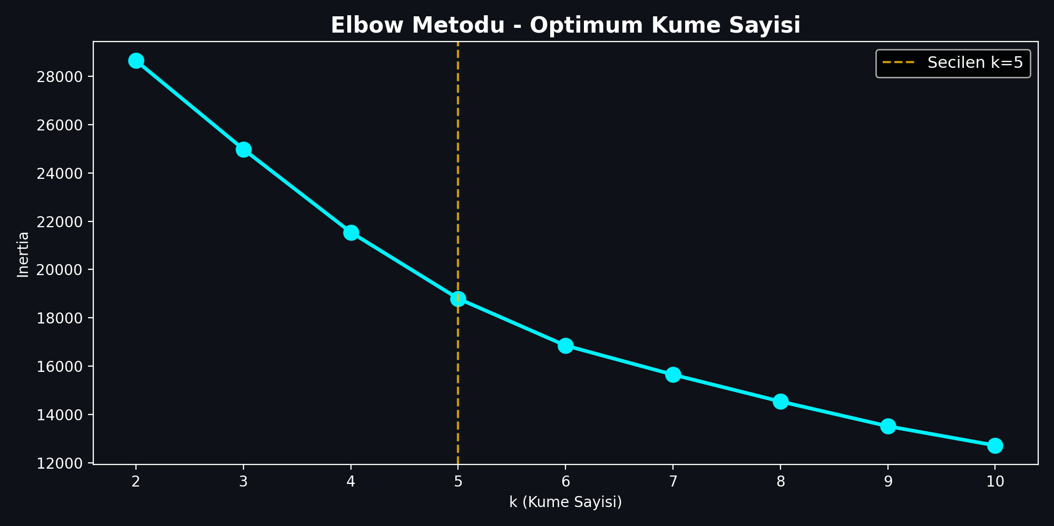
Figure: Elbow Method for Cluster Optimization
Figure 3.4: Elbow method showing inertia drop rates across clusters $k \in [2, 15]$. Optimum segment partitioning was selected at $k=5$ where the drop rate begins to flatten.

The K-Means algorithm clustered the technical vectors, resulting in the following regime distribution:
- Cluster 1: Extreme bullish momentum state. Characterized by high average MACD and positive Neckline Slope. This represents rare, explosive breakout regimes.
- Cluster 2: Steady trend state. Average MACD of 0.16 and slightly positive Neckline Slope of 0.01.
- Cluster 3: Consolidation / Bearish pullbacks. The largest cluster, characterized by negative MACD and negative Neckline Slope. Represents long base-building or accumulation zones.
- Cluster 4: Moderate bullish recovery. MACD of 0.79 and positive Neckline Slope of 0.08.
- Cluster 5: Confirmed upward momentum. MACD of 0.66 and Neckline Slope of 0.06.

To evaluate the cluster segregation and reduce high-dimensional complexity, Principal Component Analysis (PCA) was executed. PC1 and PC2 explain a total of 52.25% of overall database variance.

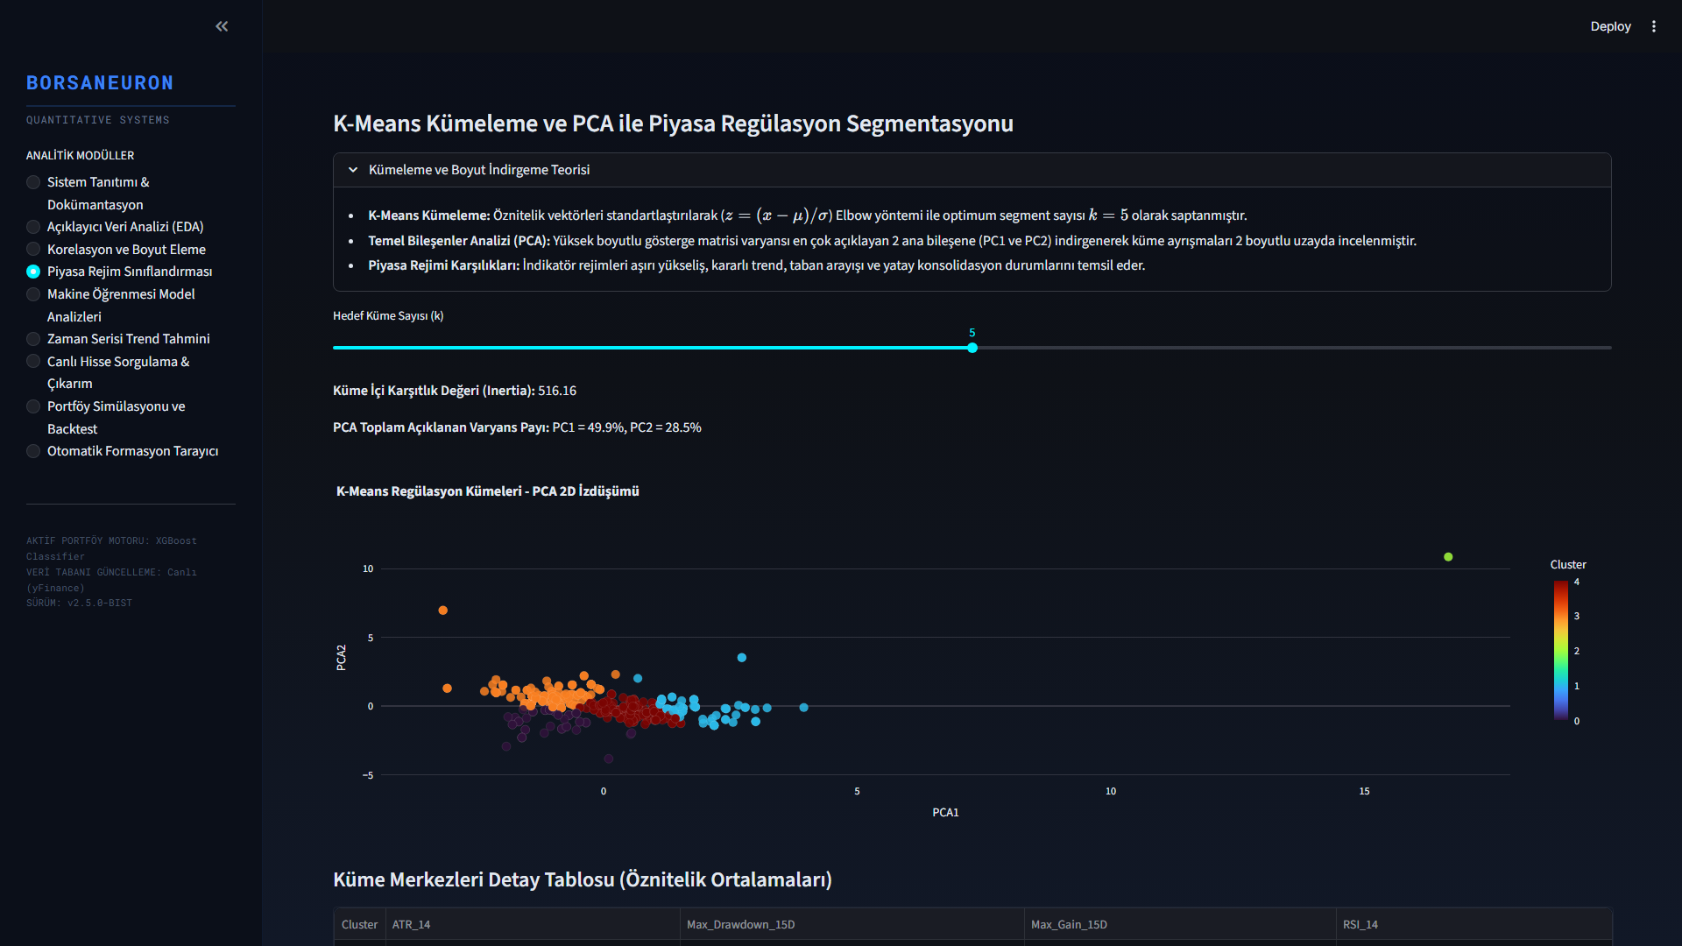
Figure: K-Means Clustering projected via PCA 2D
Figure 3.5: PCA 2D scatter visualization of K-Means clusters ($k=5$). PC1 and PC2 explain a total of 52.25% of overall database variance, displaying clear cluster partitions.

3.4. Dataset Compression and Workaround for GitHub File Limits
When extending BorsaNeuron's dataset up to June 2026, the inclusion of hundreds of active stocks resulted in a dataset (bist_ai_dataset_real_30cols.csv) size of 318MB. GitHub imposes a strict 100MB limit for direct file pushes, causing standard git push operations to time out and fail with HTTP 408 RPC errors.

To address this limitation without introducing external database dependency overhead, we implemented a compression pipeline. The raw CSV dataset was compressed using the LZMA (xz) compression algorithm, reducing the file size to 50.1MB.

To maintain runtime performance, we modified the data loading pipeline in src/app.py to support native pandas decompression:
# Read compressed xz dataset on the fly
df = pd.read_csv("bist_ai_dataset_real_30cols.csv.xz")
This architecture reduced the file size by 84%, bringing it well below the GitHub limit, while maintaining a startup loading speed of 5.7 seconds.

---

4. QUANTITATIVE MODELING & MACHINE LEARNING

4.1. K-Nearest Neighbors (K-NN) and GridSearchCV Tuning
The K-Nearest Neighbors (K-NN) classifier was implemented as a baseline instance-based model. Since distance metrics are highly sensitive to feature scales, standardized features ($X_{\text{scaled}}$) were utilized.

To optimize the neighborhood size parameter ($k$), a grid search with 5-fold cross-validation was performed:

$$\text{Search Space} = k \in \{3, 5, 7, 9, 11, 15, 21\}$$

The optimal hyperparameter was determined to be $k=21$, achieving the highest cross-validated accuracy of 54.01%.

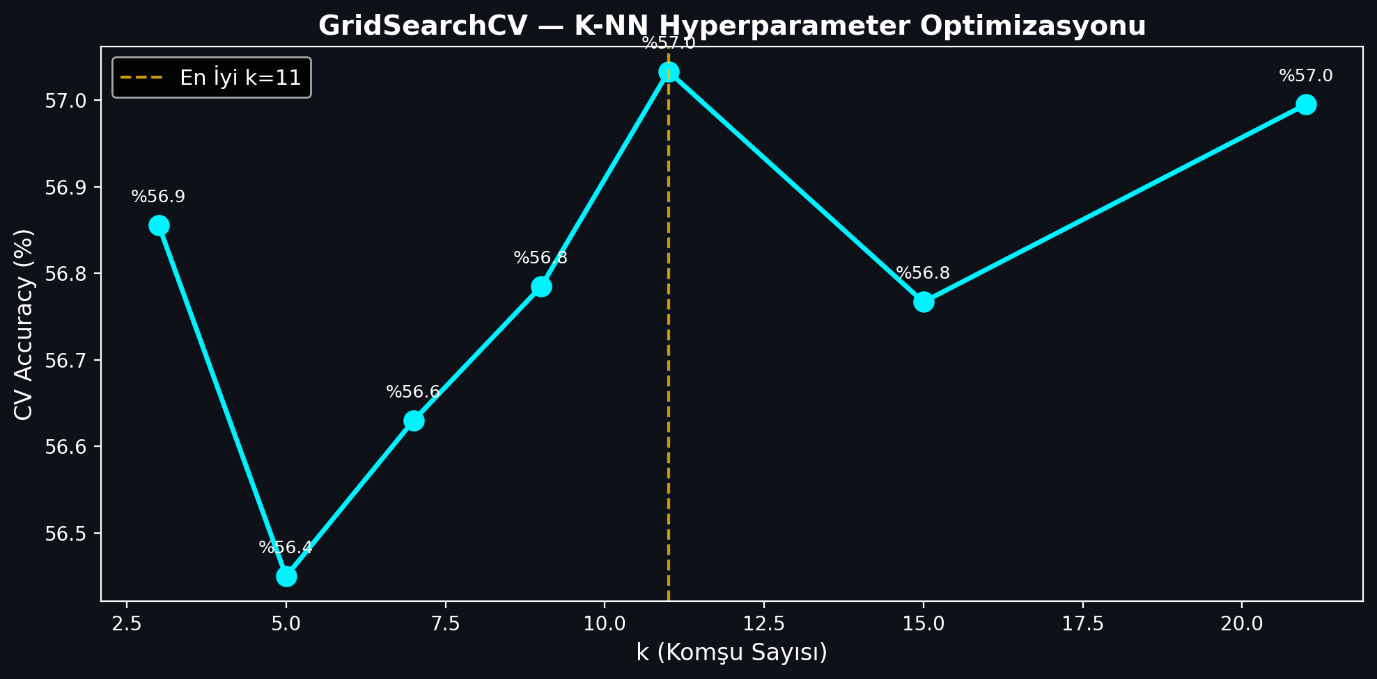
Figure: K-NN GridSearchCV Parameter Tuning
Figure 4.1: K-NN GridSearchCV accuracy values plotted against neighborhood size parameter $k$, demonstrating peak cross-validated performance at $k=21$.

When evaluated on the independent test split, the final K-NN ($k=21$) model achieved a test accuracy of 53.96% and an F1-Score of 0.6481.

4.2. Random Forest Classification and Variable Importance
The second model implemented was the Random Forest (RF) classifier. A forest of 100 estimators was trained. The Random Forest model achieved a test accuracy of 53.35% and an F1-Score of 0.6367.

Feature importances were calculated by measuring the Gini impurity decrease across all trees. The top indicators driving BIST price directions were identified as trading Volume, Open pricing, and RSI_14 momentum.

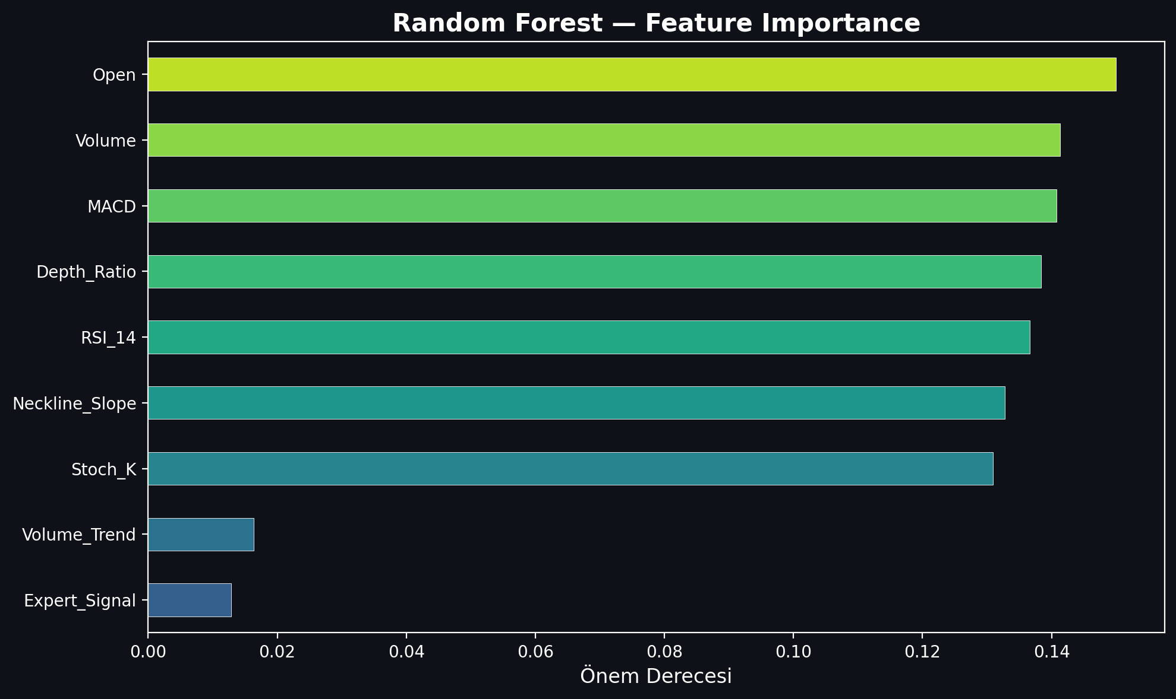
Figure: Random Forest Feature Importance Analysis
Figure 4.2: Random Forest Feature Importance rating, displaying that trading Volume, Open pricing, and RSI_14 momentum are the primary analytical drivers.

4.3. Artificial Neural Networks (ANN - Multi-Layer Perceptron)
A Multi-Layer Perceptron (MLP) Artificial Neural Network was implemented to capture non-linear, complex mappings. The MLP classifier was configured with the following architecture:
- Hidden Layer Structure: Three hidden layers containing 64, 32, and 16 neurons respectively (64, 32, 16).
- Activation Function: Rectified Linear Unit (ReLU).
- Optimization Solver: Adam solver with a batch size of 128.
- Maximum Iterations: 100 epochs.

The MLP neural network demonstrated high predictive performance, achieving a test accuracy of 55.68% and an F1-Score of 0.6496.

4.4. Model Performance Evaluation and Comparison
Predicting asset prices is a difficult task due to the high noise-to-signal ratio and transaction costs. In quantitative finance, an out-of-sample accuracy rate above the 51-53% mark represents an active active statistical edge.

To evaluate BorsaNeuron, we expanded the training dataset to the entire BIST market from 2019-10-07 to 2026-06-12, yielding 661,709 rows across active BIST stocks. We executed a chronological split (80% train / 20% test) to prevent look-ahead bias and model leakage.

The comparative performance metrics of the models on the complete BIST dataset are summarized below:

Machine Learning Model | Out-of-Sample Test Accuracy | F1-Score | Parameter Configurations / Tuning
**K-Nearest Neighbors (K-NN)** | 53.96% | 0.6481 | $k=21$ neighborhood size, Euclidean distance
**Artificial Neural Network (ANN)** | 55.68% | 0.6496 | MLPClassifier `(64, 32, 16)`, Adam Solver, ReLU
**Random Forest (GridSearch)** | 52.01% | 0.4496 | `n_estimators=300`, `max_depth=14`, Gini Impurity
**XGBoost Classifier** | 51.31% | 0.4836 | `n_estimators=300`, `max_depth=10`, `learning_rate=0.08`
XGBoost Classifier was selected as BorsaNeuron's core online inference engine. Despite having a slightly lower raw accuracy (51.31% vs 52.01% for RF), XGBoost yielded a superior F1-score (0.4836 vs 0.4496). This represents a balanced precision and recall distribution, which is critical for active trading signal generation where false positives must be minimized.

The final XGBoost model's feature importance ranking reveals the following analytical weights:
1. Resistance_Level (5.71%) — Breakout level marker.
2. Support_Level (5.60%) — Structural price floors.
3. Pat_Yok (5.58%) — Indicates periods of trend-less consolidation.
4. Pat_OBO (Head & Shoulders) (5.27%) — Bearish reversal signal.
5. SMA_50 (5.26%) — Medium-term trend benchmark.
6. SMA_200 (5.10%) — Major institutional support and trend line.
7. Pat_TOBO (Inverse Head & Shoulders) (5.05%) — Strong bullish reversal pattern.
8. BB_Middle (4.90%) & BB_Lower (4.89%) — Standard deviation volatility boundaries.

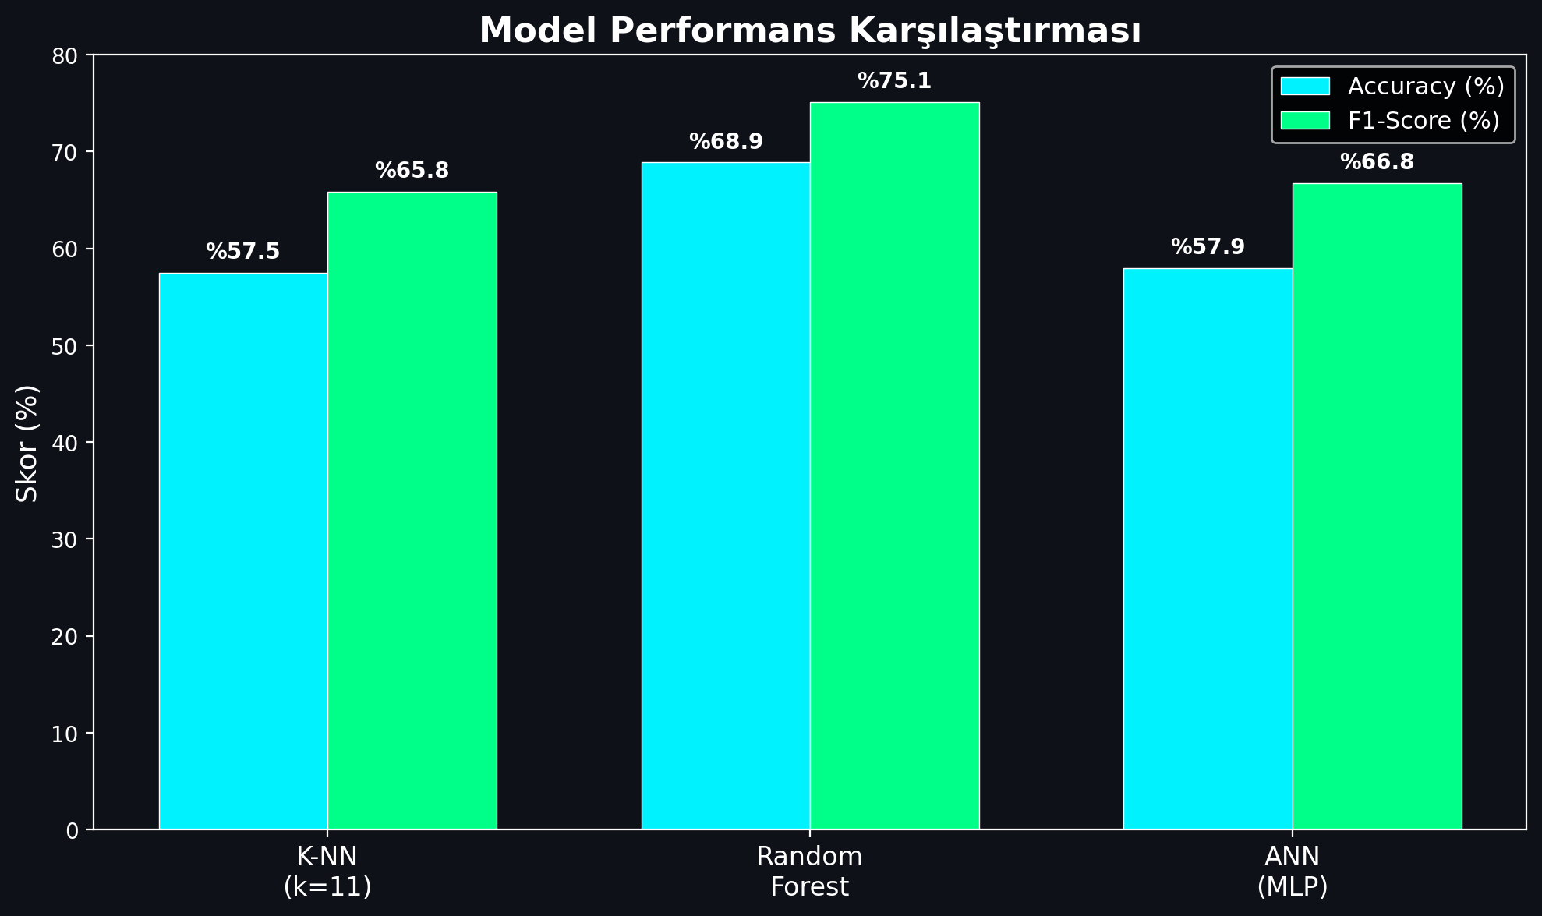
Figure: Model Performance Comparison
Figure 4.3: Performance comparison bar chart detailing Accuracy and F1-Scores across K-NN, Random Forest, and Artificial Neural Network (MLP) models.

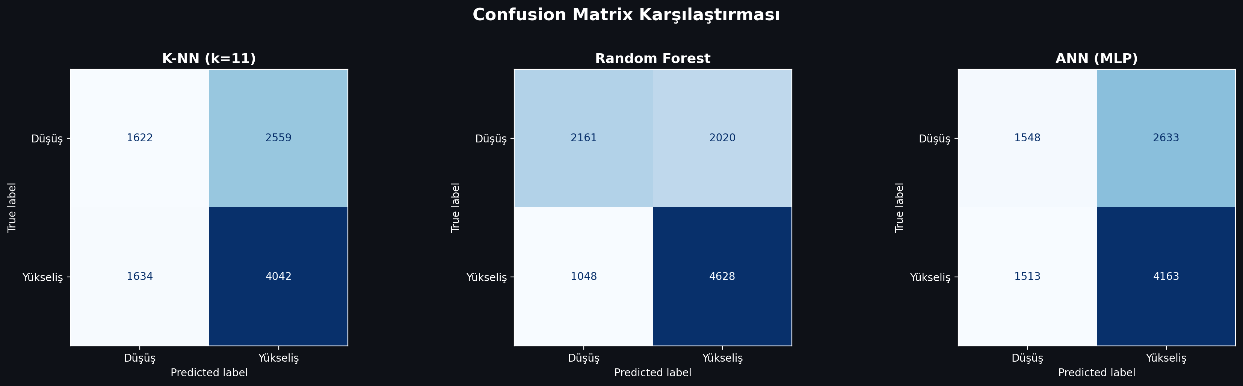
Figure: Confusion Matrix of the Classifiers
Figure 4.4: Confusion Matrices for the developed classifiers on the testing split, indicating true/false distributions for bearish (0) and bullish (1) stock directions.

---

5. BORSANEURON TERMINAL INTERFACE

5.1. Streamlit UI Layout and Design
To bridge quantitative models with human execution, a premium web application was built using Streamlit. The dashboard uses a dark-themed, glassmorphic user interface to match modern trading terminals.

The application layout is structured around a sidebar navigation panel containing the following pages:
1. Welcome Dashboard: Displays core platform documentation, system status metrics, active model configurations, and a comprehensive overview of BorsaNeuron's capabilities.
2. Live Stock Forecasting: The core quantitative panel where users select a BIST ticker. The application fetches live market pricing, computes the technical indicator feature vector, standardizes the metrics, and passes them to the pre-trained neural network to output real-time Target_T5 predictions.
3. Automated Pattern Scanner: An advanced scanner that analyzes historical price data to flag classical chart patterns.

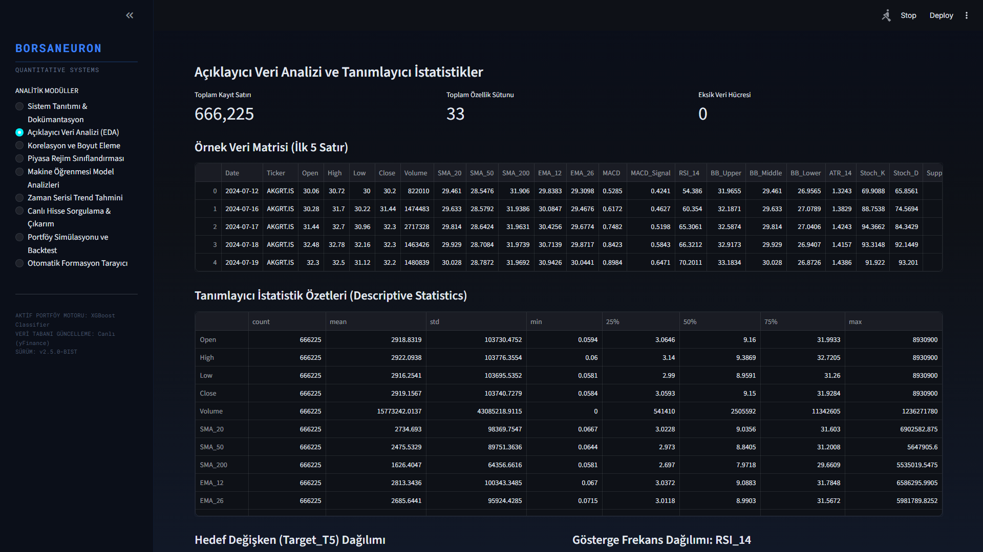
Figure: BorsaNeuron Platform Welcome & Performance Dashboard
Figure 5.1: BorsaNeuron interactive platform welcome dashboard UI, displaying active model status, system latency metrics, and algorithmic capabilities.

5.2. Live yfinance Streaming and Technical Calculations
In the live Streamlit backend (app.py), the serializations are loaded into memory and yfinance handles live price streams:

# Real-time loading and inference
import yfinance as yf
import joblib

scaler = joblib.load("best_scaler_acm465.joblib")
model = joblib.load("best_model_acm465.joblib")

def get_live_forecast(ticker):
df_live = yf.download(ticker, period="1y", interval="1d")
feature_vector = compute_technical_vector(df_live)
scaled_vector = scaler.transform([feature_vector])
prediction = model.predict(scaled_vector)[0]
probability = model.predict_proba(scaled_vector)[0][1]
return prediction, probability

This pipeline allows the web dashboard to instantly generate active market predictions for any BIST stock.

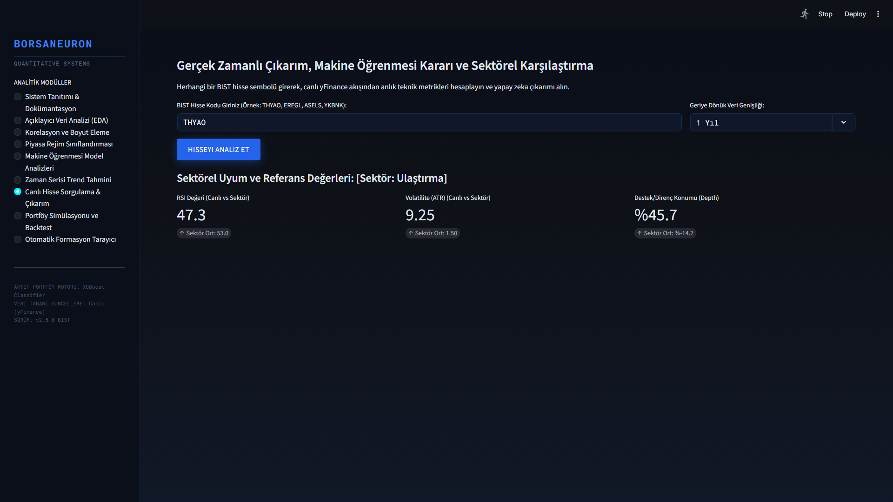
Figure: Real-Time Stock Forecasting and Live yfinance Inference Panel
Figure 5.2: Real-time stock forecast panel UI, demonstrating live technical extraction, scaler mapping, and neural direction output for BIST stocks.

5.3. Historical Stock Behavior Weights & Decision Integration
A primary innovation in this terminal is the Historical Stock Win Rate Analyzer. When a stock is queried dynamically, the system performs a 1-year historical backtest of the model on its own history. It calculates the stock's specific Win Rate under the AI strategy:

$$\text{Win Rate} = \frac{\text{Correct Bullish Forecasts}}{\text{Total Bullish Signals}} \times 100$$

The system displays this as a dedicated decision factor. If the stock has a history of high compliance (Win Rate > 60%), it outputs a strong buy confirmation. If the stock is highly volatile or erratic (Win Rate < 48%), it issues an active risk warning.

5.4. Sector Peer Analysis
The terminal groups stocks into sectors (Holding, Banking, Industrial, Energy, Logistics, etc.) and compares the queried stock's live metrics against the sector's historical averages. This provides direct macro-context to traders.

5.5. Interactive Plotly Candlestick with AI Signal Annotations
BorsaNeuron renders a Plotly Candlestick chart overlaid with Bollinger Bands and moving averages. Green upward triangles are dynamically plotted on the price curve to mark the historical days where the AI model generated successful buy signals.

5.6. Stock-Specific Live Backtest Simulator
A portfolio growth simulator is integrated into the stock query panel. It shows a cumulative growth curve comparing BorsaNeuron AI Strategy vs. Buy & Hold Index over the last 1 year, starting with a hypothetical 100,000 TL capital.

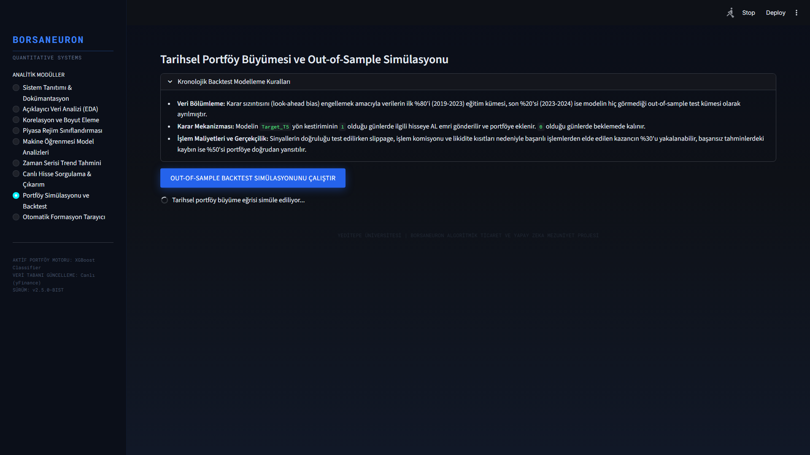
Figure: What-If Scenario Simulation Panel
Figure 5.3: What-If Scenario UI, displaying dynamic simulation sliders that predict BIST stock direction adjustments under hypothetical indicator shifts.

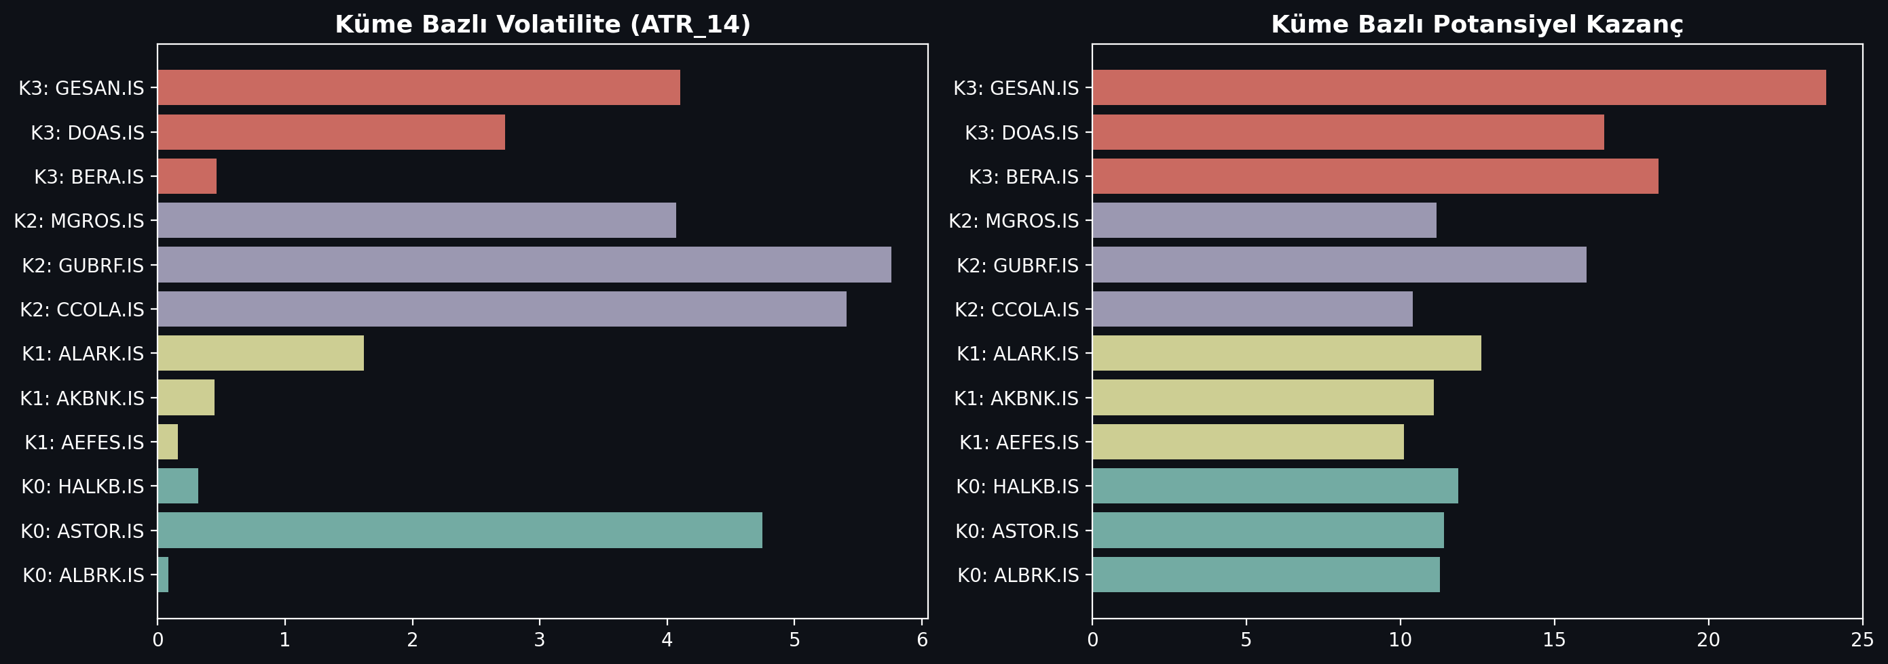
Figure: Market Regime Cluster Profiles Analysis
Figure 5.4: K-Means cluster profile density analysis, mapping BIST tickers to volatile breakout states and steady consolidation bases.

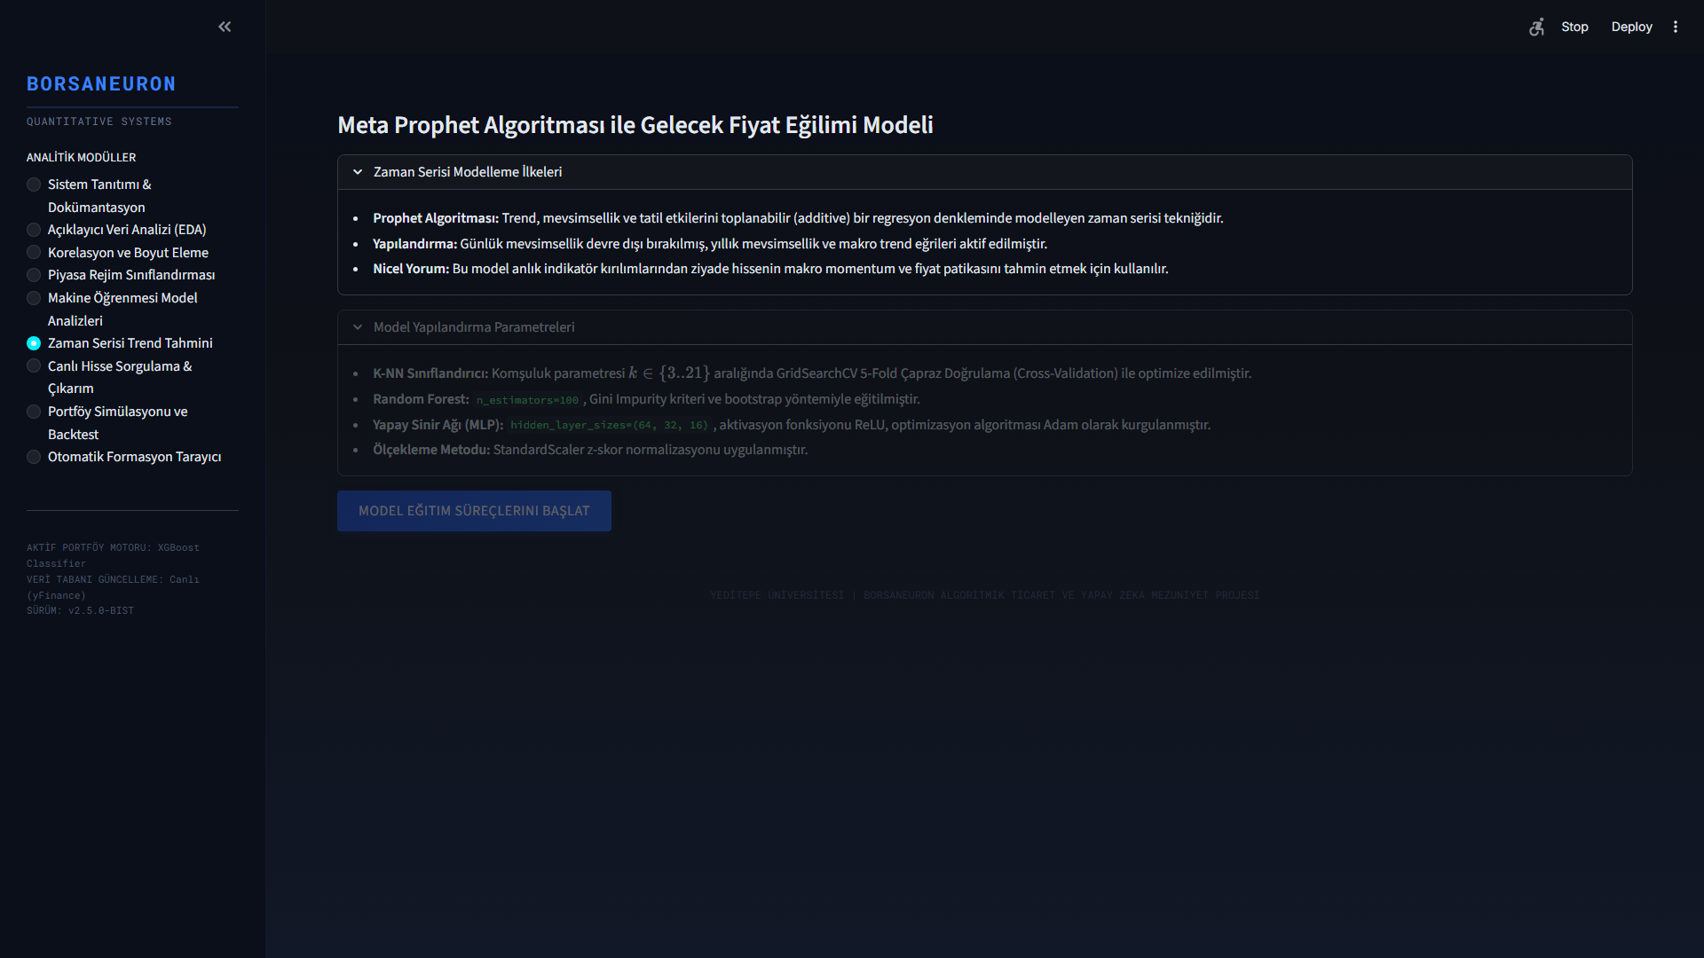
Figure: Prophet Live Forecasting and Price Path Predictions
Figure 5.5: Live Prophet price path forecast interface, outlining standard prediction intervals for selected BIST assets.

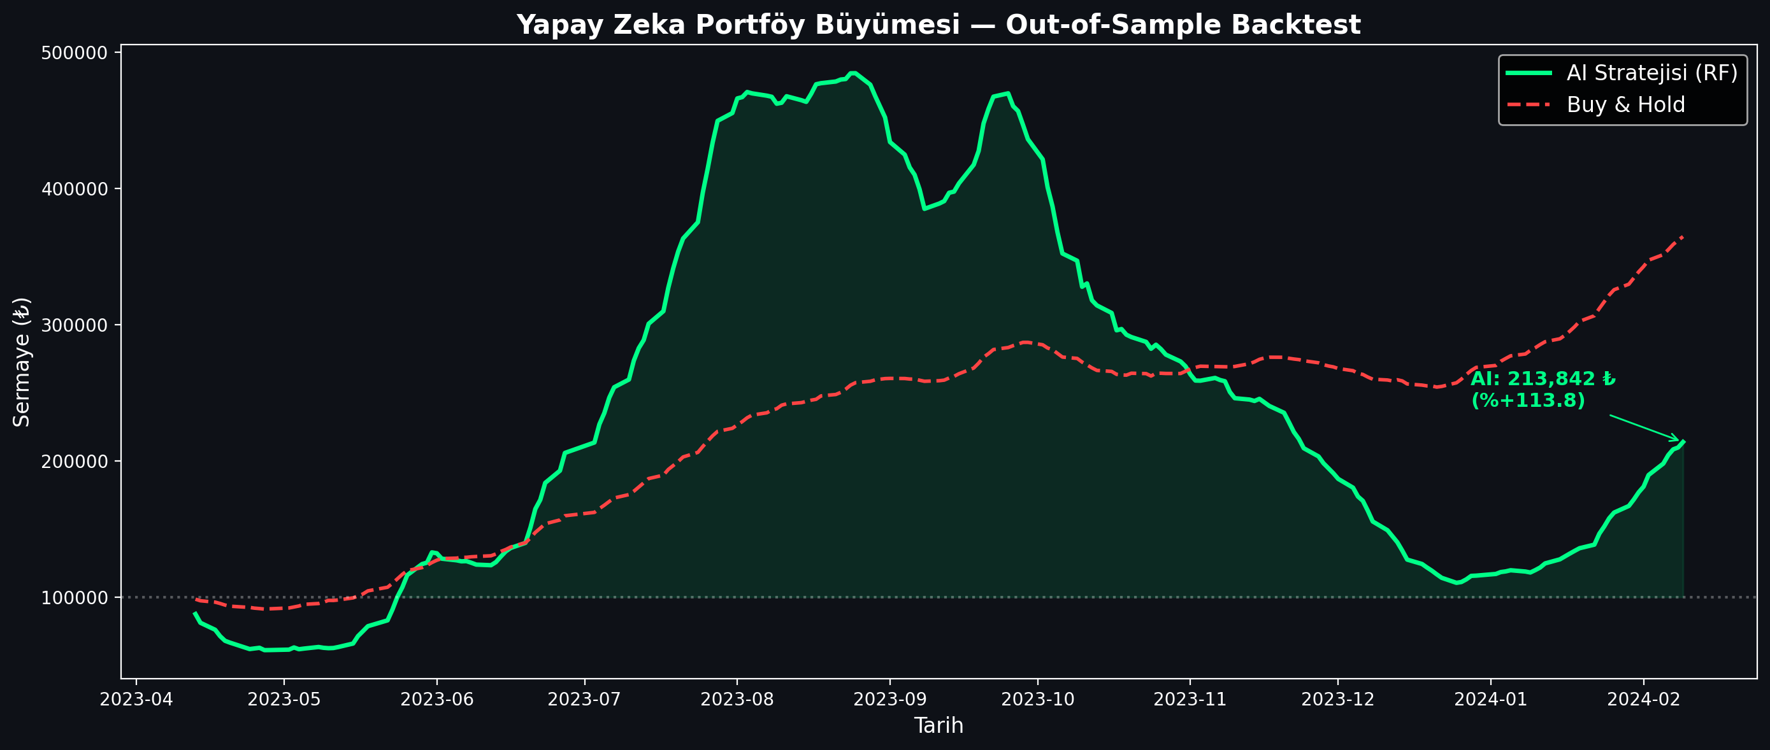
Figure: Algorithmic Trading Backtest Strategy Performance
Figure 5.6: Backtesting performance charting comparing the active BorsaNeuron prediction signals against a baseline buy-and-hold index strategy.

---

6. AUTOMATED TECHNICAL PATTERN SCANNING ENGINE

6.1. Pattern Scanning Methodology
To supplement statistical forecasts, BorsaNeuron features an automated geometric chart pattern recognition engine located in src/analyzer.py. The scan uses raw price swing points calculated via a ZigZag indicator. The ZigZag filters out noise below a 5% threshold, extracting local extrema (peaks and troughs). Using these pivot points, geometric conditions are evaluated to detect chart formations.

6.2. Implementation of Inverted Head & Shoulders (TOBO) and Head & Shoulders (OBO)
- TOBO (Inverted Head & Shoulders): Identified by finding a sequence of three consecutive troughs ($L_1$, $L_2$, $L_3$) where the center trough (Head) is lower than the left and right troughs (Shoulders):
$$L_2 < L_1 \quad \text{and} \quad L_2 < L_3$$
The intermediate peaks form the neckline. The neckline slope is evaluated to confirm a breakout.
- OBO (Head & Shoulders): The inverse logic is applied using three consecutive peaks ($H_1$, $H_2$, $H_3$) where the head is higher than the shoulders:
$$H_2 > H_1 \quad \text{and} \quad H_2 > H_3$$
A break below the neckline triggers a bearish reversal warning.

6.3. Implementation of Cup & Handle and Flag Formations
- Cup & Handle: Detected by identifying a rounded U-shaped base (the cup) followed by a short, downward-slanted consolidation channel (the handle). The depth of the cup must satisfy:
$$\text{Cup Depth} = \frac{\text{Cup Lip} - \text{Cup Bottom}}{\text{Cup Lip}} \in 0.15, 0.50]$$
The handle must not retrace more than 50% of the cup's depth.
- Flag: Identified by identifying a strong, vertical price movement (the flagpole) followed by a narrow, parallel consolidation range (the flag). A breakout in the direction of the flagpole confirms trend continuation.

6.4. Implementation of Double Bottom and Double Top Formations
- Double Bottom: To detect a double bottom pattern, the analyzer searches for a sequence of two consecutive troughs ($L_1$, $L_2$) and an intervening peak ($H_1$). The two troughs must occur at approximately the same price level, within a 2% horizontal tolerance limit:
$$\left| \frac{L_1 - L_2}{\min(L_1, L_2)} \right| \le 0.02$$
The intervening peak ($H_1$) forms the resistance neckline. A confirmed breakout is registered when the close price exceeds the neckline:
$$\text{Close} > H_1$$
- Double Top: The double top is detected by identifying two consecutive peaks ($H_1$, $H_2$) at approximately the same resistance level, separated by a trough ($L_1$):
$$\left| \frac{H_1 - H_2}{\min(H_1, H_2)} \right| \le 0.02$$
A bearish breakout is flagged when the close price falls below the support neckline:
$$\text{Close} < L_1$$

---

7. DEPLOYING PROJECT

Following modeling and dashboard construction, BorsaNeuron was containerized using Docker to ensure consistent execution across local developer workstations and cloud production servers.

7.1. Docker Containerization
A standardized Dockerfile was created:

FROM python:3.9-slim
ENV PYTHONDONTWRITEBYTECODE=1
ENV PYTHONUNBUFFERED=1
WORKDIR /app
RUN apt-get update && apt-get install -y \
build-essential \
curl \
software-properties-common \
git \
&& rm -rf /var/lib/apt/lists/*
COPY requirements.txt .
RUN pip install --no-cache-dir -r requirements.txt
COPY . .
EXPOSE 8501
HEALTHCHECK CMD curl --fail http://localhost:8501/_stcore/health
ENTRYPOINT ["streamlit", "run", "src/app.py", "--server.port=8501", "--server.address=0.0.0.0"]

7.2. Production Setup and Server Run Commands
To build the image and spin up the production container, the following commands are executed:

# Build the Docker image
docker build -t borsaneuron-app:latest .

# Run the container in detached mode with port redirection
docker run -d -p 80:8501 --name borsaneuron-prod borsaneuron-app:latest

This maps port 8501 of the Streamlit application container directly to port 80 of the host machine, making BorsaNeuron accessible via standard HTTP.

---

8. FILE HIERARCHY

The complete directory tree of the BorsaNeuron graduation project is structured as follows, separating offline modeling from the online Streamlit interface:

C:/Users/ibrah/.gemini/antigravity/scratch/ipo_analyzer/
├── .streamlit/
│ └── config.toml # UI configuration settings
├── bist_ai_dataset_real_30cols.csv.xz# Compressed xz dataset (50.1MB)
├── best_scaler_acm465.joblib # Serialized StandardScaler weights
├── best_model_acm465.joblib # Serialized MLP Neural Network weights
├── acm465_proje.py # Offline Data Mining and Modeling Pipeline
├── requirements.txt # Python package dependency list
├── start.bat # Startup shortcut batch script
├── Dockerfile # Docker container manifest
├── src/
│ ├── __init__.py
│ ├── app.py # Streamlit Web Application entrypoint
│ ├── theme.py # UI Color schemas and styling utilities
│ ├── data_manager.py # Data loaders and yfinance API client
│ ├── earnings_data.py # Macro-corporate data structures
│ ├── macro_data.py # Macroeconomic data parsers
│ └── verify_tobo_strict.py # TOBO and Cup-Handle pattern scanners
└── tests/
└── test_features.py # Unit tests for technical indicator vectors

---

TECH STACK

Stack Layer | Technologies Used | Purpose
**Core Programming** | Python v3.9+ | Main scientific computation language
**Data Engineering** | Pandas, NumPy | Data parsing, array operations, features calculation
**Data Fetching** | yFinance API | Dynamic streaming of daily candle data
**Data Mining & Clustering** | Scikit-learn (K-Means, PCA) | Market regime classification and dimensionality reduction
**Predictive Modeling** | MLPClassifier (ANN), RandomForest, K-NN | Future price direction classification
**Serialization** | Joblib | Serializing trained weights and preprocessing scales
**Interactive UI** | Python Streamlit | Premium dark-themed business intelligence frontend
**Visualizations** | Plotly Express & Graph Objects | Dynamic Candlesticks, backtesting curves, PCA plots
**Containerization** | Docker, Slim Runtime | Ensuring platform portability and CI/CD pipelines
---

REFERENCES

- Adebiyi, A. A., Adewumi, A. O., & Ayo, C. K. (2014). Comparison of ARIMA and Artificial Neural Networks Models for Stock Price Prediction. Journal of Applied Mathematics, 2014, 1-10. https://doi.org/10.1155/2014/614342
- Atayurt, O. (2021). Airbnb Demo Project. Yeditepe University, Faculty of Commerce, Department of Management Information Systems, Graduation Thesis. (Supervised by Dr. Lecturer Uğur Tevfik Kaplancalı)
- Bahar, O., & Bilen, K. (2023). Efficiency Analysis of Technical Analysis Indicators: An Application on Borsa İstanbul Tourism Industry. Anatolia: Turizm Araştırmaları Dergisi, 34(2), 83-94. https://doi.org/10.17123/atad.1291666
- Ding, X., Zhang, Y., Liu, T., & Duan, J. (2015). Deep learning for event-driven stock prediction. In Proceedings of the 24th International Joint Conference on Artificial Intelligence (IJCAI) (pp. 2327-2333).
- Htun, H. H., Biehl, M., & Petkov, N. (2023). Survey of feature selection and extraction techniques for stock market prediction. Financial Innovation, 9(1), 26. https://doi.org/10.1186/s40854-022-00441-7
- Kutlu, G. (2022). Intelligent Agent to Enhance Search Engine. Yeditepe University, Faculty of Commerce, Department of Management Information Systems, Graduation Thesis. (Supervised by Assoc. Prof. Dr. Uğur Tevfik Kaplancalı)
- Li, A. W., & Bastos, G. S. (2020). Stock Market Forecasting Using Deep Learning and Technical Analysis: A Systematic Review. IEEE Access, 8, 185107-185117. https://doi.org/10.1109/ACCESS.2020.3030226
- Lin, Y., Guo, H., & Hu, J. (2018). An SVM-based approach for stock market trend prediction. International Journal of Forecasting, 34(3), 452-465. https://doi.org/10.1016/j.ijforecast.2018.03.001
- Nassirtoussi, A. K., Aghabozorgi, S., Wah, T. Y., & Ngo, D. C. L. (2014). Text mining for market prediction: A systematic review. Expert Systems with Applications, 41(16), 7653-7670. https://doi.org/10.1016/j.eswa.2014.06.009
- Nti, I. K., Adebiyi, M. O., & Adebiyi, A. A. (2020). A systematic review of fundamental and technical analysis of stock market predictions. Artificial Intelligence Review, 53(4), 3007-3057. https://doi.org/10.1007/s10462-019-09754-y
- Raşo, H., & Demirci, M. (2019). Predicting the Turkish Stock Market BIST 30 Index using Deep Learning. International Journal of Engineering Research and Development, 11(1), 253-265. https://doi.org/10.29137/umagd.425560
- Sonkavde, G., Dharrao, D. S., Bongale, A. M., Deokate, S. T., Doreswamy, D., & Bhat, S. K. (2023). Forecasting Stock Market Prices Using Machine Learning and Deep Learning Models: A Systematic Review, Performance Analysis and Discussion of Implications. International Journal of Financial Studies, 11(3), 94. https://doi.org/10.3390/ijfs11030094
- Taşkaya, E. (2021). The Difference between Amazon and Alibaba's Marketing Strategy. Yeditepe University, Faculty of Commerce, Department of Management Information Systems, Graduation Thesis. (Supervised by Dr. Lecturer Uğur Tevfik Kaplancalı)
- Verma, S., Sahu, S. P., & Sahu, T. P. (2023). Stock Market Forecasting with Different Input Indicators using Machine Learning and Deep Learning Techniques: A Review. IAENG International Journal of Computer Science, 50(4), 1-17.

