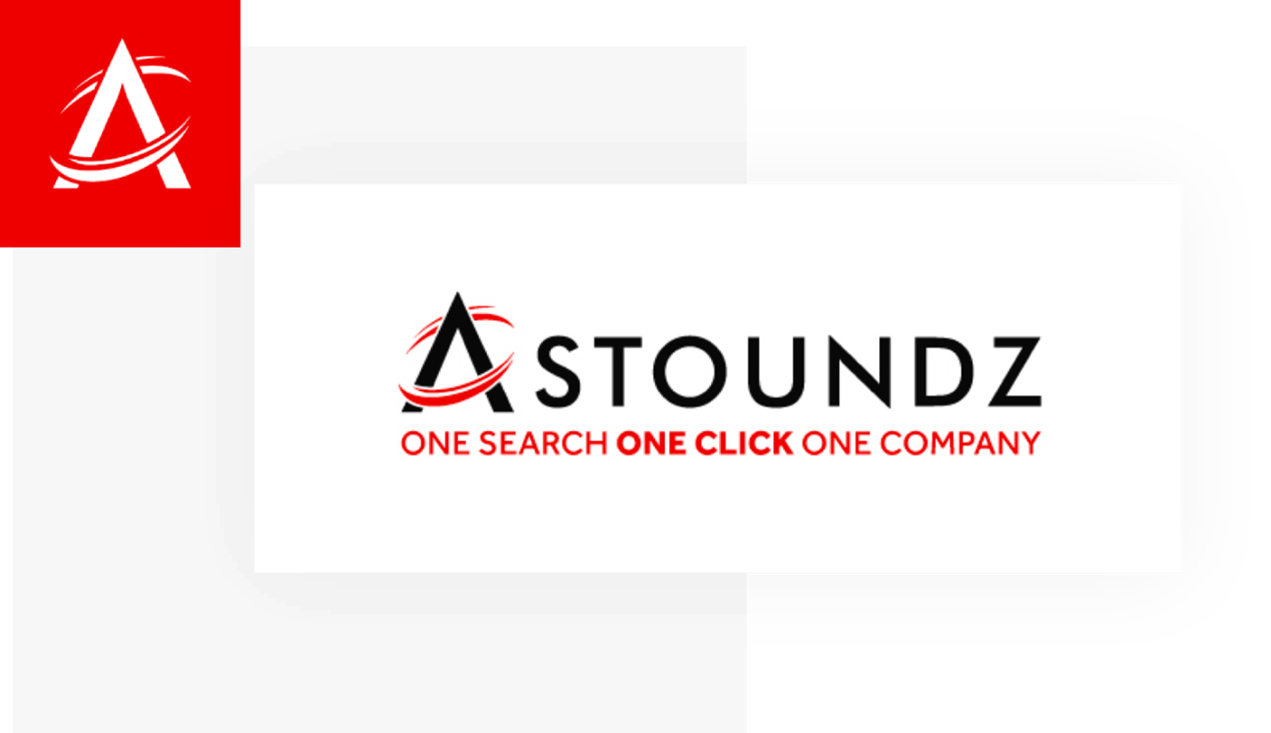

|  |  |  |
| --- | --- | --- |
| **Page Info:** |  |  |
| **Page Name** | **Goodwill changes lives through the power of work!** | |
| **Content Creator** |  | |
| **Approver** |  | |
| **Word Count** |  | |
| **Live URL** | https://www.goodwillhouston.org/ | |
| **New URL** | **/** | |
| **SEO Data:** |  |  |
| **Page Title (40-60 Characters )** | Goodwill of Houston | Thrift Stores & Donations | |
| **Meta Description (140-160 Characters)** | Goodwill of Houston Shop or Donate at one of over 100 locations throughout the greater Houston area. Learn how we provide jobs in the community. | |
| **Focus Keyword** |  | |
| **Key Variations** |  | |
| **Sprinkle Keywords (Use if you can, not required)** |  | |
| Misc/Notes |  | |
| Authority Score | 45 | |
| Backlinks | 11644 | |
| **Onpage:** |  |  |
| Content | Our Mission  We Change Lives Through the Power of Work!  Jobs  Join the Team!  Virtual Platforms & Services  Access all of Goodwill Houston’s services virtually!  Donate  1.7 million material donations  Clothes, Items & Money  Why Shop at Goodwill  Career Services  Locations  Our Mission  We educate, train, and hire individuals with barriers to employment to help them thrive. We connect people, families, and communities to improve lives and to meet the workforce needs of today and tomorrow.  Jobs  Goodwill Houston can connect you with employers inside and outside the organization. For more information on how you can connect with our employment specialists, click here.  Community Impact  People Served by Workforce Development  Volunteers  Lives Touched  People hired by Goodwill Houston  News & Press  Goodwill Houston Leader Named Among Most Admired CEOs  Jul 7, 2022  We are excited to announce that Goodwill Houston’s President & CEO, Steve Lufburrow, has been named by the Houston Business Journal as one of 2022’s Most Admired CEOs in Houston. We are so proud! Congratulations, Steve!...  Facebook  Upcoming Events  Moreton Achievement Luncheon  Your Texas Benefits Information Session  Golf Tournament  Your Texas Benefits Information Session  View More…  Did you know your Houston clothing donations and monetary contributions to Goodwill changes lives? Through job training services, by providing jobs and by providing quality goods at discounted prices for our community through our over 60 thrift stores, your donated materials are the lifeline to job training and job opportunities at Goodwill for people with disabilities and other barriers to employment.  The stuff you donate and the money you spend on cool, quality items found at our Houston donation centers and select stores is immediately channeled into job training and placement programs to help provide jobs. Anyone can use Goodwill’s job training services in Houston and have an opportunity to find a job. Goodwill Houston places 95 CENTS of every dollar into our programs, keeping overhead as low as possible. We’re a 501(c)3 charitable organization that’s served the Greater Houston Area since 1945 as a trusted name in the field of non-profits. When you support the Goodwill of Houston, you are helping to put people to work and changing their lives forever!  We educate, train, and hire individuals with barriers to employment to help them thrive. We connect people, families, and communities to improve lives and to meet the workforce needs of today and tomorrow.  1140 West Loop North  Houston, TX 77055  Email Updates  Subscribe for updates from Goodwill Houston | |

|  |  |  |
| --- | --- | --- |
| **Page Info:** |  |  |
| **Page Name** | **Get more customers, leads, and sales with our web design SEO company** | |
| **Content Creator** |  | |
| **Approver** |  | |
| **Word Count** |  | |
| **Live URL** | https://astoundz.com/ | |
| **New URL** | **/** | |
| **SEO Data:** |  |  |
| **Page Title (40-60 Characters )** | SEO Company: Internet Marketing & Web Design Agency | |
| **Meta Description (140-160 Characters)** | Looking for the best web design SEO company near me? ASTOUNDZ Digital Marketing: Web Design, SEO Content, PPC advertising & Social Media. | |
| **Focus Keyword** |  | |
| **Key Variations** |  | |
| **Sprinkle Keywords (Use if you can, not required)** |  | |
| Misc/Notes |  | |
| Authority Score | 43 | |
| Backlinks | 3721 | |
| **Onpage:** |  |  |
| Content | Internet Marketing Near Me!  We are incredibly grateful for the positive ratings our customers have given us.  Our team aims to get your website on the first page and convert prospects to clients.  Services  %  of B2B buyers  %  of website traffic  %  of people searching  %  of online purchases  AWARD-WINNING SEO AGENCY  Proven SEO Strategies That Drive Relevant Traffic  We pride ourselves on being a one-stop shop for all of your online needs. Yes, creating web traffic starts with on-page content and Houston SEO internet marketing. But a really successful campaign also needs to incorporate elements like Pay-Per-Click (PPC) advertising and custom web applications.  Reviews  What Our Clients Say  Portfolio  Great Websites  View our portfolio of case studies about our previous website and SEO work, and how our ASTOUNDZ team helped our clients reach their goals.  SEO, Website Optimization, PPC  “ASTOUNDZ went above and beyond their scope of working, creating a beautiful, yet highly functional website. Within 2 weeks of relaunching we increased traffic and SEO keywords dramatically. I applaud their vision and capabilities!”– Donae Chramosta  SEO, Website Optimization, PPC  Successfully added and verified all Goodwill Locations. Nearly every major KPI has seen a positive on their Ad Grants AdWords campaign.  SEO, Website Optimization  Commtrex Exchange has seen huge growth. Since working with ASTOUNDZ, Commtrex Exchange has seen increases of over 100% in organic traffic when compared to previous years.  Our Clients  Industries  Who We Serve  Trendz  Digital Marketing Trendz and News  Be the first to know about all things SEO, PPC, and Web with the ASTOUNDZ newsletter.  Subscribe  All About Instant Indexing: Getting Your Website Found FASTER!  SEO  It’s been a busy summer here at ASTOUNDZ! From launching new websites, starting new SEO campaigns, and working with clients to build successful PPC ad campaigns, the team has still found time to research and implement new solutions. The digital landscape only...  May 2022 Core Google Algorithm Update: Everything You Need Know  Google Updates, SEO  Each year Google releases key updates to how their search engine algorithm, or ranking system, works. These are broad by nature and don’t target specific industries or topics. Instead, these updates are often related to Google’s ability to understand/identify quality...  The Big Google Analytics Migration: UA to G4  Google Updates, SEO  Earlier this year in March, Google officially announced that Universal Analytics would be shuttered and that G4 would become the new way in which Google Analytics tracked and collected website traffic data.In addition to this announcement, there’s been a lot of...  ASTOUNDZ guarantees  First-Page Search Results  Our team of search engine optimization (SEO) experts aim to get your website on the first page, build traffic, and ultimately convert prospects to clients in ONE SEARCH!  ASTOUNDZ  © ASTOUNDZ. Sitemap | |