Dear Max,

Congratulations! You have earned an 6000 commission for your recent sale of a Ford Fusion.

Please expect to receive payment within 5 working days. Payment will be sent to your Barclays bank account you have registered with us.

Thank you for your hard work and let us know if you have any questions!

Best,

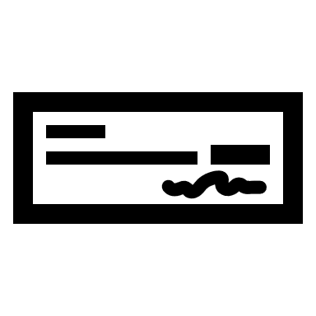

**Accounts Payable team**