Zach Trozenski

DAT-203 FA20

Pivot Table Inquiry Questions

1. What patterns exist in the gender of the respondent and their perception of Hazelwood's physical appearance? Are folks more likely to be willing to volunteer for a block watch if they believe the neighborhood's appearance is positive?

* This pivot table tells us several things about the respondents. We see first and foremost that the majority of respondents are women at more than double the rate than male respondents. Female respondents are more than twice as likely as male respondents to have a favorable view of their community, which may be more linked to distribution of respondent’s gender than to actual perception. However, we do see the majority of respondents reply with either “Fair”, “Good”, or “Poor” (which holds true as a pattern for both men and women). This distribution resembles a bell curve with the extreme values at each of the poles and most data centered around the middle. Men are only 4% more likely to volunteer their time and it’s more likely they will volunteer if they have a more positive view of their community. For women we do see a similar pattern emerge, where a positive outlook on the community appearance predicates a higher likelihood of volunteering, however we see women have a much higher likelihood of volunteering for a block watch overall, and also a higher likelihood of volunteering if their perception of the community is positive.

2. Which subgroup of respondents (sliced on relevant/interesting questions) are most likely to have indicated interest in a block watch?

**Note**: I originally had Gender, Age Group, and Education all in one pivot table but it was unwieldy and difficult to read/capture so I decided to split the two up).

**Gender & Education**

* With the caveat that some respondents did not answer this question, we can see interesting trends emerge when we examine education of the respondents and their willingness to join a block watch. From a demographic standpoint, the majority of people have a high school degree and some college or an Associate’s degree. We observe respondents with high school degrees and some college or Associate’s degrees as being the most likely to volunteer. The highest rate of positive answers to volunteering are by women with some college or Associate’s degrees. On the whole, men are less represented in the dataset and men with higher levels of education are less likely to volunteer their time. This is in contrast to women with higher levels of education, who generally are more willing to volunteer.

**Gender and Age**

* Slicing our respondent population by gender and age group gives us a valuable insight into the age distribution of the people polled. We see the median age in the 55-64 range which may suggest this neighborhood is struggling to attract younger people. 27.5% of respondents are under the age of 45 which supports this claim. However, it appears those most likely, across both men and women, to volunteer their time for a block watch appear to be in the 25-64 year old age range (multiple groups combined). Again, we see men as making up a smaller proportion of the respondents. Women of all ages outside of 18-24 and 75-85+ are more likely to volunteer for a block watch.

3. Inquire into patterns that exist in respondents’ ideas for changes to make in Hazelwood (Q6). Would creating sub-planning groups for neighborhood improvements based on age and gender makes sense to you based on the data? Is there a connection between the improvements folks would like to see and the Creative activities folks are interested in (Q29)?

* The top ten responses as filtered by grand total of respondents indicates people would like to see public safety (i.e. drugs, violence, and crime), amenities (i.e stores, shopping), and public investments/opportunities (i.e. schools, jobs, traffic). Counter to some of the other respondents, 19 people would change nothing about the neighborhood.

* Noticeably for this question there are a significant amount of responses that were either left blank or noted as none, n/a to the total of 114 respondents. Further down the list we see that many people are advocating for more youth activities with some answers more specifically geared towards creative outlets and literacy. While on the surface there aren’t many direct parallels that can be drawn between what people wish to change in the neighborhood and what creative activities they’d like, there is the broader theme of creating opportunities for the neighborhood’s youth which may also have the additional effect of mobilizing adults too.

4. To what degree are folks who indicate that they have special skills more likely to be willing to volunteer in the community (Q25)?

**Note:** I hid most of the columns which declared a response to a special skill so that I could indicate the total in a tidy screenshot.

* It appears that those individuals who responded with a special skill and noted answers about whether or not they would volunteer their time overwhelmingly declined to volunteer. That’s not to exclude the respondents who did respond positively to volunteering however it seems that people are more likely to answer negatively to whether or not they would volunteer if they also possess a special skill. We can make a number of conjectures as to why but without speaking to individuals this is impossible to generalize.

5. "People who live in larger households (more people) tend to be happier" says the policy maker in Hazelwood. What can the survey data bring to bear on this assertion? What weaknesses exist in the data limiting their ability to contribute insight to this question?

* Unless I’m missing a substitute question, Q91 which indicates the size of households (by persons living in a given household) has been scrubbed as it contains personal identifying information. Absent this data point, the question cannot be addressed.

6. A town council member suggests that people who own their own home are more "community minded" than those who rent. A recently elected council person disagrees and claims that folks who rent their home are more likely to work lower wage jobs, allowing less time for community engagement. Can the survey data shed insight into this division of thought?

- Using two different slices of renters/owners I was able to qualify criteria for “community minded” as those who would dedicate 2 hours a month to volunteer, would be a part of a block watch, try to save more energy if they knew their neighbor, and participate in a home and fire safety training course. In that order here are the tables:

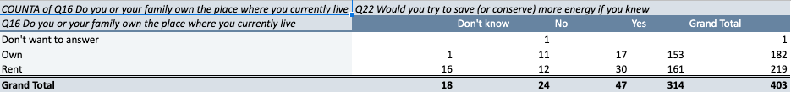

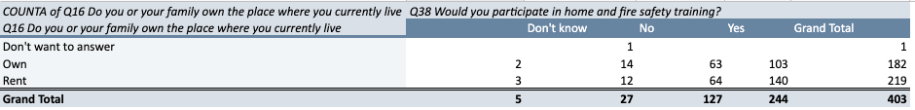

* From these tables alone we see the majority of respondents are renters. When we calculate the percentages of positive responses to each of these questions, for every question the proportion of renters who answered “yes” exceeds that of owners who also responded positively. If we accept the criteria I’ve outlined for “community minded” which would include public safety, community engagement, and environmental consciousness, the assertion that homeowners are more community minded is patently false. The suggestion that homeownership is automatically a pre-requisite for community mindedness is false and misleading and unnecessarily stratifies people who share a community.