Zach Trozenski

DAT-204 Fall 2020

Homework #2­

I wanted to take a look at a given vehicle’s engine displacement (which I’m using as a proxy metric for engine size and power) compared to vehicle class and drivetrain type in the 1998 and 2008 cohorts. I was suspecting that as time passed vehicles would become more powerful, but would they also become more efficient?

As a general trend we can see the mean and median engine displacement sizes increase in the 10-year interval. Additionally, the inner two quartiles generally shrink though with more frequent outliers present in 2008 than 1998. Midsize vehicles for both forward and 4-wheel drive however see the inner quartiles expand. This likely indicates more diversity in displacement but only within 1 standard deviation of the median.

Examining the difference between year cohorts in terms of city miles per gallon does not indicate much of a change. Two of the four four-wheel drive vehicle classes get better fuel efficiency in the city in 2008 suggesting with larger engines the vehicles are more efficient. Similarly, we see very similar behavior for forward drive vehicles with two of the four classes having better city miles per gallon in 2008 than the 1998 counterparts. As for rear wheel drive we don’t see very much change among two-seater vehicles, yet rear wheel drive subcompact vehicles become less efficient in the city in 2008 than 1998. SUVs in 2008 however do gain some efficiency in the city in 2008 as opposed to their ten-year-old predecessors. As a generalization, compact and midsize vehicles are the only classes to both gain in engine size/power and efficiency (at least in the city). We’ll examine highway efficiency next.

First and foremost, the assumptions we made about compact and midsize vehicles holds true in terms of highway fuel efficiency. SUVs perform better on the highway in 2008 but with substantially more outliers than in 1998. Minivans in 2008 perform on average better, same with pickup trucks. Rear wheel drive vehicles in 2008 are a mixed bag as subcompact vehicles and 2-seaters have very slight changes up and down on average, though SUVs on the whole appear to perform better.

Based on the findings I don’t think we can definitively say whether larger more powerful engines in 2008 signal fuel efficiency improvements over similar vehicles in 1998. Any efficiency improvements depend more on the individual vehicle class and the drive train type. Furthermore, there are also variables we are not considering that may be at play here too.

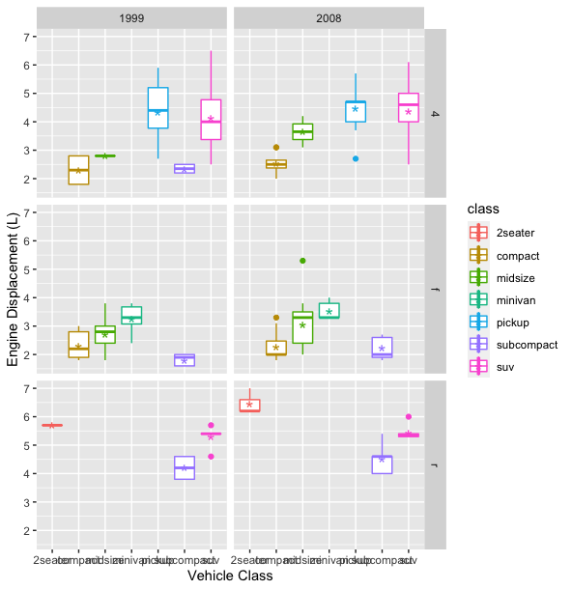

Engine displacement by year and drive train type (ggplot mpg dataset)

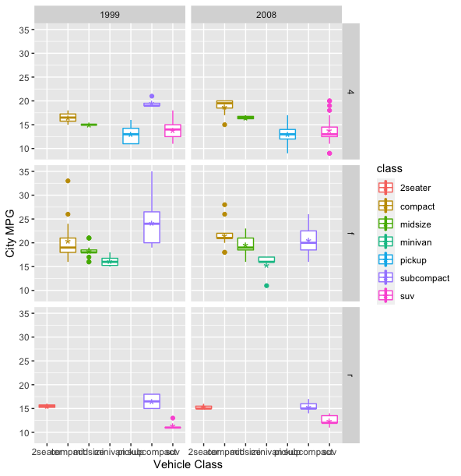

City miles per gallon by year and drive train type (ggplot mpg dataset)

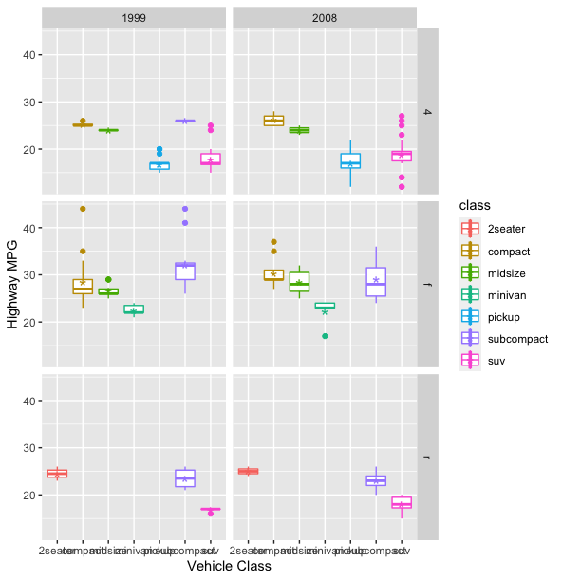

Highway miles per gallon by year and drive train type (ggplot mpg dataset)