UNIT 1 TEST
The Real Number System
Name: ______________________ | Date: ____________ | Period: ________

Score: _________ / 25
Standards Assessed: NC.8.NS.1, NC.8.NS.2, NC.8.EE.2
This test covers real-number classification, converting between fractions and decimals (including repeating decimals), estimating square roots and cube roots, ordering real numbers, perfect squares & cubes, and area/volume applications. Show all work in the space provided. Calculators are not required.

1.1 Converting Rational Numbers
Convert each number as directed. Write fractions in simplest form and show your work.
1.  Write as a decimal: 5/8  = ____________________ | 2.  Write as a fraction: 0.444… (the 4 repeats)  = ____________________
3.
Write as a fraction: 0.7272… (the digits 72 repeat)

= ____________________

1.2 Real Number Classification
Classify each number as Natural, Whole, Integer, Rational, or Irrational. Multiple labels may apply.
4.  Classify: –12  Classification = ______________________ | 5.  Classify: √121  Classification = ______________________

6.  Classify: 0.141414…  Classification = ______________________ | 7.  Classify: √50  Classification = ______________________

1.3 Estimating Square & Cube Roots
Estimate each value to the nearest tenth.
8.  Estimate: √27  ≈ ____________________ | 9.  Estimate: √120  ≈ ____________________

10.
Estimate: √15

≈ ____________________
11.  Estimate: ∛30  ≈ ____________________ | 12.  Estimate: −√40  ≈ ____________________

1.4 Ordering Real Numbers
Order each set from least to greatest.
13.  Set: { 0.5, 2/3, √3, 1.4, 3/2 }  Order = __________________ | 14.  Set: { 0.8, 5/6, √5, 1.3, 4/3 }  Order = __________________

15.
Set: { 0.9, 7/8, √2, 11/10, 5/4 }

Order = __________________
16. NUMBER LINE
Plot each value on the number line below, then list the values in order from least to greatest.
Set: { 1¼ , 2½ , 1¾ , 3⅓ , 2¼ }
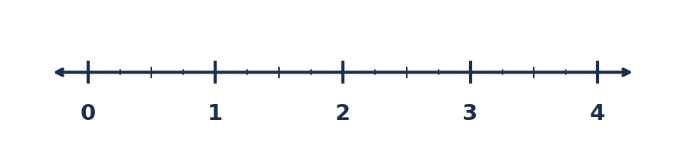
Order = ___________________________________________________________
1.5 Perfect Squares & Cubes
Evaluate each. (No calculator.)
A. Evaluate: 15² Answer = ____________ | B. Evaluate: ∛216 Answer = ____________
C. Evaluate: √169 Answer = ____________ | D. Evaluate: 7³ Answer = ____________
Now evaluate each expression by combining square roots and cube roots.
E. Evaluate: √64 + ∛27 Answer = ____________ | F. Evaluate: ∛125 − √36 Answer = ____________
G. Evaluate: 2(√49) + ∛8 Answer = ____________
1.6 ★ Challenge Problems — Area & Volume
H. CHALLENGE — AREA OF A SQUARE
A square garden has an area of 196 ft². Find the side length and the perimeter. Show all work.
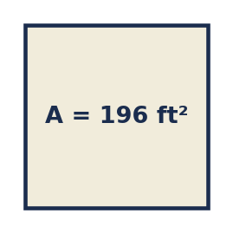
Side length = ______________ Perimeter = ______________
I. CHALLENGE — VOLUME OF A CUBE
A cubic storage container has a volume of 343 ft³. Find the edge length of the cube and the total surface area (sum of all 6 faces). Show all work.
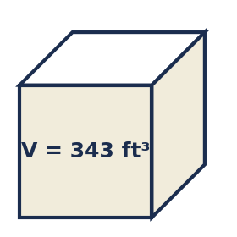
Edge length = ______________ Total surface area = ______________

