Dr. Nefario's Laboratory Safety Manual (Version 1.0)

Lab Access
This manual is for minions working on the lab floor. It does not replace Gru's field handbook. The lab has its own doors, keys, and rules. Read it before you touch a beaker. Keep one copy on the hook by the yellow door.
Only assigned lab minions may enter after 8am. Child watch stays upstairs. Banana duty stays in the kitchen. If you are not on the daily lab list, wait in the hallway. Do not lean on the yellow door. Do not knock with a wrench.
Goggles go on before the door opens. Open-toed shoes are not allowed. A costume with freeze-ray frost must be changed in the locker room. Gloves are required at every bench. If your communicator is set to music, turn it off. Nefario needs to hear the machines.
Late minions do not make up time by rushing a test. Sign the log, take bench 4 if it is free, and wait for the next instruction. Three late arrivals in one week means you inventory the red bins and you do not touch a ray that day.
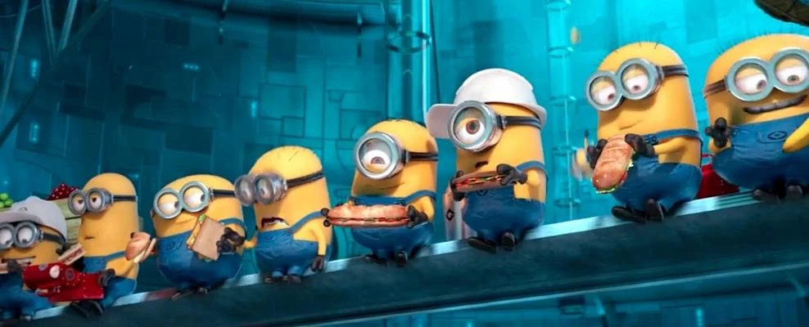

Workstations
Each bench has a number painted on the front edge. Use the bench on the daily sheet. Do not move another minion's tools. Do not trade benches to be closer to the banana crate. The banana crate is not on this floor.
Wipe the bench before you leave, even if the spill is small. A wet bench is a slip. A stained bench is a mystery, and mysteries in this lab become fires. Put used pipettes in the tall pail, not the red bin. The red bin is for objects that have been shrunk.

Freeze Ray Bench
The freeze ray stays on marked rack, safety cap on, barrel toward the brick wall. Never point it at the stairs, the door, or another minion. Test fire only when Nefario is in the room and the cone line is clear. Count out loud before you pull the trigger. If ice forms on the floor, mark it with a cone and call him. Do not lick the ice.

Shrink Ray Cabinet
The shrink ray stays in cabinet B. Gru and Nefario have the only keys. The key is not in the jelly jar. The key is not under the banana crate. Do not shrink a sandwich, a stool, a communicator, or another minion. Do not shrink a problem to hide it.
If something is already small, put it in the red bin and wait. Do not put the bin on a chair. Do not vacuum the floor until Nefario has checked the bin. A missing shrink ray is a full stop. Close the lab and find Gru.

Plasma and Fuel
Plasma flasks stay on the back shelf, never next to lunch. Rocket fuel stays in the garage, never in the lab fridge. The fridge is for samples that Nefario has labeled. A jar with no label is hostile. Do not open it to see what it is. Do not smell it.
If a flask hums, step back and get Nefario. If a flask screams, clear the aisle and get Gru. Do not carry plasma and a banana in the same hand. Do not store leftover smoothie beside a fuel can.

Inventory
Count these items at the start of the shift. Say the count out loud so the minion on the log can write it. Missing gear goes in the log before you eat. Do not wait until after the smoothie.
Item | Location | Count
Freeze ray | Rack A | 1
Shrink ray | Cabinet B | 1
Safety goggles | Hook wall | 24
Red collection bin | Under bench 3 | 2
If the freeze ray count is zero, stop all other work and find Gru. If the goggle count is under twenty, no new minions enter the floor. Extra goggles are in the gray crate under the stairs, not in the kitchen.

Accidents
A hum is a warning. A scream is a stop. Get Nefario for both. If Nefario is already yelling, get Gru. Do not add a second gadget to fix the first one. Do not pour water on a spark unless Nefario points at the bucket.
Fire, flood, and escaped test animals are get-Gru events. Close cabinet B, leave the flasks on the shelf, and take the stairs, not the rocket lift. The orange couch upstairs is for the girls. Do not send them to the lab to help.
Visitors are not allowed on the lab floor. If Vector or El Macho appears at the yellow door, do not open it. Call Gru on the communicator. Do not accept a gift crate. Do not taste a gift cookie. Write the accident log before the next banana.

