**Participant Information Sheet**

**Research Title: A Study of Decision Making**

**Researcher(s):** Zachary Breig, Lecturer, University of Queensland School of Economics, Email: [z.breig@uq.edu.au](mailto:z.breig@uq.edu.au)

Jeffrey Shrader, Assistant Professor, Columbia University School of International and Public Affairs, Email: jgs2103@columbia.edu

Matthew Gibson, Associate Professor, Williams College Department of Economics, Email: mg17@williams.edu

Thank you for your interest in participating in this research project. Please read the following information about the project so that you can decide whether you would like to take part in this research. Please feel free to ask any questions you might have about our involvement in the project.

If you decide to participate in this research, please keep in mind that your participation is voluntary. If you do not wish to take part, you do not have to. If you decide to take part and later change your mind, you are free to stop at any time, and you would not need to give any explanation for your decision to stop participating. If you choose to stop participating, your data will not be used in the research.

You may download this information sheet for your records. You can decide whether to consent to this study within the survey that you downloaded this form from. Your decision whether you take part, or not to take part, or to take part and then withdraw, will not affect your relationship with the University of Queensland.

**What is this research about?**

This research is about how people make decisions and form beliefs. You may be asked to complete tasks for payment, complete short quizzes, reflect on your beliefs, or make other choices. This research is funded purely by the researchers’ universities and will only be used for academic purposes.

**What will I need to do?**

If you agree to participate you will need to complete five separate surveys, including the one you have currently accessed. All surveys will be accessed through your Prolific dashboard. You can find the full schedule of when you will complete the surveys below.

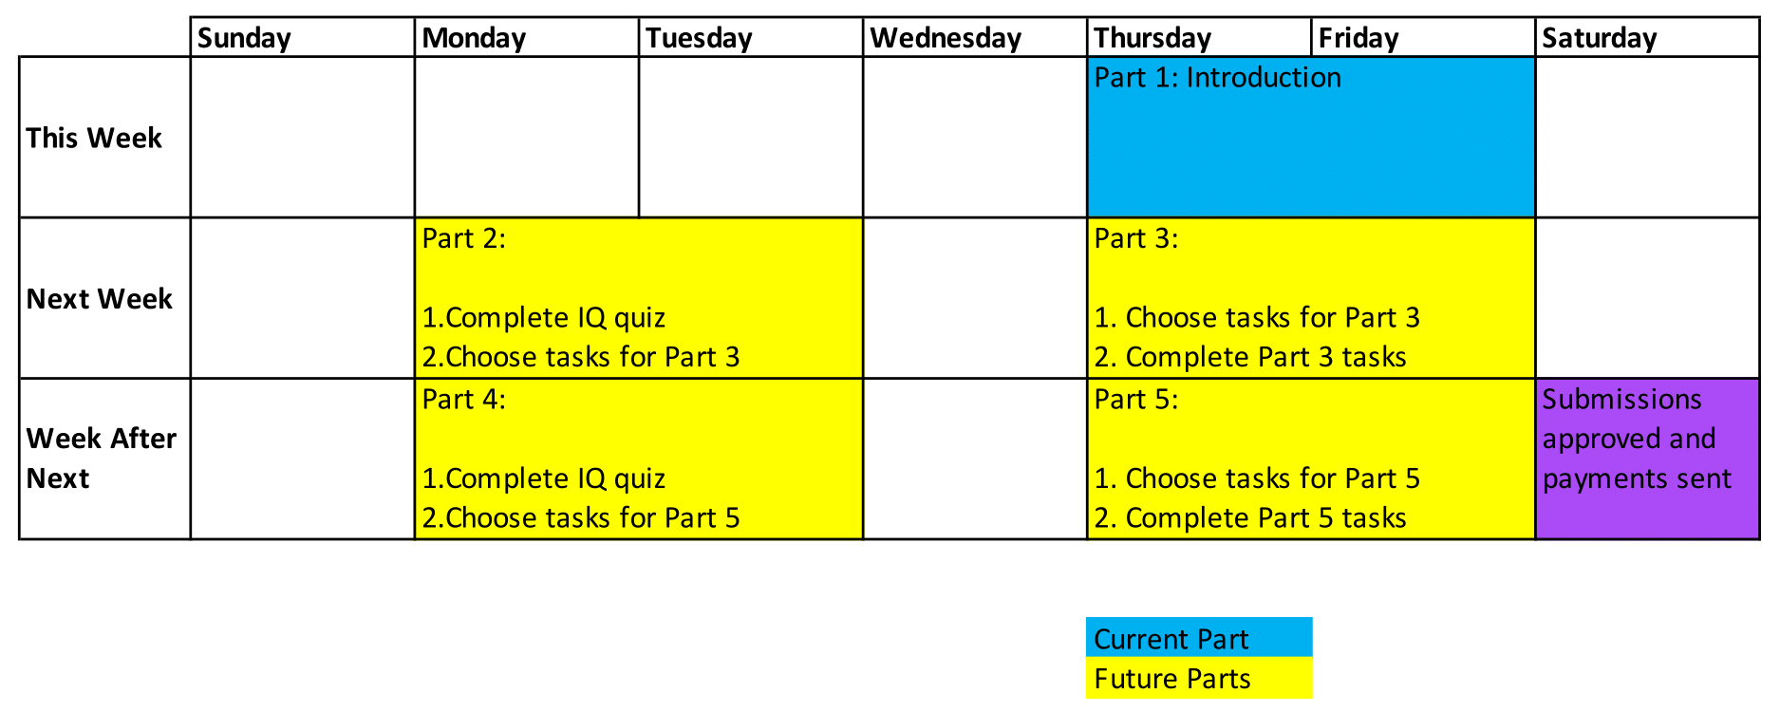

**What are the possible benefits of taking part?**

You will receive payment if you complete all parts of the study. The average hourly pay for the study is expected to be at least $8/hr.

**What are the possible risks and disadvantages of taking part?**

This study does not involve any physical or psychological risks beyond those that are present in everyday life.

**What will happen to the information about me?**

All information collected about you will remain confidential. We will collect demographic information about your gender, age, and employment status. Data will be stored in a secure online database. The data may be used for future research, but it will only be accessible to the researchers listed on this information sheet.

It is anticipated that the results of this research project will be published and/or presented in a variety of forms. In any publication and/or presentation, information will be provided in such a way that you cannot be identified.

**What will happen if I decide to withdraw?**

Your participation in this research is voluntary and you are free to withdraw from the research anytime without needing to provide any explanation, and you would not receive any penalty or bias as a result of your withdrawal. Should you decide to withdraw, all the information collected from/about you will be destroyed and will not be used in the research.

**Who can I contact if I have any concerns about the project?**

This study adheres to the Guidelines of the ethical review process of The University of Queensland and the National Statement on Ethical Conduct in Human Research. Whilst you are free to discuss your participation in this study with the researcher contactable on z.breig@uq.edu.au if you would like to speak to an officer of the University not involved in the study, you may contact the Ethics Coordinator on +617 3365 3924 / +617 3443 1656 or email [humanethics@research.uq.edu.au](mailto:humanethics@research.uq.edu.au)

This research Ethics ID number: 2022/HE002255