Tower defense game inspired from Overwatch’s Escort game mode. There will be a payload near the beginning of the map, creeps will run towards the payload instead of the end of the path. The payload will move as long as there are creeps near it. If there are no creeps near the payload, it will move back very slowly. If the creeps successfully push the payload to the end, it’s game over.

To make the payload a dynamic game mechanic instead of an arbitrary progress marker, the payload will be able to provide cover for the creeps. And they will have to be hit from behind or above to be killed.

Towers can be placed anywhere that’s not on the road. Towers can be told to prioritize highest HP, lowest HP, first, last, or healers.

Creeps will be able to attack towers. If a tower dies, it will have to wait a certain amount of time to respawn.

Creeps will stick with tank if present, otherwise they’ll run to the payload

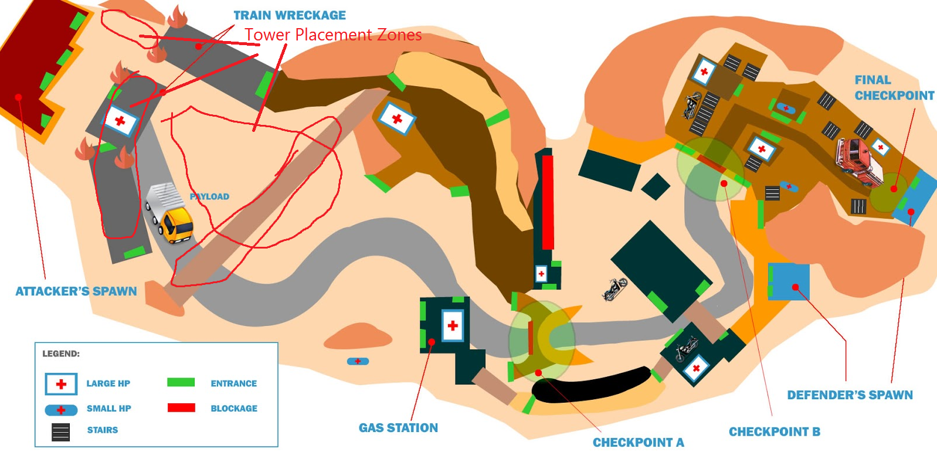

Creeps and towers will be similar to Overwatch heroes.

Creep Ideas:

|  |  |  |  |  |  |  |  |
| --- | --- | --- | --- | --- | --- | --- | --- |
| **Name** | **Diff.** | **Speed** | **HP** | **Atk Speed** | **Range** | **Damage** | **Effect** |
| McCree | Easy | Slow | Low | Slow | Long | Med |  |
| Zenyatta | Easy | Slow | Low | None | None | None | Heal lowest HP |
| D.Va | Easy | Slow | High | Fast | Close | Low |  |
| Soldier | Med | Med | Med | Fast | Long | Med |  |
| Mercy | Med | Fast | Low | None | None | None | Big Heals Lowest HP |
| Roadhog | Med | Slow | High | Med | Close | High | Self Heals |
| Mei | Hard | Med | Med | Slow | Med | High | Ice Block & Heal |
| Ana | Hard | Med | Low | Med | Long | Med | Shoots to heal creeps/heal grenade/shoots towers when creeps are at good health |
| Lucio | Med | Fast | Low | Med | Med | Low | AoE Heals |
| Reinhardt | Hard | Slow | High | None | None | None | Big shield yeah |

Tower Ideas:

|  |  |  |  |  |  |  |
| --- | --- | --- | --- | --- | --- | --- |
| **Name** | **Cost** | **HP** | **Atk Speed** | **Range** | **Damage** | **Effect** |
| **Damage** | | | | | | |
| Genji | Low | Low | Med | Med | Low | 3 round burst |
| Junkrat | Low | Low | Med | Med | Low | Splash DMG |
| Soldier 76 | Med | High | Fast | Med | Med |  |
| Mei | Med | Med | Fast | Close | Low | Slows |
| Pharah | Med | Low | Med | Med | Med | Spash DMG |
| Zarya | High | High | Fast/Med | Close/Med | High/Med | Beam close range/Spash DMG med range |
| Widowmaker | High | Low | Slow | V. Long | V. High |  |
| Bastion | High | Med | Fast | Med | High |  |
| **Support** | | | | | | |
| Lucio | Low | Low | Med | Med | Low | AoE Heal |
| Mercy | Med | Low | None |  |  | Single Target Big Heal |
| Ana | High | Low | Med | Long | Med | Shoots to heal |