1 GENERAL
  - Project Title
Automated Standup Reporting
  - Business Champion
Danielle Jennings
  - Primary User(s)
Danielle Jennings
  - Timeframe
The goal is to be live within 30 days of sign off.
  - Background
Clients of Acrowire require weekly updates on worked performed during the prior week, work being currently performed and work approved to be performed in the coming week along with a burn down chart showing visually the rate of progress. Currently these reports are being manually generated through a combination of excel and email. This process is not scalable, it is manually intensive and is by its nature prone to error.
  - Purpose
What is needed is a system that will automate the creation of these standup emails while allowing for a review and editing step to occur prior to them being sent to the client.
  - Assumptions and Constraints
Any work on the Azure database that is the source of the reporting data is out of scope.

In a possible V2 scenario we may look at ways a product owner could note risks and concerns or state that there are none. This could then allow the bypassing of the review step by the user on issue free reports and only have them concentrate on reports that either have risks and concerns or are out of bounds of some alternative measurement.

In a possible V2 scenario, a historical catalog of reports could be made available.

In a possible V2 scenario, a report can be generated to show which emails were opened by the client and which were not.

This solution is to be built using the Microsoft Azure cloud platform.
  - Definition of success
Success is defined as a process that is automated and accurate so that clients get a good look at the weekly details of the projects Acrowire is working on on their behalf. Review and validation of the reports including product owner consultations should not require more than 5-10 minutes of the users time to complete a single report and send it out.

- DESIGN

  - Solution Description
The source data appears through a separate process in an Azure based SQL database. Utilizing Azure’s scheduler feature, a report generator class will begin processing the reports on Monday at Noon. The timing is to allow for personal to finish inserting their data into PMP for the previous week and to allow the user enough time in the day to send the reports out before 5PM. The time span for the report is from Sunday to Sunday at midnight.
The report generator class will use the source data in the Azure SQL database to create text portions of the email body (Last weeks work, current work and the coming weeks work) and as the source for the burndown chart. Upon completion of the generation of the text and chart, the “in process” report will be stored in a small Azure SQL database and a notification email is sent out to the user notifying them that the weeks reports are ready for review.
Within that email are links to each report. Upon clicking the link in the email, the user is taken to a web based edit form where the email is displayed. The display while in edit form will mimic as close as possible what the final email will render as. In addition there will be a preview button to confirm the final email rendering. The email will be structured in the same way the current email is. The user has the ability at this point to modify the email and once finished, click a button to email the report to the client with a CCed version to the user.
When the email is sent, the final text is stored in the Axure database for future use. The chart image upon rendering should note in a log table that it was rendered via the client email. This will allow for future reporting as to who is opening their report emails and who is not.
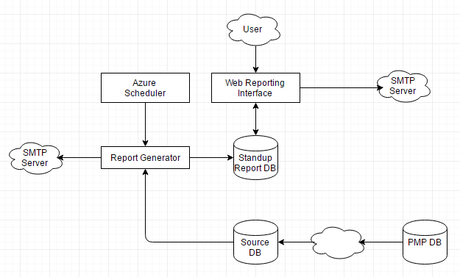
  - Technology Used
Azure Scheduler, C# Class, Azure SQL DB, .netCharting, Azure WebApp, MS SMTP Server

