Part 1

1. Create a package for soccerClub
2. Create a class named SoccerTeam
3. Class should have two data fields:
   1. teamName
   2. scores, three-dimensional int array.
4. Add only one constructor: Two-argument constructor
5. Add getter and setter for teamName
6. Create a public method that outputs scores for each tournament
7. Create a public method that display number of games that the team won out of four games for each tournament and for the season
8. Create a public method that displays total of goals scored by the team for each tournament and for the season

|  |  |  |  |  |
| --- | --- | --- | --- | --- |
|  | Game 1 | Game 2 | Game 3 | Game 4 |
| Tournament 1 | 3,2 | 4,1 | 2,2 | 5,0 |
| Tournament 2 | 4,2 | 0,3 | 3,1 | 1,1 |
| Tournament 3 | 4,1 | 3,3 | 4,3 | 6,2 |
| Tournament 4 | 1,2 | 2,3 | 0,2 | 4,0 |
| Tournament 5 | 2,3 | 3,1 | 1,0 | 0,0 |

* Create a test class
* Display scores for the scores shown above. The output should look like:

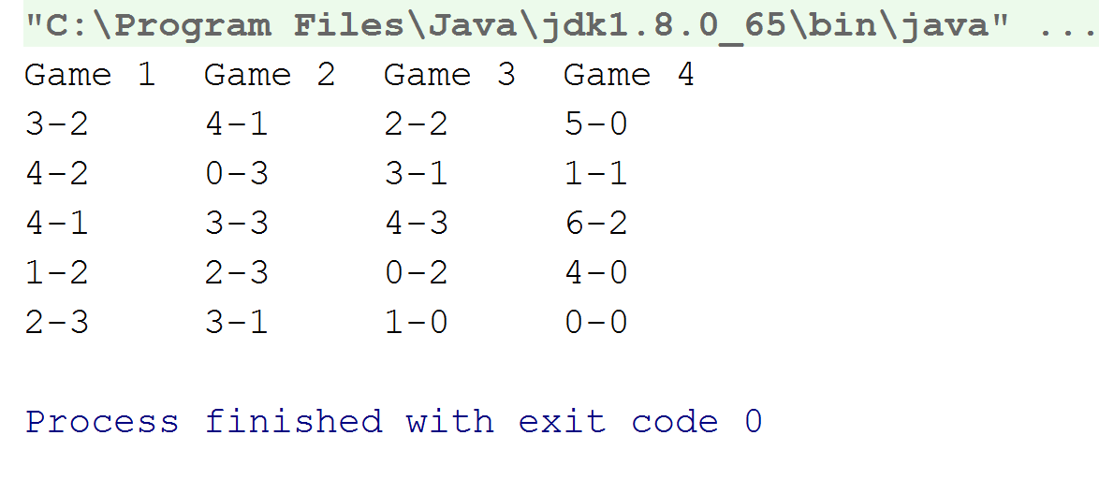

* Display total winnings as shown below

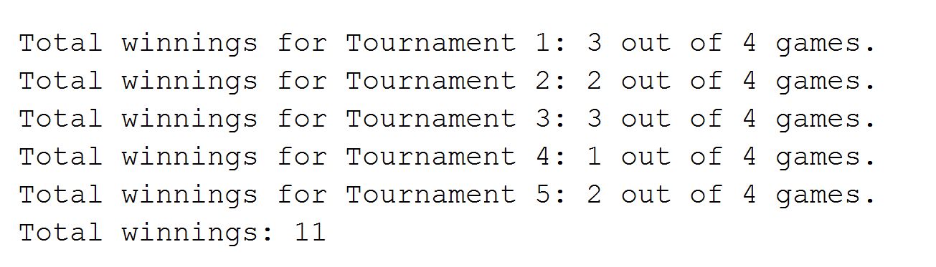

* Display total goals scored as shown below

