Lattice architecture
This is the canonical architectural specification for Lattice's distributed RTOS. Edit this Markdown source. The DOCX white paper is a generated export; see the documentation guide for ownership and the export command.
For current implemented capabilities and the next task, read KERNEL_DIRECTION.md. This specification includes behavior whose implementation is still pending; it is not a progress report.

Purpose and architectural contract
The objective is a general substrate for distributed physical computation. A home, industrial assembly, instrument network, or machine hosting a language model supplies a particular collection of peripherals and definitions. None changes the fundamental ownership or execution model. A touchscreen, compiler host, scheduler, and actuator are distinguishable by their exposed capabilities, not by exceptions to the peripheral interface.
Hardware integration proceeds in meaningful stages implementing permanent components of this model. Jarvis is a reference implementation, not the DRTOS specification or an intermediate product. Development and test discipline are defined in AGENTS.md.

Status of the specification
This document records the intended model. A requirement here is not a claim that code already implements it. Concrete formats and mechanisms remain open where stated; implementation status and the immediate work are tracked only in the kernel direction. External research informs the design rather than proving this implementation.
Requirement | Architectural consequence
Local ownership | A node owns its state and driver. Ordinary execution does not require a replicated image of other nodes or of the entire system.
Change delineation | A registered change starts dependent evaluation. There is no global polling cycle over every program.
Graph execution | Bindings contain the relationships and predicates. Successful traversal reaches mutation handles directly.
Peer operation | Execution and forwarding continue through peers without a mandatory router, Internet service, or central executor.
Bounded local resources | Kernel traffic uses fixed pools and ring buffers. Relay placement and overload behavior must respect explicit capacity.
Explicit semantics | Safety, arithmetic, lifecycle, and temporal behavior come from declared contracts. The substrate does not infer domain policy.
Independent changes | A later ordinary change initiates another traversal. It does not retroactively cancel a decision already propagated.
Complete implementation scope | Persistence, replacement, faults, and verification belong to the implementation baseline, not a later rewrite.
Lattice is neither an entity-component system nor a virtual machine that maintains a second version of the physical world. Its IR and execution machinery describe and traverse relationships among existing state locations and available operations. Local schedulers and communication buffers remain necessary implementation mechanisms; they do not create a central queue of successfully evaluated mutation tails.

The distributed kernel and its nodes
A node consists of local kernel facilities, one or more driver surfaces, resident graph bindings, and communication endpoints. Its state may be the registers of a directly attached component, the driver-maintained observed surface of a foreign machine, or the internal state of a software peripheral. Driver placement follows the peripheral rather than assuming that every driver lives at an orchestrator.
The local kernel handles interrupts, bounded task execution, local timers, binding dispatch, communication, installation, and fault response. The distributed kernel is the composition of those local mechanisms and their protocol. There is no additional machine that must possess the full current state in order for a predicate or mutation to execute.
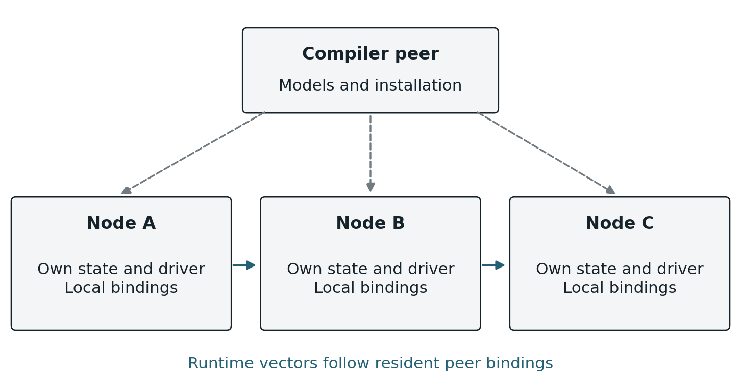
Figure 1. Node ownership and cross-node bindings. Each node retains its own state and executable fragments. A compiler peer installs relationships without becoming their runtime forwarding path.

The compiler and delegate peer
A specialized peer may host the IR toolchain, solver, optimizer, persistent source definitions, and installation delegate. It can hold the model of an entire program and the definitions needed to establish admission. That is different from maintaining a continuously reconciled copy of every peripheral register. Once installed, resident programs execute through their own bindings; ordinary execution must not require the compiler peer to relay each activation or approve each action.
Deployment may send addressed fragments or broadcast a compiled installation package whose relevant fragments are selected by their intended owners. Both mechanisms must establish the same installation and compatibility evidence. Replication or migration of the compiler role is possible, but its coordination protocol has not been selected. Compiler unavailability prevents work that requires that service, such as a new admission; it does not by itself invalidate an already installed program.
The basic installation is vertices and a tablet daemon peer; nucleus is optional. The tablet can author a limited graph directly and supplies intent IR when nucleus is present. Nucleus owns FSPS/proof/compilation, not an obligatory natural-language interface or runtime control path. Existing RTOS mechanisms own scheduling, interrupt entry and synchronization. Board integration supplies only the minimal hardware/state adapters; the common kernel owns networking, enumeration, state propagation, resident programs and their storage.

Local driver responsibility
Appliance firmware is a passive Lattice-native HAL over the board/appliance HAL. It supplies callable initialization, typed getters and native mutation functions, with their mathematical meanings and operating constraints. It has no independent runtime, main loop, monitoring loop or reporting tasks. The kernel owns startup, the main service loop, RTOS execution contexts and every acquisition/invocation. An entry stub may connect the hardware bindings; it does not become an application runtime that periodically calls Lattice as a library.
User requests and installed programs cause the kernel to invoke mutation handles. The adapter performs the requested hardware operation and returns. It does not independently schedule state mutations or publish changes. It needs no special mutable field, report call, message construction or automation callback. The kernel owns monitoring, change detection, retained-state maintenance, dependency activation and communication through the supplied functions.
The kernel retains the last established local observation needed to detect change. It reads through the getter on relevant hardware events or through kernel-owned monitoring when the device supplies no change event. Device acquisition and qualification remain hardware-specific; monitoring cadence belongs to that acquisition path, not to each automation. Sampling only observes the values it actually acquires; hardware event/latching support is needed where intervening transitions must be retained. This local observation record is not a replicated world model. An unchanged observation does not activate programs.
A mutation calls the supplied hardware function. Subsequent acquisition establishes what actually changed, including partial effects of a failed operation. Returning success does not manufacture the desired observed state. The kernel propagates established changes through the same path whether they followed a native command or originated in the environment. The program evaluator runs on activations and incoming visits, not as a continuous scan of every predicate.
A native function can remain active for the duration of a finite physical operation. The kernel must provide its execution context while continuing peer service and hardware monitoring. Do not require the adapter to return promptly, create its own task or split the operation into a firmware-owned runtime. Synchronization protects actual hardware critical sections; holding the entire appliance exclusively for a long call would defeat concurrent monitoring. This does not create program-wide serialization, supersession or cancellation of an earlier traversal.
The firmware implementation is the kernel's userspace boundary. Keep its hardware/state interfaces small and stable, following the SAS-style goal of a few primitive bindings for a new board. Framing, serialization, addressing, transport limits and program execution belong inside the kernel and its backend. Changing from IEEE 802.15.4 to a different medium must not require changes to existing appliance source or the common adapter interface; new physical hardware supplies another adapter implementation. Byte FIFOs, packet buffers and DMA are internal mechanisms, not an obligation to author packets. Matter, GPIO and other local appliance interfaces remain encapsulated behind the same state/mutation model. The hardware and state interfaces must make participation automatic without a separate firmware send/notification ritual or firmware-owned monitoring loop. Kernel-owned physical acquisition is distinct from polling programs for truth. Concrete hardware binding signatures remain implementation design work.

Independently replaceable kernel and appliance code
Independent kernel updates remain a later objective: replace the kernel while retaining the existing appliance binary, without an implementer rebuild. A stable binary interface behind the firmware's source traits and separately linked code are candidate mechanics. Their ABI and boot handoff are not selected yet.
This work is deferred until the functional distributed kernel is established. Current development builds and reflashes the combined kernel/appliance image. Preserving installed programs and commissioning data requires a protected storage boundary, not independent kernel/appliance binaries. That storage work does not make the deferred binary interface a prerequisite for program execution.

References and resident graph structure
A binding is an attachment to an already existing state location, operation, or relay slot. The graph stores the relationships among those attachments. Enumeration reveals the surface and makes its bindings available; it does not manufacture a second object model of the peripheral.
Within a node, an attachment can resolve to a direct memory reference or function pointer. Across nodes, a reference must identify an owning peer and a binding within that peer. A foreign address is never dereferenced as local RAM. This distinction is an addressing requirement of separated machines, not a requirement for a registry of copied peripheral entities.
Resident information | Purpose
Local attribute or mutation reference | Connect an edge to the state or callable handle already owned by the node.
Local predicate and value operations | Define the local test, value transfer, branch, or invocation associated with the binding.
Directed neighbor references | Identify the next semantic binding and the upstream activation relationship toward a program head.
Program revision association | Keep each admitted traversal on compatible installed fragments during replacement.
Optional relay binding | Represent an established communication path without changing the program predicate.
Optional safety and watchdog slot | Declare fault behavior and retain the bounded state needed while a protected condition is open.
Head enablement | Make admission eligibility resident in the graph rather than an external AutomationID lookup table.
These are logical requirements, not a demand for heap-allocated objects or one large structure at every attachment. Concrete layouts may use fixed arrays, compact indices, unions, and references to shared immutable definitions. An attribute participating in several programs retains the corresponding relationships; no single node has to store the complete executable.

Semantic and communication paths
A semantic edge connects the program bindings whose relationship matters to evaluation. A communication path may include additional relay bindings that carry the activation between them. Removing relay-only vertices from a path must recover the same semantic relationship. A relay must not silently become an extra predicate, alter a retained operand, or substitute for an unavailable state owner.
The graph can contain branches and multiple dependencies even when one particular traversal is serial. Each node therefore needs explicit directional references for the edges it owns. An XOR-linked representation is an optional local packing technique, not the semantic definition of the graph or a promise that raw pointers can cross machines. Its suitability depends on branching, reconstruction, and the required direction of traversal.

Durable identity and runtime address
Native appliance states and mutation functions have durable owner-local bindings. Their declarations supply permanent binding names; the kernel converts those names to numeric references and resolves them to the current native handles. Names are not display labels, Rust type names, enumeration positions or transmitted strings. Compatible firmware relocation must preserve those references. Reusing a name for a different physical meaning is an incompatible change, even if its type matches. Duplicate references must be rejected rather than ambiguously dispatched.
On reconstruction, graph traversal resolves saved native bindings and fixes local relationships after checking types and compatibility. A multi-node reference adds the owning node's identity to this reconstruction domain. Mathematical definitions and surface compatibility fingerprints must not depend on firmware addresses. Installed graph storage has separate incarnation/reuse rules: boot, replacement and reuse must distinguish a new binding from delayed traffic for its previous occupant. Stable native names do not establish that a changed program or hardware implementation is compatible. Concrete record and installation formats belong with the kernel implementation.

The common IR and peripheral semantics
The common intermediate representation (IR) defines typed state, arithmetic, comparisons, Boolean composition, operation effects, and invariants. Appliance implementors supply the mathematical meaning of their native state and functions, not the automations that will later use them. Compilation connects owner-local predicates, value calculations and native mutation endpoints through resident graph edges. Definitions supplied after firmware compilation select and bind the kernel's native primitives; they do not require a firmware-authored Rust evaluator for each automation. The common IR is not an interpreter hosted on every vertex. Concrete resident-record and installation formats are maintained with the kernel implementation.
Definitions are composed from the language's primitives rather than added as new domain-specific opcodes. Duration, duty fraction, warmth, illumination preference, or a learned intent score belongs in definitions authored using the IR. A reusable duration definition receives the relevant scope; separate compiler features for television duration and diffuser duration would violate that abstraction. Definitions are submitted as typed structured data or compiled artifacts, not strings that the kernel reparses as ad hoc source.
There is no privileged tablet SDK. A tablet is an ordinary peripheral with a relatively broad surface. An authenticated binding can connect a user action directly to an authorized mutation handle. A language model may contribute structured intent definitions through the same mechanism. Authentication, admission, and safety still apply to those contributions; a natural-language interpretation does not become an unchecked executable.

Multiple effects from one invocation
One function can affect several attributes. Its semantic mapping must express a joint transition relation over the affected state, with all per-attribute effect definitions referring to the appropriate common input state and command arguments. A tuple of references to per-attribute transition definitions is a suitable compositional representation if the mapping also preserves their coupling, execution guards, and which unaffected attributes remain unchanged.
For example, a command that changes both power and level must not be modeled as two independently selectable effects. The solver chooses the command once and reasons over its complete declared transition. That mathematical relation does not imply an atomic physical transition or simultaneous reports from the device. Delays, guards, failure outcomes, and observation behavior are part of the supplied model where relevant. The driver still owns actual convergence.

Portable arithmetic
Numeric widths belong to the IR and are independent of the host machine. Addition, subtraction, and multiplication wrap at the declared width. Signed values use two's-complement interpretation. Checking, saturation, fixed-point scaling, wider intermediates, and alternative rounding are authored explicitly when required. These are retained language decisions, not unspecified host-language behavior.
Division case | Required result at width N
Ordinary division | Quotient rounded toward zero; a nonzero signed remainder has the dividend's sign.
Zero divisor | Quotient has all N bits set; remainder is the original dividend.
Signed minimum divided by minus one | Quotient is the signed minimum; remainder is zero.
The solver and target backend must agree on every operation, including exceptional results. Solver defaults and native instruction behavior are not substitutes for the IR contract. The shared IR owns arithmetic/type rules. The compiler and installed-program ABI must preserve them rather than importing host defaults.
Each admitted traversal has bounded local work. Continuing behavior is expressed through explicit future activations or state-dependent recurrence. The presence of a scheduler does not by itself prove that the total communicating system lacks unbounded computation. The relevant implementation obligations are bounded resources and progress for admitted operations, not an informal claim about Turing completeness.

Change activation and distributed execution
A registered change identifies the resident dependency relationships affected by that attribute. For each affected program, activation travels upstream along the installed relationships toward its head. A target within direct reach can receive the transmission immediately; otherwise peers relay it. Each logical hop uses the same acknowledged delivery rules. Routing upstream activation is not itself a substitute for the program's forward conditional evaluation.
At the enabled head, an admitted activation begins traversal of the installed program revision. Each visited conditional binding reads the appropriate currently exposed local value and evaluates its predicate. A true result advances to the declared next binding; a false result terminates that path or takes the explicitly authored alternative. Values are discarded once no longer needed. There is no global snapshot assembled before evaluation.
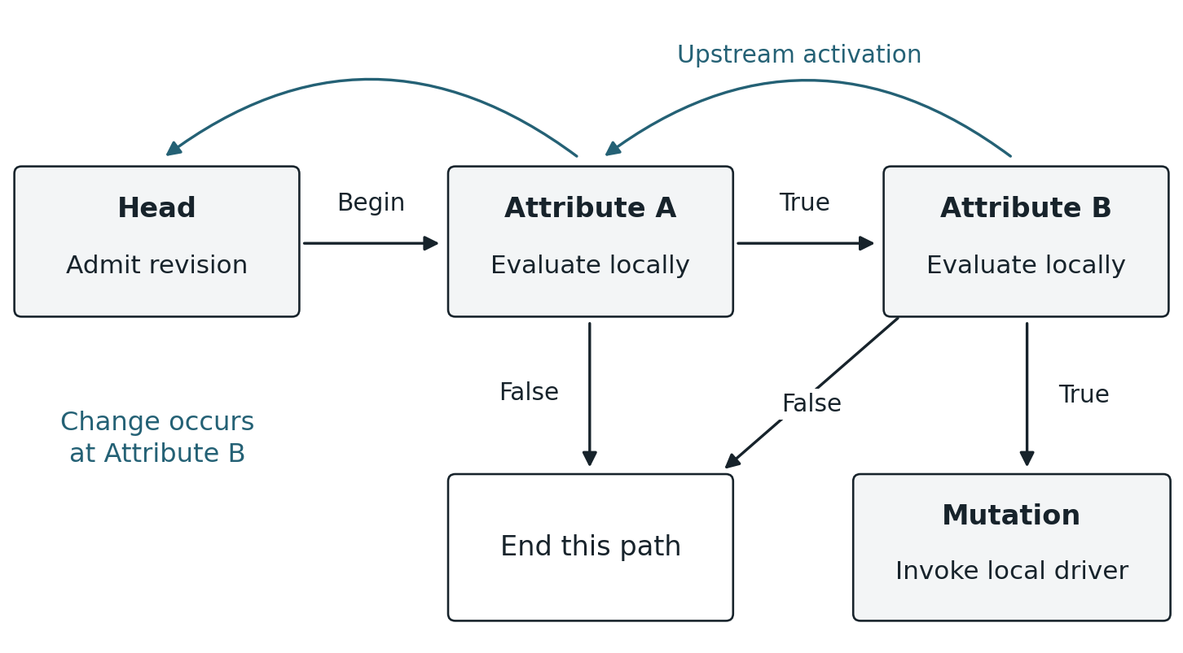
Figure 2. One change activates a program through its upstream relationships. Forward traversal evaluates the program and reaches its mutation binding only along a successful path. Every hop uses the common delivery protocol.

Interrupts and local task execution
Hardware IRQs and kernel-detected changes feed existing RTOS notification/task machinery. The interrupt acknowledges/captures the event and wakes task-context work; getters that perform I/O, native mutations and radio waits must not require blocking inside an ISR. A software-detected delta can notify the task directly.
For a local delta, the kernel follows the changed state's resident dependencies and starts the corresponding upstream activation work. An incoming forward visit selects its installed local predicate, reads the relevant state, computes needed values and follows the selected successor. A false result ends the path unless the program explicitly supplies an alternative. In an AND chain, arrival embodies the preceding successful tests; general branching follows the edge actually selected.
Local work uses RTOS tasks with statically bounded storage and independent traversal values. Task creation/reuse is a kernel implementation concern, never appliance firmware responsibility or a global graph scheduler. Radio waiting must not hold the appliance lock. Existing IRQ-driven radio task wakeups are a foundation; installed-program dispatch uses this same task machinery.

The read and write head
The evaluator performs local work along the authored path. An OR branches around its second predicate when the first is true and visits the second when the first is false; an AND reaches the second only after the first is true. The chosen edge carries the Boolean decision, without retaining that decision as another operand. The read/write head carries only values still needed downstream. Each visited owner contributes its local inputs and greedily completes calculations whose inputs have become available; the final input owner sends the most reduced result possible. The mutation owner can pass that result to its native function or finish a calculation requiring its own local state.
The compiler determines the peak live carried values, their widths and byte capacity for the emitted traversal, assigns operand locations and reuses them after their last use. This is neither a universal one-operand limit nor one slot per predicate. For (a - b) * c encountered in that order, one carried location can hold a, then a - b, then (a - b) * c if those intermediates have no later use. Each traversal owns its own working values; overlapping traversals never overwrite one another. Every path reaching an operation must supply its operands, including short-circuit paths. The existing native-call payload limit does not define this head ABI. General concurrent joins require an explicit bounded design and are not implied by serial predicate branching.

Historical inputs and current calculations
Typed calculations over current exposed states and the head's temporary working values are ordinary program work. Historical inputs require a separate declared retention capability. Installing an automation must not silently add history getters to an appliance's surface or make its correctness depend on a volatile buffer that disappears after reboot. Automation-authored history maintenance is deferred.
An optional recording vertex may retain qualified network deltas and expose historical information through its own surface. That does not require every appliance to record raw hardware samples or invent observations at a fixed sampling interval. Missing information cannot be substituted with zero or false. A public receive call log is deferred as well; it is not required for addressed dependent delivery and does not establish a historical query service.

Mutation and continuation
A successful path reaches a binding to a local mutation handle. The node invokes that function with the computed arguments. There is no central queue holding successful tail pointers while unrelated chains finish. Local processor scheduling or link availability may delay a visit, but a one-condition program does not wait merely because another program has eight conditions.
A mutation can be followed by another directed action edge. The program must specify whether continuation depends on command acceptance, a returned result, or a subsequent observed state change. Receipt of a packet, successful function return, and physical achievement of the desired state are different facts. A physical completion dependency is represented by the relevant observation or declared operation semantics, not inferred from a transport acknowledgement.
As drivers observe resulting state changes, those changes activate their own dependents in the ordinary way. No node needs to know the complete automation to perform its local part. A path reaching its last mutation means that its invocation work has progressed; it is not proof that every physical consequence has already completed.

Independent deltas and concurrency
A later change is another valid cause and starts its own dependent traversal, including when that program is already traversing. If it arrives before a predicate is read, the predicate reads the newly exposed local value; if it arrives after the predicate has passed, that decision is not unwound. There is no cancellation, supersession, program-wide atomic execution lock or global barrier waiting for earlier physical effects. Native operations and shared local state retain their ordinary synchronization. Resulting physical observations activate their dependents by the same rule.
Each node serializes access where its local state or mutation interface requires it. Independent paths and independent nodes can execute concurrently. The correctness of a program must not depend on the accidental order in which unrelated paths happen to run; admission and runtime semantics must state any required ordering or interlock.

A common peer delivery protocol
Broadcast and vector are kernel communication primitives. A broadcast reaches available local recipients and supports discovery, opportunistic forwarding, and repair. A vector addresses a particular binding, possibly through multiple peers. A vector is not a promise of direct radio adjacency. Established relay bindings make its path explicit without requiring the compiler to precompute route permutations.
Delivery responsibility follows actual installed dependencies and other explicitly addressed recipients. Each registered source change activates its own resident dependency links; it does not require every vertex to receive a copy of that change. Other vertices do not maintain a global dependency table or infer relevance from overheard traversal. The source must transmit a change notification along each affected program's upstream path. The current implementation calls this addressed notification an upstream activation. If it does not reach the next remote evaluation owner, that owner cannot continue toward the head. This is outward delta propagation; local registration alone is insufficient. The separate best-effort StateChanged broadcast carries an attribute/value notice for observation. Distinguishing these wire classes must not be mistaken for independence from change notification or from its delivery guarantee.
The same delivery protocol applies to upstream change activation, forward predicate traversal, action traversal, installation control, and safety traffic. Evaluation is not an unreliable exception that may silently disappear after the head receives an activation. Priorities and retry budgets can differ by declared message class without changing what a receipt proves.
Logical message | Meaning
DELIVER | Addressed work for a target binding and phase, with the traversal identity, revision, bounded payload, and any retained operand.
RECEIVED | The named target accepted the specified delivery; its correlated receipt establishes acceptance of this handoff.
COMPLETE | A declared unit of work has finished, including any child work covered by its accounting contract. This is stronger than receipt.
FAULT | A declared execution, availability, resource, or safety condition failed, with the scope and response defined by the binding contract.
HEALTH | Fresh evidence for an active safety dependency and protection instance, not merely evidence that a processor is alive.
INSTALL and ACTIVATE | Stage and verify a program revision, then change admission eligibility under the installation protocol.
These names define semantic distinctions, not a frozen packet format or six mandatory wire opcodes. Several may share an envelope or fit in one fixed-size frame. The wire ABI must specify identity, target, message class, revision, payload bounds, authentication, integrity checks, and fragmentation where necessary.

Continuous native control
Continuous scalar control is a required core kernel communication primitive. A peer such as the tablet can maintain an addressed control relationship with an existing native transformer and send successive typed arguments while receiving state feedback. Dragging a dimmer slider is the immediate use case. It needs no installed automation, nucleus, appliance-specific stream handler or change to the current traversal model.
The caller supplies the destination, native handle and argument. The kernel owns binary framing, correlation, ordering, bounded flow control, delivery recovery and dispatch to the native hardware function. The relationship reuses established bindings and routes; it must not require surface discovery or a new connection for each slider movement. Feedback belongs to the participating peers rather than a guarantee that every vertex receives every update. Receipt, native-call completion and observed physical state retain their distinct meanings. The final selected value needs an established outcome or an explicitly unconfirmed result, rather than silent loss when the gesture ends.
The performance goal is a short path from a compact numeric handle/argument message to native dispatch, with no text or per-value IR interpretation. Minimize buffer copies where port ownership permits reuse, but do not assume RDMA, shared MCU addresses or a zero-copy path that the implementation has not demonstrated. Measure input-to-dispatch and input-to-observed-state latency; radio airtime, contention, retries and finite native execution still contribute. A hard latency bound requires those costs to be bounded.
A live scalar stream represents the user's current intended target. Obsolete intermediate slider positions may be replaced at both sender and receiver while still pending; native preparation may be retargeted until the hardware function starts. This explicitly differs from admitting a discrete program/native operation: accepting a stream sample records current intent and does not promise to invoke every intermediate value. A running native call is not preempted. Every actual acquired appliance change retains its normal delta semantics. Hardware qualification and application units determine meaningful granularity; the kernel does not invent a universal brightness deadband.
Finishing a gesture seals its latest target for a native result and observed-state feedback. Closing an unsealed session abandons undispatched intent. A disconnected host cannot carry an old unsent target into a new attachment. Stale receiver/session identity is an explicit failure, not authorization to reopen and replay an uncertain operation. The component documentation owns the bounded session, expiry and wire details.

Dependent delivery and acceptance receipts
The source owner knows its local dependent entries from the installed graph. Activation follows their upstream links toward the head; forward evaluation follows the selected successors. A transport relay forwards toward the named owner without interpreting the predicate or deciding whether the change matters. The destination validates and accepts its own bound work. Observing another traversal is not substituted for that receipt.
The current holder retains each handoff until the named evaluation owner accepts it. Transport-hop acknowledgment proves only frame reception at that hop. After accepting work, the next evaluation owner is responsible for its own onward handoffs. Neither the origin nor a relay needs a network-wide recipient list. Reaching the head is acceptance there, not proof that the tail has executed or every other dependent has received work.
Requests and receipts have stable correlation across retries. A lost request is retried; a lost acceptance receipt is answered from retained acceptance evidence without repeating processing. Receipts do not require another chain of receipt acknowledgments. The current Release operation frees retained evidence after the sender has learned acceptance; a lost Release does not revoke acceptance or block the receiver's admitted work.
Fixed capacity remains explicit. Busy leaves work with its sender for later retry. Accepted work is not evicted to make room for another visit. Distinct local changes remain distinct causes; the existing bounded local-cause overflow report is not a lossless-delivery claim. Reboot and reused-storage identities prevent stale tickets from becoming new invocations; uncertain acceptance is reported rather than guessed. These rules do not guarantee exactly-once physical effects across arbitrary crashes.
Universal delta dissemination and a standardized public receive call log are deferred. They must not become prerequisites for this addressed delivery path. A future explicit consumer of observations would need its own receiving relationship and delivery policy; the existing best-effort broadcasts do not silently provide reliable subscriptions.

Completion and uncertain outcomes
Receipt at the head establishes delivery to that head. It does not prove that all relay traffic is quiet, that the execution has reached its tail, or that the peripheral has reached the desired state. Finite distributed work can use local accounting of spawned work and returned completion signals to establish termination. Dijkstra–Scholten provides a relevant foundation under its stated communication assumptions [1]. Its result must not be claimed for a lossy, rebooting implementation without the additional required protocol.
A target can invoke a function and lose power before its acknowledgement is received. Without durable operation evidence or a suitable operation-specific property, another node cannot infer whether invocation happened [6]. The baseline does not introduce a mutation ledger or promise exactly-once physical effects across arbitrary crashes. The implementation must state its bounded duplicate guarantee and report unresolved outcomes where that guarantee no longer applies. A fresh observation is a fresh change, not evidence that an old request should be replayed.

Adaptive relay bindings and bounded routing state
Nodes may offer a small fixed pool of relay slots. Capacity is explicit and measurable against the selected hardware. It does not impose the same limit on attributes, semantic edges or messages in flight. Current protocol capacities belong in the component documentation.
Initially, broadcast and opportunistic relay discover usable paths. Repeated useful traversal supplies evidence about which connections are worth retaining. Preferred paths become resident in relay bindings, so ordinary traffic increasingly follows vectors through established neighbors. Loss of a relay returns the affected path to discovery or repair. Broadcast becomes less prominent as useful connectivity stabilizes; it remains available when that connectivity is insufficient.

Weights describe marginal usefulness
Communication time is normalized per acknowledged payload byte and composes additively along a path. Packet overhead and retries contribute to measured service cost; unknown cost remains unknown. The wire component owns its representation and measurement rules. Choosing which relay relationships to retain under scarce storage is a separate policy from measuring path cost.
Local elapsed measurements provide cost evidence without globally synchronized clocks. If send/receive timestamps are exposed in future diagnostics, their different clock domains and uncertainty must be retained when estimating one-way latency. Public log inspection is not required to measure marginal communication cost.
A relay weight reflects the benefit of retaining a particular connection under scarce local capacity. Useful evidence includes delivery success, traversal latency, transmissions or energy spent, demand, the quality of alternatives, and replacement cost. The exact formula, quantization, decay, and comparison protocol remain open. Weight is a compact estimate derived from observed use, not a large learned representation or a claim that the network computes a global optimum.
A node retains its most useful bindings. If another available peer can serve a dependency more effectively, traffic can prefer that peer and release the displaced slot once its accepted work has cleared. The relevant value is marginal contribution: a rarely used connection that is the only bridge to a required peer can matter more than another copy of an already excellent route. A local score that ignores alternative reachability can make harmful choices even if its raw success count is high.
Replacement cost and retained evidence should discourage repeated switching between nearly equal choices. The eventual policy must be evaluated for route churn, unfair starvation, loops, and loss of unique bridges. These are properties to establish with the selected weight rule, not reasons to introduce a centralized route owner.

Changing a resident path
The implementation must establish that a replacement path is usable before depending on it, direct subsequent traffic through the new binding, and let already accepted work on the old binding finish or reach its declared fault outcome before reusing the slot. This is a local resource transition. It does not require every node to agree on one globally preferred route.
A relay slot is retained path state. A packet-buffer slot is transient delivery state. Evicting a low-value path may be appropriate; erasing a packet after acknowledging responsibility for it is a different operation. The protocol must define what acceptance commits the node to do and how inability to honor that commitment is signaled.
This architecture resembles a neural structure in its local state, conditional propagation, connection seeking, and reinforced pathways. The analogy is useful for the topology. The implementation remains explicit IR, finite storage, messages, and authored safety behavior; biological terminology does not substitute for those contracts. Directed diffusion and dissemination research offer relevant comparisons without dictating the packet or authority model [2, 3].

Safety invariants and conditional watchdogs
A broken route and a missing semantic dependency are different conditions. Broadcast repair may recover a path to a still available attribute. It cannot supply the value of an attribute whose owner is unavailable. An ordinary conditional does not become true because routing failed. The program must wait, terminate, or follow an explicitly declared alternative. A safety dependency additionally declares the consequence of losing the required observation.
Declared severity | Required interpretation
System scope | Dispatch the declared emergency response across its intended scope and perform the required local protective action.
Program or device scope | Stop or close the affected operation according to its supplied fault definition; preserve unrelated operation where permitted.
Warning with degraded operation | Continue only under an explicitly permitted degraded mode and emit the declared administrator notification.
The kernel dispatches declared responses. It does not invent a policy after a node disappears. A known false safety predicate is distinct from an unavailable safety observation, and a warning designation must not silently authorize a known violation of a hard invariant. A system-level panic can require continued communication and actuation to reach a safe state; it does not necessarily mean freezing every processor.

Protection exists while the state is open
Some invariants matter only while a particular state remains open. Such an invariant edge owns or references a watchdog slot. Entering the protected state activates the health obligation from the safety owner and the local expiration mechanism at the protected node. The exact order must ensure that the state cannot become open without the required protection being established.
Health must attest to the relevant invariant for the current protection instance. A processor-alive message or a delayed health packet from an earlier opening is insufficient. A reported false condition takes the declared violation path; missing health by the local deadline takes the declared unavailability path. Local timers supply the bound. A synchronized wall clock is not required.
As soon as the protected state is observed closed, that protection instance stops requiring health and releases its active watchdog use. There is no arbitrary post-closure heartbeat period. Merely issuing the close command is not closure. If the actuator remains open because the command failed, the safety obligation remains active.
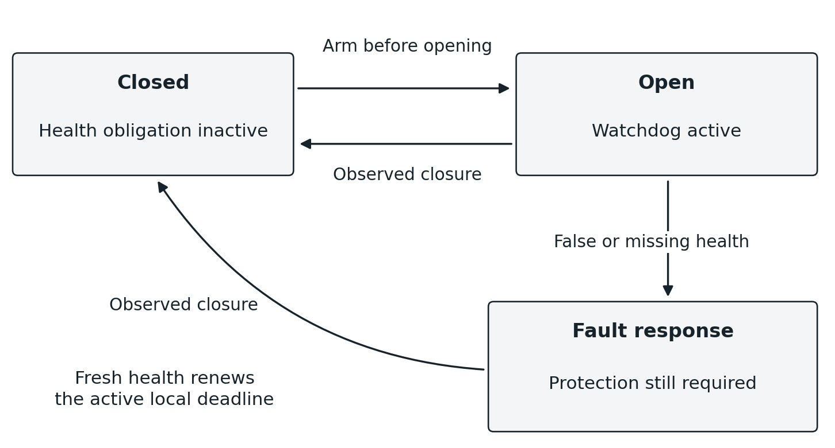
Figure 3. Conditional protection follows the observed open state. An outstanding close command does not establish closure. A fault response can continue driving closure while protection remains required.

Distributed fault behavior
A partition can prevent peers from hearing a fault immediately. Each protected node therefore needs the locally executable response declared for lost health. Timeout establishes that the required fresh evidence is unavailable; it is not a perfect proof that a remote node is dead. The distinction follows from the inability to separate arbitrary communication delay from failure without additional bounds [4]. The safety model must include detection and actuation latency; watchdog protection bounds the response to lost evidence rather than making remote failure instantaneous.
Safety obligations can outlive the traversal that opened the state. Program retirement must therefore retain or transfer the active protection binding until closure or an equivalent validated protection handoff. It must not free the watchdog merely because the last predicate traversal ended. How active protection is detached from a retiring program revision without retaining that entire revision is an explicit installation and lifetime obligation.

Installation replacement and enablement
A program replacement follows firmware-install reasoning: the old revision remains active until the new one is installed and compatibility is established. The delegate stages the new fragments in available fixed storage, obtains installation evidence from their required owners, and only then permits new activations to enter the new revision. Receipt of bytes alone is not proof of a valid installation.
Phase | Required behavior
Stage | Receive fragments without disturbing active bindings; validate identity, IR, references, capacity, and authorization.
Establish readiness | Verify that every required semantic fragment and any required protection mechanism can participate in the new revision.
Switch admission | At the program head, admit subsequent activations to the new revision once the installation condition is satisfied.
Drain old work | Previously admitted old traversals continue using compatible old fragments and their associated delivery state.
Release old bindings | Return each old fragment's storage to the fixed pool as soon as no admitted old work or retained safety obligation can use it.
A traversal must not evaluate half an old program and half a new one because nodes switched at different moments. Revision selection at admission and compatible references along the path provide the required model. This does not require every node to flip a global clock bit simultaneously. Consistent network-update research is relevant to staging and preserving one configuration per traversal, though its deployment model is not adopted wholesale [5].
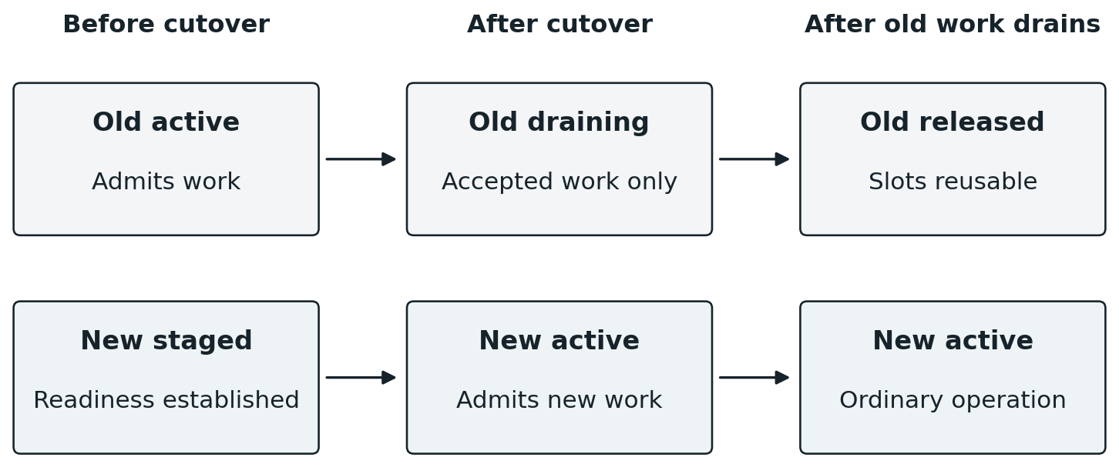
Figure 4. Hard admission cutover with independent draining. The new revision accepts new work while admitted old work finishes. Old storage is released promptly when its actual obligations end.
No historical copy is retained for sentiment or indefinite rollback. A failed staging attempt leaves the incumbent active. Once old work and required protection have cleared, its storage is reusable. Releasing a fixed slot is a lifetime operation; it does not require heap allocation or a general-purpose object reclamation framework.

What still needs a protocol
Head relocation, changes to the upstream dependency set, partitions during activation, and a crash between durable commit and admission cutover need explicit rules. A local head-pointer exchange is sufficient only when those surrounding preconditions have actually been established. Likewise, retirement requires evidence that no accepted old delivery can later reference a reused slot. A timeout alone is not proof of drain unless the protocol's delivery and identity bounds make it so.

Enablement is part of the graph
The graph should represent a program's enabled or disabled admission state at its head or incoming activation gate. The selected physical layout is still to be fixed, but it must avoid a separate global AutomationID-to-Enabled lookup on every traversal. A disabled program retains its relationships, definition, and place in admission consistency checking; disablement does not remove it from the mathematical system.
Disablement lasts until explicit resume. Resume changes the resident admission state and initiates ordinary evaluation of the currently applicable conditions. Manual mutation remains a direct authorized invocation; it does not imply a timed hold or an automatically inserted expected-starting-state guard. A later legitimate automation activation can change the peripheral again.
Initial enablement likewise admits one fresh evaluation before ordinary delta-driven operation. Repeated delivery of the same enable request must not manufacture additional enablement evaluations.
Reboot recovery temporarily uses fresh activations once the restored local state/time are available. Recovery at a dependency-bearing binding follows its ordinary upstream relationships; it cannot rely on the head also rebooting. The enabled head admits the resulting forward evaluation with current inputs, never by replaying an interrupted mutation. These independently originated recovery activations can produce repeated evaluations of the same program as its participants return. A single head does not deduplicate them, and ordinary delivery duplicate suppression does not merge them. Coordinated reconciliation after an outage remains deferred. This temporary policy does not establish once-per-program recovery across a network restart.
The ordering of an explicit disable or delete against an already admitted traversal needs a precise lifecycle contract. Ordinary state-change supersession is excluded regardless of that decision. No lifecycle operation can undo a mutation already registered with a driver, and disabling a program must not erase an active safety obligation while its protected state is still open.

Persistence reconstruction and recovery
Each node persists the local graph fragments and definitions needed to reconstruct its contribution, including enablement and any retained learning state for which it is responsible. The compiler peer may persist source definitions and installation metadata. Persistence does not require every node to store every program, and it does not imply a log of every mutation or observation.
A valid committed local image must be distinguishable from an interrupted write. The earlier committed-image approach remains a suitable local persistence mechanism; the exact storage format, flash wear policy, checksums, and commit procedure must match the target hardware.

Protected local configuration
A protected region of the MCU's writable nonvolatile memory is sufficient for local program definitions and commissioning data. An erase-aligned firmware-region limit separates replaceable code from retained configuration. Keep that limit in layout metadata or another durable location outside the ranges it protects from replacement; it need not be a filesystem or a separate storage device.
Every image writer must honor the boundary, including provisioning, staging and boot-time copy/swap. A boundary after today's binary is useful only if those erase and swap extents also stop there. Keep the established boundary across releases; a candidate that grows into retained data must be rejected or undergo an explicit layout migration. Do not move it merely by recalculating the new binary's end. This is ordinary region protection and does not imply high-frequency flash writes.

Boot reconstructs relationships
Boot establishes the local driver surface, reconstructs the graph through saved-reference traversal, binds old identities to new addresses, and resolves foreign peer bindings under the current incarnation rules. Execution must not dereference unbound locations. Persisted installation state determines which revision is eligible, while incomplete staging must not masquerade as a complete replacement.
Drivers obtain the current actual peripheral state. They do not recover an old desired state by replaying unfinished mutation requests. Newly observed state then participates in ordinary change propagation. A configured schedule may author recovery behavior for a missed activation, but that is evaluation of a valid current condition, not blind replay of an unconfirmed old command.

Recovery while protection may be required
If a peripheral can remain physically open while its controller reboots, boot must establish whether a safety obligation exists before allowing ordinary operation to proceed. The implementation must specify how the driver discovers that state and how the declared protective response operates while required dependencies are unavailable. This is a concrete hardware and driver obligation; a lost RAM watchdog cannot be assumed to imply a closed physical device.
Persisted evidence and its decay anchor form one recoverable unit. A completed checkpoint survives; an interrupted checkpoint falls back to the previous valid one. The system may lose evidence accumulated since that checkpoint. It must not combine an old statistic with an unrelated new decay anchor or claim that post-crash observations are known when they are not.
Distributed installation recovery must reconcile durable fragment readiness with admission state and old-work drainage. Local durable writes alone do not prove a globally complete installation. The necessary peer reconciliation belongs to the installation protocol, without requiring a replicated ledger of ordinary peripheral mutations.

Synthesis admission and continual refinement
Synthesis combines supplied constraints, driver invariants, transition models, and available levers to construct a candidate executable. Z3 remains the selected initial solver foundation. The compiler must reason over actual IR arithmetic and the supported execution semantics. A proof concerns the supplied models and assumptions; it is not a promise that an incomplete behavioral model describes every physical externality.
Admission rejects a candidate that is inconsistent with the declared system, including conflicting admitted programs that are currently disabled. A budget exhausted without a candidate or an infeasibility proof is unresolved synthesis, not evidence of impossibility. Candidate search, model validation, and admission are distinct outcomes. None authorizes the kernel to make up a runtime supersession policy.

Concurrency belongs in the model
Checking only that two desired final states can coexist is insufficient when their intermediate actions can interfere. The admission model must cover the allowed interleavings, command effects, and declared safety dependencies relevant to the emitted program. Where safety requires a condition to hold during an open interval, the execution needs the corresponding interlock or watchdog semantics. A prior predicate read is not evidence that a remote value remains unchanged indefinitely.

A hypothesis can improve
The initial selected program is a hypothesis. Observed outcomes and resource use update its evidence from the beginning of operation. During available compute capacity, the refinement service evaluates whether another admissible implementation is preferable. Evidence can change without replacing the executable. Acquisition, statistical modeling, synthesis, and installation may run on different boards or peers; using common evidence does not collapse them into a single loop or special tablet service.
Structural cost includes actual state/storage, deadline resources, external inputs, emitted computation, and realized invocation count; it must price the work the target performs. Invocation count is measured over a comparable workload, not merely the number of static command sites. Otherwise an arbitrarily long on/off period could look deceptively cheap while failing the desired behavior.
A later empirical cost estimates consumed resources and probability or consequence of resolution failure under the supplied objective. Replacement has a cost: remaining validation, durable writes, installation, retirement, and actual operational transition. Candidate discovery already completed is a sunk cost. Expected benefit and useful information must justify changing an admissible incumbent. Safe exploration may accept worse immediate efficiency when its expected future decision benefit warrants it; it never waives an invariant.

Bounded evidence and lazy decay
The statistical meaning of the evidence must remain explicit. A distribution of system state over time is accumulated from elapsed exposure to that state, not from the number of change messages. A conditional mutation frequency instead needs its declared opportunity or exposure denominator. These are different quantities even when they use the same attributes. Compact accumulators can support both without retaining every observation. Drivers expose the relevant typed learning surface, and inference consumers share those definitions rather than introducing separate tablet-specific and synthesis-specific meanings.
Retain sufficient statistics and model parameters rather than an indefinite history of samples. For an additive evidence accumulator H, lazy exponential aging has the form Hnew = rho × H + contribution, where rho = 2 raised to the power of negative elapsed interval divided by the chosen half-life. A baseline prior can remain separate. Aging occurs when the evidence is read or updated, not through a periodic task that visits every statistic.
Each independently aged group stores one last-aging reference beside its statistics. This is not a timestamp on every register or observation. In a distributed deployment, that reference uses the owning component's declared elapsed-time basis and epoch. Persisting it requires a defined recovery policy when the epoch changes; an unrelated peer's tick cannot simply be substituted. Exact statistical families, context selection, fixed-point implementation, and scalar cost exchange rates remain open.
Learning can improve conditional ordering, command parameters, reusable definitions, or proposed new programs when sufficient evidence exists. It cannot manufacture unobserved physical feedback. A model-derived emission estimate must remain distinguishable from an actual emission measurement. Likewise, correlation can support a hypothesis without establishing occupant intent or causation by itself.

Time resources and execution bounds
Change is the trigger for system work; a shared wall clock is not a prerequisite for propagation. Nodes still need physical oscillators for local execution, communication, elapsed intervals, retries, and watchdog deadlines. Those local measurements do not establish one globally simultaneous state of the network.
Every vertex kernel supplies the same local commissioned time and calculated solar capabilities. The program binds a time or solar predicate at the evaluation vertex where it belongs in the authored order; neither requires a special clock/solar vertex or a broadcast for every temporal boundary. Commissioning supplies a UTC reference and approximate location. Local elapsed counters and calculated boundaries drive deadline records; an expiry generates an internal delta at its predicate, which follows the normal upstream-to-head activation path. Forward traversal reads that predicate at its normal position. The kernel arms the next relevant deadline rather than repeatedly scanning every program or comparing the clock once per second.
Civil-time predicates such as 20:00–22:00 follow the installation's local civil time, including daylight-saving changes. Commissioning must therefore supply the timezone information needed to determine those changes, alongside UTC and location. UTC remains the common reference; a fixed offset alone does not implement this policy. Timezone interpretation and solar calculation belong to the kernel, not appliance adapters. A small recurring month/week/weekday rule pair allows each vertex to derive future seasonal transitions from the commissioned policy. Rules are policy, not geography: coordinates alone cannot supply civil timezone law. If that policy changes, commissioning updates it; no annual transition download is needed for an unchanged recurring rule.
A tablet or computer can supply the initial reference and rough coordinates. An outdoor observational vertex with GPS may later supply an accurate reference through the same ordinary peer mechanism. Neither GPS nor Wi-Fi is a required kernel interface, and the observation provider acquires no special network role.
Commissioned location/time configuration occupies rewritable reserved storage that survives firmware updates, separate from disposable transfer journals. Location can survive a restart; time validity also requires counter continuity. An unanchored peer cannot supply another peer's time reference.
Recurring actions arise from explicit changes or local deadline-generated deltas. Kernel time/solar inputs are distinct from a sensor's qualified physical observations. A saved timestamp cannot measure time spent without power: after loss of counter continuity, time must be reacquired from a suitable peer with a valid reference, a backed RTC or a commissioning client. There is no permanent time master or shared clock-consensus requirement. Local sequence numbers and counters still need bounded wrap and reuse rules.

Fixed capacity is part of correctness
Use fixed receive and transmit rings, fixed in-flight delivery slots, fixed installed-binding storage, bounded temporary operands, and the configured relay pool. Capacity accounting is local and concrete. This does not require a general dynamic cache or distributed object allocator.
The admission policy preserves accepted work. A receiver without free execution capacity returns Busy before accepting a visit; its sender retains that visit for retry. The bounded local-change buffer reports overflow when full rather than evicting earlier pending activations. This is distinct from the outward observation transport ring's existing hard eviction. Physical state changes can arrive faster than an overloaded link drains, so backpressure alone cannot make arbitrary arrival rates lossless.
This architecture treats separately registered changes as distinct activations. An implementation that coalesces them under pressure changes that semantic contract and needs explicit authorization in the protocol. Fixed memory is compatible with bounded delivery guarantees; it is not a proof of lossless delivery under unbounded load.

Processor and platform choices
Lattice extends the existing FreeRTOS-derived kernel. Its scheduler, CPU context switching, interrupt integration and synchronization are the foundation to reuse, not functions each appliance implementer must supply. The extensions must be as straightforward to bring up on another supported RTOS target as a small hardware adapter and ordinary initialization. Kernel or transport evolution must preserve that firmware-facing source interface. Independent binary replacement is deferred as described above; persisted graph references and appliance-image compatibility retain their separate requirements.
Local multiprocessing, threads, interrupt work, and cooperative tasks should be chosen where they simplify correctness or materially improve throughput. Serial evaluation of one path does not require a single-core machine, one global execution thread, or a new operating-system process for each chain. The earlier central-host processor choice does not dictate MCU selection for every peripheral node.
Hard real-time claims require a deployment profile: maximum local execution costs, interrupt interference, admitted activation rates, buffer capacities, link delay and loss bounds, retries, topology assumptions, and safe-state response bounds. Best-effort broadcast repair under arbitrary partition cannot provide a finite successful-delivery deadline. A protected node can still enforce a local deadline for its declared failure response.

Trust authorization and operational boundaries
Peer-to-peer operation removes the mandatory router, not the need to identify peers and protect mutation capabilities. A node must distinguish authorized installation, authorized direct mutation, ordinary graph traffic, and forged or stale messages. Binding identity is an address; possession of its numeric value alone must not be treated as permission to actuate a device.
The trust-root, enrollment, key storage, authenticated framing, replay bounds, and revocation mechanism remain implementation choices. Their memory and compute costs belong in the resource profile. A deployment without outside Internet access still needs an explicit trust model for connected peers and physical interfaces.
The delegate is authorized to install admitted graph fragments within its granted scope. A tablet or other interface may be granted direct access to selected mutation handles. A learner proposes definitions through the admission path. None acquires unrestricted authority merely because it is a large node or a convenient point of human interaction.
Diagnostics are ordinary exposed surfaces: current fault state, bounded delivery counters, binding capacity, active protection, and installation status. They should make the system inspectable without becoming a mandatory history service. Administrator notification is a directed capability and can be delivered to a tablet or another peer; the kernel is not coupled to one user interface.

Architectural integrity
Execution integrity requires that each accepted delivery addresses the intended binding incarnation, that an admitted traversal uses one compatible program revision, and that a false predicate cannot reach its success continuation. Transport integrity requires that duplicate handling preserve distinct changes, that accepted work has a defined completion or fault outcome, and that obsolete packets cannot act on a reused slot.
Safety integrity requires that every protected open state have the declared active protection, that lost freshness cause the specified local response within the deployment bound, and that closure or validated transfer be established before releasing that protection. Resource integrity requires that storage remain within configured bounds even under repeated loss, repeated discovery, revision replacement, and restart.
Progress claims must state their assumptions. Under the chosen connectivity, fairness, capacity, and fault bounds, accepted finite work should finish or report its defined failure rather than persist forever. No assumption of bounded packet lifetime, synchronized clocks, or reliable peers may be imported silently into a proof.

Research foundations and interpretation
The following research informs particular mechanisms and proof obligations. No cited paper establishes correctness of the combined Lattice protocol, selects its wire format, or requires importing a centralized controller or dynamic storage framework.
[1] E W Dijkstra and C S Scholten Termination detection for diffusing computations
Local accounting and returned signals can establish the termination of a finite distributed computation under a defined communication model. Relevant to completion and old-work drainage; not a delivery guarantee for arbitrary packet loss and reboot.
Primary source
[2] C Intanagonwiwat R Govindan and D Estrin Directed Diffusion 2000
A primary comparison for local gradients, data-oriented communication, and empirical reinforcement of useful paths. Lattice's typed binding references and program fragments remain its own execution model.
Primary source
[3] P Levis N Patel D Culler and S Shenker Trickle 2004
Demonstrates local suppression of redundant dissemination. Suppression does not establish execution completion, and adopting its ideas does not select every timing or forwarding rule for this kernel.
Primary source
[4] T D Chandra and S Toueg Unreliable Failure Detectors for Reliable Distributed Systems 1996
Provides the formal context for failure suspicion in asynchronous systems. A local watchdog enforces a freshness requirement and response deadline; it does not perfectly distinguish a failed peer from an arbitrarily delayed one.
Primary source
[5] M Reitblatt and colleagues Abstractions for Network Update 2012
A reference for staged replacement that preserves a coherent configuration for an individual traversal. Its controller architecture is not a prescription for Lattice's peer topology.
Primary source
[6] A D Birrell and B J Nelson Implementing Remote Procedure Calls 1984
Useful background for invocation identity, duplicate handling, and uncertain outcomes when a response is missing. Lattice does not thereby adopt a conventional RPC object or stub framework.
Primary source

