CS 255 System Design Document Template

UML Diagrams

UML Use Case Diagram
The following use case diagram illustrates the overall functionality of the DriverPass system and the interactions between its five actors: Customer, Secretary, Owner (Liam), IT Admin (Ian), and the DMV System (an external system). The diagram identifies 20 use cases organized into five functional groupings: account and authentication, appointment management, testing and progress tracking, administration, and DMV content synchronization. «Include» relationships show mandatory dependencies (e.g., Log In includes Authenticate User; Schedule Appointment includes Select Training Package), while «Extend» relationships model optional actions (e.g., Cancel Appointment and Modify Appointment extend Schedule Appointment).
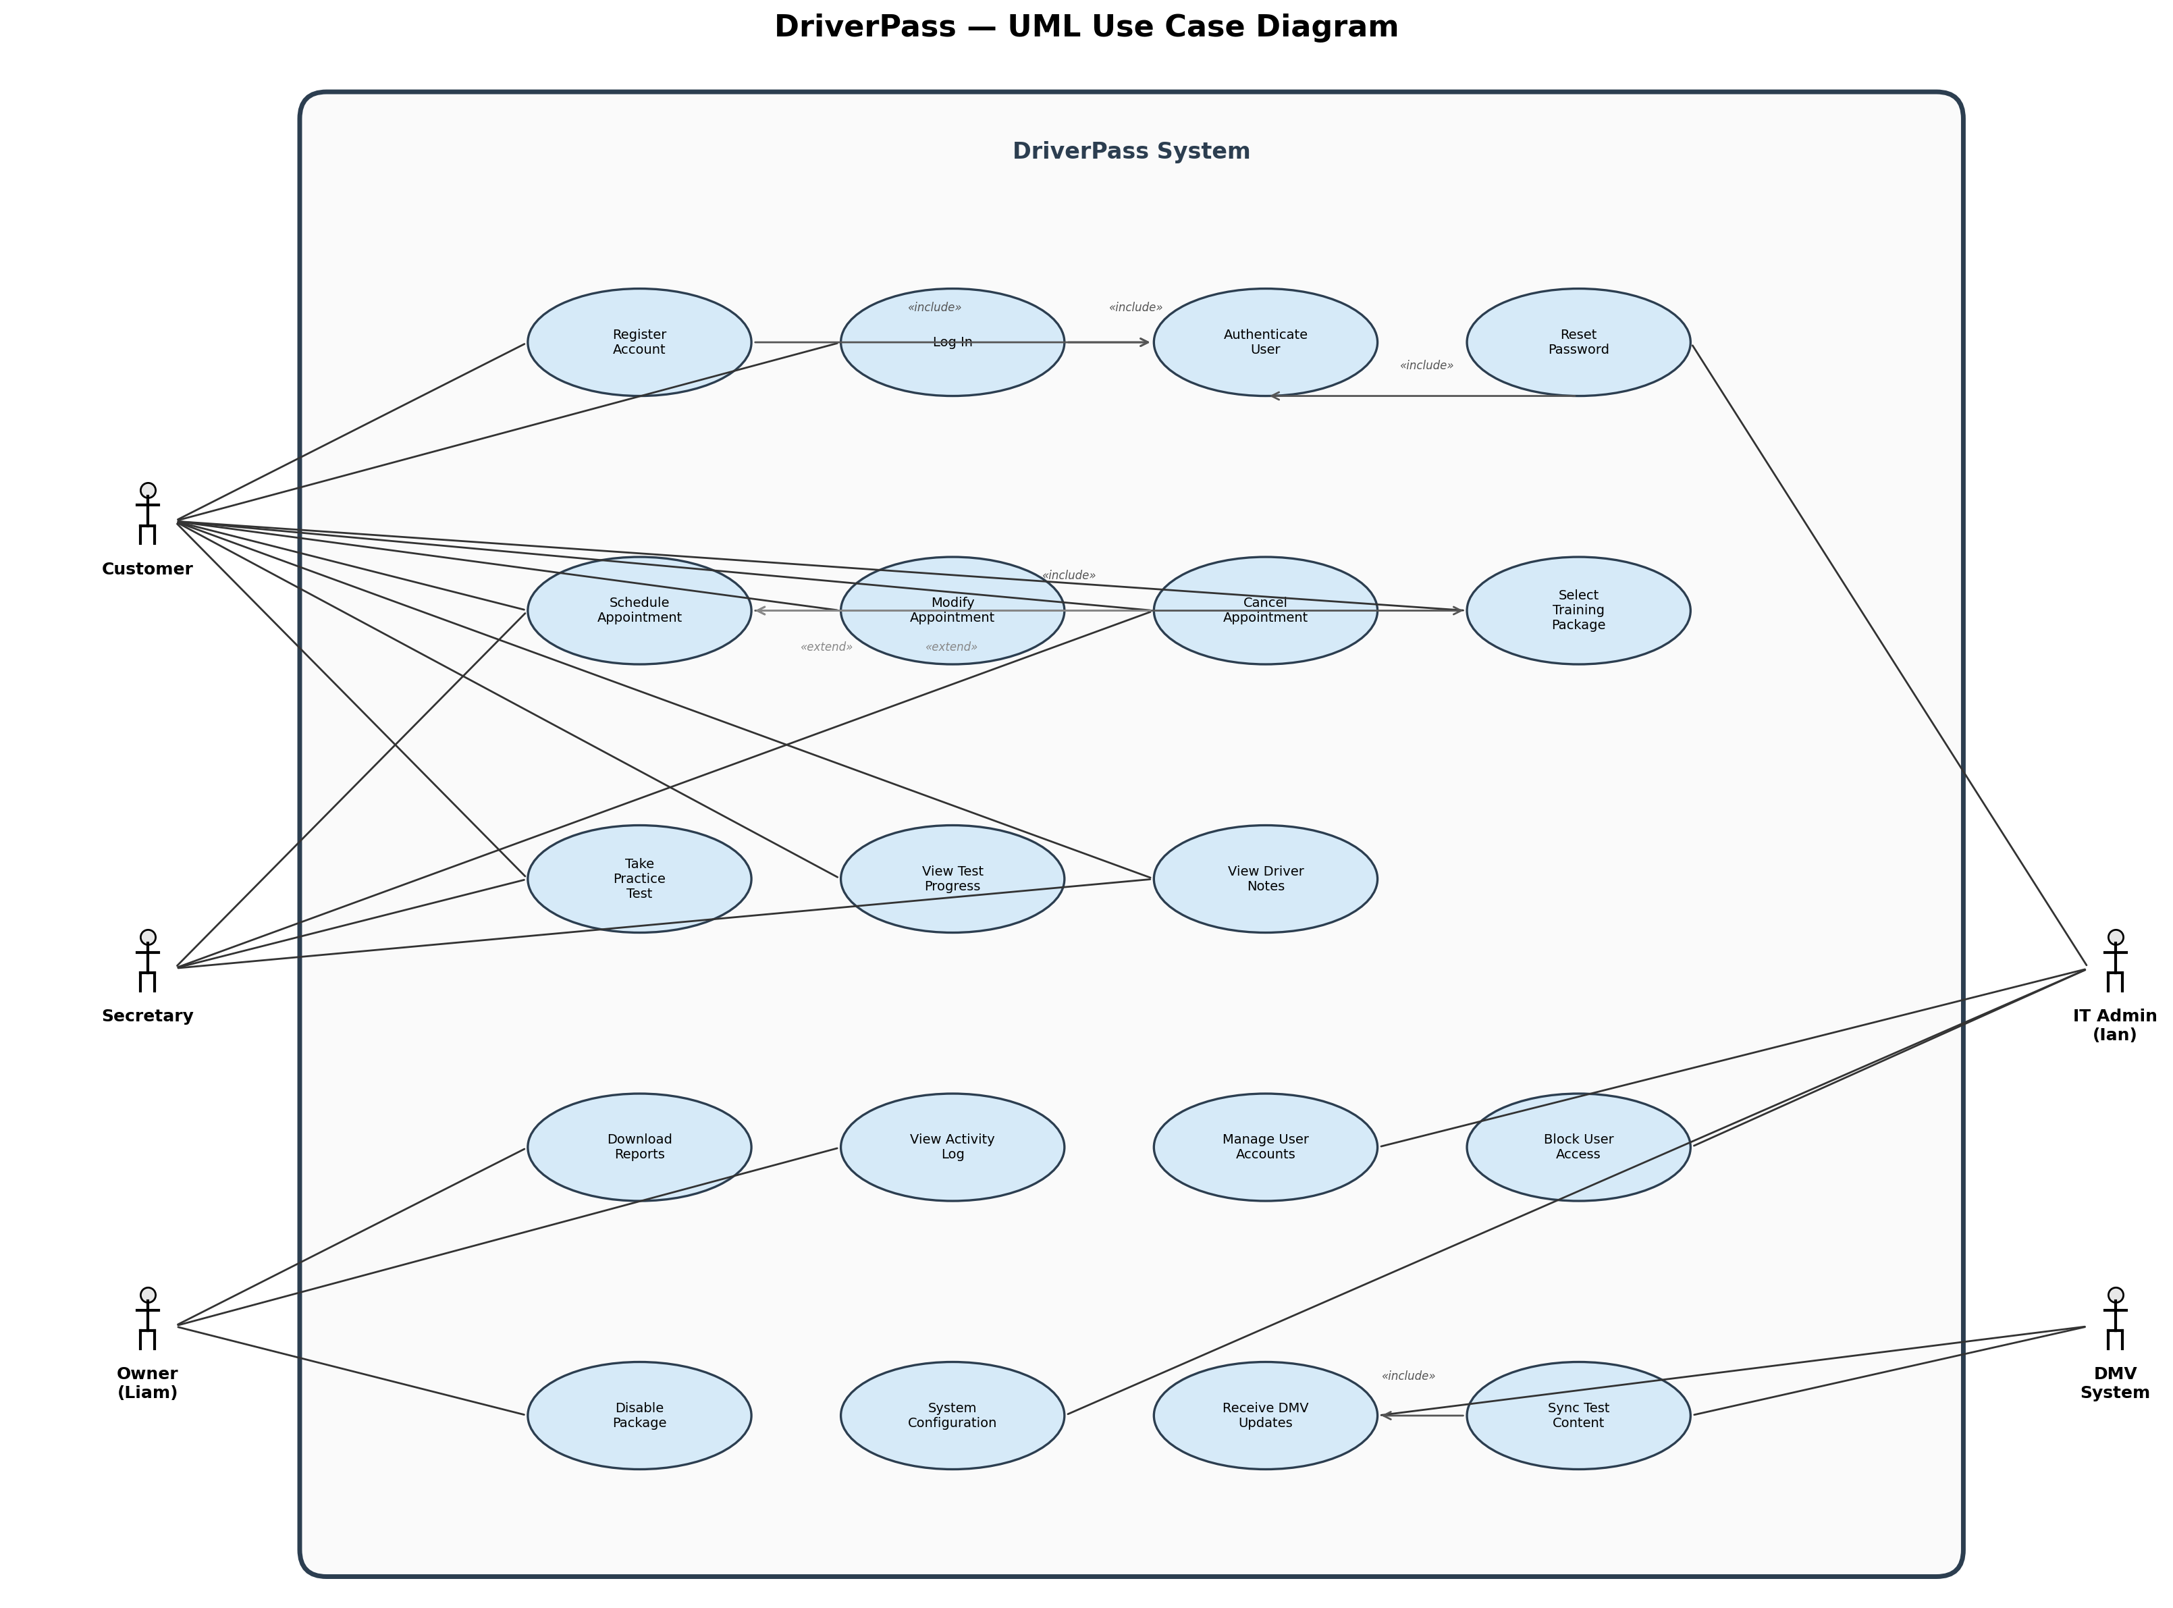

UML Activity Diagrams
Two activity diagrams were created to model the detailed workflows of key use cases. The first models the Schedule Appointment process, which handles both customer self-service online booking and secretary-assisted phone or in-person scheduling. The flow includes user authentication, package selection, driver and car availability checking, slot selection, booking confirmation, and audit trail logging. The second models the Take Practice Test process, covering the customer's interaction with the online practice test module from login through score calculation and progress tracking.
Activity Diagram 1: Schedule Appointment
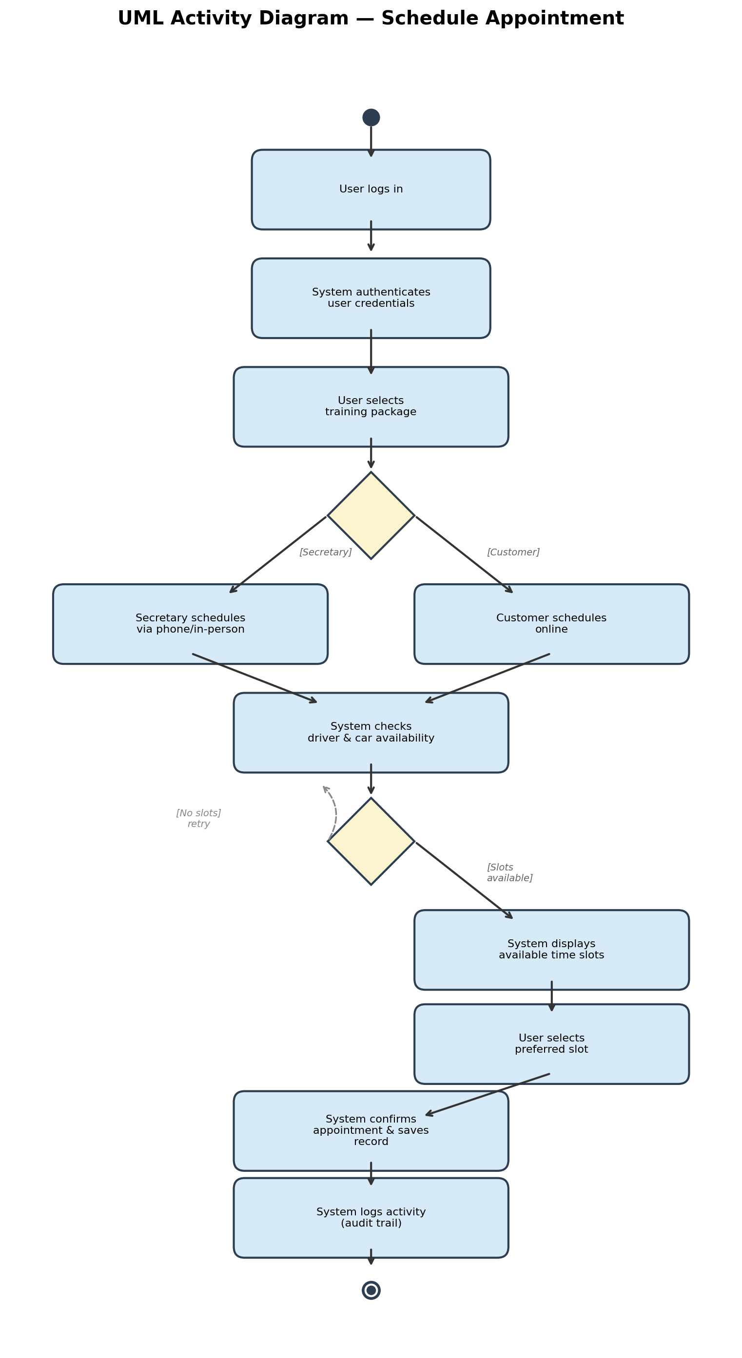
Activity Diagram 2: Take Practice Test
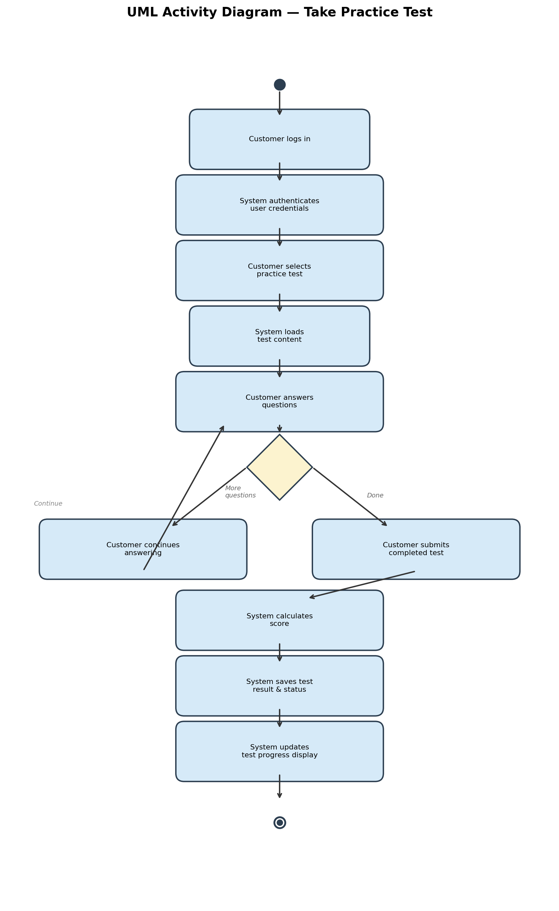

UML Sequence Diagram
The following sequence diagram models the Schedule Appointment use case, showing the interactions between four participants: the Customer, the Authentication Service, the Scheduling Service, and the Database. The diagram traces the message flow from initial login through credential verification, appointment scheduling, availability checking, booking confirmation, and audit trail logging. Solid arrows represent synchronous method calls, while dashed arrows represent return messages. Activation bars on each lifeline indicate when a participant is actively processing a request.
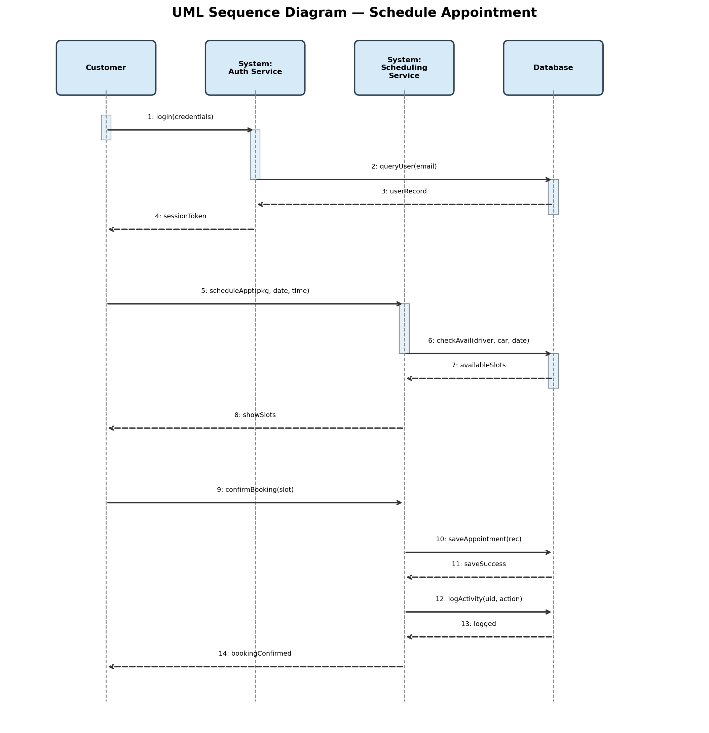

UML Class Diagram
The following class diagram models the static structure of the DriverPass system, showing the key classes, their attributes, and the relationships between them. The User class serves as the base class with common attributes (userID, firstName, lastName, email, phone, address, role, passwordHash). Customer and Secretary inherit from User, adding role-specific attributes. The Appointment class links customers to drivers, cars, and time slots with a status field tracking the booking state. The TrainingPackage class represents the three package tiers (6-hour, 8-hour + in-person lesson, and 12-hour + in-person lesson + online access). The PracticeTest class tracks test names, scores, and status (not taken, in progress, failed, passed). The ActivityLog class supports the audit trail requirement by recording every user action with a timestamp. Inheritance is shown with hollow triangle arrows, and associations are labeled with multiplicities (1, 0..*, 1..*).
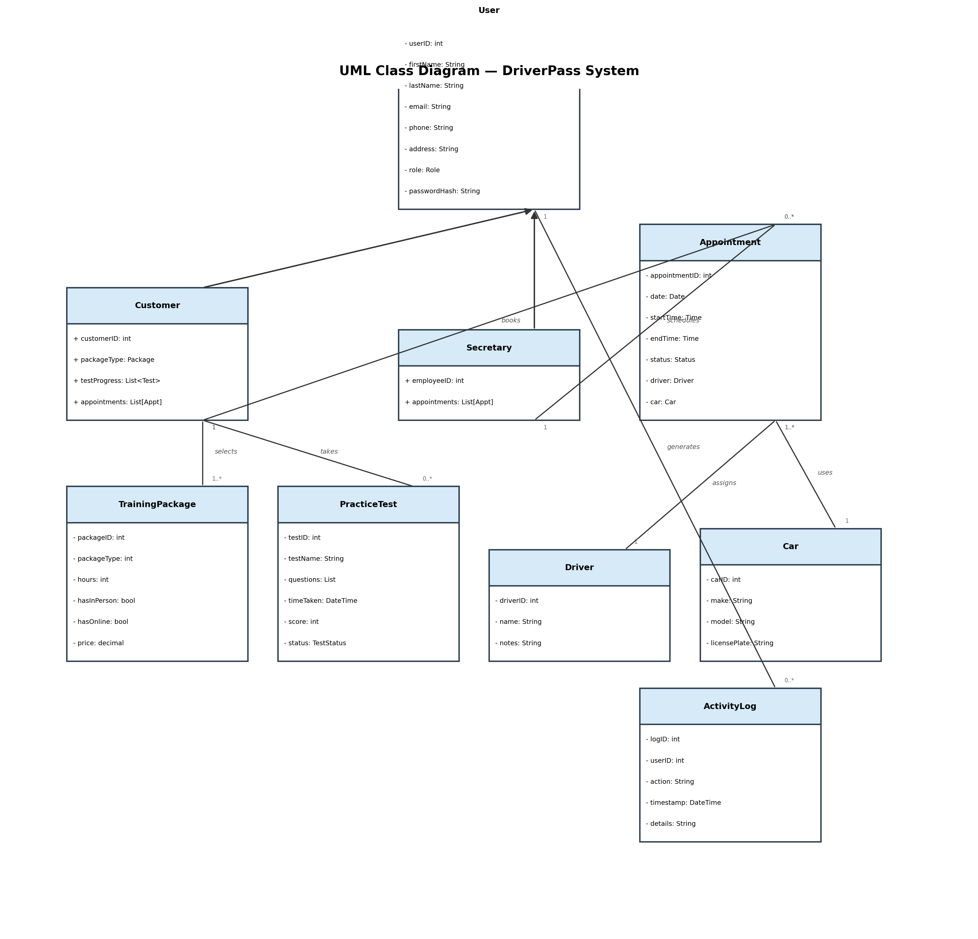

Technical Requirements
Based on the UML diagrams above, the following technical requirements describe the hardware, software, tools, and infrastructure necessary to implement the DriverPass system.
Hardware Requirements
• Web Server: A dedicated web server (or cloud-hosted virtual machine) with minimum 4 CPU cores, 16 GB RAM, and 500 GB SSD storage to host the DriverPass application and handle concurrent user sessions.
• Database Server: A dedicated database server with 8 CPU cores, 32 GB RAM, and 1 TB SSD storage to manage user accounts, appointment records, test data, and activity logs. The database must support automated daily backups with at least 30-day retention.
• Client Devices: The system must be accessible from any modern web browser on desktop computers, laptops, tablets, and mobile phones, meeting Liam's requirement for access from any computer or mobile device.
• Network Infrastructure: A reliable internet connection with sufficient bandwidth to support concurrent users accessing online practice tests and scheduling. A firewall and load balancer are recommended for production deployments.
Software Requirements
• Operating System: Linux (Ubuntu 22.04 LTS or equivalent) for server-side components, providing stability and security for the production environment.
• Database Management System: A relational database such as PostgreSQL 14+ or MySQL 8+ to store structured data including user profiles, appointments, training packages, test results, and activity logs. A relational database enforces data integrity and supports complex queries for activity reporting.
• Web Application Framework: A modern server-side framework (e.g., Django, Ruby on Rails, or ASP.NET Core) to implement the business logic layer, including role-based access control, scheduling algorithms, and DMV content synchronization.
• Frontend Framework: A responsive JavaScript framework (e.g., React, Vue.js, or Angular) to provide a cross-platform user interface that adapts to desktop and mobile devices, meeting Liam's requirement for access from any device.
• Authentication and Authorization: An identity management system or library (e.g., OAuth 2.0, JWT-based session management) to implement the four-tier role-based access control: Owner (full access), IT Admin (account and system management), Secretary (scheduling only), and Customer (self-service for their own account).
Tools and Technologies
• Lucidchart: Used for creating and maintaining all UML diagrams (use case, activity, sequence, and class diagrams) as part of the system design documentation.
• Version Control: Git (hosted on GitHub or GitLab) for source code management, enabling the development team to track changes, collaborate, and maintain an audit trail of code modifications.
• CI/CD Pipeline: A continuous integration and continuous deployment tool (e.g., GitHub Actions or Jenkins) to automate testing and deployment, ensuring code quality and reducing manual errors during releases.
• API Integration Layer: A RESTful API or webhook-based integration to receive DMV content updates when driving rules, policies, or sample test questions change. This integration must validate incoming content and synchronize it with the practice test database automatically.
• Monitoring and Logging: Application monitoring tools (e.g., Sentry, Datadog) and structured logging to support the activity logging requirement, enabling Liam to track who made, modified, or canceled reservations and generate activity reports.
Infrastructure Requirements
• Cloud Hosting: A cloud infrastructure provider (e.g., AWS, Google Cloud, or Azure) to host the application and database servers, providing scalability, redundancy, and geographic availability. Cloud hosting also supports the offline-access requirement by enabling data download for local work in tools like Excel.
• SSL/TLS Encryption: All data transmitted between clients and the server must be encrypted using HTTPS/TLS to protect user credentials, personal information, and scheduling data.
• Automated Backups: Daily automated database backups with a retention policy of at least 30 days, ensuring data can be recovered in the event of system failure or data corruption.
• Disaster Recovery: A documented disaster recovery plan with a defined Recovery Time Objective (RTO) of 4 hours and Recovery Point Objective (RPO) of 24 hours, ensuring business continuity.
• Scalability: The infrastructure must support horizontal scaling to accommodate growth in the user base, particularly during peak DMV test preparation seasons.
Security Requirements
• Role-Based Access Control (RBAC): The system must enforce four distinct permission levels — Owner, IT Admin, Secretary, and Customer — with each role seeing only the data and actions appropriate to their level. Authorization must be validated on every request, not just at login.
• Password Management: Passwords must be stored using bcrypt or Argon2 hashing with salt. The IT Admin (Ian) must have the ability to reset passwords and block user access when employees are terminated, as specified in the interview.
• Audit Trail: Every user action (appointment creation, modification, cancellation, test submission) must be logged with the user ID, action type, timestamp, and affected record. Liam must be able to download and print activity reports to determine who is responsible for any changes.
• Data Privacy: Personal information (names, addresses, phone numbers) must be handled in compliance with applicable data protection regulations, with access restricted to authorized roles only.

