Zachary Beisler

Social Demography (SOC 423)

Dr. Kevin Thomas

4 May, 2020

**A Partial Differential Equation Model for Population Center Formation**

**Abstract**

This paper proposes a new approach to modelling population center formation through the use of a partial differential equation. It examines the lack of prevalence of differential methods within demography and comments on the causes of that. This paper conjectures possible benefits of having accurate population center formation models as well as which individuals may find them the most useful. Lastly, it simulates a possible scenario using the PDE model and acknowledges its shortcomings and room for future research.

**Differential Equations in Demography**

Differential equations and similar modelling techniques have seen wide use throughout the sciences, featuring prominently in biology, ecology, physics, and chemistry. Within the realms of biology and ecology in particular, differential equations are often used to model the population dynamics of animal and plant species within an ecosystem. With the apparent success of differential models in population modelling within the natural sciences, the logical next step would be to apply the same tools at an attempt to model human behavior.

In 1798 Thomas Malthus anonymously published his Essay on the Principle of Population, in which he postulated a crude mathematical model for describing the relative rates of change in human population and food supply. In his work he described population as growing “geometrically”, while he theorized that food supply must grow “arithmetically” (Malthus, 2009). These scenarios both lend themselves to be characterized in the language of differential equations, and a simple mathematical translation follows:

$$\frac{dP}{dt}=kP, \frac{dF}{dt}=r$$

Malthus did not write down these equations explicitly, however his analysis was born from a mindset of framing population-based questions in a differential form.

Upon solving the two simple equations above one finds solutions that are coherent with Malthus’ central arguments: that unchecked fertility rates lead to exponential growth while food supply was constrained to fall on a line. Simple asymptotic calculations show that any quantity growing exponentially outpaces linear growth on rather short time scales.

Why then, in the modern era, are differential equations not widely utilized to study questions in demography? In the aptly named paper “Does Demography Need Differential Equations?”, Thomas K. Burch explores why differential equations do not find much use in contemporary demography. He places forward a few possible answers to his guiding question, however in my opinion Burch’s fourth answer summarizes best the relationship between demographers and differential methods:

Differential equations are more a theoretical than an empirical tool, and demographers have never given high priority to theory, as opposed to data and techniques (Burch, 2017).

As seen with Malthus, any differential model must be built upon assumptions about the underlying dynamics of the system in question. In Malthus’s case his guiding assumptions were the “geometric” and “arithmetic” growth rates which turned out to be largely false: we live in a world today where food supply has exploded enormously and even outpaced population growth in some regions. This reliance on assumptions and lack of empirical data seem to drive demographers away from utilizing differential equations in their work.

Not all demographers have shied away from utilizing theoretical methods, however. Burch focuses on the predator-prey equation (also called the Lotka-Volterra equation), developed by A. J. Lotka whom Burch notes as “one of the founders of modern demography” (Burch, 2017). Lotka is described as being “a theorist at heart” (Burch 2017), which might have played a role in his efficacy as a demographic researcher. The main conclusion reached by Burch in “Does Demography Need Differential Equations?” is a clear yes, although he points to some common issues when dealing with differential models. Burch stresses that differential equations are NOT a replacement for empirical and statistical techniques, and that demographers should leverage both theoretical models as well as empirical studies to better describe human population dynamics.

**Population Center Formation**

The presence of population centers (cities or urban areas) is ubiquitous among almost every country in the world. Social demographic studies tend to focus on city population composition, natural demographic change, and how policy can affect positive changes to urban populations. A less studied question surrounding population centers is the dynamics of how and why they might form in the first place. A mathematical economics paper, Henderson and Venables’ “The Dynamics of City Formation”, defines and studies an economic model of city formation and growth.

In Henderson and Venables’ paper they frame city formation as an optimization problem – given a rising urban population what is the socially optimal way to annex and grow more cities to support it (Henderson and Venables, 2008)? They found that cities grow sequentially up to optimal sizes as rent markets fluctuate to account for growth. They utilized a dynamic model (not too different from a differential approach) to prove these results theoretically and found empirical support for their claims in previously published surveys that looked at urban population growth data from around the world.

“The Dynamics of City Formation” is an extremely useful tool for economic policy creation, and its authors even provide optimal policies to encourage the optimal sequential growth they describe. However, their work is built on the assumption of the existence of a growing urban population and lacks detailed spatial considerations beyond simple utility-based travel costs. The model presented in this paper hopes to give one possible reason for urban populations to exist in the first place, as well as describe a simple differential equation that yields this behavior.

**Implications**

The “holy grail” of population center formation modelling is to have the ability to take a predefined geographic region (like the United States), a chart of its resources, and the initial distribution of population density together and be able to predict with accuracy the locations and sizes of population centers at future times. In order for a tool like this to be made available, the rules by which populations spread and form cities need to be investigated at all levels of detail and at varying time scales. A model that can make such predictions is not likely to be in the form of a simple PDE – populations are too complicated for that. However, by looking into simplified models, the hope is that insight into the rules of population center formation can be teased apart and support further research down the line.

Such a prediction tool would also prove wildly useful in city planning. Being able to test out ideas for a city plan and seeing what may happen to those plans over time will give planners much more room for experimentation, as the people they are experimenting on will be virtual. Engineers and the like make extensive use of design programs that, for example, can tell them if buildings will stand up to stresses. Having a robust tool like this for city planning and demographic purposes can afford its users the same creative reign that engineers enjoy.

With a better understanding of how cities form, policy makers and demographers would also gain knowledge on what factors can make cities prosper or die off. Armed with this information, policy makers can enact changes to prevent city necrosis (which can cause widespread social and economic damage) and to encourage the formation of population centers likely to succeed.

**Modelling Assumptions**

As with all theoretical models, the model developed for this paper rests on a set of key assumptions that not only allow the math to work out but also provide the basis for city formation. In this section we will enumerate the assumptions and defend why they are warranted for modelling.

1. Homogeneity of the Modelled Region: This assumption guarantees that the modelled region is perfectly homogeneous; that is that the region of interest has no geographic features that make any part of it better for settlement than any other part. This assumption is largely not empirical: heuristically cities tend to form near bodies of water for trade or in areas of high resource density. This particular model can take into account resource distributions, but for the sake of simplicity geographic features are not included.
2. Isolation of the Modelled Region: This assumption provides the model with a set of what are called boundary conditions. In the isolated case, the boundary conditions stipulate that no migration occurs across the modelled region’s boundaries (also known as Neumann-type boundary conditions). More complex migration conditions at the boundaries can be imposed, however those are out of the scope of this paper.
3. Migration is Dominated by Economic Gain: This model only treats the case where migration is solely a function of economic opportunity gradients within the region. In other words, the populations in the region shift towards areas of higher economic opportunity and do not migrate for any other reason. This assumption is also not entirely realistic as individuals have been shown to migrate for a multitude of reasons, only one of which is economic gain. By only factoring in economic opportunity, this model hopes to provide a basis for how city formation can happen without outside influences.
4. Locality of Information: Differential equations typically only describe local processes: for example, the heat equation can describe heat flow over an arbitrary domain but heat flow only depends on molecules “knowing about” (bumping into) neighboring molecules. In today’s world, I could live in Washington D.C. and easily access information about economic opportunity in San Francisco. If I deem that the latter provides me with marginal gain over the former, I can also migrate directly to San Francisco without smoothly moving across the whole of the United States. This kind of migratory behavior is not well handled by differential equations in which only local information is available at each point. Models such as Henderson and Venables’ (discussed the previous section) do not have locality restrictions and can easily model situations like described above.

**The PDE Model**

The underlying principle that the derivation for the PDE begins with what I will refer to as the “Law of Conservation of Population”. It posits that population can only change in a region by three mechanisms: birth, death, and migration across a region’s boundaries. Written in an equation form:

$$Total Population Change=\left(Birth Rate-Death Rate\right)×Population+Migration$$

From first principles, this makes complete sense as a law. It closes mirrors similarly named physical laws, such as the Law of Conservation of Energy.

To translate this into mathematical symbols that can be manipulated, we will first have to define some quantities. Let $u(x,t)$ be the population density at an $n$-dimensional point $x$ and specific time $t$, and let $Ω$ be an arbitrary region over the modelled domain ( $∂Ω$ will refer to its boundary, oriented outwards as is convention). We also must invoke Assumption 3 and allow migration to be proportional to the gradient of an economic opportunity function which we will call $ϵ(u, x,t)$. Our word equation from before can now be expressed in concrete mathematical terms by:

$$\frac{∂}{∂t}\int_{Ω}{u\left(x,t\right)dx}=\int_{Ω}{\left(α\left(u,x,t\right)-β\left(u,x,t\right)\right)u\left(x,t\right)dx}-\int_{∂Ω}{σ\left(u,x,t\right)∇ϵ(u,x,t)}ds$$

Where $α(u,x,t)$ is the birth rate, $β(u,x,t)$ is the death rate, and $σ(u,x,t)$ is a so-called migration rate that can control how “willing” the population is to migrate at each point. If we assume stationary birth rates, death rates, and migration rates (i.e. that none of these quantities change meaningfully with time), then those factors lose their dependence on $t$. The migration term becomes negative because the boundary of $Ω$ is oriented outwards, meaning that positive quantities indicate outward migration which in turn lowers population.

After some manipulation (the details of which can be found in the Appendix), the integral equation can be expressed in the following differential form with added boundary conditions and initial condition:

$$\frac{∂u}{∂t}=\left(α-β\right)u-∇⋅\left(σ∇ϵ\right), x∈R$$

$$\frac{∂u}{∂x}=0, x∈∂R \text{and} u\left(x, 0\right)=f(x)$$

In general, because $ϵ$ most likely depends non-linearly on $u$, this equation is a non-linear PDE and as such may not have readily available analytic solutions. The paper will cover some simulation work used to see general characteristics of solutions when the equation is nonlinear.

**Numerical Simulation**

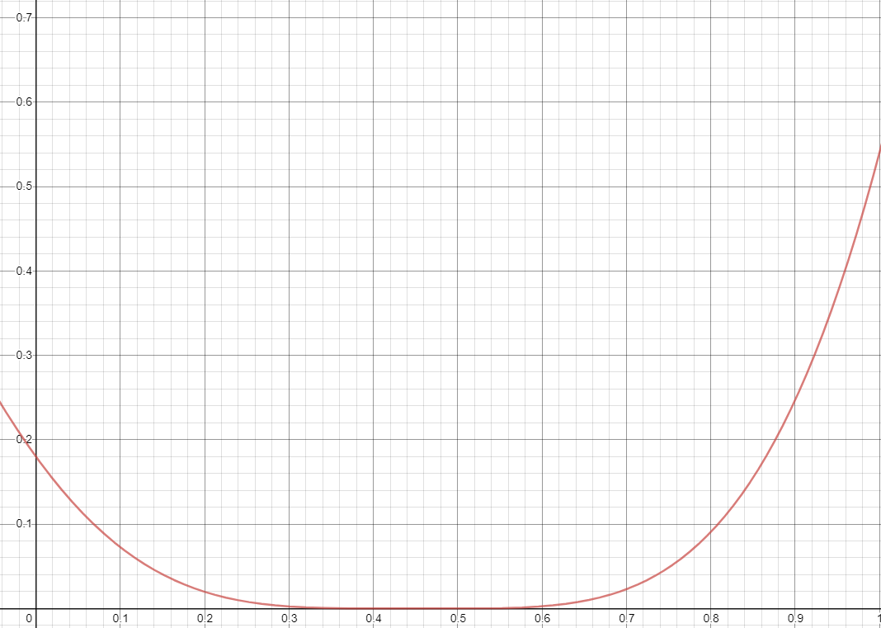Simulations of the dynamics prescribed by the PDE with specific parameters were run to explore possible scenarios in which cities may form. Through tinkering with the parameters, I found that holding death rate and birth rate constant with a slightly larger birth rate yielded the best control over population growth in the simulation. Migration rate was also held constant at a value much smaller than both death and birth rate. The economic opportunity function I found most effective in showing city growth is shown in graphical form below:

Where the horizontal axis measures population density and the vertical axis measures “economic opportunity”. It is important to note the scale: for numerical stability purposes all of the quantities (population density and economic attainment) were scaled to fall between zero and one. This prevents anomalies caused by certain numbers becoming too big or too small to be held in computer memory.

The economic opportunity function above is actually given by a seventh degree polynomial (the full form of which can be found in the Appendix). One way of rationalizing why economic attainment would take such a form is to think of the availability and efficiency of jobs as it pertains to population density. Areas of low density may have moderate economic opportunity due to the abundance of unoccupied land for development. As population density reaches middling values, we might expect economic opportunity to reach a minimum as there are enough people to occupy the land but not enough to work in large structured organizations (factories, companies, etc.). As population density reaches urban levels, there higher industry options open up and more jobs are available.

Below is an interesting simulation run, starting with a random perlin noise initial condition. In these simulations, the specific values of $t$ are not important. However, using current United States birth rates (Macrotrends, 2020) we can estimate that $t$ is measured in half years. Setting the migration rate high, however, essentially has the effect of speeding up the simulation so it may appear that cities are forming much faster than they do in the physical world.

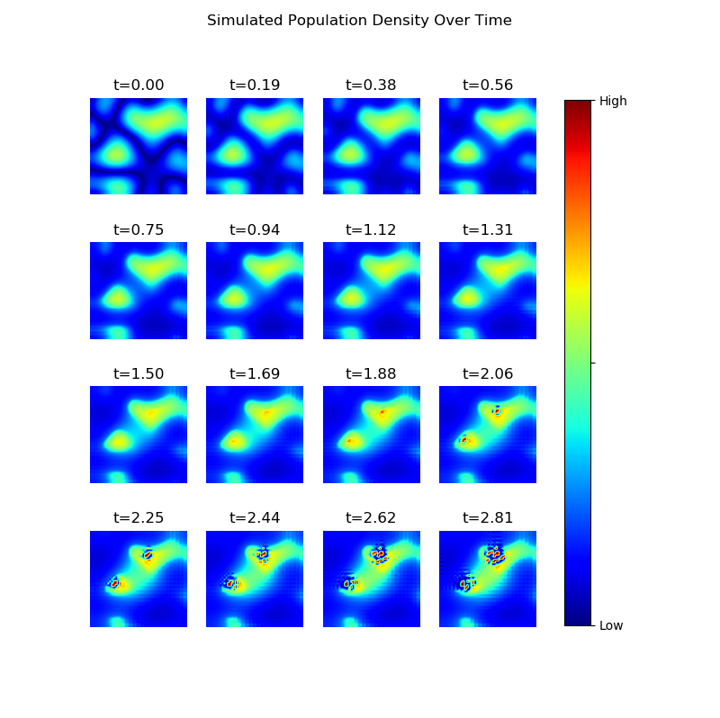The code used to generate this simulation is available upon request.

**Limitations**

One large criticism that could be leveled at this kind of experimental parameter tuning is that it is inherently non-empirical – there is no data to suggest that these choices of parameters are at all faithful to real-world scenarios which are ultimately what demographers hope to explain. To combat this, the model is left as general as possible so that it may be tuned to cover as many situations as possible. The particular parameters used in the simulations shown here do not matter much for this paper’s goals: to show that a differential model can give rise to city formation-like dynamics.

Due to how the migration term appears in the equation, after enough time has elapsed all of the modelled region’s population density will tend to concentrate into singularity-like population centers. This is clearly not what happens in our world, and is entirely non-physical because no point in space can have infinitely high population density. Therefore, this model cannot be considered a good long-term approximator of population dynamics. Instead this equation may have the ability to model the early and formational dynamics before large cities are common. A more constrained and economic model, such as Henderson and Venables’, should be used in regimes where this model’s predictions break down.

**Conclusions**

* Differential equations are a valuable tool for modelling changing dynamics like that of populations. An increase in their use for demographic modelling can provide many benefits to a theoretical foundation for the field. However, empirical studies and statistical techniques should not be replaced with theory-based models.
* Effective economic models exist for studying how population centers form and grow, however they lack explanatory power in a regime without pre-existing city structure and rent markets.
* Simple population PDEs provide the necessary set of rules to exhibit city formation-like behavior. They also have enough parameters to allow, with some tuning, the modelling of real world scenarios.
* Access to an accurate prediction tool for the formation of cities can allow demographers, city planners, and policy makers to increase the chances of cities being successful. It can also help the creation of preventative measures to avoid the heavily social and economic toll that dying cities create.
* The understanding of how populations behave in the context of a growing city, beyond just economics, can help to lay practical foundation for future work on the topic. This foundation can also be built upon and used by demographers studying different but related areas in the subject.

**References**

Burch, Thomas K. “Does Demography Need Differential Equations?” Demographic Research Monographs Model-Based Demography, 2017, pp. 79–94., doi:10.1007/978-3-319-65433-1_5.

Henderson, J. Vernon, and Anthony Venables. “The Dynamics of City Formation.” 2008, doi:10.3386/w13769.

Malthus, T. R. An Essay on the Principle of Population: an Essay on the Principle of Population, as It Affects the Future Improvement of Society with Remarks on the Speculations of Mr. Godwin, M. Condorcet, and Other Writers. Atlantic Publishers &amp; Distributors, 2009.

“U.S. Birth Rate 1950-2020.” MacroTrends, www.macrotrends.net/countries/USA/united-states/birth-rate.

**Appendix**

1. The derivation from integral equation to differential equation is as follows:

$$\frac{∂}{∂t}\int_{Ω}{u\left(x,t\right)dx}=\int_{Ω}{\left(α\left(u,x,t\right)-β\left(u,x,t\right)\right)u\left(x,t\right)dx}-\int_{∂Ω}{σ\left(u,x,t\right)∇ϵ(u,x,t)}ds$$

Under the condition that $u(x,t)$ is “nice enough” (not discussed here), we can interchange the partial derivative with the integral.

$$\int_{Ω}{\frac{∂u}{∂t}\left(x,t\right)dx}=\int_{Ω}{\left(α\left(u,x,t\right)-β\left(u,x,t\right)\right)u\left(x,t\right)dx}-\int_{∂Ω}{σ\left(u,x,t\right)∇ϵ(u,x,t)}ds$$

We can now apply the divergence theorem to the migration term and group the resulting integrals.

$$\int_{Ω}{\frac{∂u}{∂t}\left(x,t\right)-\left(α\left(u,x,t\right)-β\left(u,x,t\right)\right)u\left(x,t\right)+∇⋅\left(σ\left(u,x,t\right)∇ϵ\left(u,x,t\right)\right) dx}=0$$

Under the condition that the integrand is continuous (it should be due to physical reasons) and due to the fact that the region $Ω$ is arbitrary, we can conclude that the integrand itself must equal zero.

$$\frac{∂u}{∂t}\left(x,t\right)=\left(α\left(u,x,t\right)-β\left(u,x,t\right)\right)u\left(x,t\right)-∇⋅\left(σ\left(u,x,t\right)∇ϵ\left(u,x,t\right)\right) ∎$$

1. The exact 7th order polynomial used for economic opportunity in the simulations is given by:

$$ϵ\left(u\right)=u^{7}-7.3u^{6}+17.11u^{5}-13.315u^{4}+1.18u^{3}+3.065u^{2}-1.38u+0.18$$