Zach Bitseff

CPW 212 Winter 2019

Team Project

Bingo Calling App

Background: I attended Bingo night at my oldest son’s school and noticed that the method they were using to call and track numbers was very manual and prone to human error. After each number was called they had to manually click the number on their excel sheet to change its color. After the game was over each button had to be clicked to be cleared out. The colors of the clicked squares were all the same, so it was impossible to know what the last number called was by looking. It also might have been the announcer’s preference, but they only played traditional Bingo. Below is a picture of their interface/Excel sheet.

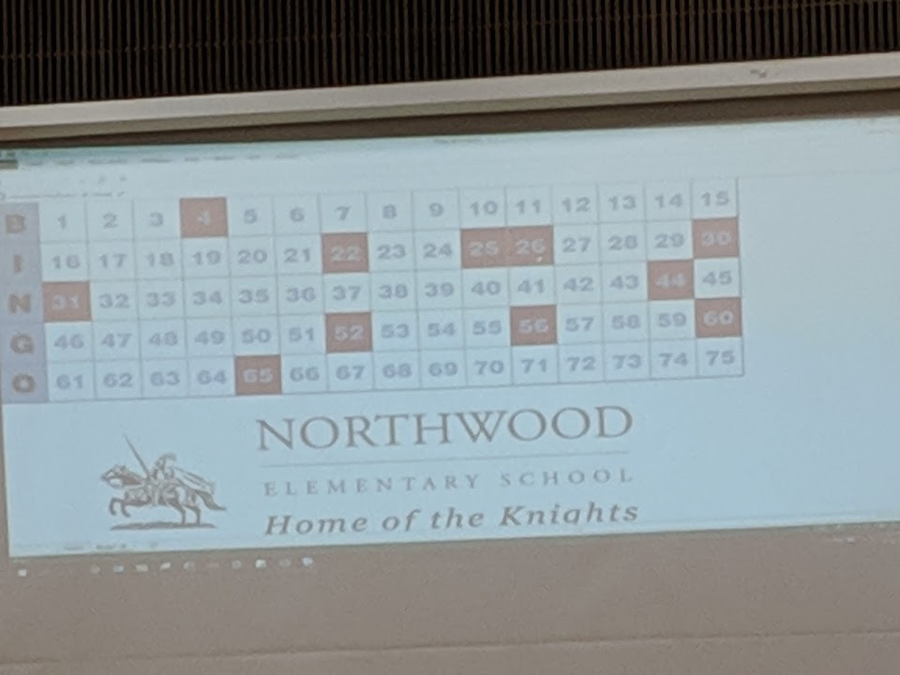

Initial planning/committed:

* Keep the interface very similar, including the school info, but adding an area to show the past 5 numbers.
* Automate number calling by including a “call button”
* Click of “call button” creates separate popup window to display number large before main window is updated.
* Modify colors so that last number called has Red background, 2nd to last number is yellow, all other called numbers are green.
* Include functionality to enable manual click/updates.
* Add “New Game” button

Backlog issues:

* Include game mode functionality – X, diagonal, blackout, four corners, diamond, square, N (for Northwood) , K (for Knights), Small square, Large square.
* Area for pattern image

Time tracking:

2 hours auditing/inspecting current use.

1 hour researching bingo patterns, and obtaining images.

1 hour creating issues for functionality