**Dynamic Routing in a Sensor Network with Emphasis on Energy Conservation**

Zach Cooper (CSE undergraduate University of Nevada, Reno)

Roniel Padua (CSE undergraduate University of Nevada, Reno)

Austin Ogilvie (CSE undergraduate University of Nevada, Reno)

***Abstract:****Wireless sensor networks (WSNs) are a technology with the a wide variety of potential applications. They rely on spontaneous formation of networks so that sensor data can be transported in a wireless manner. WSN’s are built from various nodes where each of those nodes has a sensor that has limited power. Dynamic routing is a network technique which allows the router to select paths based upon the current conditions of the network. In this way, the data is not being transmitted via a fixed path and allows much more malleability for the path of data packets. The two most popular dynamic routing protocols are the Routing Information Protocol (RIP) and the Open Shortest-Path First protocol (OSPF). By using dynamic routing in a WSN, the longevity of the WSN can most certainly be increased assuming the sensors lose some of their finite power every time a packet is transmitted.*

***Keywords –*** *WSN, RIP, OSPF*

**I. Introduction**

The team’s goal for this project was to develop a routing protocol with an emphasis on energy conservation. To achieve this, we created a sensor network simulator and run our protocol through it to show the longevity of the the sensor network via our protocol. Details of the simulation environment can be found in section III. Due to the dynamic routing aspect of the protocol, the packets will be forwarded based upon least amount of energy consumption and a minimum power threshold sensor check.

**II. Efficient Power Conservation Protocol (EPC)**

The team’s protocol focuses on conservation of the sensor network to increase the longevity of the sensors remaining on-line. The protocol decides the paths of least amount of energy consumption to reach a destination hub and will follow those paths in order to increase sensor existence in the network. Once a node’s power level reaches a certain threshold, the power conservation protocol re-routes the packets through alternate sensor nodes. Eventually, since the sensor’s power levels are finite, the sensors will be removed completely from the network once the power level reaches 0. *-Realistic aspects/Error handling/Novelty contribution-*

**III. Simulation Description**

The simulation environment was coded in C++ programming language. A weighted graph class from the team’s previous CS302 data structures course was used to simulate the structure of the sensor network and packet class of varying amounts of power consumption to be sent throughout the network nodes, eventually making their way to command and control (C&C) hubs. Detailed comments can be found within the code itself. The team created a sensor network with X amount of sensor “nodes” and X amount of C&C hubs as the destination for the packets. Every hop from a packet depletes some of the sensor’s power from which it came from. Below is a generic overview of the simulation environment during the routing of packets:

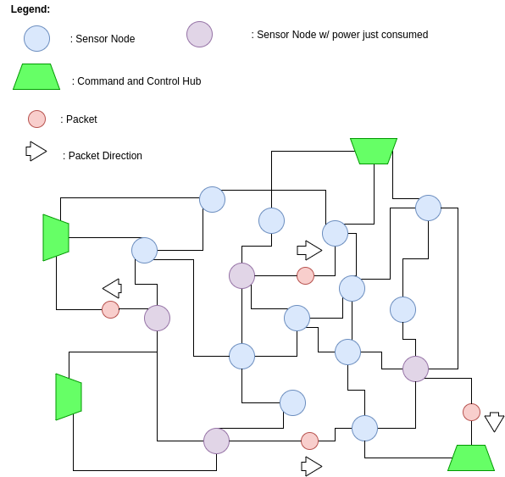

*Figure 1: A generic visual of the sensor network forwarding four nodes forwarding four packets at a certain single time frame. The packets colored purple have used up some of their energy by forwarding their respective packets.*

In order to decrease the complexity of the simulation environment, the C&C hubs have been hard coded at specified locations and designated as the destination of the packets. The simulation results are printed to the terminal in order to provide a visual of what is going on. Pictures of the program terminal output have also been included below:

**IV. Simulation Results vs. Other Protocols**

Below, we have included some results via graphical representation for our power conservation protocol vs. a shortest path algorithm. The shortest path algorithm traversed the sensor network via the shortest path based on the edge weights of the graph. As shown below, the sensor network was able to increase its longevity much more with the power conservation protocol vs. the shortest path. The shortest path was able to deliver the packets more quickly, however various sensor nodes power was consumed at a much quicker rate causing the network to power down more quickly.

**V. Conclusion and Possible Future Improvements**

In conclusion,

**References**

[1] ["ICT - Energy - Concepts Towards Zero - Power Information and Communication Technology"](https://www.intechopen.com/books/ict-energy-concepts-towards-zero-power-information-and-communication-technology)*,*

*book edited by Giorgos Fagas, Luca Gammaitoni, Douglas Paul and Gabriel Abadal Berini, ISBN*

*978-953-51-1218-1, Published: February 12, 2014 under* [*CC BY 3.0 license*](http://creativecommons.org/licenses/by/3.0/)*. © The Author(s).*

[2]