Plotting, Salting, and Smoothing using Apache Commons and JFreeChart Libraries

The Apache Statistic’s and JFreeChart libraries gives you grapical capabilities and statistical operations to plot, salt, and smooth data.

Plotting

To create a graph with JFreeChart, you must set-up a few things within the class and the main method. First, make sure the class extends ApplicationFrame (import org.jfree.ui.ApplicationFrame) then create a constructor with parameters applicationTitle and chartTitle. Within the constructor, I call super(applicationTitle) instantiate a JFreeChart and a ChartPanel object and be sure to give it the desired parameters. Then I instanitate a ChartPanel with parameter JFreeChart, set the size and contentPane of the ChartPanel. To make the program run and create the pop-up application, I instatiate the constructor named chart, with “Function” as the application title and “Simple Function as the chart title. Then I call chart.pack(); RefineryUtilities.centerFrameOnScreen(chart) ->(import org.jfree.ui.RefineryUtilities); chart.setVisible(true); After all of this is set up, I create a method that returns an XYSeries called data(), each XYSeries can be added to a XYDataset which is then plotted by the JFreeChart. Below is the output of y=(1/2)x+9 from x = -100 to 100.

Salting

In order to salt data using the Apache Commons library, you can use the UniformRandomProvider class within the Commons RNG library to generate a random number (import or.apache.commons.rng.UniformRandomProvider) the Commons RNG provides generators of pseudo-randomness that produce deterministic sequences of bytes. This library is more simple than java.util.Random since you can give both lower and upper bound parameters, then add to the y-value. In the method saltedDataSet(XYSeries data, int saltRange), each y-value in a series is salted, then the corresponding x,y pair is added to another XYSeries that is returned. Below is some results of different salt ranges to the original function y=(1/2)x+9.

Salt Range: 100

Salt Range: 300

Salt Range: 1,000

Smoothing

To smooth using Apache Commons libraries, you can use the DescriptiveStatistics class to maintain a rolling average using the getMean() method. DescriptiveStatistics maintains the input data in memory and has the capability of producing rolling statistics computed from a window of recently added values. In the method smoothedDataSet(XYSeries saltedData, int windowSize) the y-values. For each y-value in the salted dataset, I grab the surrounding y-values and place them into a DescriptiveStatistics object called stats. After the y-values are placed into stats I simply call stats.getMean() which becomes the new y-value. The corresponding x,y pairs are then added into a new XYSeries and returned. Below are some results with different window values, and multiple smooths.

Window Value: 10, First Smooth

Window Value: 10, Second Smooth

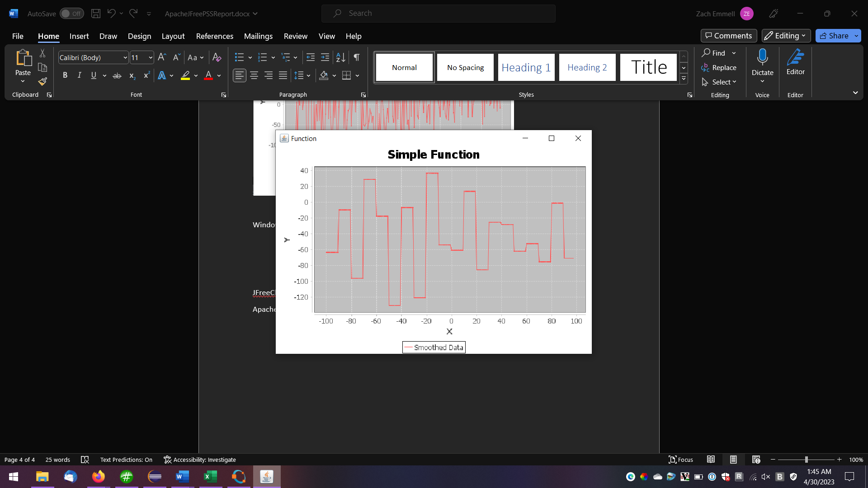

Window Value: 10, Third Smooth

For Comparison….

Window Value: 3, Third Smooth

Tutorials:

JFreeChart: <https://www.tutorialspoint.com/jfreechart/jfreechart_quick_guide.htm>

Apache Commons Math: <https://commons.apache.org/proper/commons-math/userguide/stat.html>

and <https://commons.apache.org/proper/commons-rng/userguide/rng.html>