CS 499 Module One Assignment Template

Complete this template by replacing the bracketed text with the relevant information.

- Self-Introduction: Address all of the following questions to introduce yourself.

  - How long have you been in the Computer Science program?
2 years

  - What have you learned while in the program? List three of the most important concepts or skills you have learned.
- A better understanding of data structures
- The basic design principles that are needed for software development
- Database operations

  - Discuss the specific skills you aim to demonstrate through your enhancements to reach each of the course outcomes.
My goal is to showcase my proficiency in designing and implementing efficient, maintainable, and scalable software solutions. This involves applying object-oriented programming principles, developing modular code, and incorporating best practices such as version control and thorough testing. I am committed to producing code that not only performs its intended function but also adheres to industry standards for clarity and structure.

  - How do the specific skills you will demonstrate align with your career plans related to your degree?
My project enhancements align with my software engineering and technology development career goals by building a strong technical and professional foundation. Key skills include:
- Software Design and Problem-Solving: Analyzing problems, designing algorithms, and implementing efficient, maintainable code for various applications.
- Full-Stack Development and System Integration: Designing complete, user-focused solutions using both front-end and back-end technologies, crucial for creating interactive and scalable software products for my own business.
- Data Management and Security: Proficiency in databases and securing information systems, essential for building reliable and secure applications.
Overall, my technical expertise, problem-solving, and collaborative communication skills perfectly position me for a successful software engineering career and the expansion of my indie development studio.

  - How does this contribute to the specialization you are targeting for your career?
My project enhancements highlight skills in software and mobile application development, a field requiring technical expertise, creativity, adaptability, and user-centered design—all demonstrated in my academic work.

- ePortfolio Set Up:

  - Submit a screen capture of your ePortfolio GitHub Pages home page that clearly shows your URL.

    - You already have a repository in GitHub where you uploaded projects in previous courses. Your ePortfolio will reside in GitHub but can link to work at other sites, such as Bitbucket.

  - Use the GitHub Pages link in the Resource section for directions on:
    - How to create your GitHub website and publish code to GitHub Pages
    - Issues, such as adding links to other sites

  - Paste a screenshot of your GitHub Pages home page with your URL clearly showing in the space below.

[Paste the screenshot here of your GitHub Pages home page.]
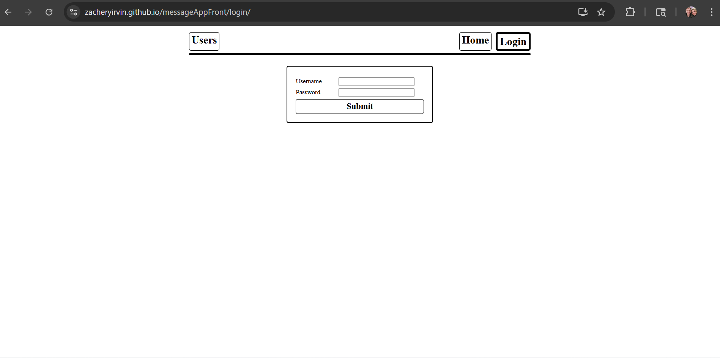

- Enhancement Plan:

  - Category One: Software Engineering and Design
    - Select an artifact that is aligned with the software engineering and design category and explain its origin. Submit a file containing the code for the artifact you choose with your enhancement plan.

[Insert your answer here.]

Note: Your artifact may be work from the following courses:

- IT 145: Foundation in Application Development
- CS 250: Software Development Lifecycle
- CS 260: Data Structures and Algorithms
- IT 315: Object Oriented Analysis and Design
- CS 320: Software Testing, Automation, and Quality Assurance
- CS 330: Computational Graphics and Visualization
- CS 340: Advanced Programming Concepts
- CS 350: Emerging Systems Architectures and Technologies
- CS 360: Mobile Architecture and Programming
- IT 365: Operating Environments
- IT 380: Cybersecurity and Information Assurance
- CS 405: Secure Coding
- CS 410: Reverse Software engineering
- IT 340: Network and Telecommunication Management
- IT 380: Cybersecurity and Information Assurance

    - Describe a practical, well-illustrated plan for enhancement in alignment with the category, including a pseudocode or flowchart that illustrates the planned enhancement.

The project i will use is a real time chat application that I have built earlier. The purpose of this project was to create a real time chat application that was secure, persisted the chats, and allowed for acceptance and rejection of friend requests. The proposed enhancement is the integration of a Chatbot contact or an “assistant” in the messaging application. The first step is a new route for the AI chatbot. This will integrate with the server.js file where all of the routes are kept. Next will be the rendering of the chatbot on the frontend. Lastly will be the UX design and user interface changes to make the application user friendly. The following is the flowchart of how the process will transpire from user to response.

AI Chat Interaction Flow
- User Initiates: The user types a message.
- Request Sent: AIChat sends this request to the AI_Client.
- API Call: A POST request is made to /api/ai containing the prompt, conversation history, and persona.
- Input Validation: The system validates the incoming input.
  - Invalid Input: If validation fails, a 400 Bad Request error is returned.
- OpenAI Integration: If input is valid, the system calls OpenAI with the message history.
- API Response Check: The system checks for the success of the OpenAI API call.
  - API Failure: If the API call fails, a 500 AI request failed error is returned.
- Data Extraction: Upon successful API response, the system extracts the reply and usage data.
- Return Data: The system returns an object containing the reply and usage information.
- Append Message: AIChat appends the assistant's message to the conversation.
- UI Update: The user interface updates to display the new message, and scrolls to the bottom of the chat.

For this category of enhancement, consider improving a piece of software, transferring a project into a different language, reverse engineering a piece of software for a different operating system, or expanding a project’s complexity. These are just recommendations. Consider being creative and proposing an alternative enhancement to your instructor.

Think about what additions to include to complete the enhancement criteria in this category. Since one example option is to port to a new language, that is the kind of scale that is expected. This does not mean you need to port to a new language but instead have an equivalent scale of enhancement. Underlying expectations of any enhancement include fixing errors, debugging, and cleaning up comments, but these are not enhancements themselves.

    - Explain how the planned enhancement will demonstrate specific skills and align with course outcomes.

      - Identify and describe the specific skills you will demonstrate that align with the course outcome.
The enhancements will demonstrate architectural design through the integration of an AI service into an existing application. This will showcase REST principles as well as modular routing. Proper data management will also be showcased with the efficient storing and handling of chat histories.

      - Select one or more of the course outcomes below that your enhancement will align with.

This aligns well with number 3 and 4

Course Outcomes:

- Employ strategies for building collaborative environments that enable diverse audiences to support organizational decision-making in the field of computer science.
- Design, develop, and deliver professional-quality oral, written, and visual communications that are coherent, technically sound, and appropriately adapted to specific audiences and contexts.
- Design and evaluate computing solutions that solve a given problem using algorithmic principles and computer science practices and standards appropriate to its solution while managing the trade-offs involved in design choices.
- Demonstrate an ability to use well-founded and innovative techniques, skills, and tools in computing practices for the purpose of implementing computer solutions that deliver value and accomplish industry-specific goals.
- Develop a security mindset that anticipates adversarial exploits in software architecture and designs to expose potential vulnerabilities, mitigate design flaws, and ensure privacy and enhanced security of data and resources.

  - Category Two: Algorithms and Data Structures

- Explain how the planned enhancement will demonstrate specific skills and align with course outcomes.

  - Identify and describe the specific skills you will demonstrate to align with the course outcome.

For this enhancement I will implement a friend suggestion algorithm that utilizes graph data structures by comparing connections, chat frequency, etc. This will demonstrate graph traversal and weighted scoring. It will also provide a practical impact as it makes the user experience more pleasant for the end user.

  - Select one or more of the course outcomes listed under Category One that your enhancement will align with.

3 aligns well here.

  - Category Three: Databases

    - Select an artifact that is aligned with the databases category and explain its origin. Submit a file containing the code for the artifact you choose with your enhancement plan. You may choose work from the courses listed under Category One.

The config.js and message.js files house the implementation of of the Postgress creation, sessions and how messages are passed and saved. I will integrate MongoDB alongside the Postgress for data visualization the is easily readable for non programmers.

    - Describe a practical, well-illustrated plan for enhancement in alignment with the category, including a pseudocode or flowchart that illustrates the planned enhancement.

Currently my application uses Postgress for sessions, messages, and user data. I plan to integrate MongoDB alongside to provide in depth chat analytics and storage. My goal is to continue to use Postgress for relational transactions such as active chats, users, and messages while adding MongoDB for long-tem message storage, analytic and message trend visualizations. I will create a dashboard that provides the visualizations of the MongoDB data. This will affect current files of config.js and messages.js as well as the creation of a couple of new ones.

Data Pipeline Flow
- User Initiates: The user sends a message.
- Request Received: The message is received by the Express backend at the /messages POST endpoint.
- Live Chat Storage: The message is inserted into PostgreSQL to manage the live chat session.
- Archival and Analytics: The message is simultaneously inserted into MongoDB for archival and analytics purposes.
- Data Processing: A MongoDB Aggregation Pipeline processes the raw data.
- API Exposure: The processed data is made available through the /analytics API endpoint.
- Data Fetch: An HTML/JS dashboard fetches the analytics data from the API.
- Visualization: Charts.js is used to visualize the trends on the dashboard.

For this category of enhancement, consider adding more advanced concepts of MySQL, incorporating data mining, creating a MongoDB interface with HTML/JavaScript, or building a full stack with a different programming language for your artifact. These are just recommendations; consider being creative and proposing an alternative enhancement to your instructor. Note: You only need to choose one type of enhancement per category.

Think about what additions to include to complete the enhancement criteria in this category. Since one example option is to port to a new language, that is the kind of scale that is expected. Perhaps you might increase the efficiency and time complexity of an algorithm in an application and detail the logic of the increased time complexity. Remember, you do not need to port to a new language but instead have an equivalent scale of enhancement. Underlying expectations of any enhancement include fixing errors, debugging, and cleaning up comments, but these are not enhancements themselves.
    - Explain how the planned enhancement will demonstrate specific skills and align with course outcomes.

      - Identify and describe the specific skills you will demonstrate that align with the course outcome.
The implementation of the data visualization board clearly showcases a visual communication and data presentation skill set. These allow for a clear visualization of data trends at a glance without pouring over columns of data.

      - Select one or more of the course outcomes listed under Category One that your enhancement will align with.

This aligns with number 2.

- ePortfolio Overall Skill Set

  - Accurately describe the skill set to be illustrated by the ePortfolio overall.
    - Skills and outcomes planned to be illustrated in the code review

- Algorithmic principles and efficient data structures
- Industry best practices
- Secure database operations
- Integration of multiple technologies

    - Skills and outcomes planned to be illustrated in the narratives

- Database Management
- Effective communication
- Secure Software development

    - Skills and outcomes planned to be illustrated in the professional self-assessment

- Highlight key competencies
- Showcase understanding of software engineering and data management
- Demonstrate professional, ethical learning skils.

