INSERT COVER PAGE HERE

INSERT TABLE OF CONTENTS HERE

INSERT EXECUTIVE SUMMARY HERE

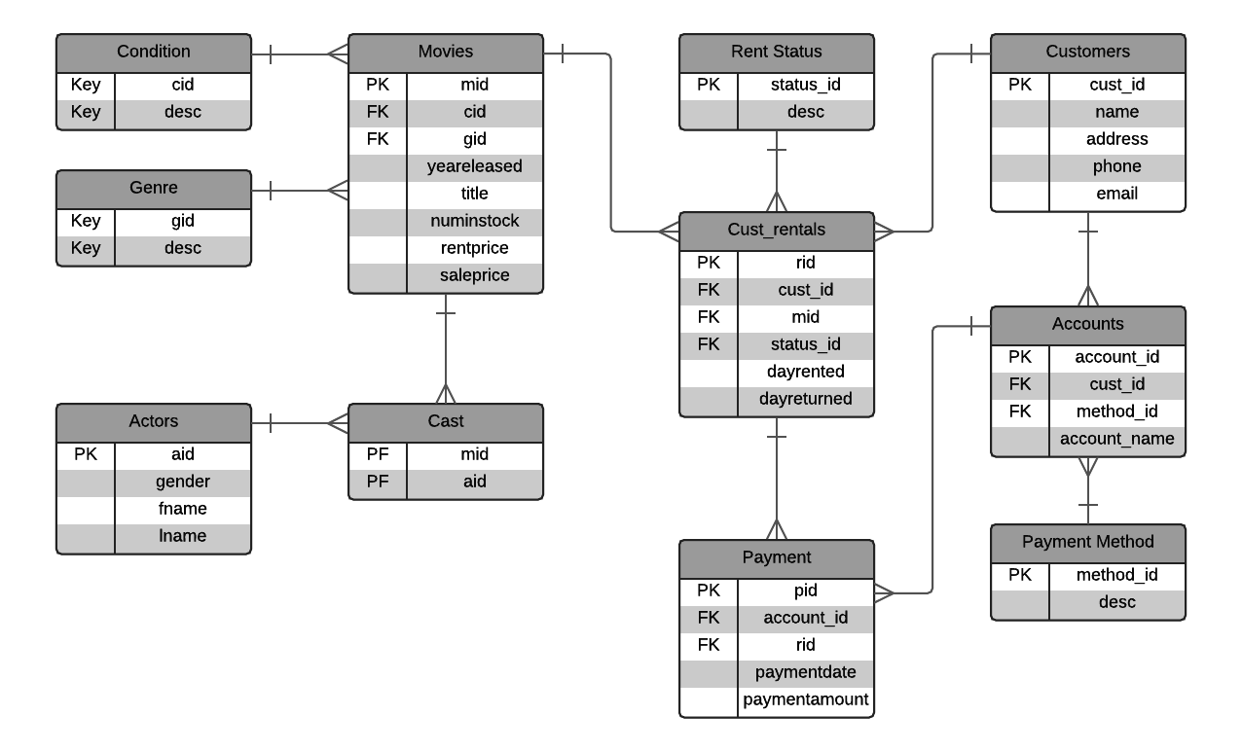ENTITY RELATIONSHIP DIAGRAM

TABLES

**CONDITION**

**Purpose**

This table is used to store the state of the conditions of different movies

**Create Statement**

CREATE TABLE Condition (

cid int not null,

desc text,

Primary Key (cid)

);

**Functional Dependencies**

cid🡪 desc

**Sample Data**

GENRE

**Purpose**

This table is used to identify the genres for each movie.

**Create Statement**

CREATE TABLE Genre (

gid int not null,

desc text,

Primary Key (gid)

);

**Functional Dependencies**

gid 🡪 desc

**Sample Data**

ACTORS

**Purpose**

**Create Statement**

CREATE TABLE Actors (

aid int not null,

gender text,

fname text,

lname text,

Primary Key (aid)

);

**Functional Dependencies**

aid 🡪 gender, fname, lname

**Sample Data**

MOVIES

**Purpose**

**Create Statement**

CREATE TABLE Movies (

mid int not null,

cid int not null refernces Condition(cid),

gid int not null refernces Genre(gid),

yearrelased int,

title text,

rentprice int,

saleprice int,

Primary Key (mid)

);

**Functional Dependencies**

mid🡪 cid,gid,yearreleased, title, rentprice,saleprice

**Sample Data**

CAST

**Purpose**

**Create Statement**

CREATE TABLE Cast (

mid int not null refernces Movies(mid),

aid int not null refernces Actors(aid),

);

**Functional Dependencies**

**Sample Data**

**Purpose**

**Create Statement**

**Functional Dependencies**

**Sample Data**

RENT_STATUS

CREATE TABLE Rent Status (

status_id int not null

desc text,

Primary Key (status_id)

);

**Purpose**

**Create Statement**

**Functional Dependencies**

**Sample Data**

CUST_RENTALS

CREATE TABLE Cust_rentals (

rid int not null,

cust_id int not null refernces Customers(cust_id),

mid int not null refernces Movies(mid),

status_id int not null refernces Rent Status(status_id),

dayrented timestamp not null,

dayreturned timestamp not null,

Primary Key (rid)

);

**Purpose**

**Create Statement**

**Functional Dependencies**

**Sample Data**

PAYMENT

CREATE TABLE Payment (

pid int not null,

account_id int not null references Accounts(account_id),

rid int not null references Cust_rentals(rid),

oaymentdate timestamp,

paymentamount int,

Primary Key (pid)

);

**Purpose**

**Create Statement**

**Functional Dependencies**

**Sample Data**

CUSTOMERS

CREATE TABLE Customers (

cust_id int not null,

name text,

address text,

phone int not null

email text,

Primary Key (cust_id)

);

**Purpose**

**Create Statement**

**Functional Dependencies**

**Sample Data**

ACCOUNTS

CREATE TABLE Accounts (

account_id int not null,

cust_id int not null references Customers(cust_id),

method_id int not null references Payment Method(method_id),

account_name text,

Primary Key (account_id)

);

**Purpose**

**Create Statement**

**Functional Dependencies**

**Sample Data**

PAYMENT METHOD

CREATE TABLE Payment Method (

method_id int not null,

desc text,

Primary Key (method_id)

);