**This document details each page of the Cereals Inventory System upon submission.**

Open the site at [https://cereals-inventory.vercel.app](https://cereals-inventory.vercel.app/) using any browser.

I. Login Screen

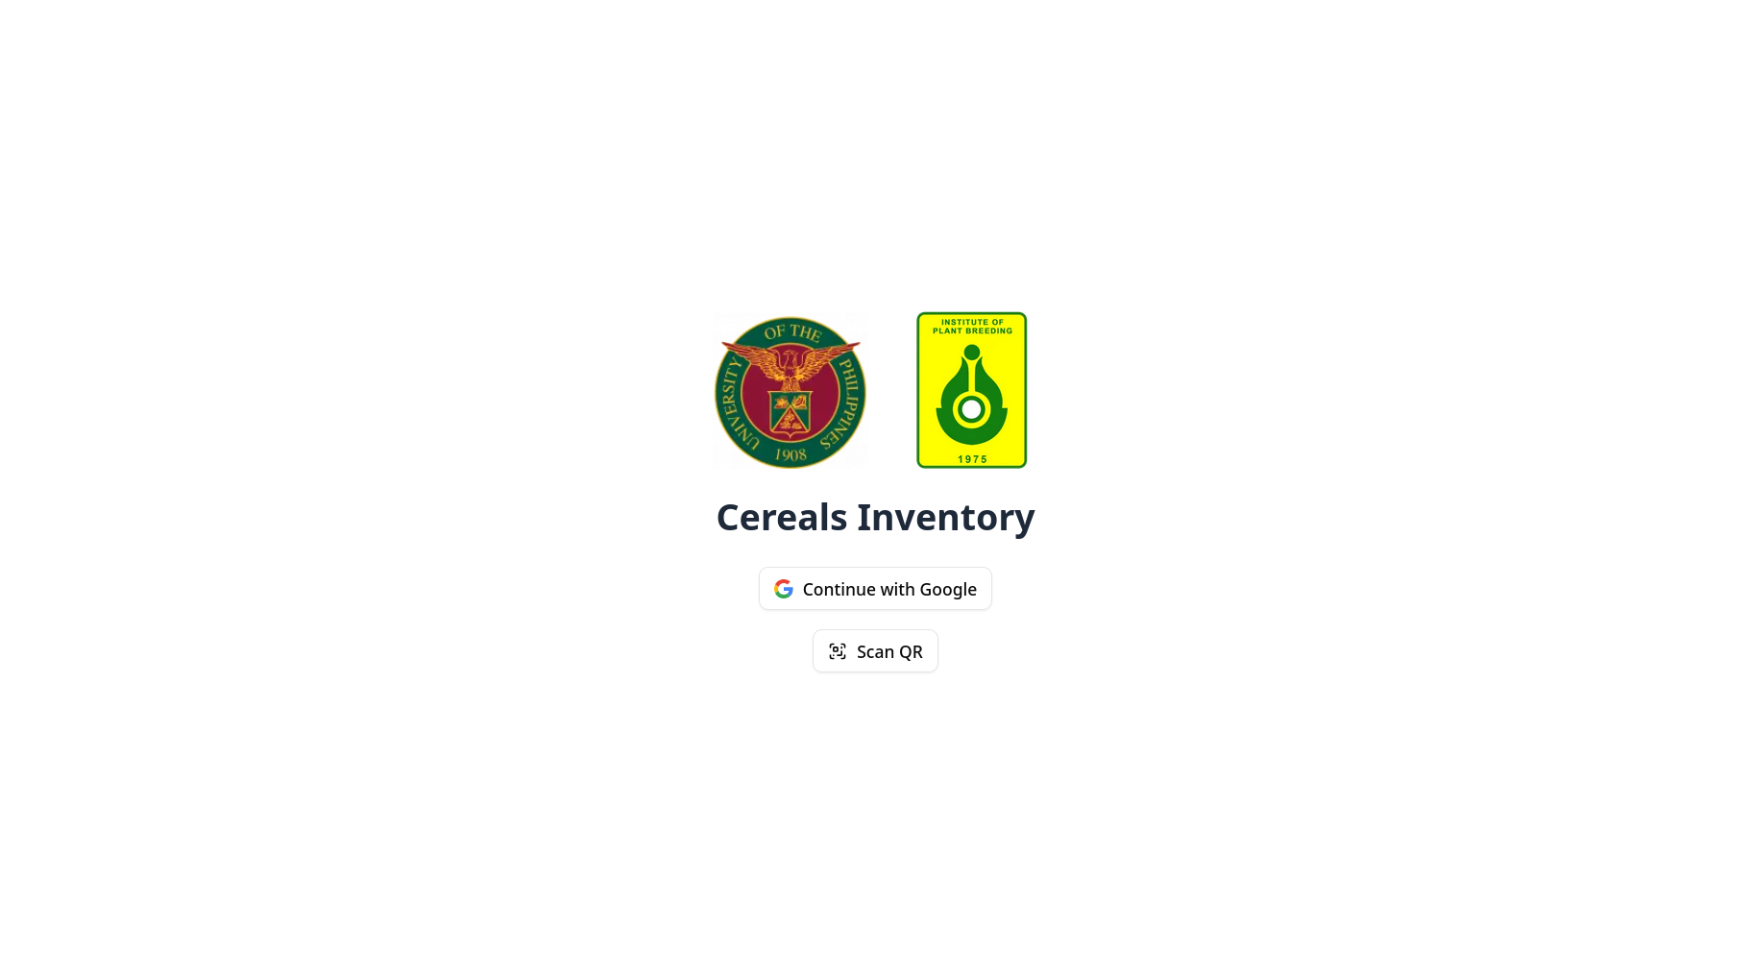

The login screen lets you:

1. Log into the system using your UP mail account, and

2. Scan a box’s QR code.

If you are already logged in, you will be automatically redirected to the Dashboard.

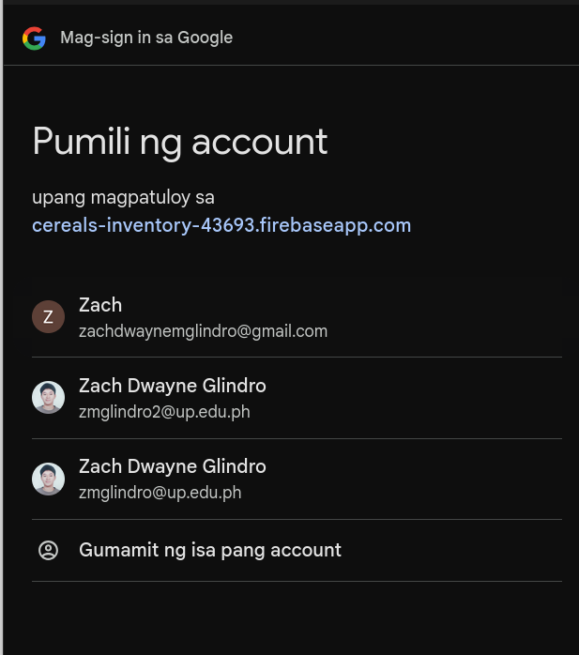**Logging into the system**

A UP Mail account is required to log into the site.

1. Tap **Continue with Google**, and a pop up or new tab will open.

2. Log in with your UP Mail account.

3. If you are already verified by the site admins, you will be able to access the system. You will be redirected to the Dashboard. Otherwise, please wait until you are verified by the site admins.

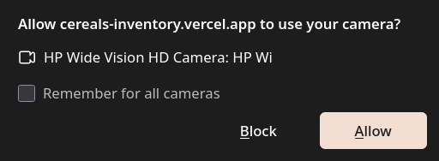**Scanning a QR code**

A printed QR code may be scanned by tapping the Scan QR button.

1. Tap the **Scan QR** button.

2. Your phone may ask for permission to use your camera. Tap **Allow**.

3. Scan the QR code by pointing your camera at the QR code. You will hear a beep when the camera detects the QR code.

4. The site will load the box’s contents.

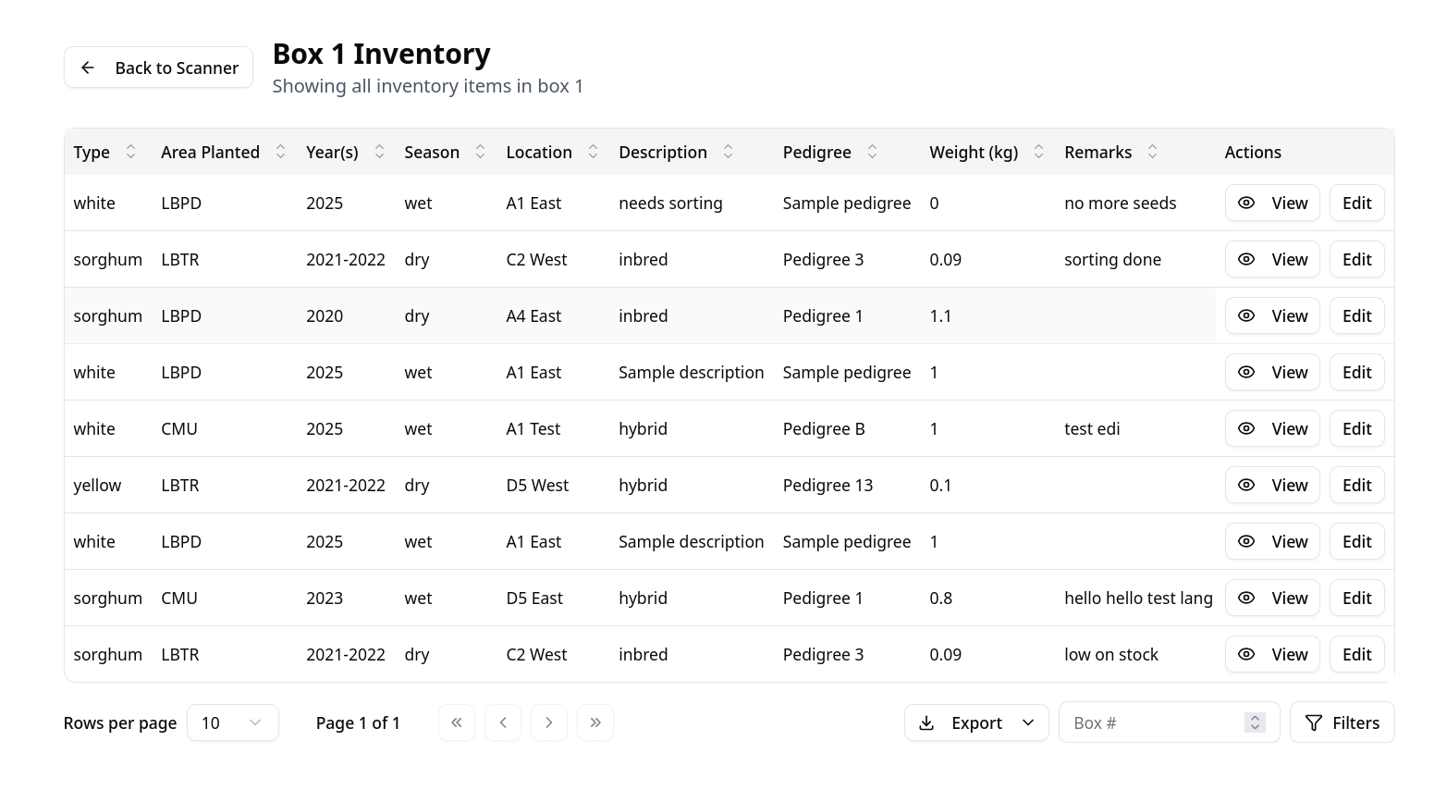

**Editing a row**

Logged-out users can edit the weight and remarks of a seed envelope by scanning the box’s QR code.

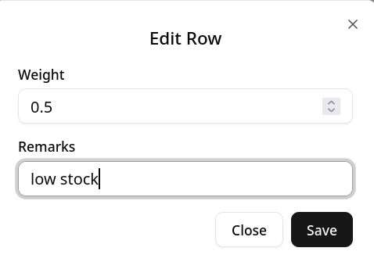

1. Tap **Edit** or the **Pencil**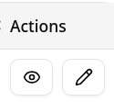 button.

2. Edit the data, then tap **Save**.

3. The site should then say “Inventory updated successfully.”

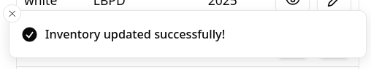

II. Dashboard

When you are logged in, you will automatically be redirected to this page.

The Dashboard has four main features:

1. **Scan QR**,

2. **Table**,

3. **Add Inventory**, and

4. **Statistics**.

The Scan QR button only shows on mobile phones. The Statistics feature only shows on wider screens, such as PCs or laptops.

**Scan QR**

The Scan QR button behaves just like the Scan QR button in the QR page.

1. Tap the **Scan QR** button.

2. Your phone may ask for permission to use your camera. Tap **Allow**.

3. Scan the QR code by pointing your camera at the QR code. You will hear a beep when the camera detects the QR code.

4. The site will load the box’s contents.

**Table**

The table shows all inventory entries. It allows you to view or edit each entry’s details. It also lets you export all of the data in the database.

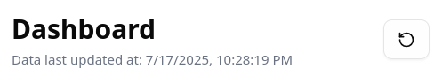

The table downloads the data and refreshes it every hour. To manually refresh the data, tap Refresh.

The table contains the following columns:

1. Box Number

2. Shelf Code

3. Type – white, yellow, sorghum, special maize

4. Area Planted

5. Year(s)

6. Location – LBTR, LBPD, CMU

7. Description

8. Pedigree

9. Weight (kg)

10. Remarks – optional.

We can **search** for specific entries in the table by searching or filtering.

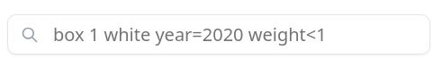

To search, use the **search bar**. The search bar will search all fields for any matches.

Some fields have specific formats:

To search for a specific **box**, type “box a.” e.g. box 1, box 2, box 15

To search for seeds in a **box range**, type “box a-b.” e.g. box 1-20, box 21-40, box 1-5

To search for **years or weight**, we can either search for it directly or with operators. Do not include spaces in the search.

Examples:

To search for 2020: type “2020” or “year=2020”

To search for all seeds with year after 2020 but before 2024: type “year>2020 year<2024”

To search for all seeds with less than 2 kg but more than 0.5 kg: type “weight<2 weight>0.5”

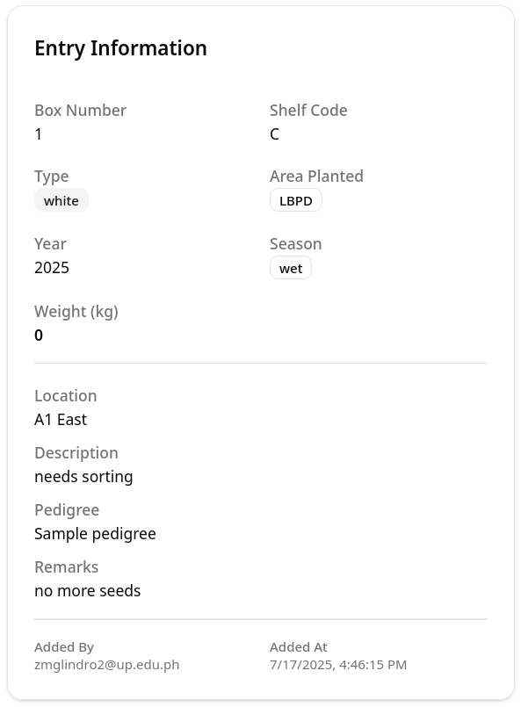**Table actions**

We can **view** or **edit** each entry’s details.

**View**

To **view** 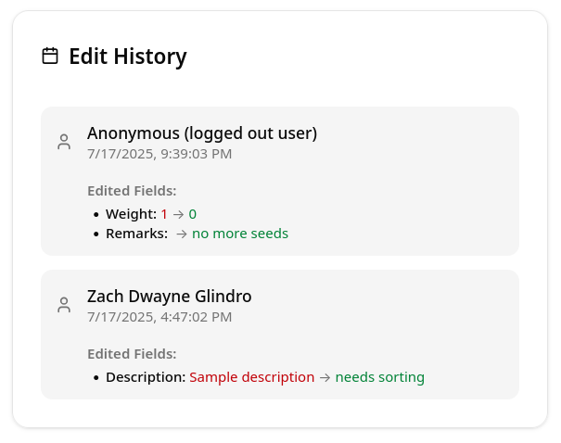the entry’s details, tap the Eye or the View button.

The details will show you the **Entry Information**: box number, shelf code, type, area planted, and year, among others.

It also contains the **Edit History** of that entry. The Edit History lists all users who have edited that entry. It also shows which fields they edited, and when they edited those fields.

**Edit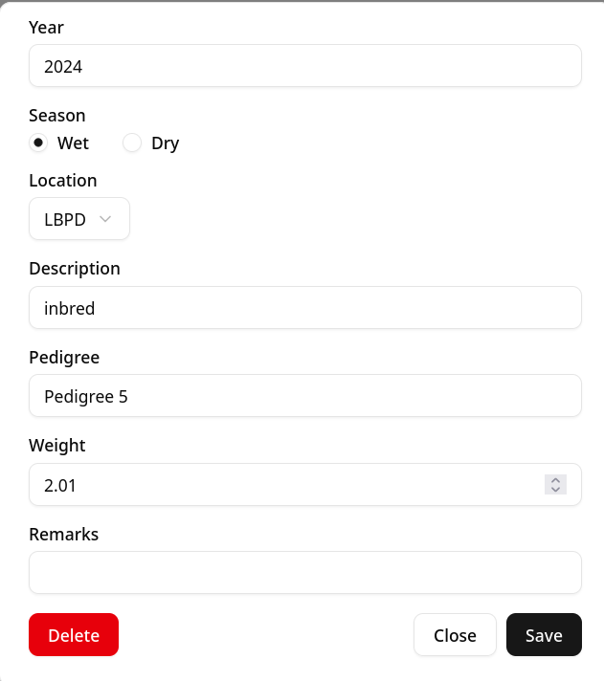/Delete**

We can edit any field of an entry by tapping the **Edit** or the **Pencil** button. We can also **delete** an entry in the same pop-up.

To **edit** an entry,

1. Tap the **Edit** or the **Pencil** button.

2. Edit the values to be edited.

3. Tap **Save** to save your edits.

To delete an entry,

1. Tap the **Edit** or the **Pencil** button.

2. Tap **Delete** at the bottom of the pop-up.

3. Tap **Delete** again to confirm the deletion.

We can **export** the inventory’s data by using the Export function. Ex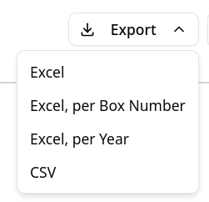port is only available for larger screens.

1. Click the **Export** button.

2. Choose the format you want the file to be in.

To create an **Excel** (xlsx) file, click **Excel**. Alternatively, if you want the data to be separated into sheets with each box number or year, click *Excel, per Box Number* or *Excel, per Year.*

To create a CSV (comma-separated values) file, click **CSV.**

3. The browser will prompt you where to save the file. After choosing the file’s location, the file will then start to be downloaded.

**Add Inventory**

The Add Inventory form allows you to add a single entry to the database.

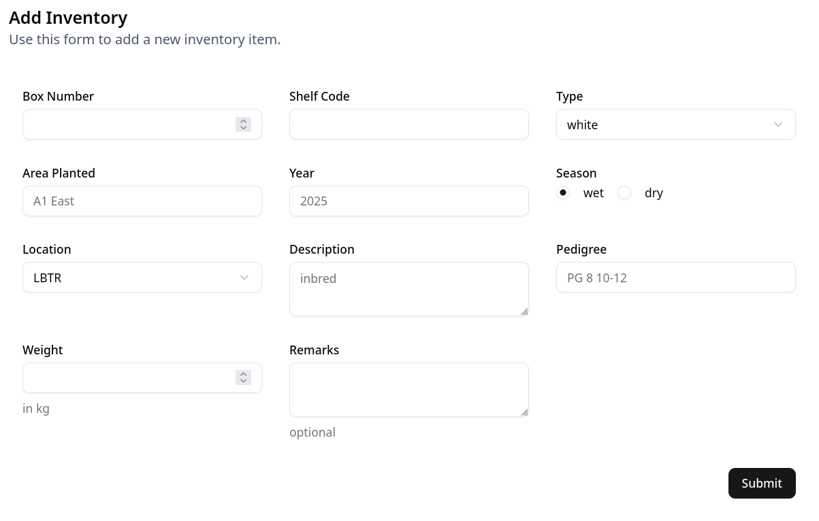

1. **Fill out** all of the fields in the Add Inventory form.

2. Tap the **Submit** button to add the new inventory entry.

**Statistics**

The statistics overview is only available for wide screens, such as PCs or laptops. Some charts are customizable; click the dropdown button to customize them.

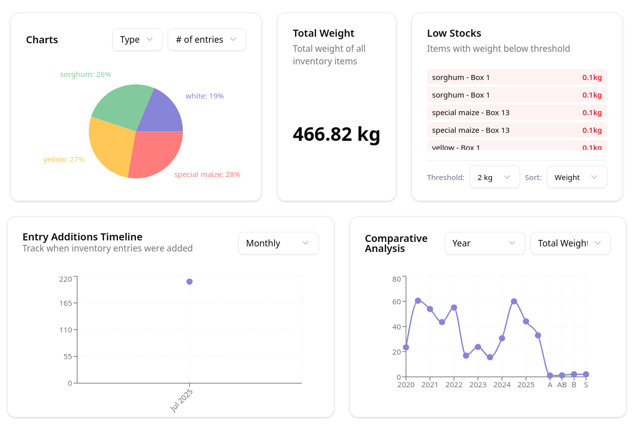

III. Import

The **Import** page allows you to import data directly from a spreadsheet. It also lets you generate a template ready for importing.

IV. Admin

V. Technical Details

Technical details, such as the code’s file structure and steps on running the code, are available in the README.md file. The README.md file can be viewed using a Markdown viewer or editor.

We use the following to host the site:

1. **Firebase** – Firebase is a Google product offering backend as a service. It offers two relevant services: Firebase Auth and Firestore. **Firebase Auth** lets the site sign in users using the Google sign in page. **Firestore** is the database holding all of the site’s data, from the inventory entries to the users.

Pricing and usage limits are available at <https://cloud.google.com/firestore/pricing>. Billing was disabled at the time of submission, meaning the site is on its free tier and will not be charged for using Firebase.

2. **Vercel –** Vercel deploys the site to the URL cereals-inventory.vercel.app.

Billing was disabled at the time of submission. Pricing and usage limits are available at <https://vercel.com/pricing>. Billing was disabled at the time of submission, meaning the site is on its free tier and will not be charged for using Vercel.

Contact:

Zach Dwayne M. Glindro

zmglindro2@up.edu.ph