Zach Healy

18.3

package com.mycompany.ch6.hw7;

/\*

Author: Zach Healy

Problem: 18.3

Description: Takes two numbers and outputs the greatest common denominator

\*/

import java.util.Scanner;

public class gcd {

public static void main(String[] args) {

int m, n;

Scanner input = new Scanner(System.in);

System.out.println("Enter a digit: ");

m = input.nextInt();

System.out.println("Enter another digit: ");

n = input.nextInt();

int gcd = gcd(m, n);

System.out.println("GCD is " + gcd);

}

public static int gcd(int m, int n) {

if (m % n == 0) {

return n;

} else {

return gcd(n, m % n);

}

}

}

18.6

package com.mycompany.ch6.hw7;

/\*

Author: Zach Healy

Problem: 18.6

Description: Writes the 1/2 + 2/3 ... + i/i+1 function

\*/

public class sum {

public static void main(String[] args) {

System.out.println(m(1));

}

public static double m(double i) {

if (i > 11) {

return 0;

} else {

return (i / (i + 1) + m(i + 1));

}

}

}



18.10

package com.mycompany.ch6.hw7;

import java.util.Scanner;

/\*

Author: Zach Healy

Problem: 18.10

Description: Counts the number of times a character is in a string

\*/

public class count {

public static void main(String[] args) {

String str;

char a;

Scanner input = new Scanner(System.in);

System.out.print("Enter a String: ");

str = input.nextLine();

System.out.print("Enter a Character: ");

a = input.next().charAt(0);

System.out.println(count(str, a));

}

public static int count(String str, char a) {

int count = 0;

if (str.length() == 0) {

return 0;

}

if (str.charAt(0) == a) {

count = count + 1;

}

return count + count(str.substring(1), a);

}

}

18.13

package com.mycompany.ch6.hw7;

/\*

Author: Zach Healy

Problem: 18.13

Description: Takes an array and outputs the greatest number

\*/

import java.util.Scanner;

import java.lang.Math;

public class arrMax {

public static void main(String[] args) {

int a[] = new int[8];

int size = a.length;

Scanner input = new Scanner(System.in);

System.out.println("Enter 8 digits: ");

for (int i = 0; i < 8; i++) {

a[i] = input.nextInt();

}

System.out.println(arrMax(a, size));

}

public static int arrMax(int a[], int size) {

if (size == 1) {

return a[0];

}

return Math.max(a[size - 1], arrMax(a, size - 1));

}

}

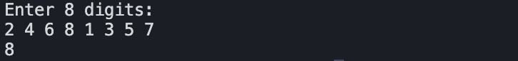

18.16

package com.mycompany.ch6.hw7;

/\*

Author: Zach Healy

Problem: 18.16

Description: Count the number of upper case characters

\*/

import java.util.Scanner;

public class arrUpper {

public static void main(String[] args) {

char a[] = new char [10];

Scanner input = new Scanner(System.in);

System.out.println("Enter a series of characters for an array: ");

for(int i = 0; i < a.length; i++) {

a[i] = input.next().charAt(0);

}

System.out.println(count(a));

}

public static int count(char[] chars) {

return count(chars, chars.length);

}

public static int count(char[] chars, int high){

if(high == 0){

return 0;

}else if(Character.isUpperCase(chars[high - 1])){

return 1 + count(chars, high - 1);

}else{

return count(chars, high - 1);

}

}

}

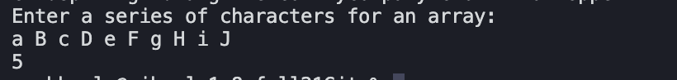

No, there are no non-negative arguments that will not run. All of the numbers will eventually run through, being able to be boiled down to the minimum of 0, 1, or 2. And if the number is 0, 1, or 2, it will not iterate and will just immediately return the 2 \* number.