Analysis:

For this prompt, we must make a program to create and track various information about an account. The user inputs their ID number, and a balance amount. The interest rate is set and there are options to withdraw and deposit money. The output should display the balance, monthly interest, and when the account was created.

ULM Diagram:

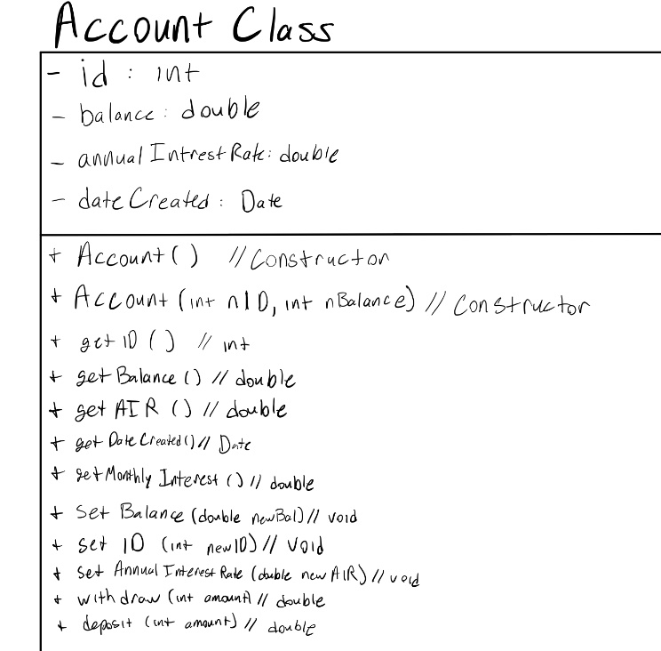

Output:

