12.7

package com.mycompany.ch3.closeLab7.homework4;

import java.util.\*;

public class hw4 {

public static void main(String[] args) {

Scanner input = new Scanner(System.in);

System.out.print("Enter a binary number: ");

String binary = input.nextLine();

int decimal = bin2Dec(binary);

}

private static int bin2Dec(String binaryString) {

int dec;

try {

dec = Integer.parseInt(binaryString, 2);

System.out.println(binaryString + " in decimal is " + dec);

return dec;

} catch (NumberFormatException e) {

System.out.println("Not a binary number.");

}

return 0;

}

}

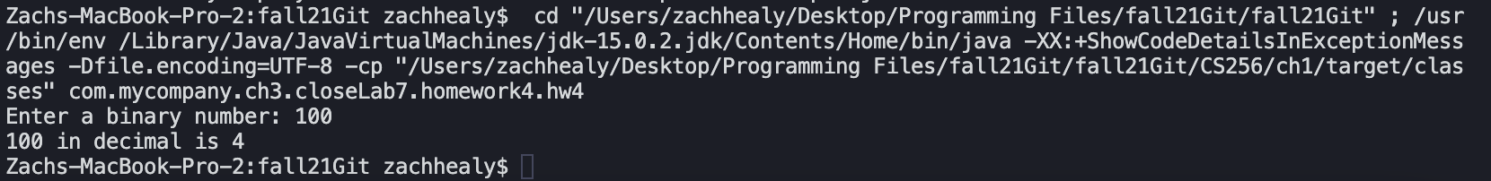

12.9

package com.mycompany.ch3.closeLab7.homework4;

import java.util.\*;

public class hw4pt2 {

public static void main(String[] args) {

Scanner input = new Scanner(System.in);

System.out.print("Enter a binary number: ");

String binary = input.nextLine();

bin2Dec(binary);

}

private static int bin2Dec(String binaryString) throws BinaryFormatException {

if (!isBinary(binaryString)) {

throw new BinaryFormatException(binaryString);

}

int dec = Integer.parseInt(binaryString, 2);

System.out.println(binaryString + " in decimal is " + dec);

return 0;

}

public static boolean isBinary(String binary) {

for (int i = 0; i < binary.length(); i++) {

if (binary.charAt(i) != '1' && binary.charAt(i) != '0')

return false;

}

return true;

}

public static class BinaryFormatException extends IllegalArgumentException {

public BinaryFormatException(String error) {

super("Invalid input");

}

}

