Psudocode:

Set up registers for the base numbers as well as the amount we are going to need

call function

Counter to count until we reach 20 prints

Print the first number

Print a new line

Print the second number

Print a new line

Loop for all of the numbers

Add the two numbers together and store in new variable

Print out the new number

Move the past numbers to their new places

Print out a new line

Add 1 to counter and check if the counter has been reached. If not, restart loop

End program

Screenshot of code:

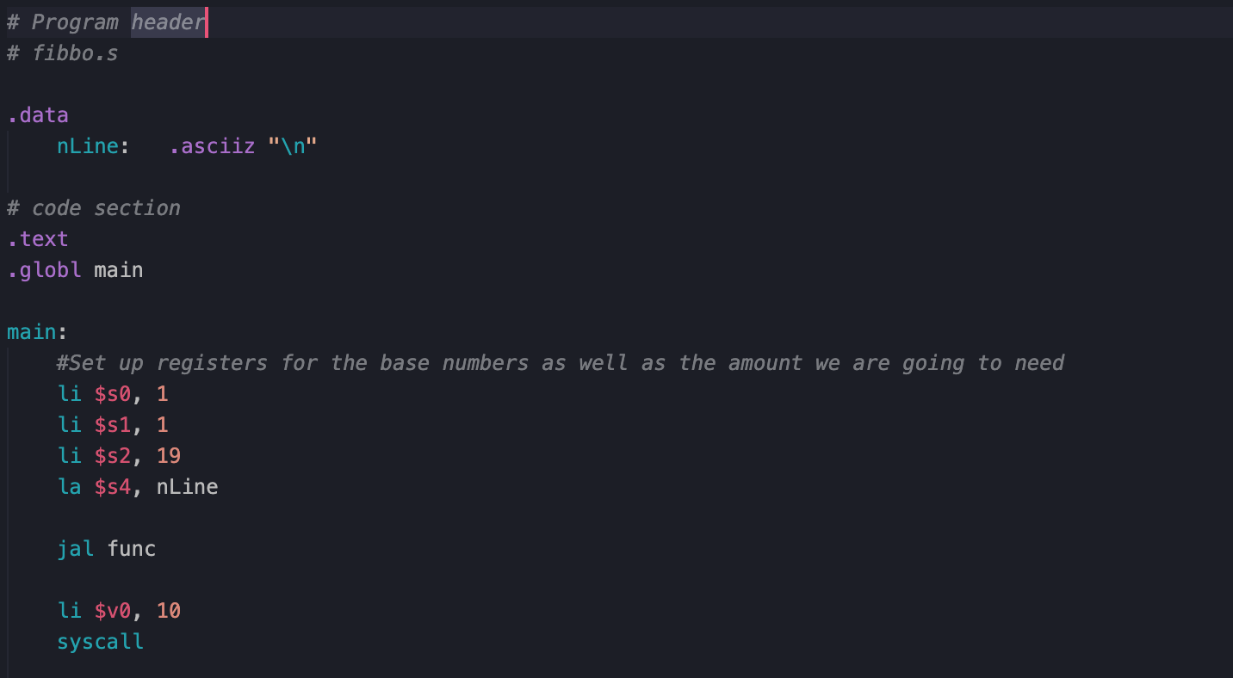

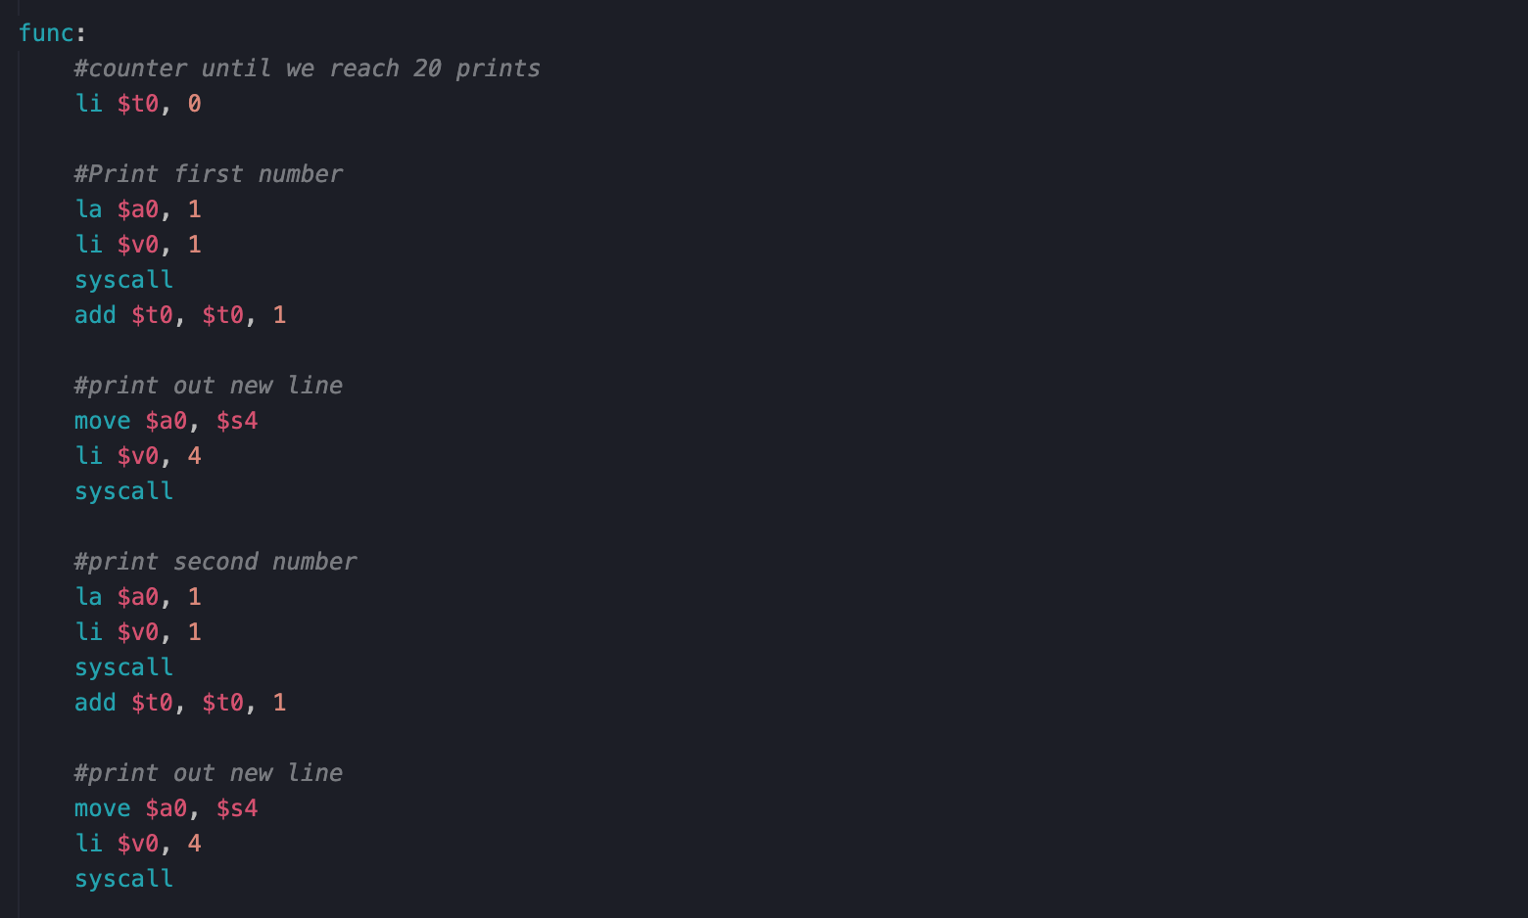

Output:

