1. A screenshot of a computer

   Description automatically generated
2. A screen shot of a computer screen

   Description automatically generated with low confidence
3. Used “sudo apt update && sudo apt upgrade -y”
4. 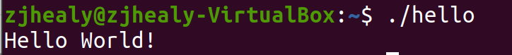Graphical user interface, application

   Description automatically generated