Part A

1) The ____Kernel_____ is the base operating system, and it interacts directly with the hardware, software services, application programs, and user-created scripts.

2) _______Bash______ is the default shell in Linux, and it is the shell many users prefer.

3) An IP address is a set of _____four____ numbers (in the commonly used IP version 4) separated by periods.

4) _____Secure Shell_____ (SSH) was developed for UNIX/Linux systems to provide authentication security for TCP/IP applications, such as FTP and Telnet.

5) Use the _____Cal___ command to show the system calendar.

6) To determine information about who is logged in, use the ____who_____ command.

7) The man program in UNIX/Linux displays this online manual, called the ___man pages_____, for command-line assistance.

8) You can type more than one command on the command line by separating commands with a(n) ___semicolon_____.

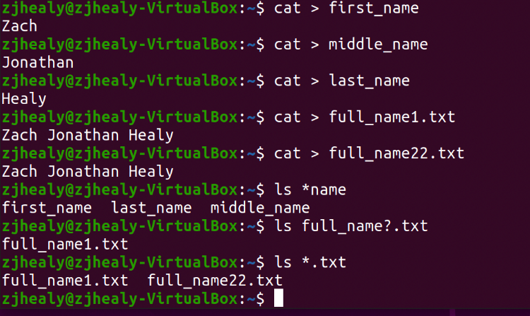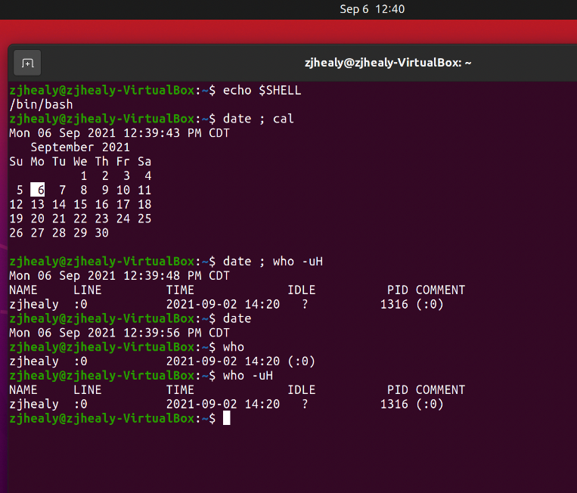Part B

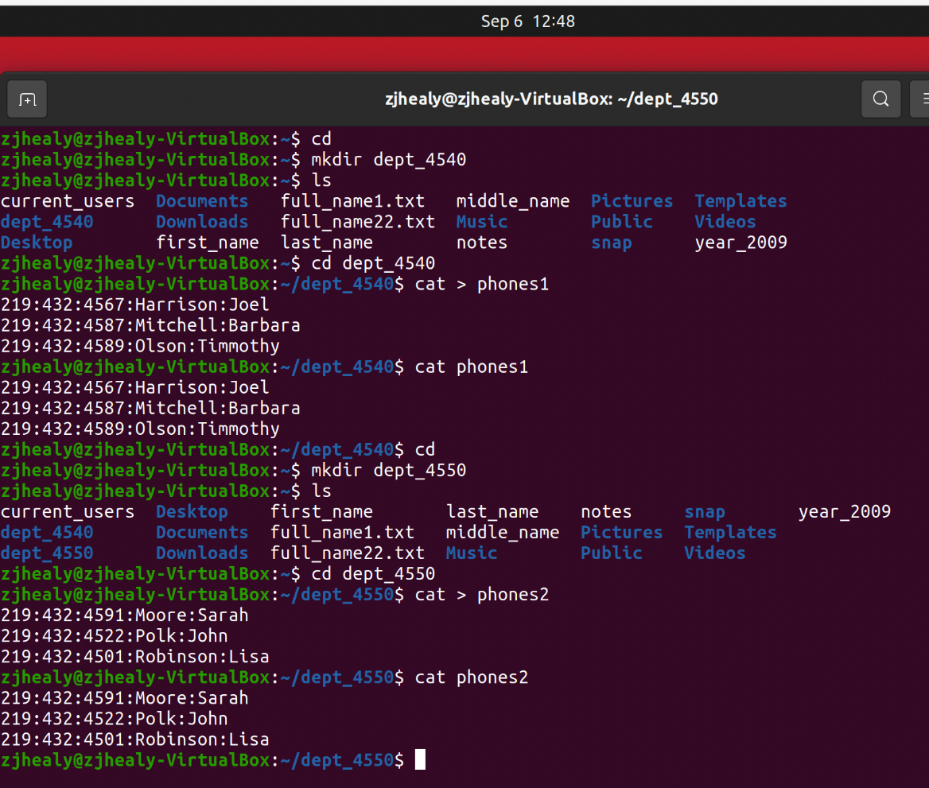

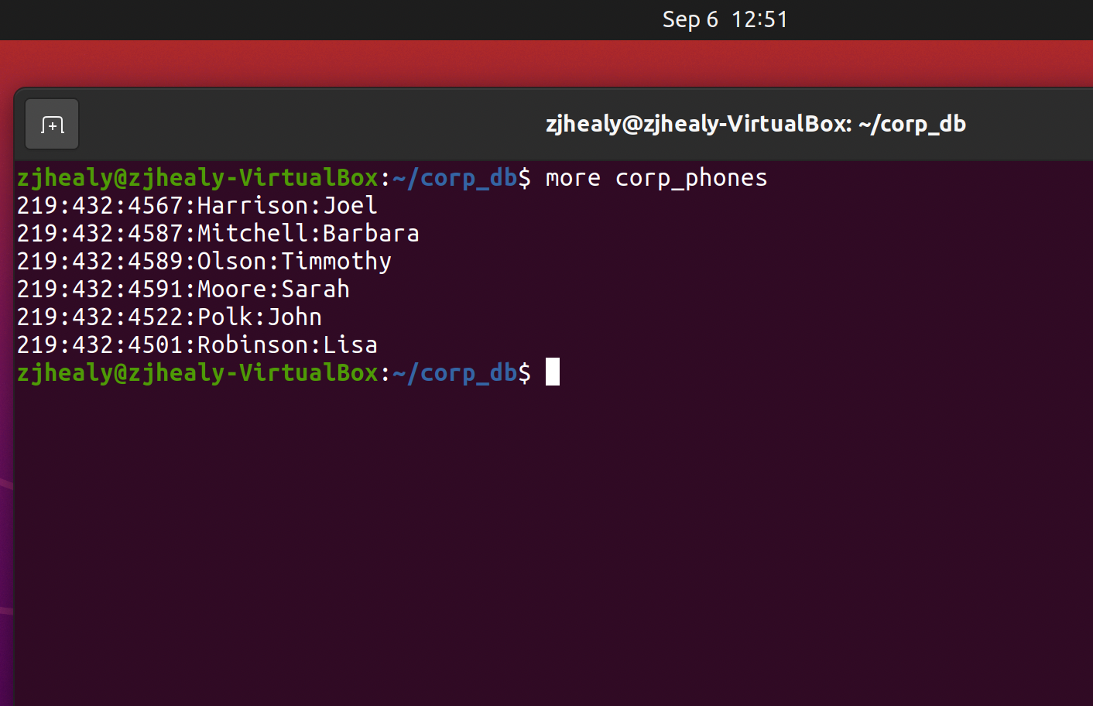

Part C

The main thing that I took away from the paper was the file system that was described to us. It does a good job of explaining how it works and gives good ways of describing it that made it easy for me to understand. Linux has a very different way of finding and getting files from storage. Seeing the diagram and commands all laid out was very helpful for me and helped me to realized why and how each command works. Onto of that it had some helpful diagrams explaining the ways that the layers of a system work. We have been looking at the triangle/pyramid in class a lot, but seeing the layers stacked on top of each other seemed to make more sense to my brain. Alongside that it also went into better detail than what we originally discussed in class which also made more sense to me. It helped me to not only understand more about Linux but also about computers in general. Something else that interested me was the who idea of how things were optimized in Linux, I was fascinated when setting up the virtual machine that an os could run so well on such little RAM, and when it is explained to me on the paper it made a lot of sense. Between clever file storage and using the cache well it made it so that the OS works well. Overall, I would say that I got a lot of good take aways from this paper. I think it is going to be something that will end up helping me to understand more better visually about Linux and in turn help me succeed in this class.

