Page 179

Project 4 – mysizeof.c

**zjhealy@zjhealy-VirtualBox**:**~**$ vi mysizeof.c

#include<stdio.h>

#define N 10

int main(void){

int a[N], i;

printf("Enter %d numbers: ", N);

for(i = 0; i < N; i++)

scanf("%d", &a[i]);

printf("In reverse order: ");

for (i = N - 1; i >=0; i--)

printf(" %d", a[i]);

printf("\n");

int w = (sizeof(a)/sizeof(a[0]));

printf("Array Length: %d\n", w);

return 0;

}

Project 7 – five2five.c

#include<stdio.h>

#define rows 5

#define col 5

int main(){

int arr[rows][col];

int rowTotals[rows];

int colTotals[col];

for(int i = 0; i < rows; i ++){

printf("Enter row %d: ", i + 1);

scanf("%d %d %d %d %d", &arr[i][0], &arr[i][1], &arr[i][2],

&arr[i][3], &arr[i][4]);

}

for(int j = 0; j < rows; j ++){

for(int i = 0; i < col; i ++){

rowTotals[i] = rowTotals[i] + arr[i][j];

colTotals[j] = colTotals[j] + arr[i][j];

}

}

for(int i = 0; i < rows; i++){

printf("%d ", rowTotals[i]);

}

printf("\n");

for(int i = 0; i < col; i++){

printf("%d ", colTotals[i]);

}

printf("\n");

}

Page 215

Exercise 12 - product.c

**zjhealy@zjhealy-VirtualBox**:**~**$ vi product.c

#include<stdio.h>

double inner_product(double a[], double b[], int n);

int main(){

double a[] = {1, 2, 3, 4, 5};

double b[] = {1, 2, 3, 4, 5};

int n = 5;

double x = inner_product(a, b, n);

printf("%f\n", x);

}

double inner_product(double a[], double b[], int n){

int temp = 0;

for(int i = 0; i < n; i++){

temp = temp + (a[i] * b[i]);

}

return temp;

}

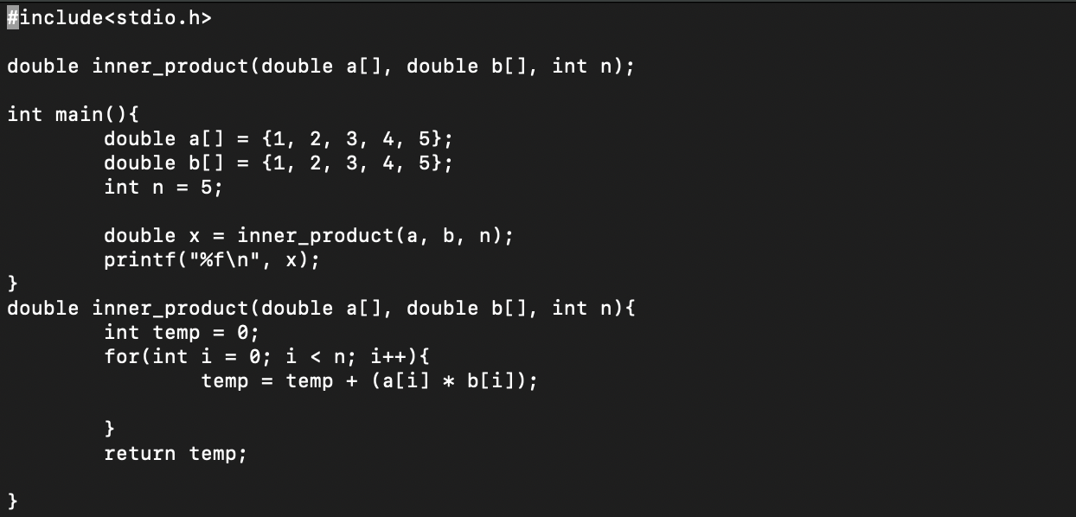

Page 217

Project 6 – polyfun.c

#include <stdio.h>

double poly(int x){

int temp = (3*(x*x*x*x*x)) + (2*(x*x*x*x)) - (5*(x*x*x)) - (x*x) + (7*x) - 6;

return temp;

}

int main(){

int w;

printf("Enter a number: ");

scanf("%d", &w);

printf("%f\n", poly(w));

}

