Project Description

Base URL: https://mitcheza-api-2.appspot.com

My database contains 3 entities: art museums / collectors (users), works of art, and artists. User information is not saved in my database, but is instead outsourced to a 3rd party application, Auth0. Artworks and artists are saved in the database. An entity-relationship diagram of the database, with all corresponding entity properties looks like so:
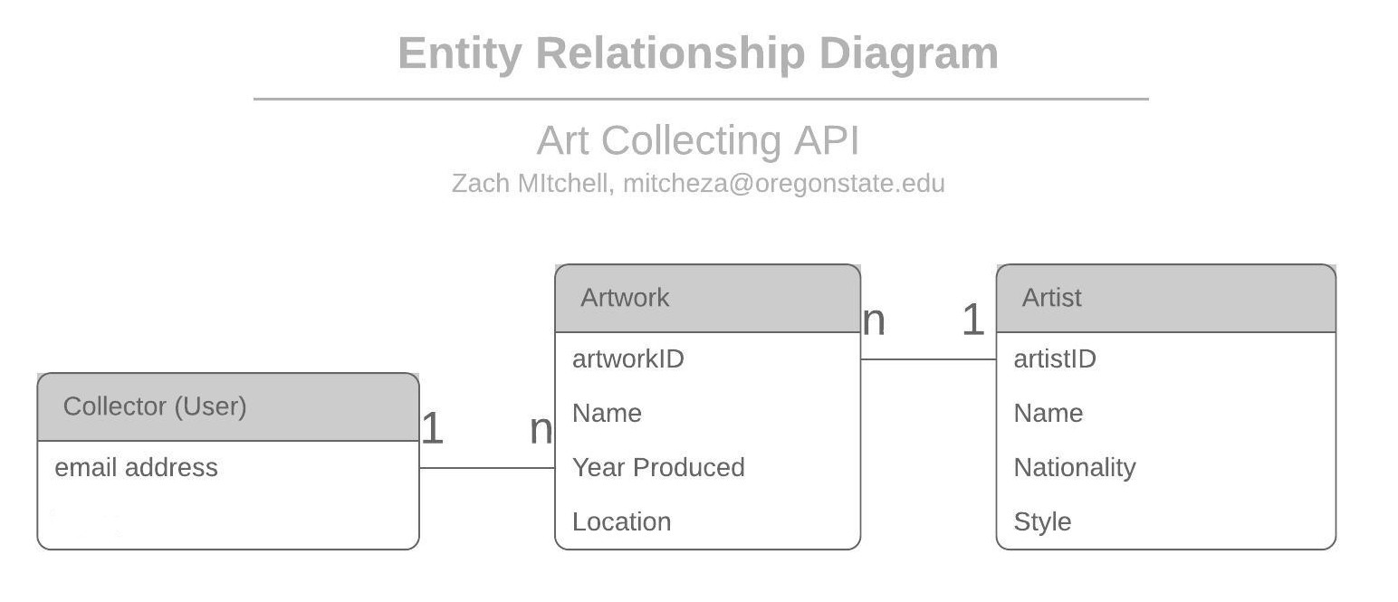
JSON Representation of Entities

Artwork:
{
"owner": "museo@seattle.com",
"name": "La Vie",
"year": 1903,
"location": "Cleveland",
"artist": {
"id": "5129017531301888",
"self": "https://mitcheza-api-2.appspot.com/artists/5129017531301888",
"name": "Pablo Picasso"
},
"id": "5633369601736704",
"self": "https://mitcheza-api-2.appspot.com/works/5633369601736704"
}

Artist:
{
"name": "Paul Gauguin",
"nationality": "French",
"style": "Post-Impressionism",
"works": [
{
"id": "5635321228165120",
"self": "https://mitcheza-api-2.appspot.com/works/5635321228165120",
"name": "Woman with a Flower"
},
{
"self": "https://mitcheza-api-2.appspot.com/works/5762273213677568",
"name": "Where Do We Come From? What Are We? Where Are We Going?",
"id": "5762273213677568"
}
],
"id": "5764984579555328",
"self": "https://mitcheza-api-2.appspot.com/artists/5764984579555328"
}

API Documentation - Base URL: https://mitcheza-api-2.appspot.com

All calls to the API must explicitly accept ‘application/json’ in the header.

- Museums / Collectors (Users)

To make any call to the database using the API, a user must first be registered and then login and use their Bearer token for all subsequent interactions.

Create a New User: Adds a new user to our Auth0 application for future authenication/authorization requests.

Call: POST /newuser

Parameters:
“username”: - String, email address
“password”: - String, password to login to authenticate for API usage

Response:
Status: 201 Created

“<username> account created!”
User Login: Authenticates user and gives them a Bearer token which they can then use to authorize future calls to the API.

Call: POST /login

Parameters:
“username”: - String, email address
“password”: - String, password to login to authenticate for API usage

Response:
Status: 200 OK

{
"access_token": "eyJ0...DsQ",
"id_token": "eyJ0e….eEig",
"scope": "openid profile email address phone read:current_user update:current_user_metadata delete:current_user_metadata create:current_user_metadata create:current_user_device_credentials delete:current_user_device_credentials update:current_user_identities",
"expires_in": 86400,
"token_type": "Bearer"
}

