 | FPT ACADEMY INTERNATIONAL  FPT – APTECH COMPUTER EDUCATION
Centre Name: ACE-HCMC-2-FPT.
Address: 590 Cach Mang Thang 8, District 3, Ho Chi Minh City, Viet Nam.

eProject – Sem 3
Jamesthew.com

Supervisor: | MR. TRAN PHUOC SINH
Semester: | 3
Batch No: | T1.1805.E0
Group No: | 5
Order: | Full name | Roll No.
1. | MAI TRUNG NGUYEN | Student1102046
2. | LA THANH NHAT | Student1102051
3. | BUI TRONG NGHIA | Student1102050
4. | NGUYEN NGOC SON | Student1102042
5. | NGUYEN TRONG DANG | Student1085538

Aug 2019
Contents

1. Acknowledgements 3
2. Introduction 4
3. System requirements Specifications 4
3.1. Server Requirement 4
3.2. Client Requirement 5
4. Objective and Scope of the thesis.......................................................................6
4.1. Techology Used 6
4.2. Target 6
5. Design 8
5.1. Function diagram 8
5.2. Data Flow diagram 10
5.3. Entity Relationship diagram 12
5.4. Flow chart 13
6. Site Map 15
7. Database Design 18
8. System Prototype 21
8.1. Screenshot of page 21
8.2. Screenshot of code 25

This is to certify that
Mr.
Mai Trung Nguyen____________________________________
Bui Trong Nghia _____________________________________
La Thanh Nhat ______________________________________
Nguyen Ngoc Son _____________________________________
_Nguyen Trong Dang____________________________________

has successfully designed & developed
project: JAMESTHEW.com________________________________________

Submitted by:
Bui Trong Nghia________________________________________________

Date of issue: August 19th 2019__________________________________
Authorised Signature:

- Acknowledgment

We would like to acknowledge all those who have given support and help us make the project a success.
We wish to express our deep gratitude to all teachers who have been devoting their lives to teach us how to stand-alone and walk ahead.
We are grateful to our families who take care and encourage us even though we are successful or failed, also to our friends who are always care of us. They never leave us alone and always look forward to us when we are on any road of the life.
We are much thankful to the entire staff and chairpersons at the Head Office of Aptech Worldwide, Aptech – Vietnam, and FPT – Aptech Center who have been organizing and looking after our studying course.
There are no words to show our appreciation for teachers of FPT Aptech Centre who have been organizing and looking after us during our studying course to finish this project. Our special thanks Mr Tran Phuoc Sinh who works day by day to teach and guide us,e-Project Team at the Head Office who instruct and help us.
Finally, we would like to offer many thanks to all our schoolfellows for their valuable suggestions.
We would like to thank sincerely!

- Introduction
James Thew is one of the famous cook working in one of the five star hotels in the city. He is so famous that the publishers approach him to write recipes book, and provide some of the tips pertaining to the recipes, etc. Also some of the producers want him to work for their recipe shows where he needs to cook two or three recipes of different categories like juices, non-vegetarian and vegetarian recipes, Italian recipes, etc.

He actually loves cooking, and during his free time he spends his time by cooking and trying out new recipes that he had come across. He also wanted to conduct the cookery classes and share his recipes where he can interact with different people and can get their feedback. So he has started the classes near by his home, as a part-time job during the weekends, where people used to attend for learning the different varieties of recipes from him. He generally charges with very less fares for these weekend classes, so as to attract the maximum number of people to the classes.

- System requirements Specification
  - Server Requirement
- Hardware
Component | Requirement
CPU | Processor type:  Pentium IV-compatible processor or faster  Processor speed:  Recommended: 2.0 GHz or faster
OS | Microsoft Windows Server 2012 with IIS
Memory (RAM) | RAM:  Minimum: 512 MB  Recommended: 2 GB or more
Hard Drive | Free space:  Minimum: 200 MB  Recommended: 50 GB or more  Maximum: Operating system maximum

- Software
Component | Requirement
Microsoft .NET Framework | Version 4.6 or higher
RDBMS | Microsoft SQL Server 2017

3.2 Client Requirement
- Hardware
Component | Requirement
CPU | Processor type:  Pentium III-compatible processor or faster  Processor speed:  Recommended: 1.0 GHz or faster
OS | All OS(Window, Linux, Android, Mac OS …)
Memory (RAM) | RAM:  Minimum: 512 MB  Recommended: 1 GB or more  Maximum: Operating system maximum
Hard Drive | Free space:  Minimum: 10 MB

- Software
Component | Requirement
Web Browser | Chrome, Opera (up to date)

- Objective and Scope of the thesis
  - Technology Used
Using framework: ASP.NET for building project and services with .net, c#.
  - Objective
- The main menu of website:
- Home Page describing about the owner (Mr. James Thew)
- Show Recipes and show the contests
- Customer can register with Register Page provided he makes the payment (Monthly Subscription – 10$ and Yearly Subscription – 100$ )

- Admin or owner (Mr. James):
- Can access to all the cookery recipes on the site.
- View, search, update and delete the recipes and tips online.
- Can view all the feedbacks received for recipes.
- Post new contests or remove the contests.
- View, update, delete the posts, recipes and tips
- Login User:
- View all the cookery recipes on the site.
- View and search the recipes and tips online.
- Can view the announcements made by the owner.
- Can send a feedback for a recipe.
- View and Participate in the contests.
- View or update or delete the tips and recipes that he/she has sent.
- General User (who is not the member of the site):
- Can register User to Login in the site.
- View and search the recipes and tips online on the free recipes alone, but can have access to only the cookery recipes and the tips that are available as free on the site.
- Can view the announcements made by the owner.
- Can send a feedback for a recipe.

Task Sheet Review I

Project Ref. No: 4 | Project Title:  Jamesthew.com | Date of Preparation of Activity Plan
No. | Task | Actual Start Date | Actual Days | Team Member Names | Status
01 | Acknowledgment | Aug 19,2019 | 2 | All Members | Completed
02 | Introduction | Aug 19,2019 | 2 | All Members | Completed
03 | System requirements Specification | Aug 19,2019 | 2 | All Members | Completed
04 | Objective and Scope of the thesis | Aug 19,2019 | 2 | All Members | Completed
05 | Task sheet | Aug 19,2019 | 2 | All Members | Completed

 | Prepare By: Group 5 | Approved By: Faculty
Date: Aug 23, 2019 | Team Leader  La Thanh Nhat | Mr. Tran Phuoc Sinh

- Design
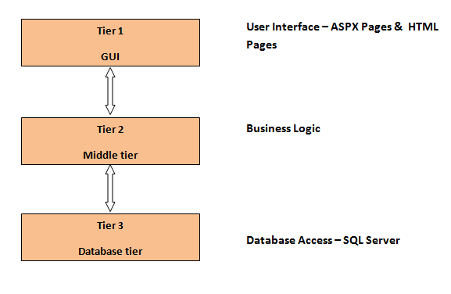
We build this project with three packages which corresponding 3 tiers : SystemGUI, Business, DataAccess.

- FUNCTION DIAGRAM
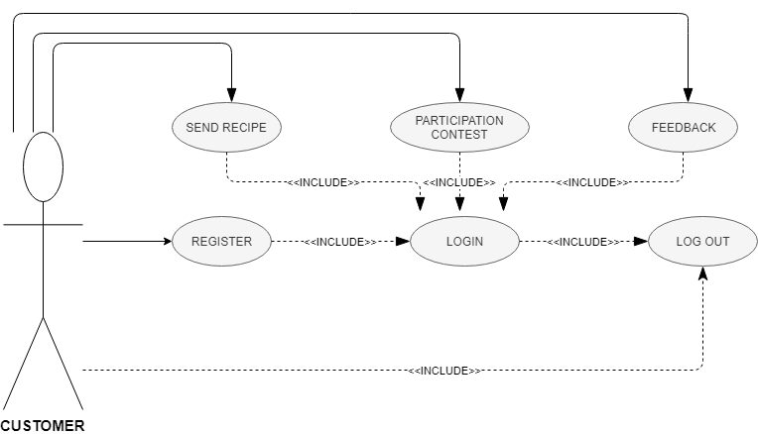
VISITOR

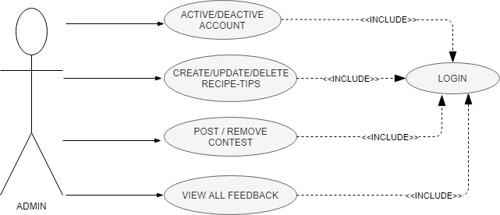
ADMINISTRATOR

- Data Flow Diagram:
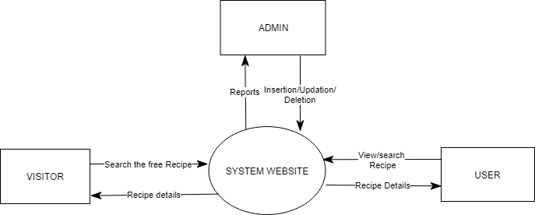

Display Recipe
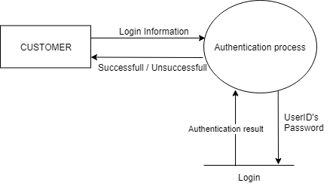
Login

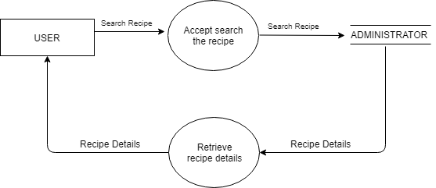

Search DFD

- E-R Diagram

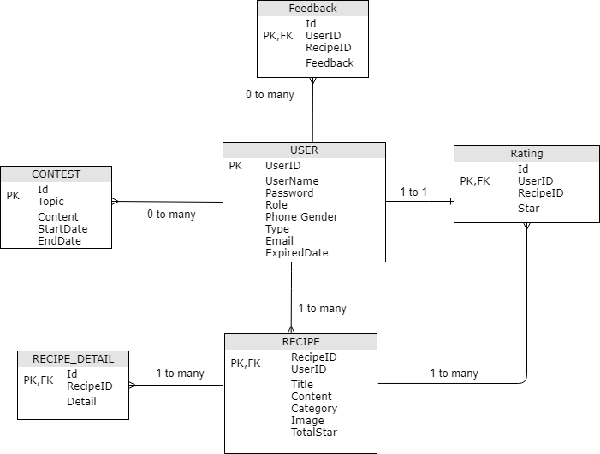

Flow chart
Add the recipe:
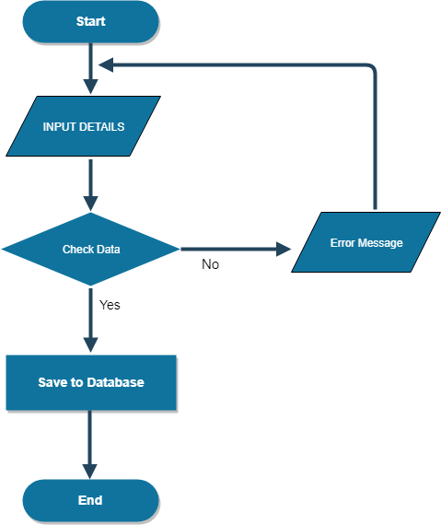
Edit the recipe:
Search recipes:
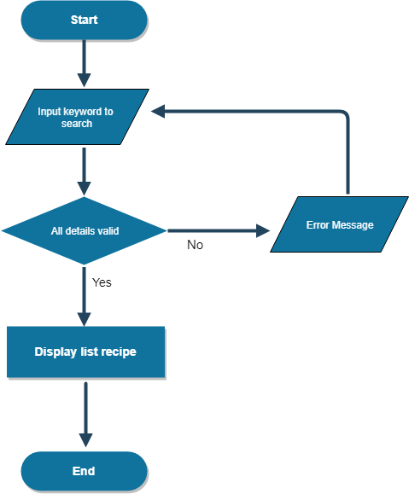
Delete Recipe:

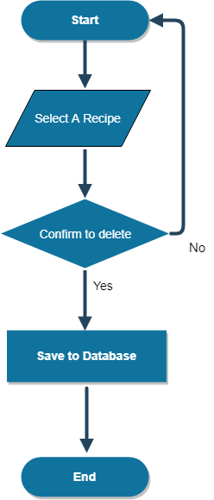
- Site Map
- The visitor’s website:
- Home:
- Display the recipes and contest.
- Recipe page:
- Display recipes.
- Recipe detail:
- Display detail recipe
- Rating recipe
- Feedback recipe
- Contest page:
- Display the content of the contest
- Sign-up:
- Allow visitors to create an Account
- Log-in:
- Allow visitor to log in
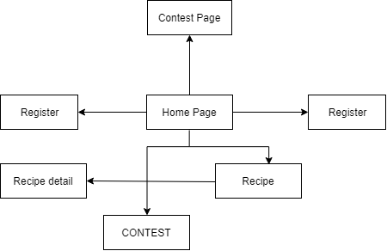

- The admin’s website:

- View, add, edit, delete the recipe.
- Add, edit, delete the contest.
- Disable and enable the user.



Task Sheet Review II

Project Ref. No: 4 | Project Title:  Jamesthew.com | Date of Preparation of Activity Plan
No. | Task | Actual Start Date | Actual Days | Team Member Names | Status
01 | Flow Chart | Aug 23,2019 | 5 | All Members | Completed
02 | DF DIAGRAM | Aug 23,2019 | 5 | All Members | Completed
03 | ER DIAGRAM | Aug 23,2019 | 5 | All Members | Completed
04 | Task sheet |  |  | All Members | Completed
05 | Site Map |  |  | All Members | Completed

 | Prepare By: Group 5 | Approved By: Faculty
Date: Aug 23, 2019 | Team Leader  La Thanh Nhat | Mr. Tran Phuoc Sinh

Database Design
- Recipes table:
Column Name | Data type | Null | Key | Note
id | uniqueidentifier | no | primary key
name | Nvarchar(30) | no
category | nvarchar(MAX) | no
content | nvarchar(MAX) | no
type | nvarchar(MAX) | no
createAt | Datetime | no
enabled | Bit | no
image | nvarchar(MAX) | yes
manager | uniqueidentifier | no | foreign key

- Feedbacks table:
Column Name | Data type | Null | Key | Note
id | uniqueidentifier | no | primary key
content | nvarchar(MAX) | no
createAt | Datetime | no
userId | uniqueidentifier | no | foreign key
recipe_id | uniqueidentifier | no | foreign key

- User table:
Column Name | Data type | Null | Key | Note
id | uniqueidentifier | no | primary key
name | Nvarchar(30) | no
email | nvarchar(30) | no
phone | nvarchar(MAX) | no
gender | nvarchar(MAX) | no
role | nvarchar(MAX) | yes
expireDate | Datetime | yes
enaled | Bit | no
emailVerify | nvarchar(MAX) | yes
pass | nvarchar(MAX) | no

- Contest table:
Column Name | Data type | Null | Key | Note
id | uniqueidentifier | no | primary key
name | nvarchar(30) | no
startDate | Datetime | no
endDate | Datetime | no

- Rating table:
Column Name | Data type | Null | Key | Note
Id | uniqueidentifier | no | primary key
userId | uniqueidentifier | no | foreign key
recipeId | uniqueidentifier | no | foreign key
Star | int | yes

- System Prototype
8.1 Screenshot of Page
- Register page:
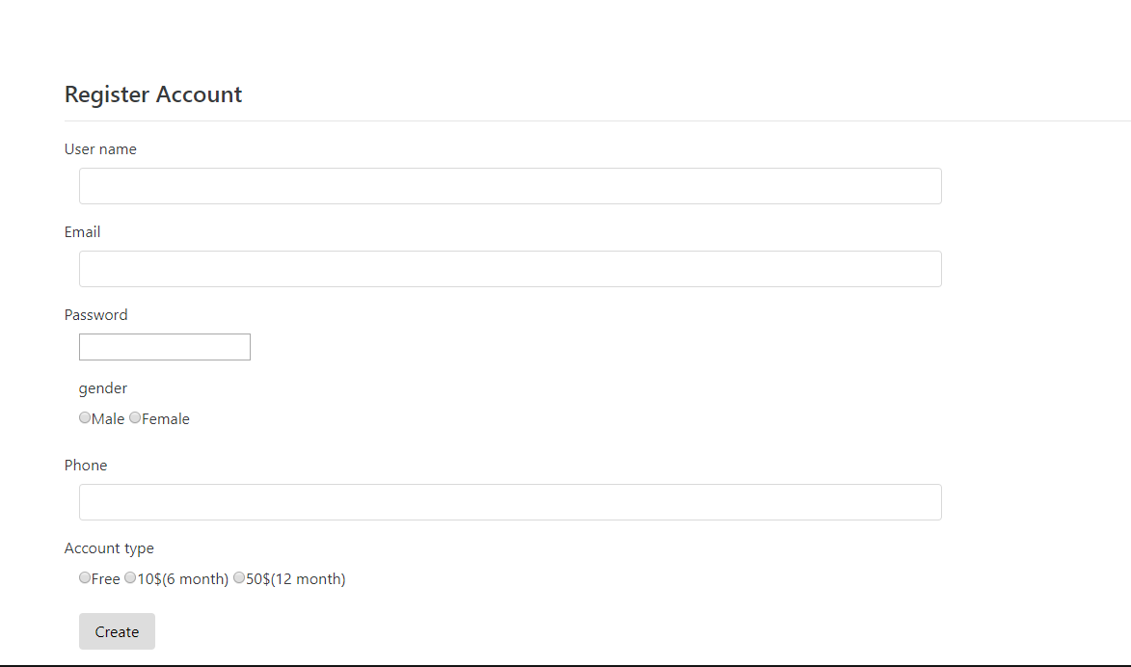
- Overview: Visitors can register an account here with paid or free form. After they can login by that account.

- Recipe page:
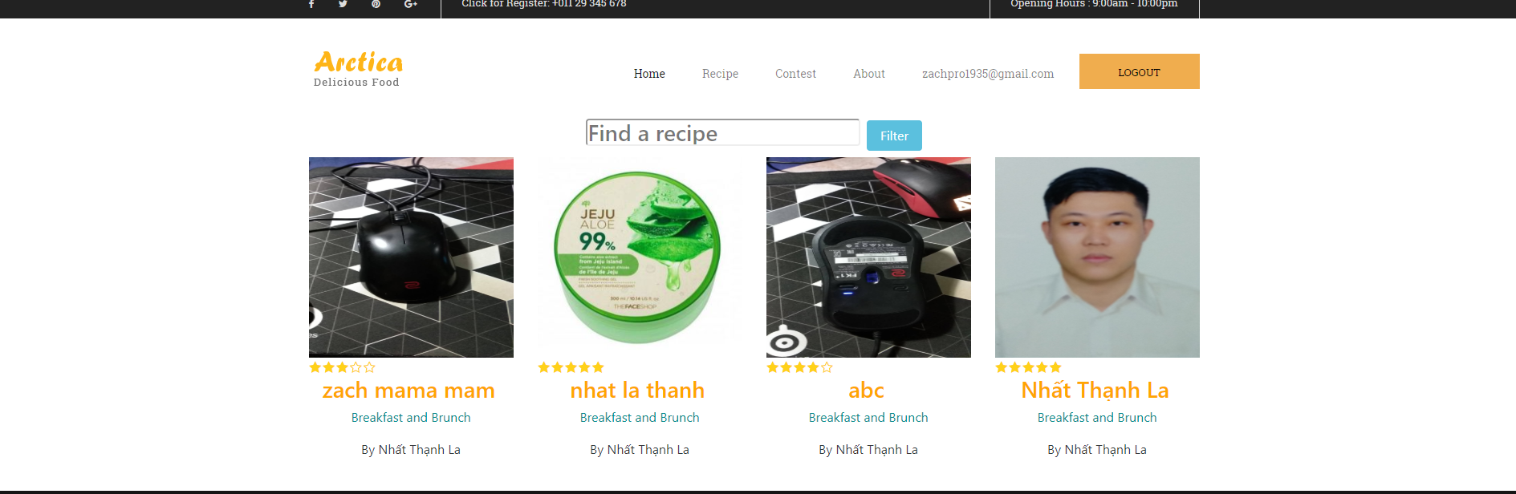
- Overview: This page will show all recipe for Payment User and only free recipe for free user. Click the Recipe to redirect to the recipe detail of the Recipe clicked.
- Recipe detail page:
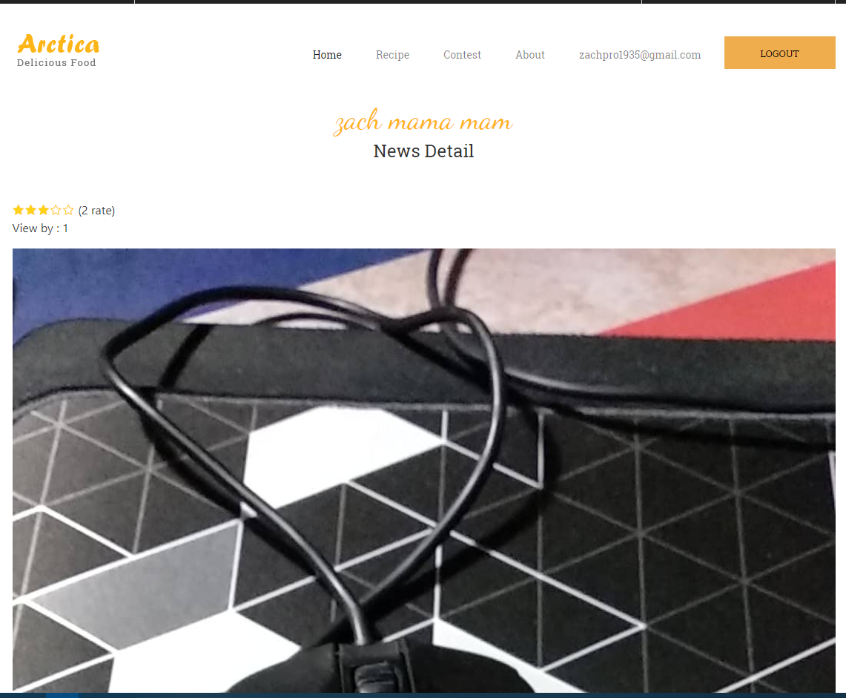
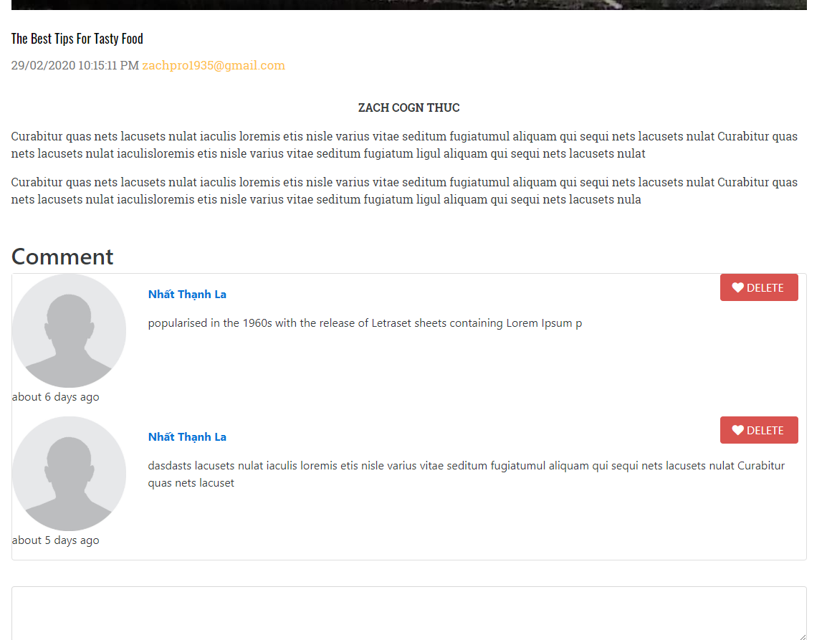
- Overview: On this page, users can view recipes. Every user have once time to rating. Users can comment and delete comments that they themselves have commented.
- User page:
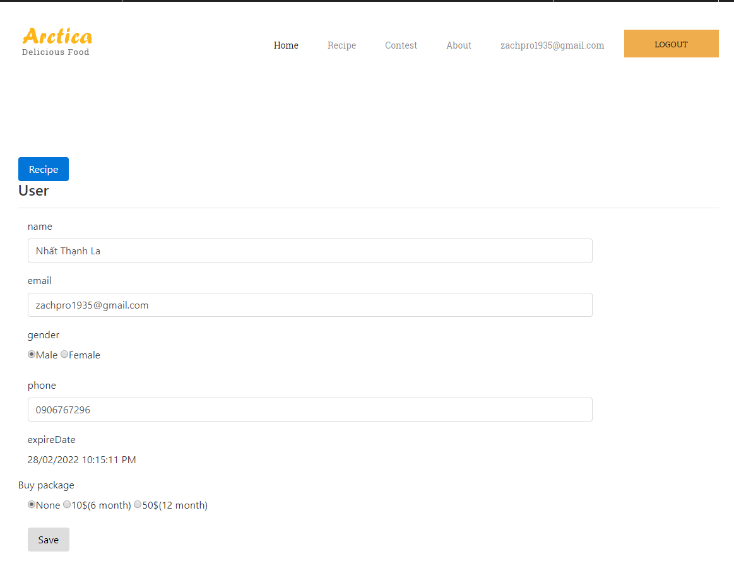

- Overview: User can see and edit their information and can create new the recipe and new recipe need enabled by Admin User in Admin page

- Create contest page:
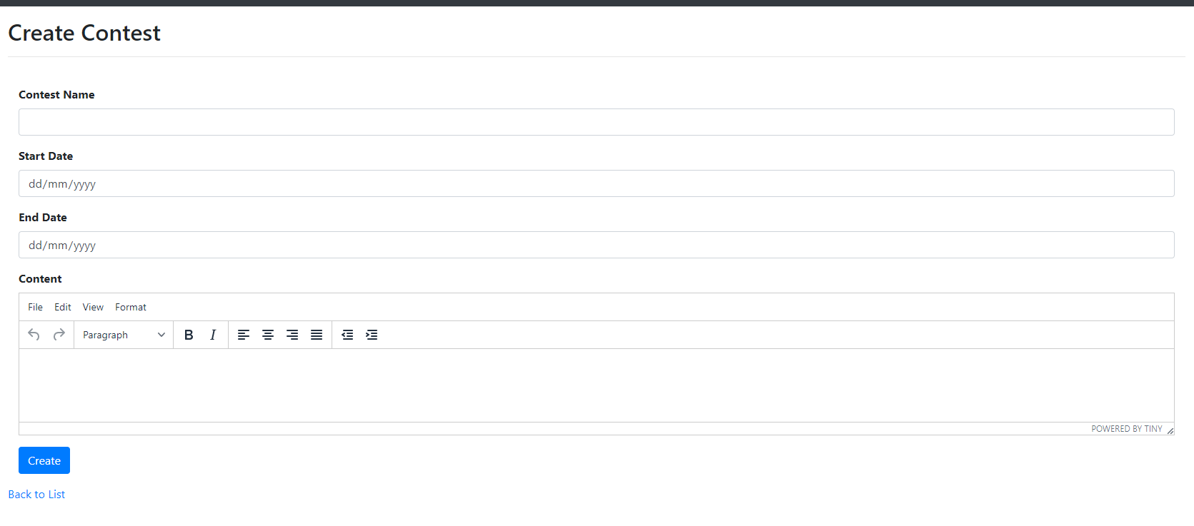
- Contest page
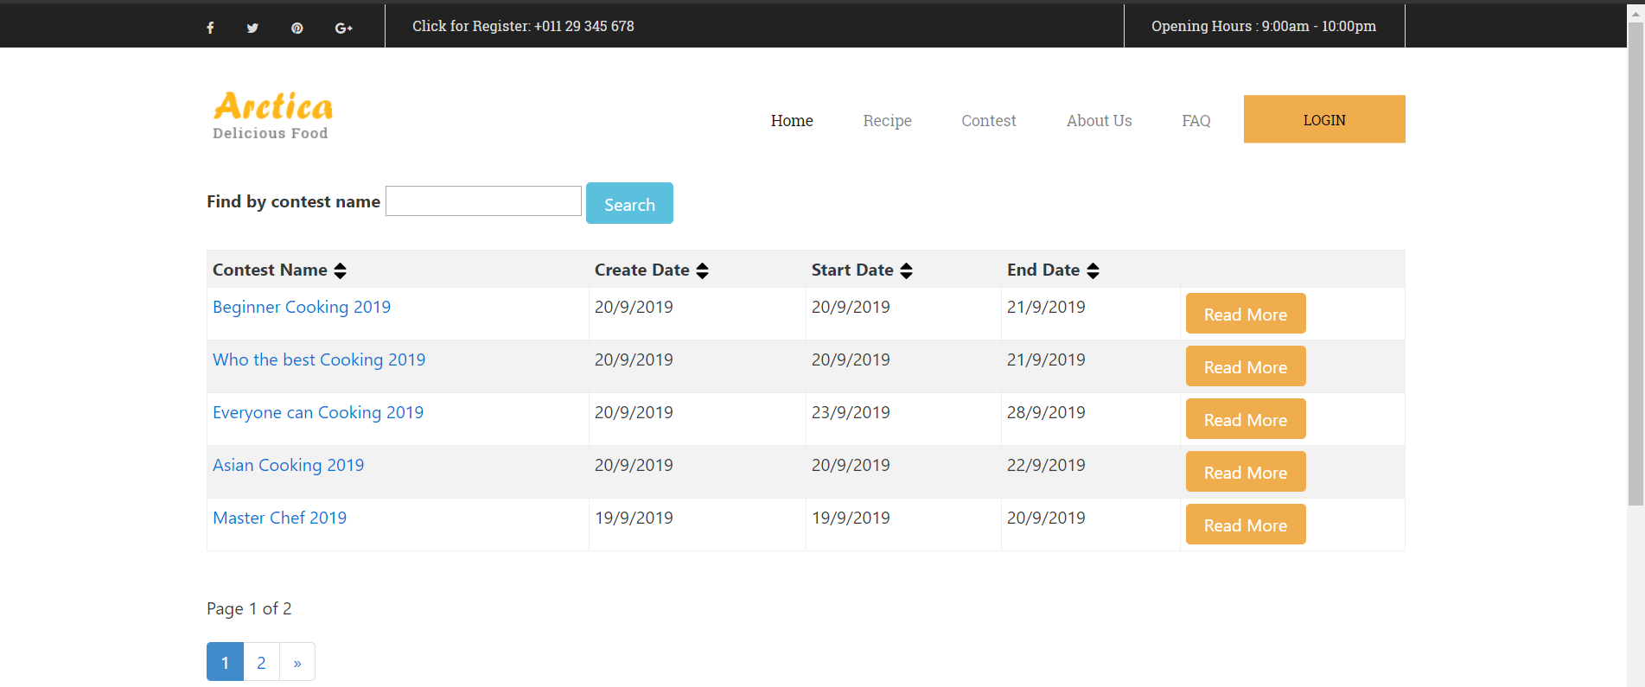
Overview: User view the contests click to see the winner and read detail.
- Admin page:
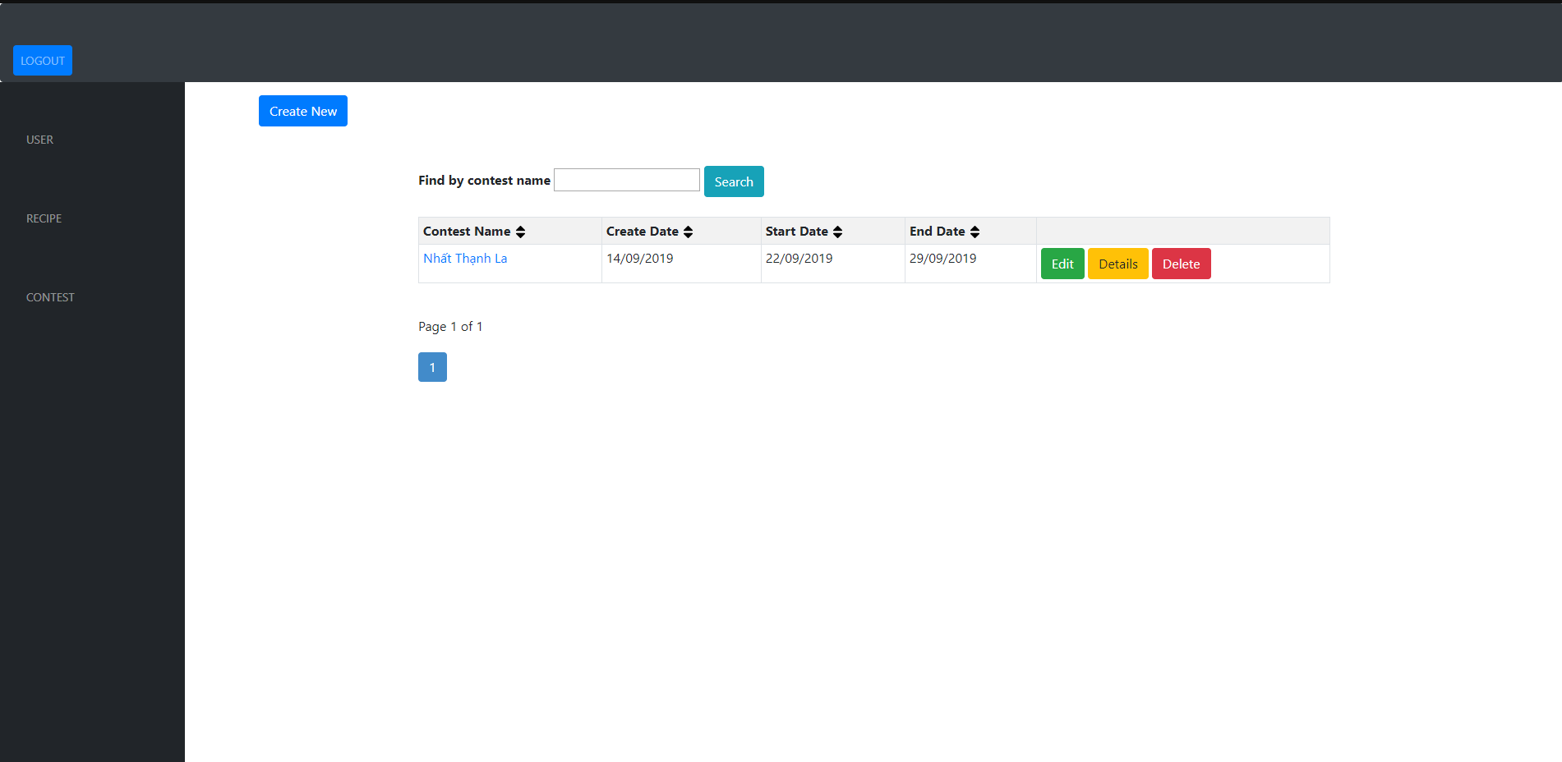

- Overview: need add “/admin” in URL to redirect to admin page when login with admin account.
  - Admin create new, edit and delete recipes, contest.
  - Admin can disable/enable the user account.
  - Admin enable the recipe in Recipe tab to show in Recipe page.
  - Admin can’t set the winner contest until end date of the contest.

  - Screenshot of Code
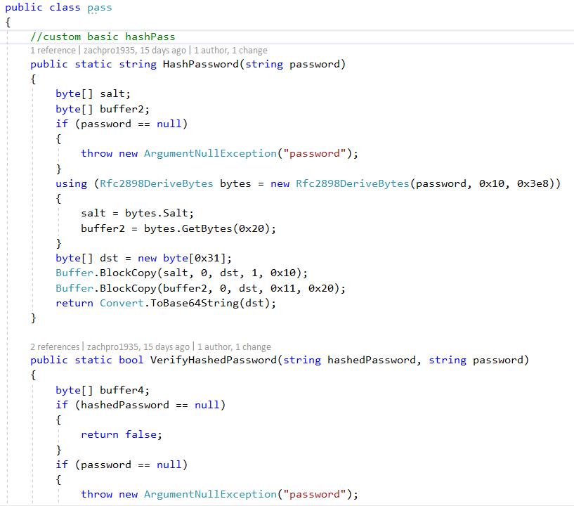

Hash the password

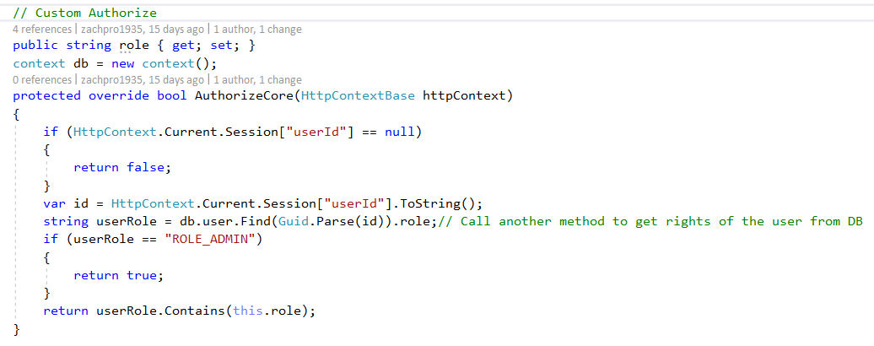
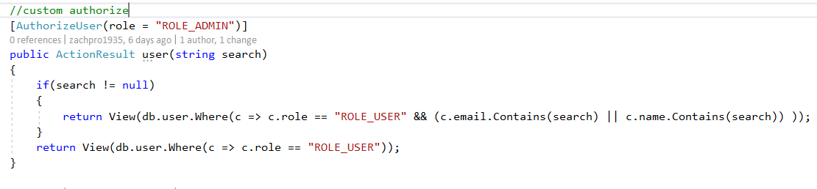
Authorized user

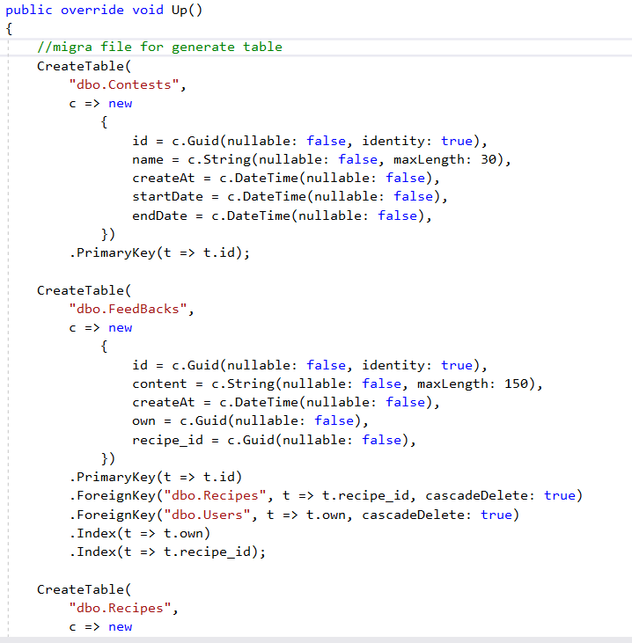

Create table

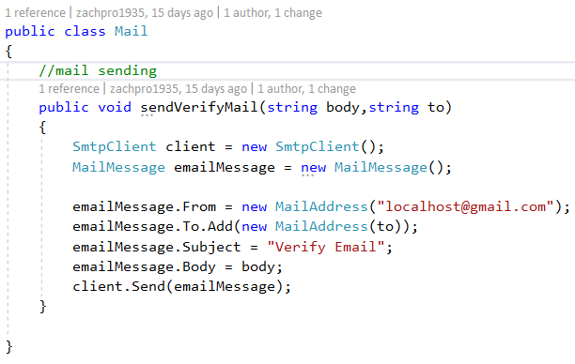
Verify mail of User
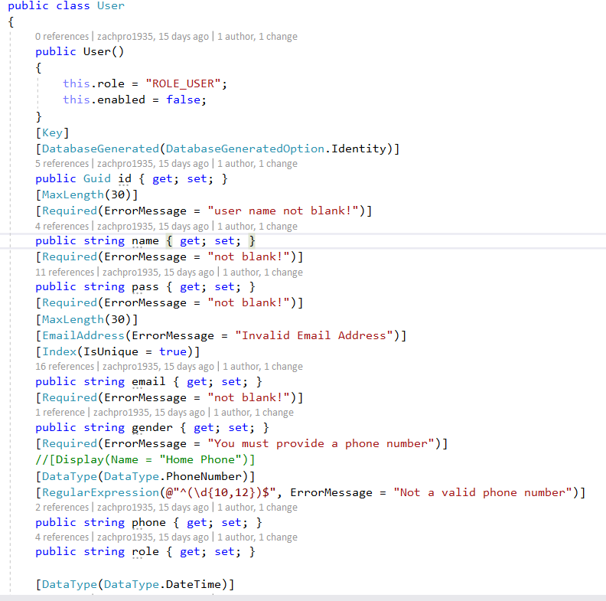
Validate on User entity

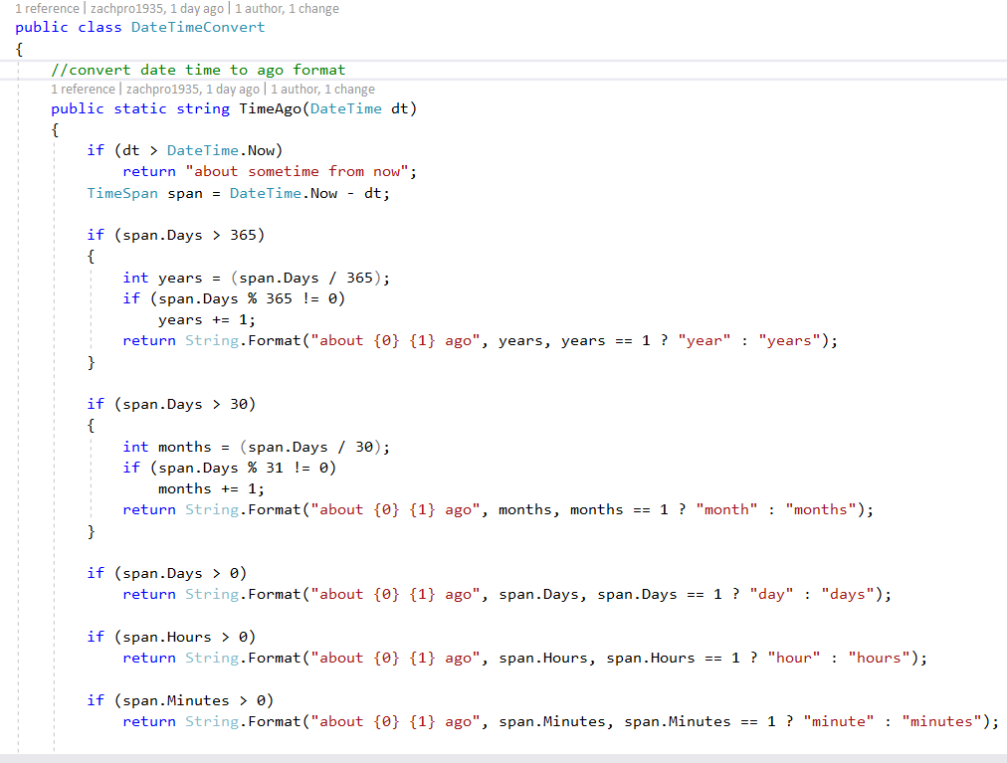
Timestamp to time ago

Task Sheet Review III

Project Ref. No: 4 | Project Title:  Jamesthew.com | Date of Preparation of Activity Plan
No. | Task | Actual Start Date | Actual Days | Team Member Names | Status
01 | Application analyse | Sep 1,2019 | 20 | ALL Member | Completed
02 | Font-end Design | Sep 1,2019 | 20 | Mai Trung Nguyen | Completed
03 | Database Design | Sep 1,2019 | 20 | ALL Member | Completed
04 | Manage Contest (Admin page) |  |  | Nguyen Ngoc Son | Completed
05 | Manage Recipe (Admin page) |  |  | Nguyen Trong Dang | Completed
06 | Manage User (Admin page) |  |  | Bui Trong Nghia | Completed
07 | Login and Register Account |  |  | La Thanh Nhat | Completed
08 | Timestamp function |  |  | La Thanh Nhat | Completed
09 | Verify Email User |  |  | La Thanh Nhat | Completed
10 | Authorization User |  |  | Bui Trong Nghia | Completed
11 | Feedback(comment) Recipe |  |  | Mai Trung Nguyen | Completed
12 | Rating Recipe |  |  | Nguyen Trong Dang | Completed
13 | Home page |  |  | Mai Trung Nguyen | Completed
14 | Recipe detail page |  |  | La Thanh Nhat | Completed
15 | Contest page |  |  | Nguyen Ngoc Son | Completed
16 | Paging function |  |  | Nguyen Ngoc Son | Completed
17 | Sort function |  |  | Nguyen Ngoc Son | Completed
18 | Design Admin page |  |  | Mai Trung Nguyen | Completed
19 | Search function |  |  | Bui Trong Nghia | Completed
20 | All recipe page |  |  | Nguyen Trong Dang | Completed
21 | Report page |  |  | Mai Trung Nguyen | Completed
22 | User detail |  |  | Bui Trong Nghia | Completed
23 | Join code and test |  |  | ALL Members | Completed
24 | Final Report & document |  |  | ALL Members | Completed

