Character Ideas

1. Geometric Shape + Basic Shading
   1. Space can be expanded to squares, triangles, rectangles, and more basic geometric shapes.
   2. Focus on shading for salience

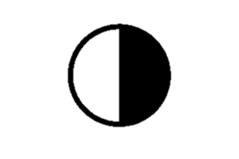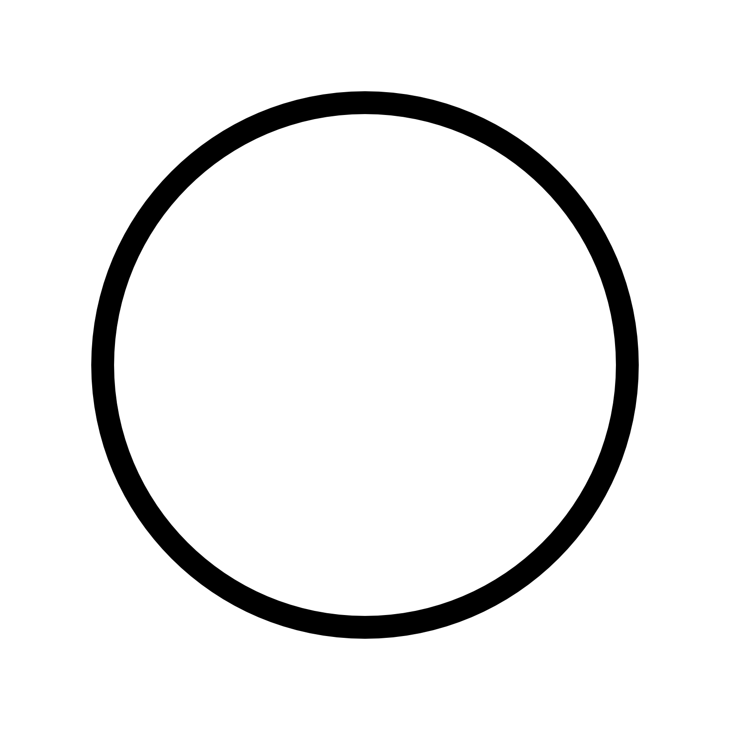

1. Letters/More complex polygons.
   1. Shadding is possible
   2. Focuses on rotation for salience

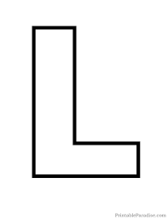

1. Flower Design
   1. Focuses on petal number and shading for salience
   2. Petal shape could be a dimension
   3. In reality, it is simply a circle where different petal like shapes can be rotated around it, allowing for variation.
   4. Another possible dimension, although I am highly doubtful that is would necessary or helpful, is ‘layering’ where petals can appear behind the the frontmost petals.
   5. Could be too complicated. Perhaps if we stick to one to four petals, that might help.

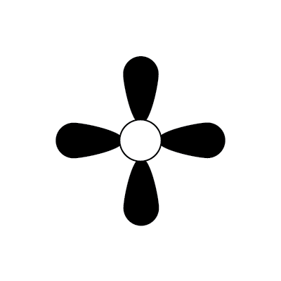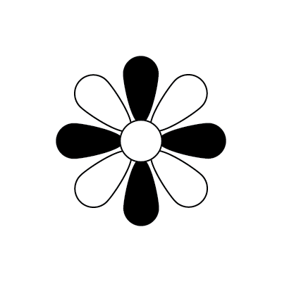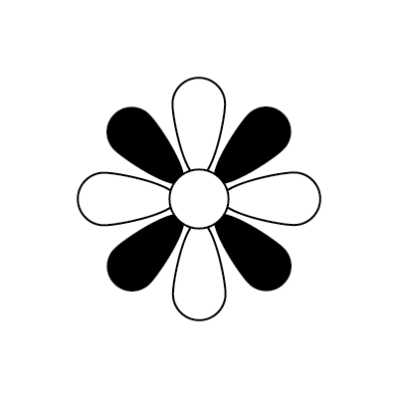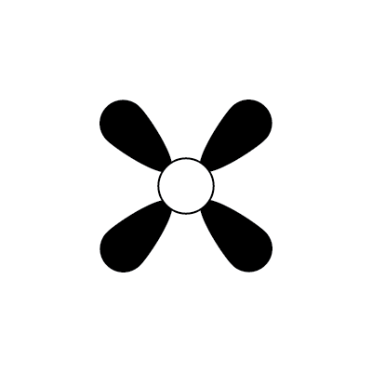

Additional Dimensions Ideas

1. X,Y,Z body Compression/Expansion
   1. Alter the object body by a given percentage or value. This could increase Height, Width, or Depth. This could have a stretch or scaling affect. If scaling, the material and uvwmap will need to be manipulated accordingly. I lean toward the latter.
   2. Viewpoint independent
2. Tilting
   1. Give a slight bend to the object.
      1. Could be slightly awkward with the pyramidal and other body types.
3. Twist
   1. Twist the object along the z axis
4. Holes…?
   1. Perhaps we could make an indention into the object body, or a hole that goes all the way through the center of the object.
   2. Could be increased in number.
   3. Size can be varied
   4. It could also be possible to do a whole with a ring in it.

Reworking the pedestal.

Although the character is a good dimension, the pedestal needs to look natural as Thilo said. To fix this I think a flat faced semi-circle may do the trick. I can play with this idea around in 3ds max. I would hope that it would make it seem natural and stylistically better. I’m sure there are better ways to approach this, but this is would I came up with as of now.