CabinVerify
Simple STR Issue Verification Report
Fictitious Sample Report - Hot Tub Cover Replacement Verification
Property | Bear Hollow Ridge Cabin - Pigeon Forge, TN (sample)
Requested By | Smoky Ridge Property Management (sample)
Owner Concern | Owner requested neutral verification before approving hot tub cover replacement.
Site Visit | May 28, 2026 | 10:20-10:42 AM
Verification Type | $99 Simple Verification - One reported issue
Overall Finding | Verified: visible condition supports replacement or immediate vendor review

Executive Summary
The reported hot tub cover concern was verified during the visit. Visible wear includes split vinyl at the front-left corner, exposed internal foam, sagging at the center seam, and strap/hinge wear. From a normal guest approach angle, the cover presents as worn and neglected even before close inspection. For an STR cabin, this creates both a guest-experience concern and an owner asset-protection concern. Based on visible condition only, CabinVerify recommends replacement or immediate hot tub vendor review.
Verification  VERIFIED | Guest Impact  MODERATE-HIGH | Urgency  NEXT 0-30 DAYS | Recommended Action  REPLACE / VENDOR REVIEW

What Was Reported
- Property manager reported that the hot tub cover was likely beyond normal cleaning/maintenance and needed replacement.
- Owner requested a neutral second look before approving replacement cost.
- CabinVerify was asked to document visible condition only, not diagnose hot tub mechanical condition or quote repair cost.

Observed Visible Conditions
Observation | Evidence Level | Owner/Guest Relevance
Front-left vinyl corner is split with foam visible. | High | Visible deterioration; likely supports replacement discussion.
Center seam appears sagged and does not sit evenly across hot tub. | Moderate-High | May affect heat retention and first impression; vendor should review.
Strap/hinge area shows wear and reduced clean presentation. | Moderate | May reduce owner confidence and guest perception of maintenance.
Cover is noticeably worn from normal guest approach angle. | High | Guest-facing appearance issue; likely review-sensitive for premium cabins.

Photo Evidence Log
Template use: replace each placeholder with actual site photos. Keep captions short and factual. Use overview photo first, then close-up evidence, then guest-facing angle.
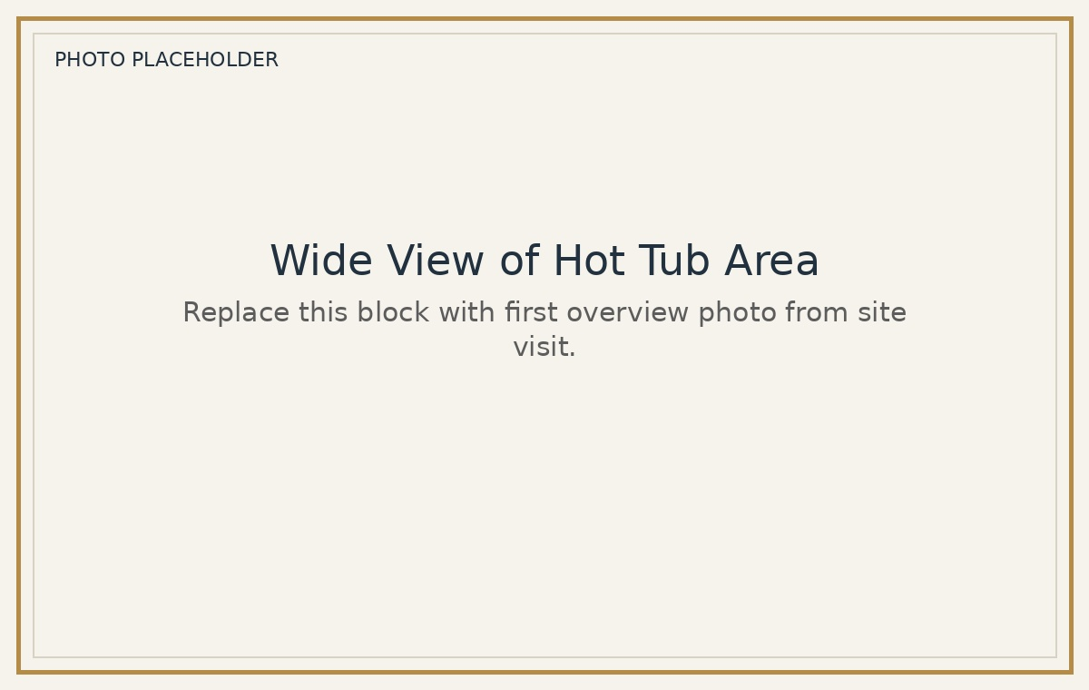  Photo 1 - Wide view | 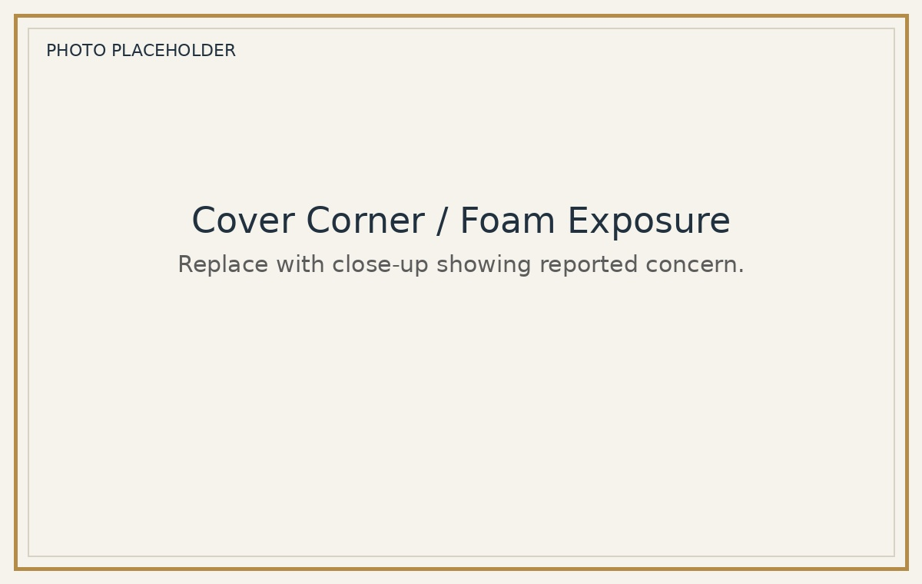  Photo 2 - Corner damage
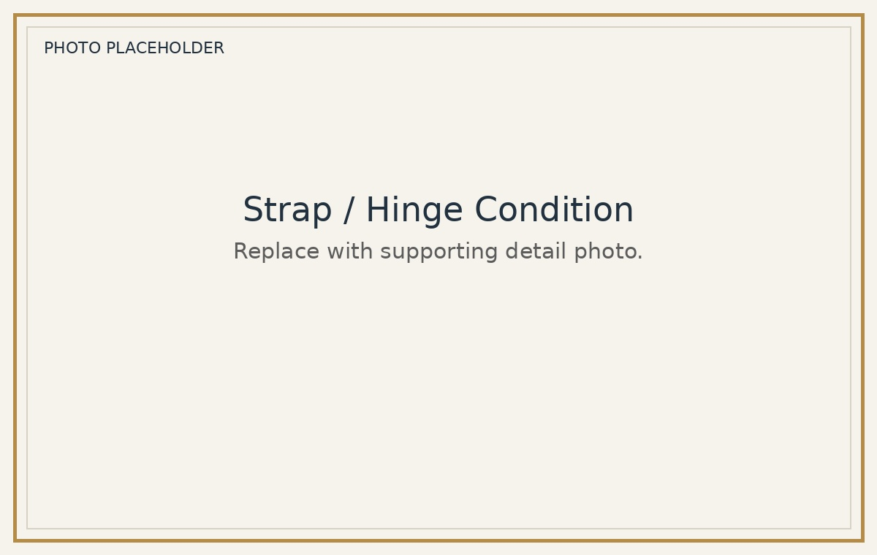  Photo 3 - Strap/hinge wear | 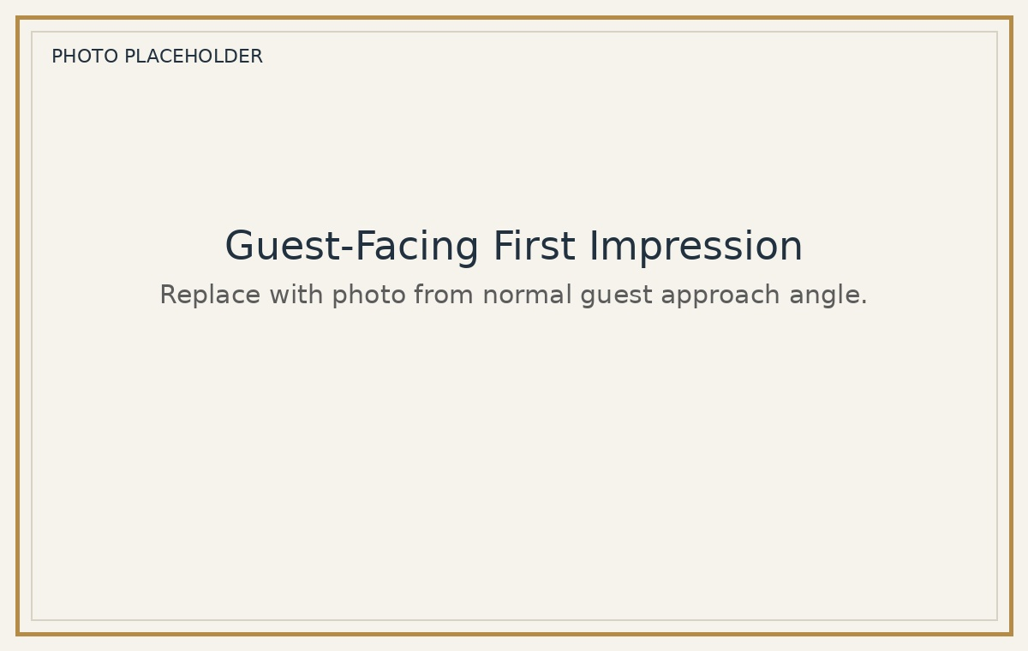  Photo 4 - Guest approach angle

Owner Decision Summary
Decision Question | Does the visible condition support approving replacement or vendor review?
CabinVerify Answer | Yes. The reported issue was visually verified.
Best Next Step | Approve replacement quote or request a hot tub vendor replacement recommendation.
If Delayed | Monitor closely, but visible wear is already guest-facing and may continue to deteriorate.

Plain-English Owner Note
This is not a borderline cosmetic note. The cover has visible deterioration from both close-up and normal guest-view angles. For a cabin marketed as a clean, cared-for STR, this kind of wear can weaken guest confidence before they ever use the hot tub. Because the cover is also part of hot tub protection and heat retention, the practical recommendation is to approve replacement or have the hot tub vendor confirm replacement timing.

Scope and Limitations
- This report documents visible conditions observed during a limited site visit. It is not a licensed home inspection, code inspection, engineering opinion, insurance adjustment, mold assessment, appraisal, or repair estimate.
- CabinVerify does not perform the repair, quote the repair, or receive compensation from repair vendors. The purpose is neutral documentation for owner/manager decision-making.
- Mechanical performance of the hot tub was not diagnosed. Any mechanical, electrical, sanitation, or safety concerns should be referred to the appropriate licensed or qualified vendor.
- Findings are based only on visible condition at the time of visit and provided access.

Template Notes for Future Reports
Use this for | $99 one-issue verification where owner needs neutral evidence.
Best photo count | 4-8 photos: overview, close-up, supporting angle, guest-view angle.
Keep language | Visible, neutral, plain-English, owner-facing.
Avoid | Code claims, causation claims, repair quotes, blame language, or contractor diagnosis.
Fast workflow | Open template > replace photos > update observations > export PDF > send to PM/owner.
Upgrade path | If there are multiple issues, convert to Standard or Owner Dispute Report pricing.

CabinVerify Report Template
Reusable Quick-Fill Field Checklist
Copy this page internally when creating a live report. Replace bracketed text and delete unused fields before final client delivery.
Field | Fill-In Value
Property Name | [Property name / cabin nickname]
Address/Area | [Address or area, if allowed]
Requested By | [Owner / Property manager / Other]
Issue Reported | [One sentence description]
Visit Date/Time | [Date / time onsite]
Photos Taken | [Number of photos]
Finding | [Verified / Not verified / Inconclusive / Refer to vendor]
Guest Impact | [Low / Moderate / High]
Urgency | [Monitor / 30-60 days / 0-30 days / immediate vendor review]
Recommended Action | [Clean / Repair / Replace / Refer / No action]

