Homework #2

By: Zachary Sweep

2/9/18

1. **Starting from the definition of the Chebyshev function**

$$C_{N}\left(x\right)=f\left(x\right)=\left\{\begin{aligned}cos(N \cos^{-1}{x)}, &|x|≤1 \\ cosh(N \cosh^{-1}{x)}, &|x|>1\end{aligned}\right.$$

**Show that $C_{N}(x)$ obeys the following recursion: $C_{N+1}(x) = 2xC_{N}(x) - C_{N-1}(x)$. Consider the cases $|x|≤1$ and $|x|>1$ separately.**

For |x| ≤ 1:

$$C_{N}\left(x\right)=cos\left(Ncos^{-1}x\right)$$

$$C_{N+1}\left(x\right)=cos\left(\left(N+1\right)cos^{-1}x\right)=cos\left(Ncos^{-1}x+cos^{-1}x\right)=cos\left(Ncos^{-1}x\right)cos\left(cos^{-1}x\right)-sin\left(Ncos^{-1}x\right)sin\left(cos^{-1}x\right)=cos\left(Ncos^{-1}x\right)x-sin\left(Ncos^{-1}x\right)sin\left(cos^{-1}x\right)$$

$$C_{N-1}\left(x\right)=cos\left(\left(N-1\right)cos^{-1}x\right)=cos\left(Ncos^{-1}x - cos^{-1}x\right)=cos\left(Ncos^{-1}x\right)cos\left(cos^{-1}x\right)+sin\left(Ncos^{-1}x\right)sin\left(cos^{-1}x\right)=cos\left(Ncos^{-1}x\right)x+sin\left(Ncos^{-1}x\right)sin\left(cos^{-1}x\right)$$

$$C_{N+1}\left(x\right)+C_{N-1}\left(x\right)=cos\left(Ncos^{-1}x\right)x-sin\left(Ncos^{-1}x\right)sin\left(cos^{-1}x\right)$$

$$+cos\left(Ncos^{-1}x\right)x+sin\left(Ncos^{-1}x\right)sin\left(cos^{-1}x\right)$$

$$C_{N+1}\left(x\right)+C_{N-1}\left(x\right)=2x*cos\left(Ncos^{-1}x\right)$$

$$C_{N+1}\left(x\right)=2x*cos\left(Ncos^{-1}x\right) - C_{N-1}\left(x\right)=2xC_{N}\left(x\right) - C_{N-1}\left(x\right)$$

For |x| > 1:

$C_{N}\left(x\right)=cosh\left(Nco{sh}^{-1}x\right)$:

$$C_{N+1}\left(x\right)=cosh\left(\left(N+1\right)co{sh}^{-1}x\right)=cosh\left(Nco{sh}^{-1}x+co{sh}^{-1}x\right)=cosh\left(Nco{sh}^{-1}x\right)cosh\left(co{sh}^{-1}x\right)+sinh\left(Nco{sh}^{-1}x\right)sinh\left(co{sh}^{-1}x\right)=cosh\left(Nco{sh}^{-1}x\right)x+sinh\left(Nco{sh}^{-1}x\right)sinh\left(co{sh}^{-1}x\right)$$

$$C_{N-1}\left(x\right)=cosh\left(\left(N-1\right)co{sh}^{-1}x\right)=cosh\left(Nco{sh}^{-1}x - co{sh}^{-1}x\right)=cosh\left(Nco{sh}^{-1}x\right)cosh\left(co{sh}^{-1}x\right)-sinh\left(Nco{sh}^{-1}x\right)sinh\left(co{sh}^{-1}x\right)=cosh\left(Nco{sh}^{-1}x\right)x-sinh\left(Nco{sh}^{-1}x\right)sinh\left(co{sh}^{-1}x\right)$$

$$C_{N+1}\left(x\right)+C_{N-1}\left(x\right)=cosh\left(Nco{sh}^{-1}x\right)x+sinh\left(Nco{sh}^{-1}x\right)sinh\left(co{sh}^{-1}x\right)+cosh\left(Nco{sh}^{-1}x\right)x-sinh\left(Nco{sh}^{-1}x\right)sinh\left(co{sh}^{-1}x\right)$$

$$C_{N+1}\left(x\right)+C_{N-1}\left(x\right)=2x*cosh\left(Nco{sh}^{-1}x\right)$$

$$C_{N+1}\left(x\right)=2x*cosh\left(Nco{sh}^{-1}x\right) - C_{N-1}\left(x\right)=2xC_{N}\left(x\right) - C_{N-1}\left(x\right)$$

1. **Design a bandpass discrete-time Elliptic filter with the following specifications: $ω_{s1}=0.2π, ω_{p1}=0.3π, ω_{p2}=0.7π, ω_{s2}=0.8π, G_{p}=0.99, G_{s}=0.01$. Plot the Magnitude response and group delay for the resulting filter design. Realize the transfer function as a cascade of first-order and second-order sections with real-valued coefficients. List the coefficients for each section.**

ws1 = 0.2*pi;  
wp1 = 0.3*pi;  
wp2 = 0.7*pi;  
ws2 = 0.8*pi;  
Gp = 0.99;  
Gs = 0.01;  
  
Rp = -20*log10(Gp);  
Rs = -20*log10(Gs);  
  
% Calculating digital Elliptic filter order and new w using normalized pass  
% band and stop band frequencies.  
[N,wpnew] = ellipord([wp1/pi wp2/pi],[ws1/pi ws2/pi],Rp,Rs);  
  
% Calculate Zeros, Poles, and Gain for digital Elliptic filter  
[z,p,k] = ellip(N,Rp,Rs,wpnew);  
  
% Calculate Z domain numerator polynomial  
Bz = poly(z);  
  
% Calculate Z domain denominator polynomial  
Az = poly(p);  
  
% Adjust for gain using k computed in line 24  
Bz = k*Bz;  
  
% Calculating Magnitude Response  
[H,wh] = freqz(Bz,Az);  
  
% Calculating Group Delay  
[Gpd,wg] = grpdelay(Bz,Az);  
  
% Plotting Magnitude Response and Group Delay  
figure(1)  
subplot(211)  
plot(wh/pi,abs(H),'-')  
xlabel('Normalized Frequency'); ylabel('Magnitude Response');  
subplot(212)  
plot(wg/pi,Gpd,'-')  
xlabel('Normalized Frequency'); ylabel('Group Delay (s)');

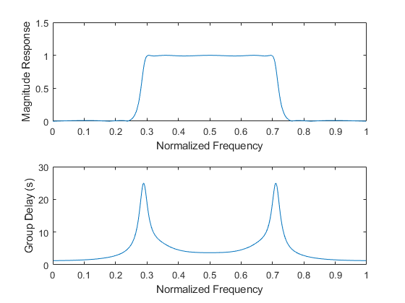

## Realize transfer function as cascaded 2nd order terms

The 2nd Order terms were acquired by using MATLAB poly function on complex-conjugate pairs for variables z (zeros) and p (poles).

% 2nd Order Numerator coefficients indexed as follows:  
% Z^2*p(1) + Z*p(2) + p(3)  
z0 = [1 0 -1];  
z1 = [1 -1.6954 1];  
z2 = [1 1.6954 1];  
z3 = [1 1.4663 1];  
z4 = [1 -1.4663 1];  
  
% 2nd Order Denominator coefficients indexed as follows:  
% Z^2*p(1) + Z*p(2) + p(3)  
p0 = [1 0 0.3335];  
p1 = [1 -0.8406 0.6311];  
p2 = [1 0.8406 0.6311];  
p3 = [1 1.1701 0.9050];  
p4 = [1 -1.1701 0.9050];  
  
% Frequency response of each term  
h0 = freqz(z0,p0);  
h1 = freqz(z1,p1);  
h2 = freqz(z2,p2);  
h3 = freqz(z3,p3);  
[h4,ww] = freqz(z4,p4);  
  
% Cascading 2nd order Transfer functions  
% Compensating for Gain  
H_cascaded = k*(h0.*h1.*h2.*h3.*h4);  
  
figure(2)  
hold on  
title('|H(e^{jw})| realized as cascaded 2nd order terms');  
xlabel('Normalized Frequency'); ylabel('Magnitude Response');  
plot(ww/pi, abs(H_cascaded),'-');

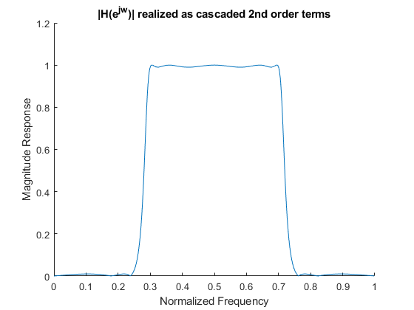

[*Published with MATLAB® R2017b*](http://www.mathworks.com/products/matlab)

