**MODULE 04 HOMEWORK**

**2/26/18**

**EN.525.718.81.SP18 MULTIRATE SIGNAL PROCESSING**

**SPRING 2018**

## Contents

Problem 1 1

Problem 2 4

Problem 3 7

## Problem 1

**Using the Kaiser window, design a highpass filter with the following specifications: ωp=0.6π, ωs=0.5π and Rs=40dB. Plot the impulse response and the frequency response magnitude.**

wp = 0.6*pi;  
ws = 0.5*pi;  
Rs = 40; %dB  
  
% Compute kaiser window filter order, wn, and beta parameters  
[N,wn,beta,ftype] = kaiserord( [ws/pi wp/pi], [0 1], [10^(-Rs/20) 10^(-Rs/20)] );  
  
% Create filter using kaiser window  
b = fir1(N, wn, ftype, kaiser(N+1,beta), 'noscale');  
  
% Impulse Response  
figure(1)  
stem((0:N),b);  
title('Filter Impulse Response'); xlabel('Samples (n)'); ylabel('Amplitude');  
  
% Frequency Response  
figure(2)  
[H,w] = freqz(b);  
plot(w/pi,20*log10(abs(H)));  
title('Filter Frequency Response');  
xlabel('Normalized Frequency (x pi rad/sample)'); ylabel('Magnitude (dB)');  
line([0 wp/pi],[-Rs -Rs],'color','red','LineStyle','--');  
line([wp/pi 1],[0.01 0.01],'color','red','LineStyle','--');  
line([wp/pi wp/pi],[-Rs 0],'color','red','LineStyle','--');  
legend('Kaiser Window LPF', 'Ideal LPF');  
  
% Zoomed view of stopband  
figure(3)  
plot(w/pi,20*log10(abs(H)));  
title('Zoomed View of Stopband');  
xlabel('Normalized Frequency (x pi rad/sample)'); ylabel('Magnitude (dB)');  
axis([0.4 0.55 -Rs-5 -Rs+5]);  
line([0 wp/pi],[-Rs -Rs],'color','red','LineStyle','--');  
line([wp/pi 1],[0.01 0.01],'color','red','LineStyle','--');  
line([wp/pi wp/pi],[-Rs 0],'color','red','LineStyle','--');  
legend('Kaiser Window LPF', 'Ideal LPF');  
  
% Zoomed view of passband  
figure(4)  
plot(w/pi,20*log10(abs(H)));  
title('Zoomed View of Passband');  
xlabel('Normalized Frequency (x pi rad/sample)'); ylabel('Magnitude (dB)');  
axis([0.55 0.7 -20 1]);  
line([0 wp/pi],[-Rs -Rs],'color','red','LineStyle','--');  
line([wp/pi 1],[0.01 0.01],'color','red','LineStyle','--');  
line([wp/pi wp/pi],[-Rs 0],'color','red','LineStyle','--');  
legend('Kaiser Window LPF', 'Ideal LPF');

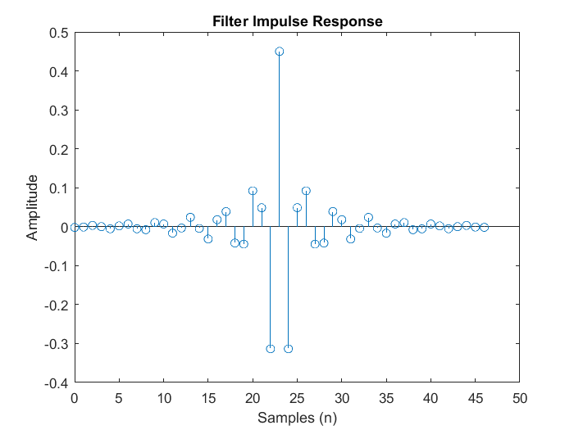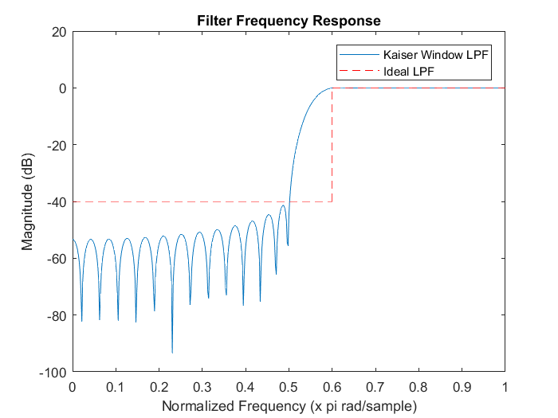

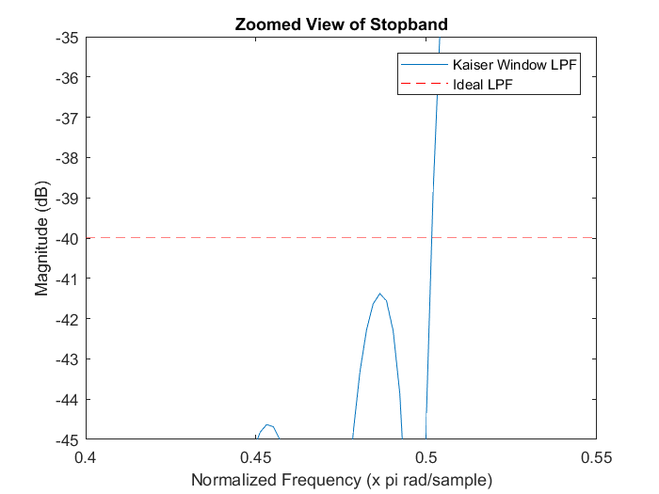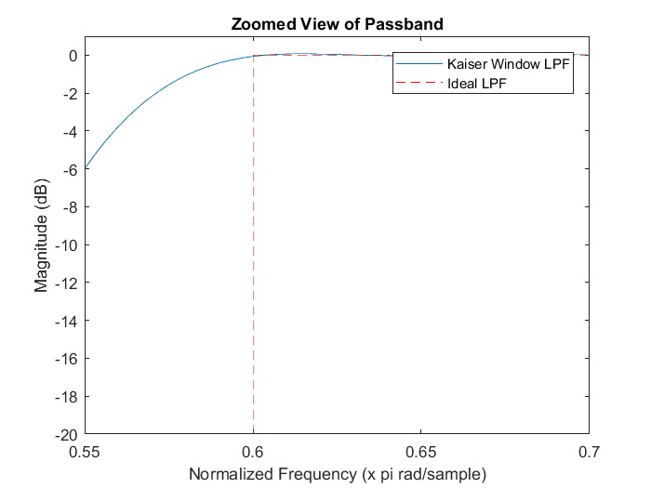

## Problem 2

**Using the Dolph-Chebyshev window, design a bandpass filter of minimum order with the following specifications: ωp1=0.4π, ωp2=0.6π, ωs1=0.3π, ωs2=0.7π and Rp=4dB, Rs=40dB. Normalize the impulse response coefficients such that the gain at the center of the passband (ωp1+ωp2)/2 is 0dB. Plot the impulse response and the frequency response magnitude. Show clearly that your design meets all specifications by plotting the specification template on the frequency response graph. You will find the MATLAB function chebwin helpful for this problem. Please note that some trial and error will likely be required to achieve the design specifications.**

The design of a bandpass filter of minimum order using the Dolph-Chebyshev window requires much trial and error. The specifications stated in the problem are final specifications as opposed to design parameters. With that in mind the specs can be used as a starting template for the design and adjusted accordingly to achieve minimum order while still meeting the filter specifications. After iterating through many changes in the different design parameters (adjust sidelode levels, and increasing/decreasing filter passband bandwidth) it was found that a 30th order bandpass filter can be achieved using a 31 point Dolph-Chebyshev window with sidelobe levels of -30dB. An order less than 30 was not able to be accomplished through the iteration design method.

% Bandpass filter Specifications  
wp1 = 0.4*pi;  
wp2 = 0.6*pi;  
ws1 = 0.3*pi;  
ws2 = 0.7*pi;  
Rp = 4; %dB  
Rs = 40; %dB  
  
  
% Create the Dolph_Chebyshev window using N+1 since the fir1() function  
% expects an N+1 window. In this case the filter order is 30.  
N = 30;  
  
  
% Adjusting initial parameters so filter meets spec @ minimum order  
wp1 = wp1 - 0.05; % Increasing filter bandwidth  
wp2 = wp2 + 0.05; % Increasing filter bandwidth  
sLobeLevel = Rs - 10; % Adjusting window sidelobe level  
  
  
% Create Dolph-Chebyshev window  
w = chebwin(N+1,sLobeLevel);  
  
  
% Plotting impulse response of window  
figure(5)  
stem((0:length(w)-1),w);  
title('Dolph-Chebyshev Impulse Response');  
xlabel('Samples(n)'); ylabel('Amplitude');  
  
  
% Plotting frequency response of window  
figure(6)  
freqz(w);  
title('Dolph-Chebyshev Frequency response');  
  
  
% Using fir1() to create bandpass filter using a Dolph-Chebyshev window.  
% The window size is N+1 since fir1() expects an N+1 window.  
h = fir1(N,[wp1/pi wp2/pi],'bandpass',chebwin(N+1,sLobeLevel));  
  
  
% Compute frequency response of the filter.  
[H,wn] = freqz(h);  
H_dB = 20*log10(abs(H));  
  
  
% Plot Magnitude Response of BPF  
figure(7)  
hold on  
plot(wn/pi,H_dB);  
title('BP-Filter Frequency Response');  
xlabel('Normalized Frequency (x pi rad/samp)'); ylabel('Magnitude (dB)');  
grid('on');  
line([0.4 0.4],[-40 0],'color','red','LineStyle','--');  
line([0.6 0.6],[-40 0],'color','red','LineStyle','--');  
line([0.3 0.3],[-40 -4],'color','red','LineStyle','--');  
line([0.7 0.7],[-40 -4],'color','red','LineStyle','--');  
line([0.3 0.7],[-4 -4],'color','red','LineStyle','--');  
line([0 0.3],[-40 -40],'color','red','LineStyle','--');  
line([0.7 1],[-40 -40],'color','red','LineStyle','--');  
hold off  
  
  
% Zoomed in view of passband  
figure(8)  
hold on  
plot(wn/pi,H_dB);  
plot(0.5,0,'x');  
title('Zoomed View of BPF Passband');  
xlabel('Normalized Frequency (x pi rad/samp)'); ylabel('Magnitude (dB)');  
axis([0.39 0.61 -4.5 0.1]);  
grid('on');  
text(0.5,0.1,num2str(abs(H_dB(255))));  
line([0.4 0.4],[-100 0],'color','red','LineStyle','--');  
line([0.6 0.6],[-100 0],'color','red','LineStyle','--');  
line([0.3 0.7],[-4 -4],'color','red','LineStyle','--');  
hold off  
  
  
% Zoomed in view of stopband  
figure(9)  
hold on  
plot(wn/pi,H_dB);  
plot(0.5,0,'x');  
title('Zoomed View of BPF Stopband');  
xlabel('Normalized Frequency (x pi rad/samp)'); ylabel('Magnitude (dB)');  
axis([0.2 0.8 -45 -39.5]);  
grid('on');  
line([0.3 0.3],[-100 0],'color','red','LineStyle','--');  
line([0.7 0.7],[-100 0],'color','red','LineStyle','--');  
line([0 0.3],[-40 -40],'color','red','LineStyle','--');  
line([0.7 1],[-40 -40],'color','red','LineStyle','--');  
hold off  
  
  
% Plot impulse response of BPF  
figure(10)  
stem((0:length(h)-1),h);  
title('BPF Impulse Response')  
xlabel('Samples (n)'); ylabel('Amplitude');

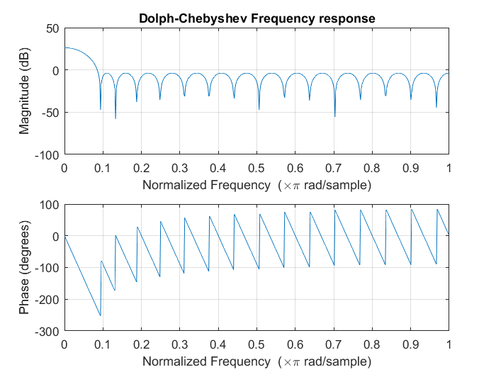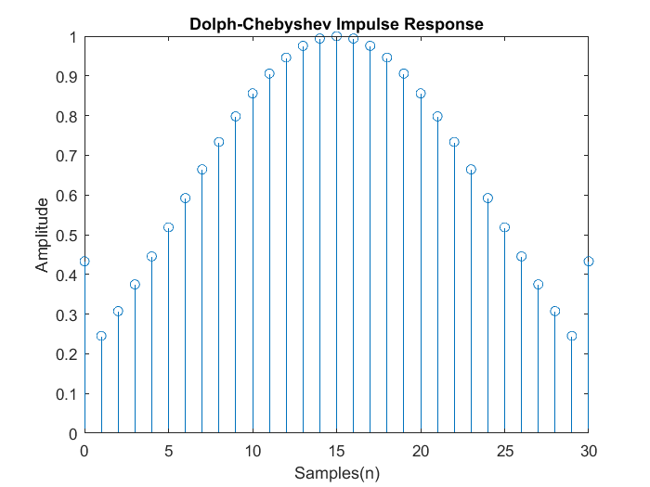

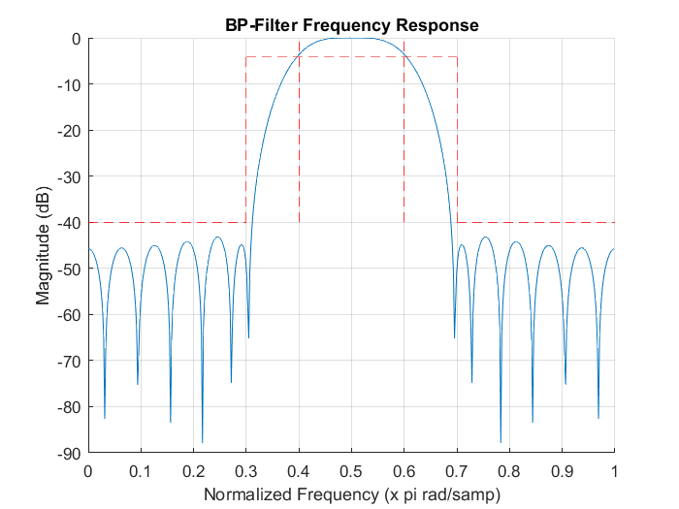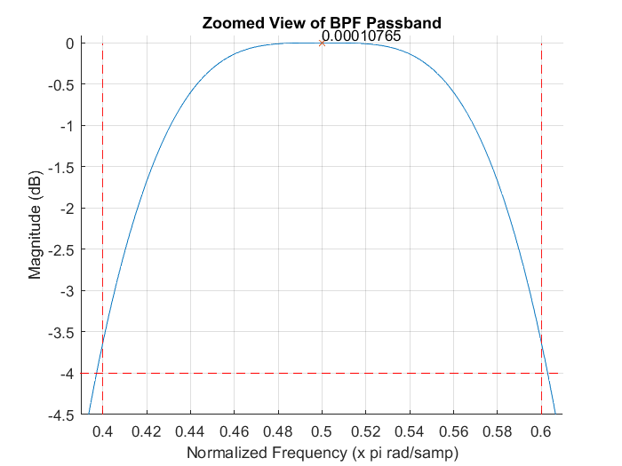

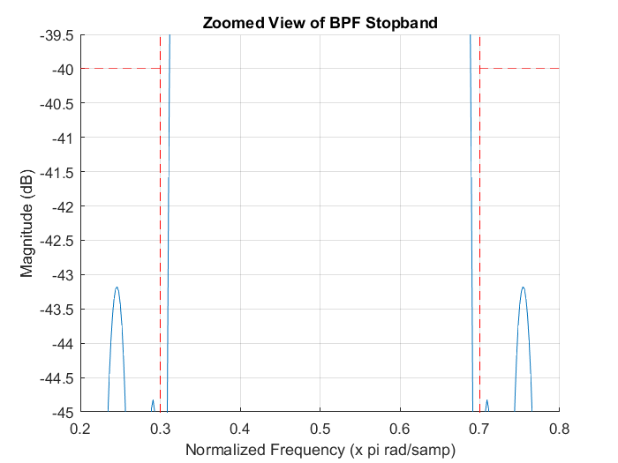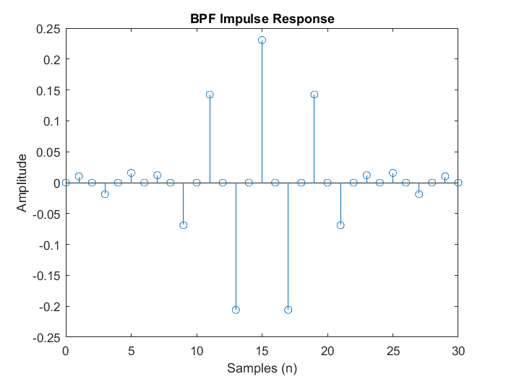

## Problem 3

**Following the approach presented in the lecture, show that the Type III FIR response must have a zero at z=-1.**

Evaluate H(z) for z = -1:

$H\left(z\right)|_{z=-1}=\sum_{m=0}^{M}{h\left(m\right){\left(-1\right)}^{m}}$ ( 1.0)

Since Type III FIRs are even in order and odd in symetry the value of the impulse response at h(M/2) = 0 and the values at h(m) = -h(M-m). To utilize this property equation 1.0 is split into three sumations.

$$H\left(z\right)|_{z=-1}=\sum_{m=0}^{\frac{M}{2}-1}{h(m){\left(-1\right)}^{m}}+h\left(\frac{M}{2}\right){\left(-1\right)}^{\frac{M}{2}}+\sum_{m=\frac{M}{2}+1}^{M}{h(m){\left(-1\right)}^{m} }( 1.1)$$

We now apply the property of h(M/2) = 0 to equation 1.1 to get:

$$H\left(z\right)|_{z=-1}=\sum_{m=0}^{\frac{M}{2}-1}{h(m){\left(-1\right)}^{m}}+\sum_{m=\frac{M}{2}+1}^{M}{h\left(m\right){\left(-1\right)}^{m}+0 }$$ ( 1.2)

By changing the index of the right summation, equation 1.2 can be express as:

$$H\left(z\right)|_{z=-1}=\sum_{m=0}^{\frac{M}{2}-1}{h(m){\left(-1\right)}^{m}}+\sum_{m=0}^{\frac{M}{2}-1}{h\left(M-m\right){\left(-1\right)}^{m}}=\sum_{m=0}^{\frac{M}{2}-1}{\left(h\left(m\right)+h\left(M-m\right)\right){\left(-1\right)}^{m}=0}$$ ( 1.3)

Since h(m) = -h(M-m) the equation 1.3 cancels out to 0.

The proof above can also be verified using a practicle example where the impulse response of an FIR filter is [-5, -1, 0, 1, 5]. Since the length of the impulse response is odd (order is even) and h(m) = -h(M-m) it is a Type III response. Now if we evaluate H(z) at z = -1 for the given impulse response we will see that H(-1) = 0.

$$H\left(z\right)=\sum_{m=0}^{4}{h\left(m\right){\left(z\right)}^{-m}}=-5z^{0}-1z^{-1}+0z^{-2}+1z^{-3}+5z^{-4}$$

Evaluating H(z) for z = -1.

$$H\left(z\right)|_{z=-1}=-5{\left(-1\right)}^{0}-1{\left(-1\right)}^{-1}+0{\left(-1\right)}^{-2}+1{\left(-1\right)}^{-3}+5{\left(-1\right)}^{-4}$$

$$=-5+1+0-1+5=0$$