Module 2 Homework 1
Realize transfer function as cascaded 2nd order terms 2

Module 2 Homework
Design a bandpass discrete-time Elliptic filter with the following specifications: Ws1=0.2pi, Wp1=0.3pi, Wp2=0.7pi, Ws2=0.8pi and Gp=0.99 and Gs=0.01. Plot the magnitude response and group delay for the resulting filter design. Realize the transfer function as a cascade of first-order and second-order sections with real-valued coefficients. List the coefficients for each section.
ws1 = 0.2*pi;
wp1 = 0.3*pi;
wp2 = 0.7*pi;
ws2 = 0.8*pi;
Gp = 0.99;
Gs = 0.01;
Rp = -20*log10(Gp);
Rs = -20*log10(Gs);
% Calculating digital Elliptic filter order and new w using normalized pass
% band and stop band frequencies.
[N,wpnew] = ellipord([wp1/pi wp2/pi],[ws1/pi ws2/pi],Rp,Rs);
% Calculate Zeros, Poles, and Gain for digital Elliptic filter
[z,p,k] = ellip(N,Rp,Rs,wpnew);
% Calculate Z domain numerator polynomial
Bz = poly(z);
% Calculate Z domain denominator polynomial
Az = poly(p);
% Adjust for gain using k computed in line 24
Bz = k*Bz;
% Calculating Magnitude Response
[H,wh] = freqz(Bz,Az);
% Calculating Group Delay
[Gpd,wg] = grpdelay(Bz,Az);
% Plotting Magnitude Response and Group Delay
figure(1)
subplot(211)
plot(wh/pi,abs(H),'-')
xlabel('Normalized Frequency'); ylabel('Magnitude Response');
subplot(212)
plot(wg/pi,Gpd,'-')
xlabel('Normalized Frequency'); ylabel('Group Delay (s)');
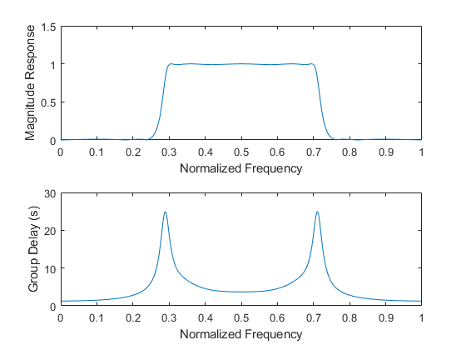

Realize transfer function as cascaded 2nd order terms
The 2nd Order terms were acquired by using MATLAB poly function on complex-conjugate pairs for variables z (zeros) and p (poles).
% 2nd Order Numerator coefficients indexed as follows:
% Z^2*p(1) + Z*p(2) + p(3)
z0 = [1 0 -1];
z1 = [1 -1.6954 1];
z2 = [1 1.6954 1];
z3 = [1 1.4663 1];
z4 = [1 -1.4663 1];
% 2nd Order Denominator coefficients indexed as follows:
% Z^2*p(1) + Z*p(2) + p(3)
p0 = [1 0 0.3335];
p1 = [1 -0.8406 0.6311];
p2 = [1 0.8406 0.6311];
p3 = [1 1.1701 0.9050];
p4 = [1 -1.1701 0.9050];
% Frequency response of each term
h0 = freqz(z0,p0);
h1 = freqz(z1,p1);
h2 = freqz(z2,p2);
h3 = freqz(z3,p3);
[h4,ww] = freqz(z4,p4);
% Cascading 2nd order Transfer functions
% Compensating for Gain
H_cascaded = k*(h0.*h1.*h2.*h3.*h4);
figure(2)
hold on
title('|H(e^{jw})| realized as cascaded 2nd order terms');
xlabel('Normalized Frequency'); ylabel('Magnitude Response');
plot(ww/pi, abs(H_cascaded),'-');
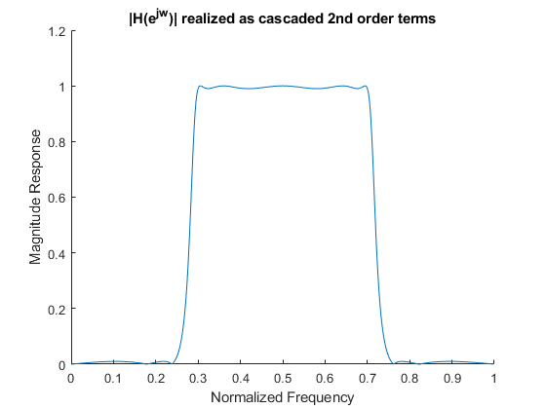
Published with MATLAB® R2017b

