Homework #3, Part 3
Find the magnitude response for the highpass power complement to the lowpass filter. Adjust the passband ripple specification (Rp) for the lowpass filter to achieve equal stopband attenuation for both lowpass and highpass filters (within ±1dB). Plot the magnitude response for both filters.
**I got the stopband to be within +-1dB of the LPF stopband by keeping the filter order at 5 and changing Rp to 0.00435;
wp = 0.45*pi;
ws = 0.55*pi;
% new Rp
Rp = 0.00435; %dB
Rs = 30; %dB
% Recompute order and w
[N,wpnew] = ellipord(wp/pi,ws/pi,Rp,Rs);
% fix filter order to 5th order
[z,p,k] = ellip(5,Rp,Rs,wpnew);
% Recompute allpass filters
AMaz = poly([p(3) p(4)]);
AMbz = flip(AMaz);
ANaz = poly([p(1) p(2) p(5)]);
ANbz = flip(ANaz);
[pAM,wm] = phasez(AMbz,AMaz);
[pAN,wn] = phasez(ANbz,ANaz);
% High pass filter response
Hhp = (exp(1j*pAM)-exp(1j*pAN))/2;
% Low pass filter response
Hlp = (exp(1j*pAM)+exp(1j*pAN))/2;
figure(5)
hold on
plot(wn/pi,20*log10(abs(Hhp)));
plot(wn/pi,20*log10(abs(Hlp)));
line([0 wn(end)/pi],[-30 -30],'color','black');
title('HPF (power complement to lowpass)');
xlabel('Normalized Frequency'); ylabel('Magnitude Response(dB)');
legend('HPF','LPF');
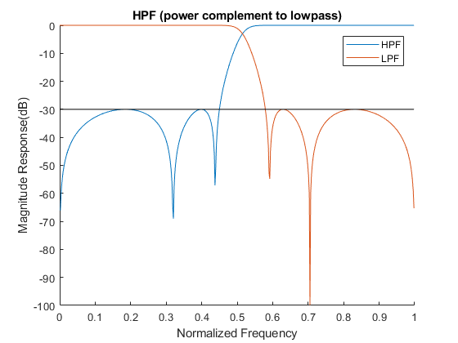
Published with MATLAB® R2017b

