Part 4
Determine the lattice realization for each allpass section. List the multiplier coefficients for each stage of the lattice for both allpass sections (use the MATLAB function tf2latc).
%........................... REPEAT OF PART 1
wp = 0.45*pi;
ws = 0.55*pi;
Rp = 0.1; %dB
Rs = 30; %dB
[N,wpnew] = ellipord(wp/pi,ws/pi,Rp,Rs);
[z,p,k] = ellip(N,Rp,Rs,wpnew);
% Calculate Z domain numerator polynomial
Bz = poly(z);
Bz = k*Bz;
% Calculate Z domain denominator polynomial
Az = poly(p);
% Calculating Magnitude Response
[H_orig,wh] = freqz(Bz,Az);
%.......................... REPEAT OF PART 2
% 2nd Order All-Pass Filter
AMaz = poly([p(3) p(4)]);
AMbz = flip(AMaz);
% 3nd Order All-Pass Filter
ANaz = poly([p(1) p(2) p(5)]);
ANbz = flip(ANaz);
%.......................... START OF PART 4
K1 = tf2latc(ANaz);
K2 = tf2latc(AMaz);
disp('All-Pass filter 1 multiplier coefficients (3rd Order):')
disp(K1)
disp('All-Pass filter 2 multiplier coefficients (2nd Order):')
disp(K2)
All-Pass filter 1 multiplier coefficients (3rd Order):
-0.1327
0.8546
-0.1822
All-Pass filter 2 multiplier coefficients (2nd Order):
-0.2122
0.4290

Part 5
Quantize the filter coefficients for the lowpass filter (direct form) designed in step 1 to 16 bits. Quantize the lattice coefficients to 16 bits. Determine the frequency response for both direct form and lattice realizations with quantized coefficients (use the MATLAB function latc2tf to convert the lattice coefficients back to direct form). Compare both to the direct form frequency response without coefficient quantization. Repeat step 5 with 10 bit coefficient quantization. To ensure uniformity of results, please use the supplied MATLAB function quantize.m.
%...........16 bit Quantization
% Quantize direct form LPF coefficients and Compute
% Frequency response of quantized direct form LPF
[H_dir,wh] = freqz(quantize(Bz,16),quantize(Az,16));
% Quantize Latice form LPF coefficients and
% Compute Latice realization transfer function for both all-pass sections
[num1,den1]=latc2tf(quantize(K1,16),'allpass');
[num2,den2]=latc2tf(quantize(K2,16),'allpass');
% Compute phase response for each all-pass section
[phAN,wn] = phasez(num1,den1);
[phAM,wm] = phasez(num2,den2);
% Compute frequency response of parallel all-pass sections
H_lat = (exp(1j*phAN)+exp(1j*phAM))/2;
figure(6)
hold on
plot(wh/pi,20*log10(abs(H_orig)));
plot(wh/pi,20*log10(abs(H_dir)));
plot(wn/pi,20*log10(abs(H_lat)));
title('LPF with 16 bit Quantization');
xlabel('Normalized Frequency'); ylabel('Magnitude Response');
legend('Direct form LPF (No Quantization)','Direct form LPF (I16)','Latice form LPF (I16)')
%...........10 bit Quantization
% Quantize direct form LPF coefficients and Compute
% Frequency response of quantized direct form LPF
[H_dir,wh] = freqz(quantize(Bz,10),quantize(Az,10));
% Quantize Latice form LPF coefficients and
% Compute Latice realization transfer function for both all-pass sections
[num1,den1]=latc2tf(quantize(K1,10),'allpass');
[num2,den2]=latc2tf(quantize(K2,10),'allpass');
% Compute phase response for each all-pass section
[phAN,wn] = phasez(num1,den1);
[phAM,wm] = phasez(num2,den2);
% Compute frequency response of parallel all-pass sections
H_lat = (exp(1j*phAN)+exp(1j*phAM))/2;
figure(7)
hold on
plot(wh/pi,20*log10(abs(H_orig)));
plot(wh/pi,20*log10(abs(H_dir)));
plot(wn/pi,20*log10(abs(H_lat)));
title('LPF with 16 bit Quantization');
xlabel('Normalized Frequency'); ylabel('Magnitude Response');
legend('Direct form LPF (No Quantization)','Direct form LPF (I16)','Latice form LPF (I16)')
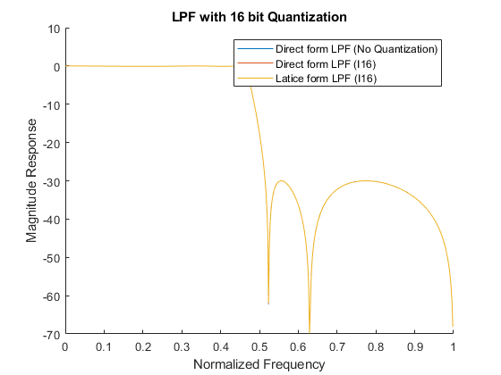
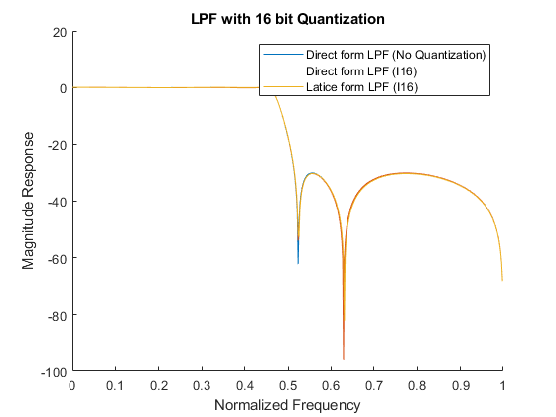
Published with MATLAB® R2017b

