Problem 1 1
Problem 2 6

Problem 1
% LPF passband/stopband specifications
wp = 0.6*pi;
ws = 0.5*pi;
% Rp was assumed to be the peak to peak passband ripple value as opposed to
% the peak ripple value. I asked in the for clarification on this in the
% module 5 discussion forum but did not recieve any responses.
Rp = 1; %dB
Rs = 40; %dB
% Change Rp to Peak Ripple value using to peak to peak
Rp = Rp/2;
% Calculate linear 1-ds and 1+ds ripple parameters. The smallest value of
% ds will be used in the firpmord() function.
% 20*Log(1-d1) = -Rp
% 20*Log(1+d1) = Rp
Rp_linear = min([(1-10^(-Rp/20)) (10^(Rp/20)-1)]);
% Compute estimated filter order and other design params using firpmord()
[N,fo,mo,w] = firpmord([ws/pi wp/pi], [0 1], [10^(-Rs/20) Rp_linear]);
% Increase filter order by 2 since original order was under estimated
N = N+2;
b = firpm(N,fo,mo,w);
% Compute Frequency Response
[H,w] = freqz(b);
% Plot Impulse Response
figure(1)
stem((0:N),b);
axis([0 N+1 min(b)-0.01 max(b)+0.01]);
title('Impulse Response');
xlabel('Samples (n)'); ylabel('Amplitude');
% Plot Frequency Response
figure(2)
hold on
plot(w/pi, 20*log10(abs(H)));
title('Magnitude Frequency Response');
xlabel('Normalized Frequency (x pi rad/sample)'); ylabel('Magnitude (dB)');
line([wp/pi wp/pi],[-Rs-10 Rp],'color','red','LineStyle','--');
line([ws/pi ws/pi],[-Rs-10 Rp],'color','red','LineStyle','--');
line([0 wp/pi],[-Rs -Rs],'color','red','LineStyle','--');
line([wp/pi 1],[-Rp -Rp],'color','red','LineStyle','--');
line([wp/pi 1],[Rp Rp],'color','red','LineStyle','--');
% Zoomed view of passband
figure(3)
hold on
plot(w/pi, 20*log10(abs(H)));
title('Zoomed View of Passband');
xlabel('Normalized Frequency (x pi rad/sample)'); ylabel('Magnitude (dB)');
axis([wp/pi-0.01 1 -Rp-0.1 Rp+0.1]);
line([wp/pi wp/pi],[-Rs-10 Rp],'color','red','LineStyle','--');
line([ws/pi ws/pi],[-Rs-10 Rp],'color','red','LineStyle','--');
line([0 wp/pi],[-Rs -Rs],'color','red','LineStyle','--');
line([wp/pi 1],[-Rp -Rp],'color','red','LineStyle','--');
line([wp/pi 1],[Rp Rp],'color','red','LineStyle','--');
% Further zoomed view on passband at wp
figure(4)
hold on
plot(w/pi, 20*log10(abs(H)));
title('Zoomed View of Passband @ Wp');
xlabel('Normalized Frequency (x pi rad/sample)'); ylabel('Magnitude (dB)');
axis([0.59 0.62 -0.6 -0.1]);
line([wp/pi wp/pi],[-Rs-10 Rp],'color','red','LineStyle','--');
line([ws/pi ws/pi],[-Rs-10 Rp],'color','red','LineStyle','--');
line([0 wp/pi],[-Rs -Rs],'color','red','LineStyle','--');
line([wp/pi 1],[-Rp -Rp],'color','red','LineStyle','--');
line([wp/pi 1],[Rp Rp],'color','red','LineStyle','--');
% Zoomed view of stopband
figure(5)
hold on
plot(w/pi, 20*log10(abs(H)));
title('Zoomed View of Stopband');
xlabel('Normalized Frequency (x pi rad/sample)'); ylabel('Magnitude (dB)');
axis([0 ws/pi+0.01 -43 -39.5]);
line([ws/pi ws/pi],[-Rs-10 Rp],'color','red','LineStyle','--');
line([0 wp/pi],[-Rs -Rs],'color','red','LineStyle','--');
% Further zoomed view of stopband at ws
figure(6)
hold on
plot(w/pi, 20*log10(abs(H)));
title('Zoomed View of Stopband @ Ws');
xlabel('Normalized Frequency (x pi rad/sample)'); ylabel('Magnitude (dB)');
axis([0.47 0.52 -43 -39.5]);
line([ws/pi ws/pi],[-Rs-10 Rp],'color','red','LineStyle','--');
line([0 wp/pi],[-Rs -Rs],'color','red','LineStyle','--');
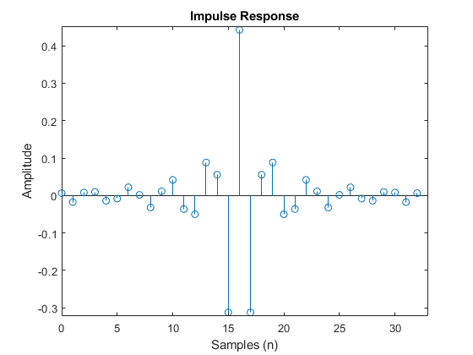
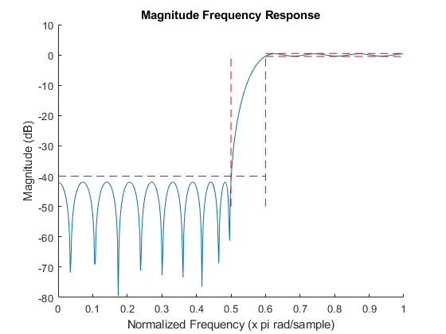
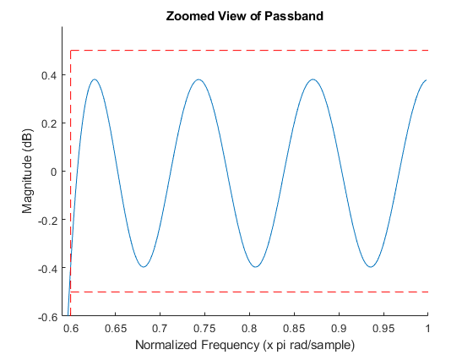
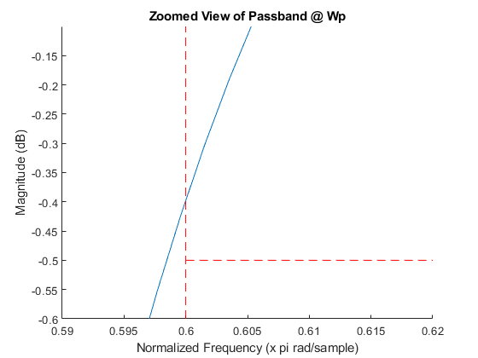
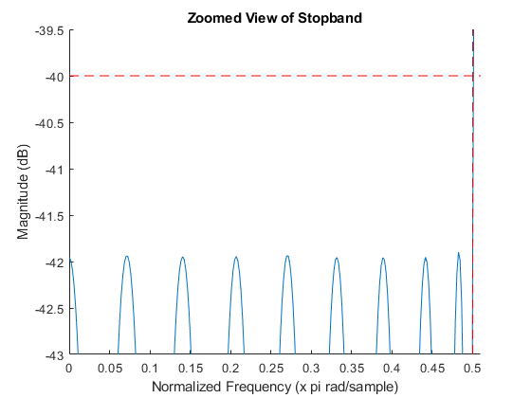
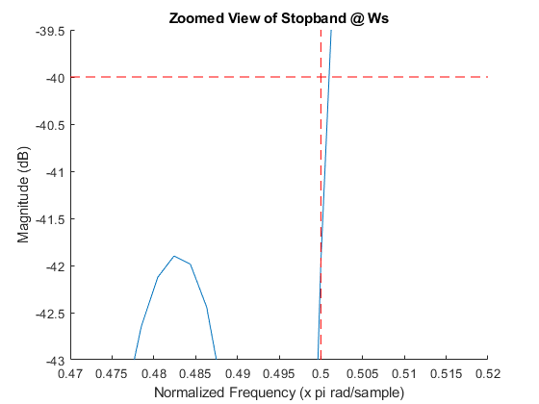

Problem 2
% Filter specifications
wp = 0.3*pi;
ws = 0.5*pi;
N = 30;
M = N/2;
alpha = [0.2 0.5];
h = zeros(length(alpha),N+1);
% Compute impulse response for alpha=0.2 and alpha=0.5
for a=1:length(alpha)
% Compute Ps Matrix
syms w;
cw = cos((0:M)*w).';
cw = cw*cw.';
Ps = zeros(M+1,M+1);
w = linspace(ws,pi,5000);
for m=0:M
for n=0:M
% Evaluate cw(m,n) at each value of w
c = eval(cw(m+1,n+1));
% Handling cases where c = 1 or 0
if c==1
c = ones(length(w),1);
elseif c==0
c = zeros(length(w),1);
end
% Compute integral
Ps(m+1,n+1) = (1/pi)*trapz(w,c);
end
end
% Compute Pp Matrix
syms w;
cw = cos((0:M)*w).';
cw = (1 - cw)*(1 - cw).';
Pp = zeros(M+1,M+1);
w = linspace(0,wp,5000);
for m=0:M
for n=0:M
% Evaluate cw(m,n) at each value of w
c = eval(cw(m+1,n+1));
% Handling cases where c = 1 or 0
if c==1
c = ones(length(w),1);
elseif c==0
c = zeros(length(w),1);
end
% Compute Integral
Pp(m+1,n+1) = (1/pi)*trapz(w,c);
end
end
% Compute P
P = alpha(a)*Ps + (1-alpha(a))*Pp;
% Compute Eigen Vectors/Values of P
[V,D] = eig(P,'vector');
% Find index of smallest Eigen value in the Eigen value column vector
ind = find(D==min(D));
% Find Eigen Vector containing smallest Eigen value using the index
b = V(:,ind);
% Re-organize bn to get h(n)
% h(M) = b(0)
h(a,M+1) = b(1);
% h(n) = b(n)/2 for n = 1 to M
h(a,M+2:end) = b(2:M+1).'/2;
h(a,1:M) = flip(b(2:M+1).'/2);
h(a,:) = h(a,:)/sum(h(a,:));
end
% Least Squares Impulse Reponse and Frequency Response
hls = firls(30,[0 .3 0.5 1],[1 1 0 0]);
[Hls,wls] = freqz(hls);
% Magnitude Response for alpha = 0.2
h_02 = h(1,:);
[H_02,w02] = freqz(h_02);
% Magnitude Response for alpha = 0.5
h_05 = h(2,:);
[H_05,w05] = freqz(h_05);
% Plot Impulse Response for alpha=0.2, alpha=0.5, and
% least squares
figure(7)
hold on
stem(h_02);
stem(h_05);
stem(hls);
title('Impulse Response');
xlabel('Samples (n)'); ylabel('Amplitude');
legend('Eigen,alpha=0.2','Eigen,alpha=0.5','Least Squares');
% Zoomed view of some of the impulse response values
figure(8)
hold on
stem(h_02);
stem(h_05);
stem(hls);
axis([15.99 16.01 0.396 0.408]);
title('Zoomed View of h(16)');
xlabel('Samples (n)'); ylabel('Amplitude');
legend('Eigen,alpha=0.2','Eigen,alpha=0.5','Least Squares');
% Plot Magnitude Response for alpha=0.2, alpha=0.5, and
% least squares
figure(9);
hold on
p1 = plot(w02/pi,20*log10(abs(H_02)));
p2 = plot(w05/pi,20*log10(abs(H_05)));
p3 = plot(wls/pi,20*log10(abs(Hls)));
title('Magnitude Response');
xlabel('Normalized Frequency (x pi rad/sample)'); ylabel('Magnitude Response (dB)');
line([ws/pi ws/pi],[-100 10],'color','red','LineStyle','--');
line([wp/pi wp/pi],[-100 10],'color','red','LineStyle','--');
legend([p1 p2 p3],'Eigen,alpha=0.2','Eigen,alpha=0.5','Least Squares');
% Zoomed view of Magnitude Response (Passband)
figure(10);
hold on
p1 = plot(w02/pi,20*log10(abs(H_02)));
p2 = plot(w05/pi,20*log10(abs(H_05)));
p3 = plot(wls/pi,20*log10(abs(Hls)));
axis([0 0.35 -0.1 0.1]);
title('Zoomed View of Passband');
xlabel('Normalized Frequency (x pi rad/sample)'); ylabel('Magnitude Response (dB)');
line([wp/pi wp/pi],[-100 10],'color','red','LineStyle','--');
legend([p1 p2 p3],'Eigen,alpha=0.2','Eigen,alpha=0.5','Least Squares');
% Zoomed view of Magnitude Response (Stopband)
figure(11);
hold on
p1 = plot(w02/pi,20*log10(abs(H_02)));
p2 = plot(w05/pi,20*log10(abs(H_05)));
p3 = plot(wls/pi,20*log10(abs(Hls)));
axis([ws/pi-0.1 1 -100 -40]);
title('Zoomed View of Stopband');
xlabel('Normalized Frequency (x pi rad/sample)'); ylabel('Magnitude Response (dB)');
line([ws/pi ws/pi],[-100 10],'color','red','LineStyle','--');
legend([p1 p2 p3],'Eigen,alpha=0.2','Eigen,alpha=0.5','Least Squares');
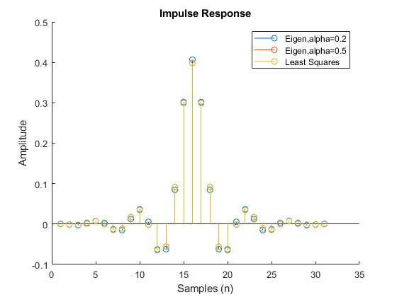
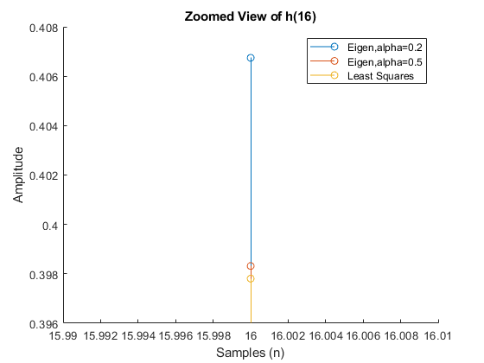
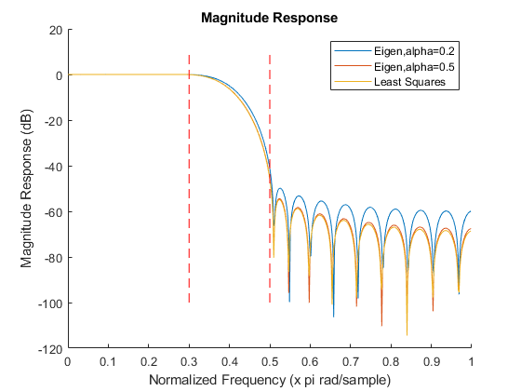
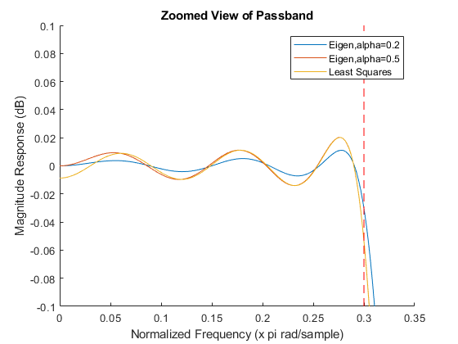
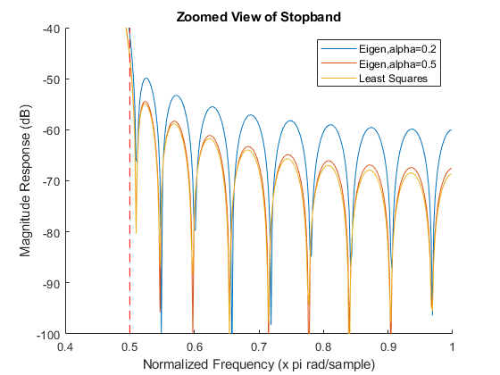
Published with MATLAB® R2017b

