Pokémon, dominated by Mathematics
by Tycho Neve (a.k.a. Actaeon)

“Pokémon, dominated by Mathematics” is a short overview of all important Pokémon-related formulas including example calculations, in which the formulas the games of the 3rd generation use to calculate certain values are analyzed. Note that basic Pokémon knowledge is acquired to fully understand this guide; this guide explains the formulas entirely, but most of the variables are considered to be within the basic knowledge. I hope the reader will read this guide with full interest.

Index
§ 1. The Damage Formula pg. 2
  - Critical Hits pg. 3
  - Confusion Damage pg. 4

§ 2. The Stat Formula pg. 5
  - Stat modifications pg. 6
  - Accuracy, Evasion and Hit Rate pg. 7
  - Status Effects pg. 8

§ 3. Hidden Power calculations pg. 9

§ 4. Experience pg. 11

§ 5. The Catch Chance Formula pg. 13

§ 6. Various unimportant formulas pg. 15
  - Pay Day Money pg. 15
  - Berry Powder Formula pg. 15
  - Special Moves pg. 16
  - Accuracy of OHKO moves pg. 17
  - Escape Chance pg. 18

§ 1. The Damage Formula

This paragraph is devoted to the Damage Formula, which is famous among competitive players, allowing them to calculate the amount of Damage an attack will do to the opponent. The formula is as follows:

Where:  is the amount of HP Damage that will be dealt;
is the Level of the attacking Pokémon;
is the (Sp.) Atk. of the attacking Pokémon;
is the Power of the move that is used by the attacking Pokémon;
is the (Sp.) Def. of the defending Pokémon;
is the “STAB variable”; if the attacking Pokémon’s type is (partially)
the same as the move it uses, it equals 1.5. Otherwise, it equals 1;
is the Effect the move has on the defending Pokémon; if the move has a
neutral effect, it equals 1. If the move is either “super effective” or “not
very effective”, it equals 2 and 0.5 respectively and if the move is either
“super effective” on both types or “not very effective” on both types, it
equals 4 or 0.25 respectively. If the move does not have any effect on the
defending Pokémon at all, it equals 0, causing D to be 0 as well;
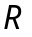 is a random percentage between 85% and 100%. R is a round
percentage.

An example: Let’s say we have Lv. 100 Arcanine with 315 Sp. Atk. using Fire Blast on a Lv. 100 Venusaur with 300 Sp. Def and 320 HP. How much damage would Venusaur take?
First of all, let’s see what information we have. 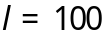, 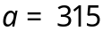, 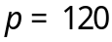, 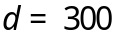,
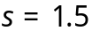, 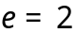. We will run 2 calculations because we want to know both minimum and maximum damage: if 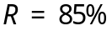, the damage will be minimum and if 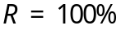, maximum damage will be dealt. First we will calculate the minimum damage, then the maximum damage:

So the damage would be between 275 and 324 HP.
§ 1.1. Critical Hits

A “Critical Hit”, or abbreviated, “Crit or CH”, is a situation in which an attack deals more damage, approximately twice as much as it would’ve normally dealt. Also, they ignore (Sp.) Atk. reductions or (Sp.) Def. enhancements, so they are always in favour of the attacking Pokémon. The moment it occurs is based on a chance. Critical Hits are a very critical part in Pokémon, since they are one of the factors an advanced player does not even have much control on.
First, the amount of damage that will be dealt when a Critical Hit occurs will be explained. Then the different chances of scoring a Critical Hit will be given.

To be precise, the l (Level) variable in the Damage Formula is doubled, so the Damage will be almost doubled as well. When discussing about Pokémon situations, we can accept a Crit deals a little less than double damage. Let’s calculate the Damage Venusaur receives when the Arcanine scores a Critical Hit in the previous example 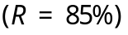:

So the Venusaur would be easily OHKO’d, even with minimum damage!

For the chance of scoring a Critical Hit, first find the result of the following formula:

Where: “hchr” applies when the Pokémon uses a “High Critical Hit Ratio” move,
like Slash or Karate Chop;
“pei” applies when the Pokémon has a “Pokémon exclusive item”, e.g.
Farfetch’d holding Stick or Chansey holding Lucky Punch;
“sl” applies when a Scope Lens is attached to the attacking Pokémon;
“fe/lb” applies when either Focus Energy is used, or Lansat Berry is
activated. These can’t be applied at the same time.

If a variable in this formula is applied, it equals 1. Otherwise, it equals 0.
The Crit Rate depends on the Crit Number (CN), according to the following:

If 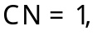 the Crit Rate is 6.25%;
If 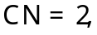 the Crit Rate is 12.5%;
If 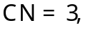 the Crit Rate is 25%;
If 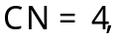 the Crit Rate is 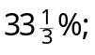
If 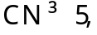 the Crit Rate is 50%.

§ 1.2. Confusion Damage

This paragraph is written to explain how the amount of damage the Pokémon gets when it “hurts itself in its confusion” is calculated.

The definition: “When a Pokémon hurts itself in its confusion, it attacks itself with a 40 Power physical, unSTABbed, neutral move with constant maximum damage.”
Simply put, that means Confusion can not critically hit.

We can put this information in the damage formula, simplifying it a little bit:

Where 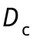 is the “Confusion Damage”.

§ 2. The Stat Formula

Pokémon Statistics, or shortly, Stats, are the values that made Pokémon so different and individual. They determine offensive and defensive capabilities, as well as the opportunity to strike first in a battle. There are six stats in the 3rd generation: Hit Points, Attack, Defense, Speed, Special Attack and Special Defense. They are always abbreviated as HP, Atk., Def., Spd., Sp. Atk. or SpA, and Sp. Def or SpD. The formula for HP is different from the formulas for the other Stats.
The formula to calculate the absolute Stat, is as follows:

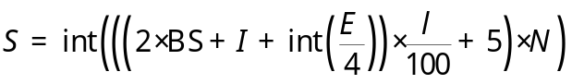

And the formula to calculate the HP, is as follows:

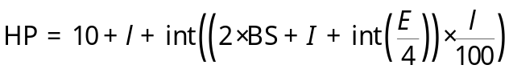

Where: is the Stat calculated;
 is the BaseStat for the Stat that is currently calculated;
is the Individual Value for this Stat, 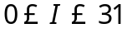;
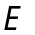 is the Effort Value for this Stat, 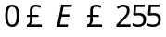;
is the Level of the Pokémon;
 is the Nature Value; if the nature is boosting the Stat,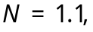 if the
nature is neutral,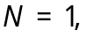 and if the nature is lowering the Stat,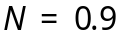.

Let’s have an example again. We have a Lv. 80 Gyarados with an Adamant nature, his Atk. is outmaxed and it has perfect IVs for this stat. How much Atk. does it have?
First, we should gather the information:
Then we simply use the Stat Formula:

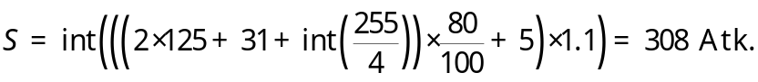

It’s easy to understand that when the Stat Formula and the Damage Formula are combined, people can EV their Pokémon to get the right stats to survive specific hits or deal specific damage because they know how much (Sp.) Atk. they need, and the
amount of EP’s (Effort Points) to get that Stat, without spilling EP’s.
§ 2.1. Stat modifications

Stat modifications are processes during the battle in which a Stat either increases or decreases in value. For example, if Umbreon would use Charm on a Salamence, Salamence’s Atk. would decrease with 2 levels, according to the game description.
How do these “levels” of modification exactly effect the Stat?

First of all, there are 13 levels of modification (including 0). They go from 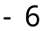 to .
In the formulas, “modification Level” is referred to as  For every  there is a Modifier 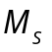which is multiplied by the original Stat, according to the following chart:

 | -6 | -5 | -4 | -3 | -2 | -1 | 0 | 1 | 2 | 3 | 4 | 5 | 6
 | 1/4 | 2/7 | 1/3 | 2/5 | 1/2 | 2/3 | 1 | 3/2 | 2 | 5/2 | 3 | 7/2 | 4

We use the following formula to calculate the exact modified Stat 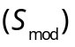

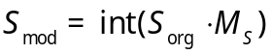

Where  is the original, unmodified Stat.

Let’s use this formula on the example with Umbreon and Salamence, assuming Salamence is Lv. 100 and has maximum Atk. (405). Note that Charm makes 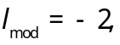 which causes M to equal 1/2. So 
§ 2.2. Accuracy, Evasion and Hit Rate

Accuracy and Evasion determine whether moves hit or not. Like Stats, these values can be modified, causing moves to hit or miss more frequently. Besides Pokémon themselves, moves also have an Accuracy, but this value is constant, e.g. Hyper Beam is 90% accurate, so it will have a 10% miss chance. Note that Accuracy and Evasion have no influence on moves hitting the user, such as Recover.

Accuracy and Evasion can be modified as said before, for example, Double Team raises the user’s Evasion with 1 level, Sweet Scent lowers the foe’s Evasion with 1 level, and Sand-Attack lowers the Accuracy of the foe with 1 level.

Before I show the formula for calculating the actual chance of a move to hit, I will first show the charts of the Accuracy and Evasion modifiers:

 | -6 | -5 | -4 | -3 | -2 | -1 | 0 | 1 | 2 | 3 | 4 | 5 | 6
 | 1/3 | 3/8 | 3/7 | 1/2 | 3/5 | 3/4 | 1 | 4/3 | 5/3 | 2 | 7/3 | 8/3 | 3

 | -6 | -5 | -4 | -3 | -2 | -1 | 0 | 1 | 2 | 3 | 4 | 5 | 6
 | 3 | 8/3 | 7/3 | 2 | 5/3 | 4/3 | 1 | 3/4 | 3/5 | 1/2 | 3/7 | 3/8 | 1/3

Where 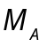 is the Accuracy modifier and 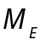 is the Evasion modifier. Note that the Evasion modifier becomes greater when the modification level becomes lower. This is explained by the fact that the higher the Evasion is, the harder it gets to hit a move. This makes it an easier variable to define the Hit Rate formula:

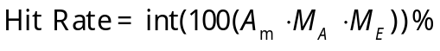

Where 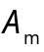 is the Accuracy of the move that is used.

An example: We have a Slaking that is about to use Hyper Beam on a Pidgeot. The Pidgeot managed to use Double Team twice and to use a Sand-Attack on Slaking. What will the chance be for Slaking to hit the Pidgeot? Let’s gather the information:
Then the Hit Rate will be:

§ 2.3. Status Effects

Status Effects or Status Ailments are hindering conditions Pokémon can have during battle when struck by specific moves. For example, if a Pokémon uses Thunder Wave, the opponent will get paralyzed, this is one of those conditions which hinder Pokémon.

In total, there are 5 different Status effects, including burned (Brn), paralyzed (Par), asleep (Slp), poisoned (Psn) and frozen solid (Frz). Confusion and being flinched are not being considered as Status Effects because they are not permanent (after switching, fainting, or ending the battle their effects end).

Now, only 2 of those Status Effects influence the Stat. Namely, having the Burned condition will halve your (only physical) Attack Stat:

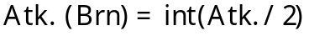

And having the Paralyzed condition will divide your Speed Stat by 4:

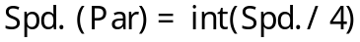
§ 3. Hidden Power Calculations

Hidden Power is very unique move that has a different Type and Power, depending on the Pokémon that uses it. More specifically said, Hidden Power has a different Type and Power according to the Individual Values of the Pokémon that uses it.

The Power of Hidden Power lies somewhere between 30 and 70, 30 and 70 inclusive.
The Type of Hidden Power may be any Type, besides Normal.

The formula for the Power is different from the formula for the Type. First, determination of Power will be explained (Note that HP now means Hidden Power):

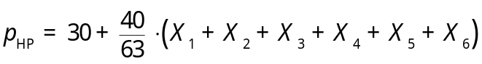

Where: 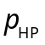 is the Power calculated (any decimals are rounded normally);
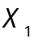 equals 1 if the Hit Points IV divided by four has a remainder of 2 or 3;
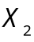 equals 2 if the Attack IV divided by four has a remainder of 2 or 3;
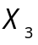 equals 4 if the Defense IV divided by four has a remainder of 2 or 3;
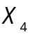 equals 8 if the Speed IV divided by four has a remainder of 2 or 3;
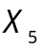 equals 16 if the Sp. Atk. IV divided by four has a remainder of 2 or 3;
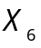 equals 32 if the Sp. Def. IV divided by four has a remainder of 2 or 3.
If a certain X does not equal its given value, then it equals 0.

For the Type calculation, the following formula is applied:

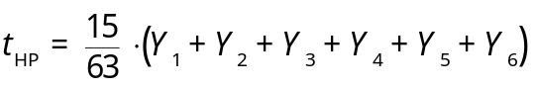

Where: 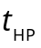 is the Type calculated (any decimals are rounded normally);
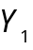 equals 1 if the Hit Points IV is odd;
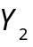 equals 2 if the Attack IV is odd;
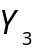 equals 4 if the Defense IV is odd;
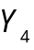 equals 8 if the Speed IV is odd;
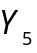 equals 16 if the Sp. Atk. IV is odd;
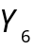 equals 32 if the Sp. Def. IV is odd.
If a certain Y does not equal its given value, then it equals 0.
But because the outcome of the Hidden Power Type formula is a number, we don’t have a type yet. Every Type has a set number in the Pokémon games, according to the following information:

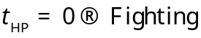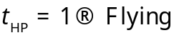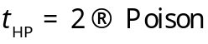
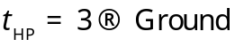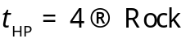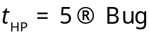
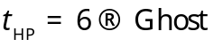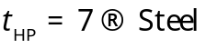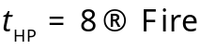
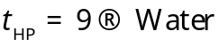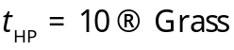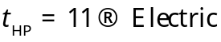
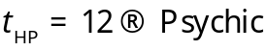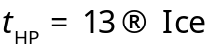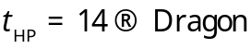
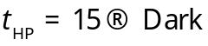

Let’s have an example calculation again. I have an ingame Exeggutor and I know his Individual Values: 13 HP, 30 Atk., 2 Def., 18 Spd., 22 Sp. Atk., 11 Sp. Def.
First, the Power is calculated: 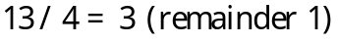, so 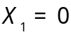. And so we go on:

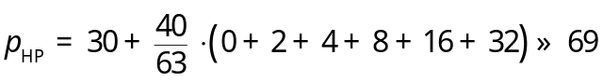

Then, the Type: 13 is odd, so 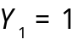. Every Y is determined that way:

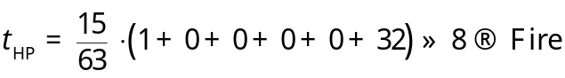

So my Exeggutor has HP Fire with 69 Power.
§ 4. Experience

The Experience of a Pokémon is an indication of how much it has battled. Pokémon gain EXP. Points (Experience Points) by participating in winning battles without fainting. When a Pokémon accumulates sufficient EXP. Points, it levels up.

The cumulative total amount of experience required to reach a specific level is determined by set formulas. Each species of Pokémon follows a set evolution formula. In the 3rd generation games, there are six different formulas and thus 6 different evolution-rate “types”. To contrast these types, we made names for them:

- “Erratic”
- “Fast”
- “Medium”, “Medium Fast” or “Cubic”
- “Medium Slow” or “Parabolic”
- “Slow”
- “Fluctuating”

The following (piecewise) functions determine the amount of EXP. Points acquired to reach level l:

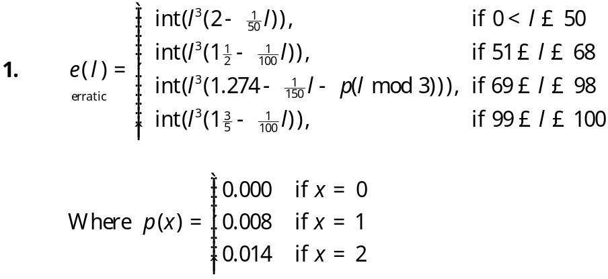

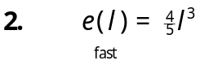
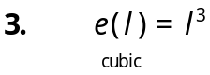
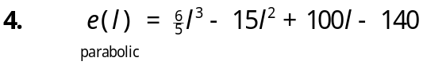
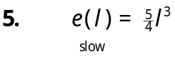
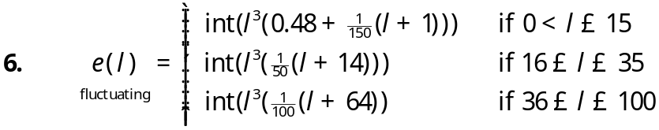

Due most likely to the issue of speed when using these formulas, the GBA games will simply use a lookup table for each value of all types except “erratic” instead of computing them. Because of this, these formulas are not actually part of the game mechanics.

The amount of EXP. Points a Pokémon receives by beating another Pokémon is defined by the following formula:

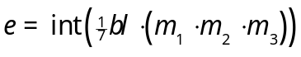

Where is the amount of EXP. Points obtained by the winning Pokémon;
is the Base Experience of the defeated Pokémon;
is the level of the defeated Pokémon;
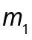 equals 1.5 if the winning Pokémon’s ID Number and the trainer that
currently uses the winning Pokémon’s ID Number are not equal;
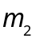 equals 1.5 if the defeated Pokémon belonged to a trainer;
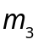 equals 1.2 if the winning Pokémon is from another country than the native one of the player.
Experience is not of great importance for competitive play. Therefore, there is no example calculation included.
§ 5. The Catch Chance Formula

When a Poké Ball is thrown at a wild Pokémon, the game calculates a chance for catching that Pokémon, based on several values like Status Effects and the amount of HP the wild Pokémon has left. The formula is as shown:

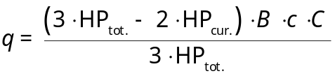

Where:  is the total or maximum HP of the wild Pokémon;
 is the current HP of the wild Pokémon;
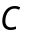 is the Catch Value of the wild Pokémon, this value can be found at the Pokédex on http://www.serebii.net, for example. This constant is
often called “Catch Rate”, but it is a set value.
is the Poké Ball Constant;
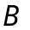 is the Status Effect Bonus: it equals 2 if the Pokémon is Frz or Slp, and it equals 1.5 if the Pokémon is Brn, Psn or Par. Otherwise, it equals 1.

The Poké Ball Constants:

Poké Ball: 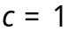;
Great Ball: 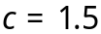;
Ultra Ball: 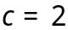;
Safari Ball: ;
Luxury Ball: ;
Premier Ball: ;

Net Ball: 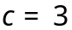 if the Pokémon is a Water- or Bug-type;
Dive Ball: 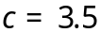 if the battle is underwater;
Nest Ball: if the Pokémon’s level is between 1 and 19;
if the Pokémon’s level is between 20 and 29;
if the Pokémon’s level is higher than 29;
Repeat Ball: if the Pokémon is already under the “owned” category of the
Pokédex.
Timer Ball: if the number of turns that have passed is between 1 and 9;
if the number of turns that have passed is between 10 and 19;
if the number of turns that have passed is between 20 and 29;
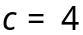 if the number of turns that have passed is above 29
Master Ball: 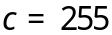 (Pokémon is always caught).
If 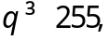 then the Pokémon is caught. If not, then calculate r as follows:

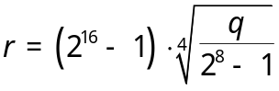

The game now generates 4 random numbers between 0 and 65535, including 0 and 65535. If all those random numbers are less than or equal to r, the Pokémon is caught. Otherwise, the ball shakes n times, where n is the number of random numbers that are less than or equal to r. Therefore, the Catch Rate is defined as follows (always round to one decimal):
:
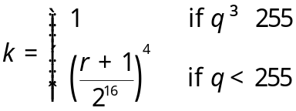

Now that is a lot of algebra to apply. Let’s run an example calculation.
We encounter a Lv. 50 Zapdos with 158 HP and we manage to bring it down to 1 HP using False Swipe. Then, we paralyze it and we try to catch it with an Ultra Ball. How much chance do we have to capture the Zapdos?

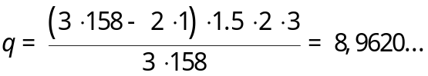

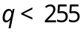, so we have to calculate r as follows:

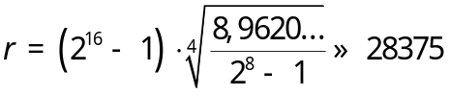
, so:
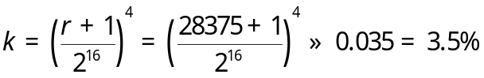

So after all the effort we did to weaken the Zapdos, we still only have 3.5% chance to capture the Zapdos using an Ultra Ball!

§ 6. Various unimportant formulas

In this last paragraph, I will introduce a few uncertainties about the Pokémon Formulas. Imagine not being able to calculate how much your Houndoom will hurt an opposing Blissey with Beat Up! How much money will Meowth earn after the battle if it uses Pay Day in the battle? Why does a high level Articuno hit more often with Sheer Cold than a lower level Articuno? These questions, and a lot more, will be answered in this paragraph.

§ 6.1. Pay Day Money

For the amount of money earned after a battle if the move Pay Day was used in the battle, either by the opponent or your Pokémon, we have the following formula:

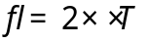

Where: is the amount of Pokédollars collected after the battle by the winning
trainer;
is the level of the Pokémon that first used Pay Day;
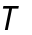 is the amount of turns the battle lasted.

§ 6.2. Berry Powder Formula

Remember using the Berry Crusher in FRLG/E? A berry was thrown in, and the point was pressing A continuously as fast as possible. For the amount of Berry Powder obtained, the following formula gives us information:

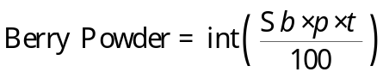

Where: 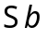 is the sum of all Berry Values; you can find this value on Bulbapedia;
is the Performance of the Crusher (the % value the game gives),
this value lies between 0 and 100
is the number of players that crushed berries.
§ 6.3. Special Moves

When I say “Special Move”, it means it does not use the Damage Formula the logic way. Here, I will give the things that you should know about certain moves.

Explosion / Selfdestruct
These self-destructing moves as they are defined, will use the integer of half the Defense of the Pokémon that is defending. This information is not included in the description of the move, so it is an important thing to know if, for example, Gengar needs to be able to OHKO a Blissey with Explosion.

Beat Up
If a Pokémon uses Beat Up, the opponent will receive damage from every Pokémon that is not fainted of the party the attacking Pokémon is in. It is a standard Damage Calculation, and the Power p is 10, but the Attack a equals the attacker’s BaseStat Physical Attack and the Defense d equals the defender’s BaseStat Physical Defense.
Some other notes: STAB applies, so 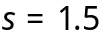 for Dark-types but type advantages do not, so 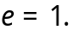
The randomization factor is entirely skipped. 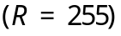

Doom Desire and Future Sight
Doom Desire has 120 Power with 85% accuracy. Future Sight has 80 Power with
90% accuracy.
Doom Desire is a Steel-type move and Future Sight is a Psychic-type move.
However, their type has no effect in battle. Type advantages do not apply using these 2 moves. So Future Sight will hit Fighting types and Dark types with exactly the same amount of damage, for example. STAB does not apply for these moves either. However, the applicable attacking stat still applies (Doom Desire runs off Atk. and Future Sight runs off Sp. Atk.).
They hit at the end of the turn, after any Leftovers have been applied.
This means that several things don't work against these moves, including
Destiny Bond, Grudge, Counter/Mirror Coat, Protect, and Endure.
When calculating damage for these moves, the randomization factor is skipped entirely.

Dodging moves
Fly/Bounce - Sky Uppercut, Thunder, Twister, Gust
Dig - Magnitude, Earthquake, Fissure
Dive - Surf

Doesn’t this information look familiar? If any of the moves on the right are used when the opponent is Flying, Bouncing, Digging, or Diving, the Power p of these moves is doubled.

Stockpile / Spit Up / Swallow
Stockpile can be used up to three times to power Spit Up and Swallow.

One Stockpile = 100 power for Spit Up = 25% HP recovered for Swallow
Two Stockpiles = 200 power for Spit Up = 50% HP recovered for Swallow
Three Stockpiles = 300 power for Spit Up = 100% HP recovered for Swallow.

They also can't cause a Critical Hit, and if you miss, your Stockpiles will remain piled. Only if you hit with Spit Up, or switch, or successfully recover HP, your piles become unpiled. Spit Up unarguably becomes one of the most powerful attacks in the game if the Pokémon used Stockpile 3 times.

If I forgot anything important (or unimportant), feel free to tell me.

§ 6.4. Accuracy of OHKO moves

OHKO moves, like Horn Drill and Sheer Cold, ignore all Accuracy and Evasion modifiers, but instead have their own accuracy formula. OHKO moves fail if the user’s level is less than the target’s level. The formula:

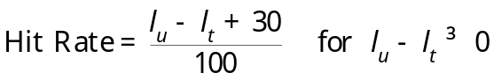

Where is the user’s level and is the target’s level.
§ 6.5 Escape Chance

If one tries to escape from a wild Pokémon, it may occur that the game says “Can’t escape!”. The chance a Pokémon has to escape from a wild Pokémon, is given by the following formula:

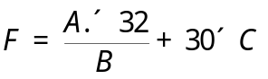

Where A is the current speed of the player’s active Pokémon;
B is the opposing Pokémon’s speed divided by 4 (mod 255);
C is the number of times the player has tried to escape during the battle,
counting the current attempt.

If 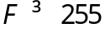, the player escapes automatically. Otherwise, a random number is generated between 0 and 255. If that number is less than or equal to F, the player escapes. If not, the escape fails and the player's Pokémon does not make a move that turn.

So the probability P of escaping is 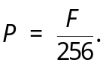 (Counting zero)

