**Conclusion:**

All curves and plots are generated with the same parameters.

1. With Idopa: For each curve, the location where most variance occurs is close to the middle point.

Without Idopa: We can see more shifts in the time-series. The location where most variance occurs is not always around the middle point.

It makes me wonder whether the medication of Idopa supresses certain subset or all of brain nodes responses (i.e. notice there are less overshoot in the Idopa groups in the Original TS plots), so that the nodes responses will be more “syncronized”.

1. In order to tell whether there are some significant differences between healthy control group and PD group, I think I need more data from both PD and Healthy control group to back up any hypothesis.
2. I also tried on some subset of time points with less overshoot, and result from our way of analyzing the data seems robust.

**“Variance” of each node on 1st Principle Component** (k=32)

PD-Idopa group

HC-Placebo group

PD-Placebo group

**Mean Curve of each node**

­­­­­­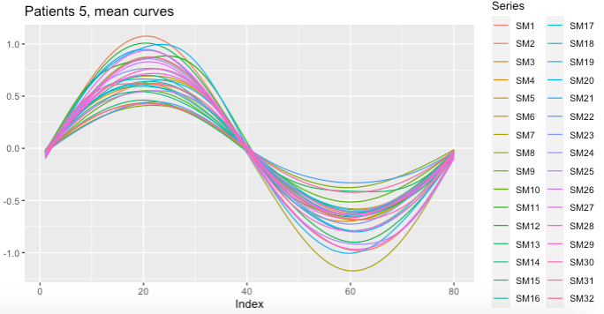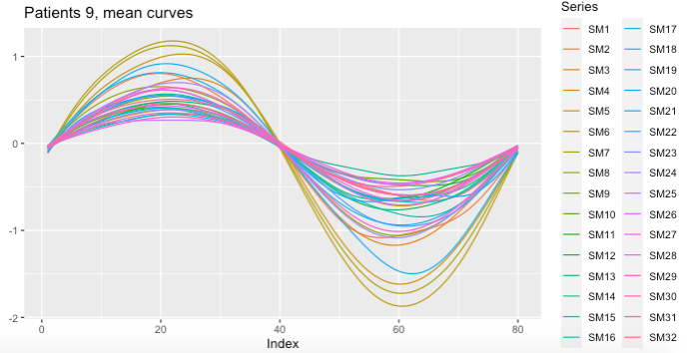

**Original Time-Series**

