Function documentations & Examples

Zach Wang

8/19/2020

## 1. Function Implementations

### 1.1 function 1: *ReadFile* and attach packages

### 1.2. function 2: *Wave*

### 1.3. function 3: *fourier_smooth*

### 1.4. function 4: *fPCA.nodes*

### 1.5. function 5: *node.scaler*

### 1.6. function 6: *row.check*

# **main script**

## 2. Examples of using each function

### 2.1 Read data

file_loc = '/Users/hanwang/desktop/Git_desktop/Functional_Data_Analysis/data_15may2020.csv'  
data_15may2020 <- ReadFile(file_loc, time_subset=c(1:600), node_subset=c(1:32))

read in data from the specified file location

### 2.2 *Wave* function

**Wave** function takes the a single node data as input, and transforms the data to N complete sinusoidal cycles. Below are some examples of using Wave function on data of a single node.

* **Notes:**
  + *Wave* has two arguements:
    - node_data: input takes one column at a time (here is a 600x1 matrix)
    - register: set to 0 if want the result to be the original curves; set to 1 if want the result curves to center around 0

The following 2 plots are generated by the *Wave* function applied on the raw data of node 1 (before smoothing).

# extract periodic curves from a single node (before smoothing)  
node1 = Wave(data_15may2020[,1], register=0)  
ggplot(node1, aes(time, y_value,group=cycle, colour=cycle)) + geom_line() + theme(legend.position="top")

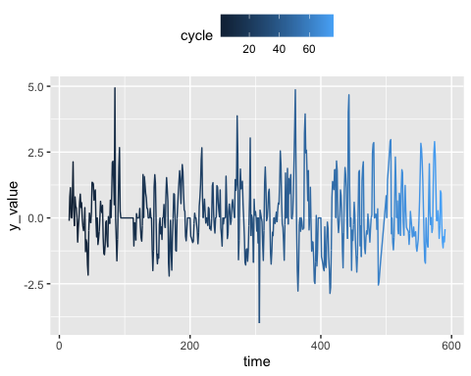

node1 = Wave(data_15may2020[,1], register=1)  
ggplot(node1, aes(time, y_value,group=cycle, colour=cycle)) + geom_line() + theme(legend.position="top")

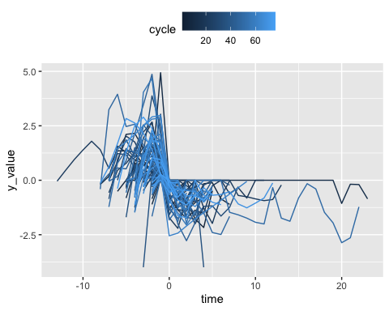

The following 2 plots are generated by *Wave* functions on the transformed data of node 1 (after smoothing). In the examples below, another function, **fourier_smooth** is called first to smooth the raw data using fourier basis functions.

* **Notes:**
  + *fourier_smooth* has four arguments:
    - data_mat: Input data matrix, which should contains the entire data set, but we can use other arguments to select only *“subsets”* or *“Region of interest”* of the data for analysis
    - time_subset: specify a subset of time or all for analysis
    - node_subset: specify a subset of node or all for analysis
    - k: specify the *“nummber of fourier basis functions”* to be used in the smoothing process

# extract periodic curves from a single node (after smoothing)  
result_obj <- fourier_smooth(data_mat=data_15may2020, time_subset=c(1:600), node_subset=c(1), k=32)  
node1_smoothed = eval.fd(c(1:600),result_obj$fd)  
node1_smoothed_extraced = Wave(node1_smoothed, register=0)  
ggplot(node1_smoothed_extraced, aes(time, y_value,group=cycle, colour=cycle)) + geom_line() + theme(legend.position="top")

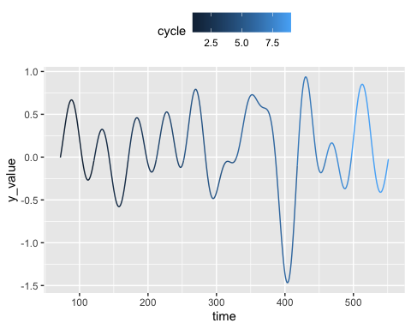

node1_smoothed_extraced = Wave(node1_smoothed, register=1)  
ggplot(node1_smoothed_extraced, aes(time, y_value,group=cycle, colour=cycle)) + geom_line() + theme(legend.position="top")

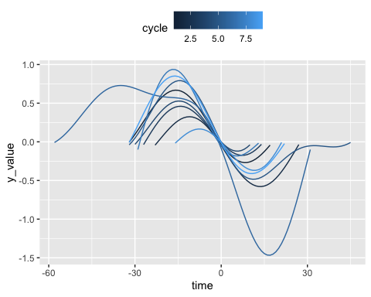

### 2.3 *fPCA.nodes* function

**fPCA.nodes** function takes input data in matrix form (N rows x M columns), and transform the data to N complete sinusoidal cycles – there has to be more than one column, otherwise PCA won’t make sense.

* **Notes:**
  + *fPCA.nodes* has four arguements:
    - data_mat: data in matrix form (N rows x M columns).
    - k: number of fourier basis functions used
    - nharm: number of Principle Components interested
    - plt: set to 1 if want to generate plot; set to 0 if don’t want plot

Below are some examples of using **fPCA.nodes** function on the original data.

# fPCA on raw data  
rotpcalist = fPCA.nodes(data_15may2020, k=11, nharm=2, plt=1)

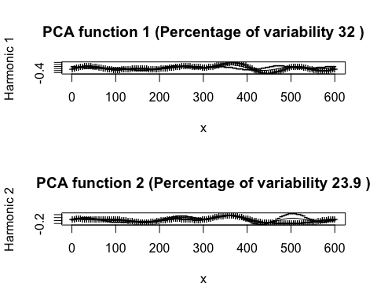

### 2.4 *node.scaler* & *row.check* functions

**node.scaler** function is designed to transform a single node curves into T complete sinusoidal cycles (*Wave* function is called). The returned matrix has 3 columns (*cycle*, *time*, *y_value*). The *time* columns will be scaled between range of [-1,1].

* **Notes:**
  + *node.scaler* has two arguements:
    - data_mat: input data in matrix form (N rows x M columns).
    - node: specify which node will be currently used, since scaler function only look at one node at a time

**row.check** function is designed to transform the returned dataframe from calling the *node.scaler* function, and most importantly make sure the total number of rows is the same for every column. The result is a 80 x T matrix (the pivot of the matrix from *node.scaler* result), so that each column now represents a different *cycle* and each row stores the *y_value* corresponding to each time point.

* **Notes:**
  + *row.check* has only one input argument:
    - node_data: the transformed node data from *node.scaler*.

Below are examples of using **node.scaler** together with **row.check** function on a single node. Two plots were generated to show that the result shape of curves after calling the node.scaler and row.check functions are the same.

# apply scaler to *single node* and match row numbers  
a = node.scaler(data_15may2020, node=c(1))  
ggplot(a, aes(time, y_value,group=cycle, colour=cycle)) + geom_line() + theme(legend.position="top")

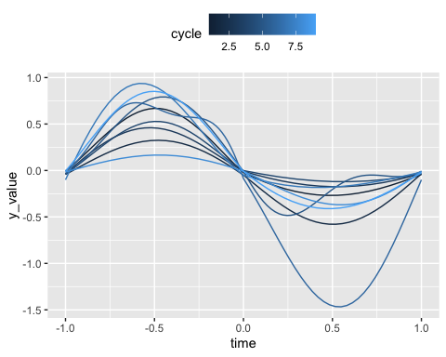

b = row.check(node_data=a)  
b = read.zoo(b, index='index')  
autoplot(b, facet = NULL)

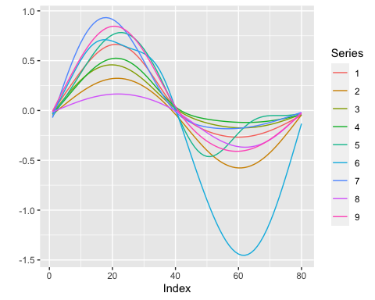

## 3. Use all the functions defined above to analyze the entire dataset (all nodes, all time points)

# fPCA on all nodes  
PC1_df = data.frame(matrix(nrow=80))  
PC2_df = data.frame(matrix(nrow=80))  
mean_df = data.frame(matrix(nrow=80))  
for(node in 1:32){  
 node.df = node.scaler(data_15may2020, node)  
 node.df = as.matrix(row.check(node.df))  
 rotpcalist = fPCA.nodes(data_mat=node.df, k=11, nharm=2, plt=0)  
 # PC1 & PC2  
 harmfd <- rotpcalist[[1]]  
 basisfd <- harmfd$basis  
 rangex <- basisfd$rangeval  
 x <- seq(rangex[1], rangex[2], length = harmfd$basis$rangeval[2])  
 fdmat <- eval.fd(x, harmfd)  
 meanmat <- eval.fd(x, rotpcalist$meanfd)  
 PC1_df[,ncol(PC1_df)+1]=fdmat[,1]   
 PC2_df[,ncol(PC2_df)+1]=fdmat[,2]  
 mean_df[,ncol(mean_df)+1]=meanmat  
}  
PC1_df = data.frame(PC1_df[,2:(ncol(PC1_df))])  
names(PC1_df)=colnames(data_15may2020)  
PC2_df = data.frame(PC2_df[,2:(ncol(PC2_df))])  
names(PC2_df)=colnames(data_15may2020)  
mean_df = data.frame(mean_df[,2:(ncol(mean_df))])  
names(mean_df)=colnames(data_15may2020)  
## plot  
### PC1  
z_1 = read.zoo(PC1_df, index='index')  
### PC2  
z_2 = read.zoo(PC2_df, index='index')  
### Mean Functional Curves  
z_3 = read.zoo(mean_df, index='index')  
autoplot(z_1, facet = NULL)

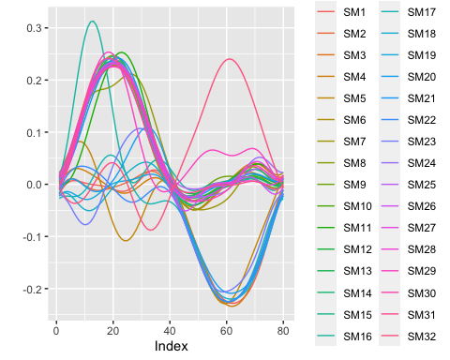

autoplot(z_2, facet = NULL)

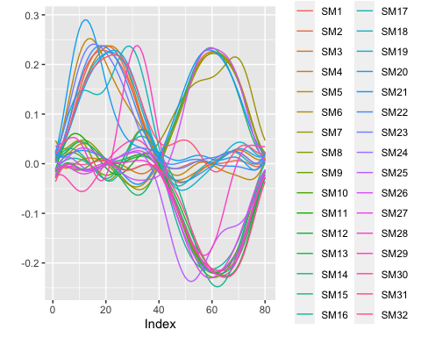

autoplot(z_3, facet = NULL)

