Due Date: May 3, 2017 Points: 40

This assignment will have to be done as a pdf or word document and uploaded to the course webpage.

1) Number Conversion: Convert the follow number to the requested base. (8 points)

A) 10100101₂ → Four digit Hexadecimal
0x00A5

B) 1010₁₀ → 10 (16 bit signed number)
10

C) 55AA₁₆ → (16 bit binary)
21930

D) 2222₁₀ → Four digit Hexadecimal
0x08AE

2) Binary Addition: Show the results of the following binary additions, being sure to show all carries. Assume a zero carry in. (6 points)

A) 0 0¹ 1 0¹ 1 0¹ 1 0 ⁰
+ 0 0 1 0 1 0 1 0

0 1 0 1 0 1 0 0

B) 0¹ 1¹ 1 0 0 0 1 0 ⁰
+ 0 0 1 0 1 0 0 0
1 0 0 0 1 0 1 0

    - Overflow: Interpreting the additions in question 2 as 8-bit signed numbers, do either have an overflow and why? (2 points)

No because the last digit is a zero carry.
3) Masking: Write a line of c code that performs the following operations, you can not use the bitSet or bitClear functions. (6)

A) Force bit 4 in the variable A, high.

A |= 0x01;

B) Force bit 9 in the variable B, low.

B &= ~0x002;

C) Toggle bit 6 in the variable A.

A ^= 0x06;

4) Conditionals: For what values of A do the following logical equations evaluate as true. (8)

A) if( A > 5 && A < 0 )

A = is always false

B) if( A )

A = anything but 0

C) if( A < 10 && A > -10 )

A = -9 through 9

D) if( A & 0x0042 )

A = bits 9 or 12 are high

5) Code Reading/Timing: Fill in the timing diagram, as it would appear if the code in Appendix A were running. (10)
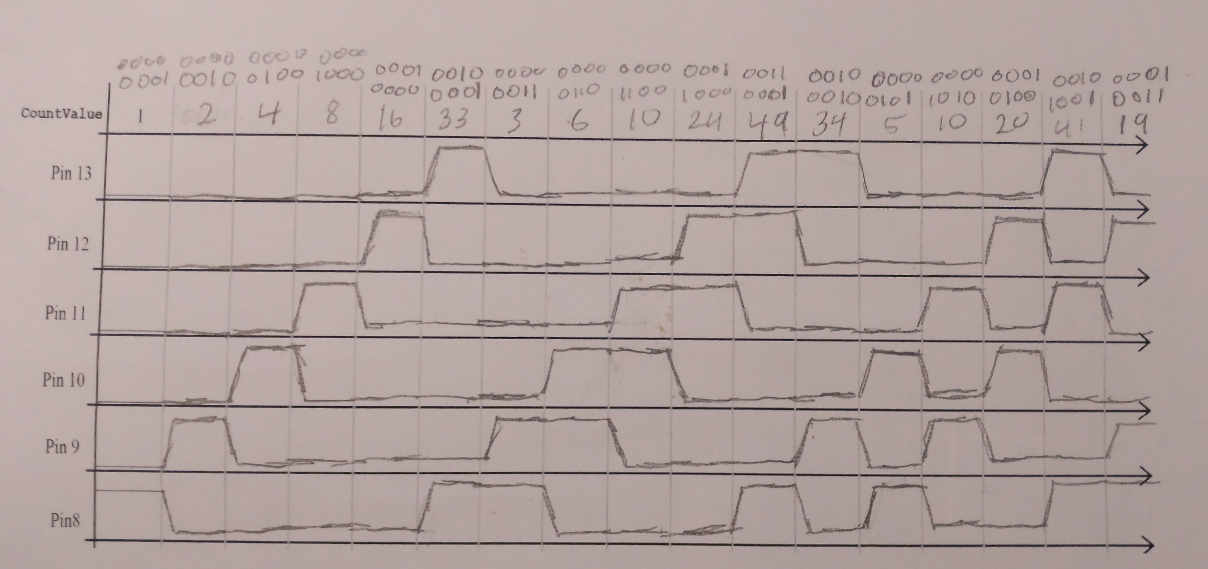
Appendix A: Output Function Generator.

#include <MsTimer2.h>
int CountValue = 1;
void CountValueISR()
{
// Compute next output value.
// if bit 5 set is equal to bit 4
if (bitRead(CountValue, 5) == bitRead(CountValue, 4))
CountValue = CountValue << 1; // shift to the left
else
CountValue = (CountValue << 1) // shift to the left
+ 1; // and set bit 0.
CountValue &= 0x3f;
// Send output to portb, or pins 13-8.
PORTB = CountValue;
} // End of ISR

// Runs at start up to initialize system.
void setup()
{
DDRB |= 0x3f; // Set pins 13-8 as outputs.
// set up Timer2 for 50 millisecond interval.
MsTimer2::set(50, CountValueISR);
MsTimer2::start();
} // End of setup()

// loop called continuously.
0void loop()
{
// Nothing in loop.
} // End of loop.

