Project: Moffat Bay Lodge | Members:  Jacob Achenbach  Tabari Harvey  Zachariah King  Ryan Monnier
Course: CSD 460 Capstone
Description: Module 10 Testing
Date: 2025/12/07
To complete the test case plan, fill out the information for Project, Course, Description and Date in the header below.
.
TABLE OF CONTENTS
Attractions Page Loads properly 3
Make sure the user can navigate away from the Attractions page 4
<DESCRIPTION> 8

For each test, the developer should: provide a test description, a test objective, the developer name and date tested. For each step, fill out the actions to be taken and describe the expected results, and indicate yes or no for each step depending upon the result. The peer tester should provide their name, date tested, indicate yes or no for each step depending upon the result, and a screenshot (thumbnail) of the result.

Test 1 | Attractions Page Loads properly
 | Test Objective: Verify functionality of attractions page | Developer: Ryan  Date tested: 2025/12/07 | Peer tester: Zach  Date tested: 2025/12/07
Step | Action | Expected results: | Developer pass/fail | Tester pass/fail  + Screenshot
1 | Click ‘Attractions’ link from index.php | Page should load, be consistent in design, and display relevant attraction information | Yes | Yes
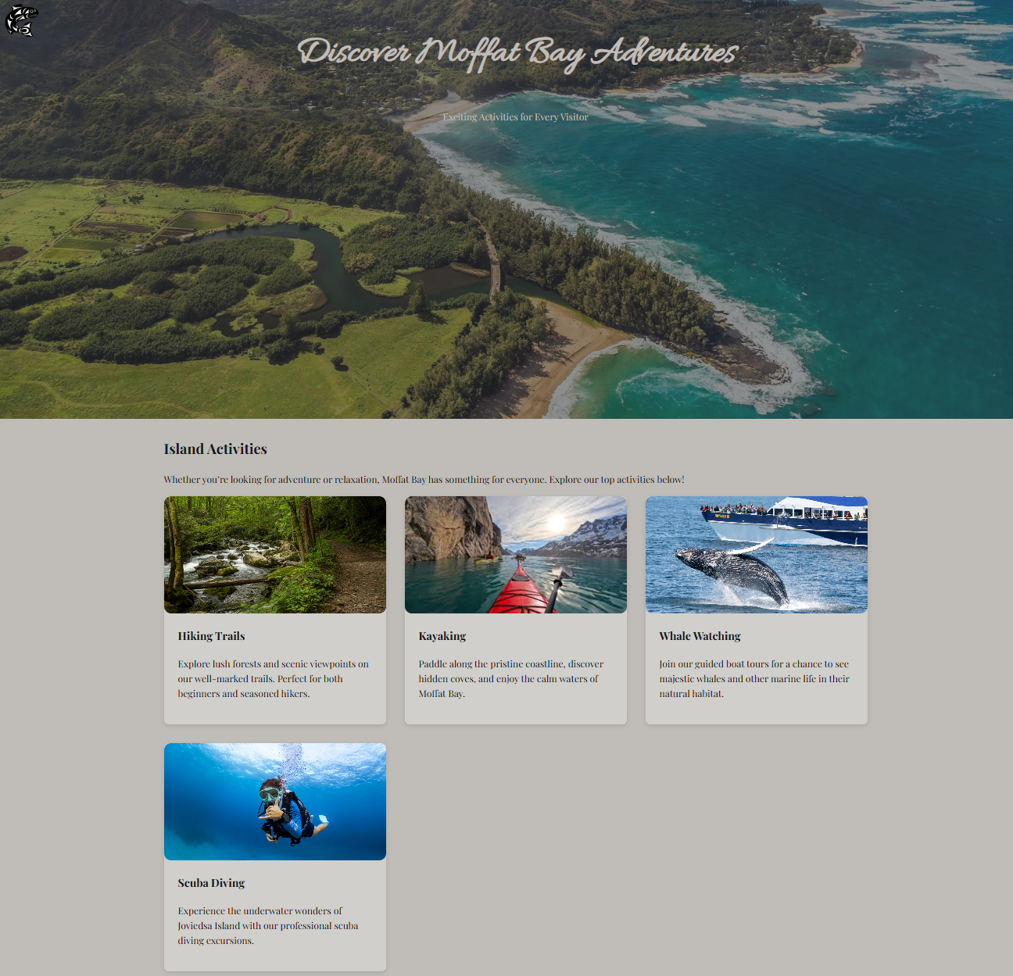
2 | Read information about Moffat Bay Attractions | Basic information should be available about the advertised attractions, pictures should be relevant to the topic | Yes | Yes
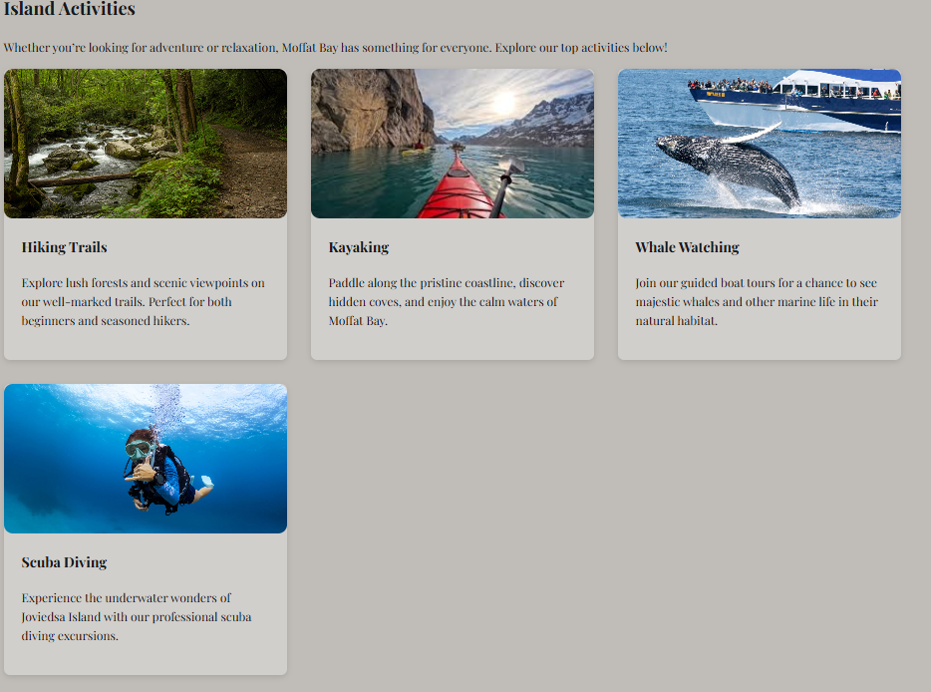
Comments | The page indeed loads after clicking the Attractions link on the index page, as well as from the About Us page. The design is consistent with the rest of the site, and relevant information about the attractions offered at Moffat Bay are presented to the user.

Test 2 | Make sure the user can navigate away from the Attractions page
 | Test Objective: Links to other pages should work and allow easy navigation for the user | Developer: Ryan  Date tested: 2025/12/07 | Peer tester: Zach  Date tested: 2025/12/07
Step | Action | Expected results: | Developer pass/fail | Tester pass/fail
1 | Click ‘About’ link | Be redirected to the about us page | Yes | Yes  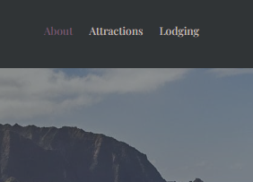
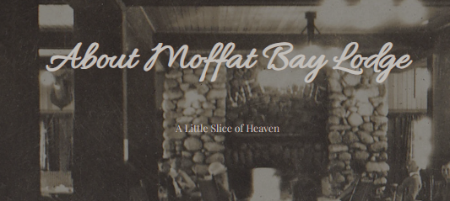
2 | Click Lodging | Be redirected to the reservations page | Yes | Yes  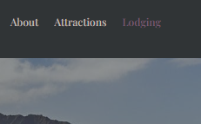
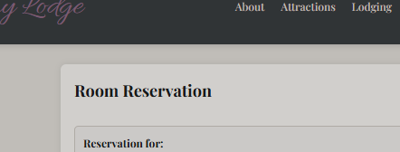
3 | Click ‘Login’ | Be redirected to the login page | Yes | Yes  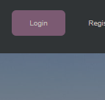
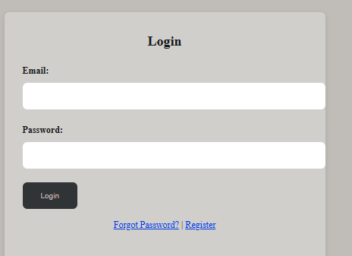
4 | Click ‘Register’ | Be redirected to the registration page | Yes | Yes  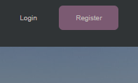
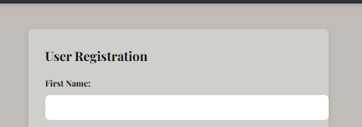
Comments | There isn’t a whole lot of functionality to the Attractions page because its basically just html, but the page loads as expected and all navigation tests were successful. Links to all previously developed and tested pages seem to work well.

